Specialised Cells

SPERM CELL | - Designed to __________ _____.  - Found in the Testes  - A sperm is ______ and has a long tail that provides ____________ so it can swim and find an egg cell.  - The _______ contains enzymes which allow it to digest into an egg cell and join with it.
EGG CELL  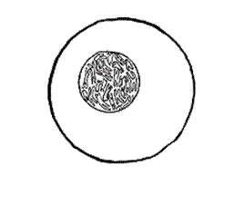 | - Designed to be ____________.  - Found in the ________.  - Contains yolk which provides a large ________ _______ for the new cell being formed.
PALISADE CELL  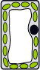 | - Designed for ________________.  - Tall and has a large surface area to absorb ________ and _________.  - Packed with ____________ to help make ________ ________.
CILIATED CELL | - Designed to stop ______ ______.  - They line all the air passages in the lungs.  - They have tiny hairs called cilia.  - Hairs sweep _____ with trapped dust and bacteria back up the throat.
ROOT HAIR CELL  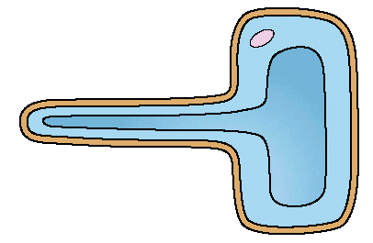 | - Designed for ____________.  - Has a large _________ which helps it to absorb water and minerals.  - Thin cell wall makes it easy for ____________to pass through.
NERVE CELL  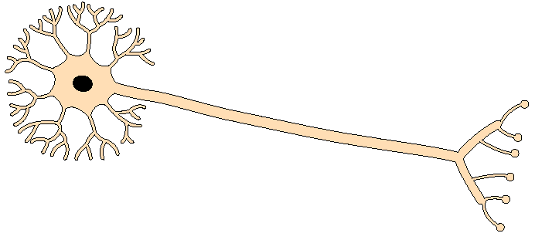 | - They are long.  - They have ____________ at each end.  - Can carry ____________ _________.  - Their job is to carry nerve ________to different parts of the body.
RED BLOOD CELL | - Designed to carry oxygen.  - Found in ________.  - Large surface area, for ________ to pass through.  - Contains haemoglobin, which joins with oxygen.  - Has no _________.

This homework must be printed and filed to hand in. Extension questions from powerpoint to be typed below with an appropriate title or completed on lined paper.

