Keeping the Lungs Clean

This diagram shows how  sticky ________  (made in ________ cells)  traps ________ and ________.  The beating ________  move the dirty mucus _____  and ______ of the airways.  It is then ________ and  the bacteria killed in the  stomach’s ________. | 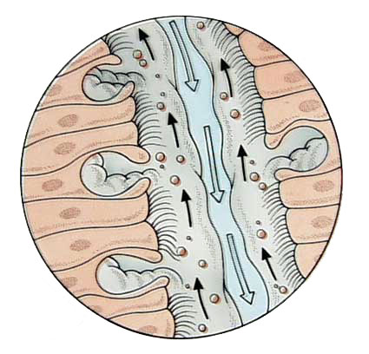

What effects how healthy our lungs are?

- This destroys or _________________ the __________, so the ____________ cannot be moved
- ___________ mucus is produced
- Smokers ___________ to remove to mucus from their lungs (this can damage the alveoli)
- __________________ caught in the mucus _________________ and cause _________________ in the lungs

