BREATHING

Label the following on the diagram:

Ribs, intercostal muscles, lungs, diaphragm, trachea, bronchi, bronchioles and alveoli.

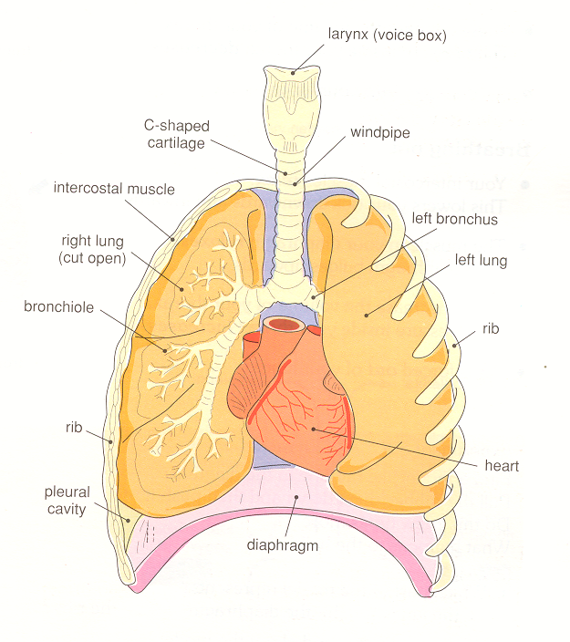

Complete the following:

There are two lungs situated in the chest (t______). The sides of the chest are bounded by the r______. Between the ribs are the i_________ m___________.

Air entering through the n______ and m_______ enters the w___________ (t_______). The trachea splits in to two, each short tube is called a b________. Each b_______ divides many times to give lots of smaller branches called b__________. Each b___________ leads to a bunch of a__________ (air sacs). A network of b________ c____________ surrounds each air sack.

The lungs are spongy and surrounded by a p_______ m_________. This allows the lungs to slide smoothly over the chest wall during breathing.

Breathing in (i________) and breathing out (e___________)

I____________:
- I_________ m___________ contract/relax – rib cage moves down/up and out/in.
- D__________ contracts/relaxes – d_________ flatteed/raised.
- Volume of thorax increases/decreases so pressure of air in thorax and lungs increases/decreases below atmospheric pressure.
- Air is sucked into lungs to equalise pressures so lungs inflate/deflate.

E___________:
- I____________ m__________ contract/relax – rib cage moves down/up and out/in.
- D__________ muscles contract/relax – d________ raised/lowered.
- Volume of thorax decreases/increases so pressure on air in lungs increases/decreases above atmospheric pressure.
- Lungs deflate/inflate as air leaves through passages.

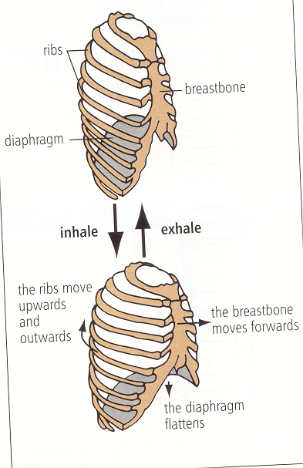

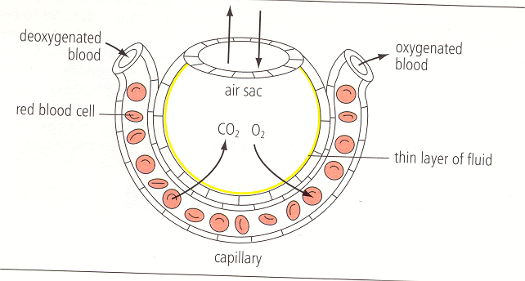
GAS EXCHANGE IN THE LUNGS

- Blood arriving in a lung is d_____________ - it contains a low/high concentration of oxygen
- Air breathed into an alveolus contains a higher/lower concentration of oxygen than air in the blood capillaries that surround them therefore d___________ occurs and oxygen enters the blood capillaries.
- Since deoxygenated blood contains a higher/lower concentration of c___________ d___________ than air breathed into an alveolus, carbon dioxide diffuses from the blood/alveolus into the blood/alveolus from where it is exhaled.
How are our lungs kept clean??

Our breathing passages are lined with a c________ m_________ m____________. Microbes and dust get caught up in the m________ which is then wafted away from the lungs by beating c________.
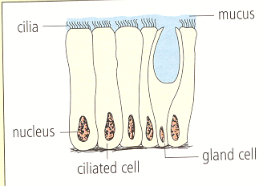

C________ c_______ have tiny hair-like cilia projecting from the surface. The cilia beat by moving backwards and forwards very quickly.
G_______ c_______ secrete m______ onto the surface of the membrane.

SMOKING
There are links between smoking and respiratory diseases:
- Excess m_______ production when tiny particles in the smoke get caught on the lining of the windpipe and bronchial tubes causes the c_____ to stop beating. The mucus therefore collects in the bronchial tubes giving rise to a “smoker’s cough”. The bronchial tubes can become infected leading to inflammation. This is called b________.
- Persistent coughing can cause the delicate walls of the a____ s_______ to break down. This reduces the surface area for g____ e__________, so the person gets very short of breath. This is called e__________.
- Carcinogens (substances that cause cancer) in tobacco smoke are a group of dark coloured chemicals referred to as “tar”. These are associated with l______ cancer.

