Year 9 Cells questions
- The diagram shows a plant cell from a leaf.
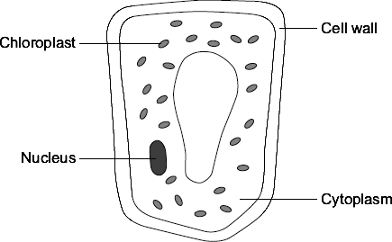
(a) List A gives the names of three parts of the cell. List B gives the functions of parts of the cell. Draw a line from each part of the cell in List A to its function in List B.

List A  Parts of the cell |  | List B  Functions
Where most of the chemical
reactions take place
Nucleus
 |  | Absorbs light energy to make food
Cytoplasm
 |  | Strengthens the cell
Chloroplast
 |  | Controls the activities of the cell
(3)
(Total 3 marks)

- The diagrams show an animal cell and a bacterial cell.
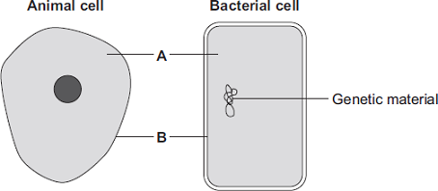
(a) (i) Structures A and B are found in both the animal cell and the bacterial cell. Use words from the box to name structures A and B.

cell membrane | chloroplast | cytoplasm | vacuole
A ______________________________
B ______________________________ (2)
(ii) Both cells contain genetic material. Name the structure in the animal cell that contains genetic material.
______________________________________________________________ (1)

(Total 3 marks)
3. The diagrams show four cells, A, B, C and D.

A | B
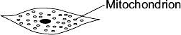 | 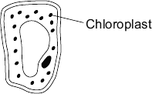
C | D
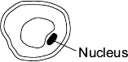 | 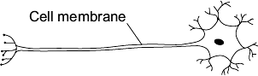
Use letters A, B, C or D to answer these questions.

(a) | Which cell can photosynthesise? |  | (1)

(b) | Which cell is adapted for receiving and sending information? |  |  | (1)

(c) | Which cell is adapted to respire quickly? |  | (1)
(Total 3 marks)
- (a) The diagram shows the structure of a bacterial cell.
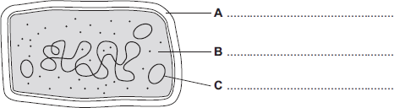
(i) On the diagram use words from the box to label structures A, B and C.

cell membrane | cell wall | chloroplast | cytoplasm | plasmid
(3)
(ii) Give one difference between the structure of the bacterial cell and an animal cell.
______________________________________________________________ (1)
(iii) Name one structure that is found in a plant cell but is not found in a bacterial or an animal cell.
______________________________________________________________ (1)
(b) Cells can be specialised for a particular job. The diagram shows the structure of a human sperm cell.
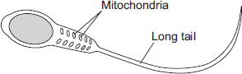
Describe how the long tail and the mitochondria help the sperm to do its job.
Long tail ___________________________________________________________
___________________________________________________________________
___________________________________________________________________

Mitochondria ________________________________________________________
___________________________________________________________________
___________________________________________________________________ (4)
(Total 9 marks)
- The figure below shows four different types of cell.
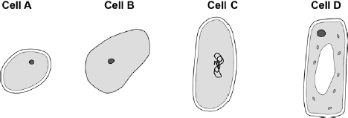
(a) Which cell is a plant cell? Give one reason for your answer.
Cell _________
Reason ____________________________________________________________ (2)
(b) Which cell is an animal cell? Give one reason for your answer.
Cell _________
Reason ____________________________________________________________ (2)
(c) Which cell is a prokaryotic cell? Give one reason for your answer.
Cell _________
Reason ____________________________________________________________ (2)
(d) A scientist observed a cell using an electron microscope.
The size of the image was 25 mm. The magnification was × 100 000
Calculate the real size of the cell.
Use the equation:
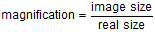
Give your answer in micrometres.
___________________________________________________________________
___________________________________________________________________
___________________________________________________________________
Real size = __________________ micrometres
(3)
(Total 9 marks)
- This question is about cell structures.
(a) Draw one line from each cell structure to the type of cell where the structure is found.

Cell Structure |  | Type of cell where the structure is found
Nucleus |  | Prokaryotic cells
Permanent vacuole |  | Plant cells only
Plasmid |  | Eukaryotic cells
(2)
(b) Figure 1 shows a plant cell.
Figure 1
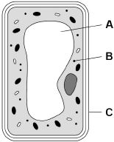
What are the names of structures A, B and C? Tick one box.

Structure A | Structure B | Structure C
Chloroplast | Vacuole | Cell wall | 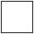
Nucleus | Chloroplast | Cell membrane
Vacuole | Mitochondrion | Cell membrane
Vacuole | Ribosome | Cell wall
(1)
A student observed slides of onion cells using a microscope.
Figure 2 shows two of the slides the student observed.
Figure 2
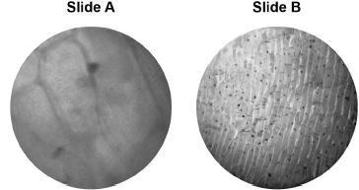
The cells on the slides are not clear to see.
(c) Describe how the student should adjust the microscope to see the cells on Slide A more clearly.
___________________________________________________________________
___________________________________________________________________
(1)
(d) Describe how the student should adjust the microscope to see the cells on Slide B more clearly.
___________________________________________________________________
___________________________________________________________________
___________________________________________________________________
(2)
(e) The student made the necessary adjustments to get a clear image.
Figure 3 shows the student’s drawing of one of the cells.
Figure 3
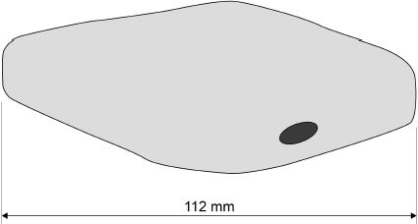

The real length of the cell was 280 micrometres (µm).
Calculate the magnification of the drawing (use the space on the next page)
___________________________________________________________________
___________________________________________________________________
___________________________________________________________________
___________________________________________________________________
___________________________________________________________________
Magnification = × _________________________
(3)
(Total 9 marks)
- Figure 2 shows a section through a leaf.
Figure 2
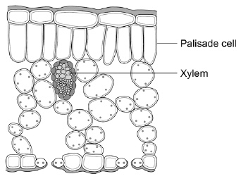
(a) The function of palisade cells is to photosynthesise.
Describe one way palisade cells are adapted to carry out their function.
___________________________________________________________________
___________________________________________________________________ (1)
(b A student observed palisade cells using a microscope.
The microscope had four objective lenses, each with a different magnification. Which objective lens should the student use first? Tick one box. Give a reason for your answer.

×4 magnification | 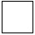
×10 magnification
×40 magnification
×100 magnification
Reason ____________________________________________________________
___________________________________________________________________ (2)
The student measured the width of 5 different palisade cells at a total magnification of ×400
(c) Eyepiece lenses are usually ×5 or ×10 magnification. What combination of eyepiece and objective lenses would give a total magnification of ×400?
Eyepiece lens ____________________
Objective lens ____________________
(1)
(d) Table 2 shows the student’s results.

Table 2
Cell | Width of cell image in mm
1 | 12
2 | 13
3 | 16
4 | 10
5 | 11
(e) Calculate the mean width of the palisade cell images.
___________________________________________________________________
___________________________________________________________________
Mean width = ____________________ mm
(1)
(g) Calculate the real width of a palisade cell.
Use the mean width you calculated in part (f).
Use the equation:
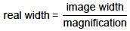
___________________________________________________________________
___________________________________________________________________
Real width = ____________________ mm
(2)
(Total 11 marks)
Mark schemes
Q2.
(a)
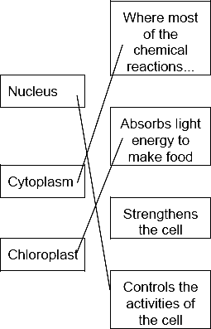
1 mark for each correct line
mark each line from left hand box
two lines from left hand box cancels mark for that box
3
(b) energy
1
[4]
Q3.
(a) (i) A = cytoplasm
1
B = (cell) membrane
1
(ii) nucleus
accept chromosome / DNA / genes
accept phonetic
1

(b)
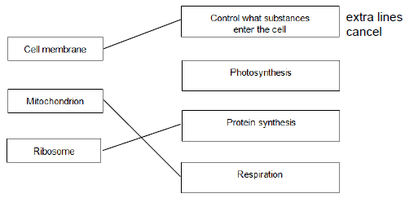
3
[6]
Q4.
(a) B
1
(b) D
1
(c) A
1
[3]
Q5.
(a) (i) A − (cell) wall
1
B − cytoplasm
1
C − plasmid
1
(ii) bacterium cell has cell wall / no nucleus / no mitochondria / plasmids present
accept its DNA / genetic material is not enclosed / it has no nuclear membrane
it = bacterium cell
accept converse for animal cell
ignore flagella
1
(iii) any one from:
• chloroplast
ignore chlorophyll
• (permanent) vacuole
1
(b) (Long tail) moves the sperm / allows the sperm to swim
1
towards the egg
allow correct reference to other named parts of the female reproductive system
1
(Mitochondria) release energy (for movement / swimming)
allow supply / produce / provide
1
in respiration
1
[9]
Q6.
(a) D
1
any one from:
• has chloroplasts
• has a (large) vacuole
ignore has a (cell) wall
1
(b) B
1
does not have a (cell) wall
allow has only a nucleus, (cell) membrane and cytoplasm
1
(c) C
1
any one from:
• genetic material is not in a nucleus
allow no nucleus
• has a single loop of DNA
1
(d) real size = 25 / 100 000
1
0.00025
1
(conversion to) 0.25 (µm)
allow 0.25 (µm) with no working shown for 3 marks
1
[9]
Q7.
(a) 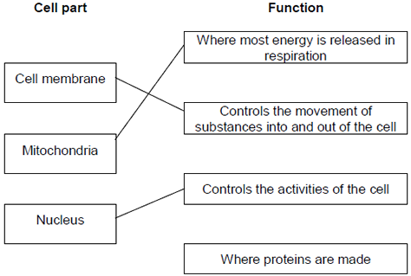
extra lines cancel
3
(b) Cell wall
in either order
1
Chloroplast
allow (permanent) vacuole
1
[5]
Q8.
(a)
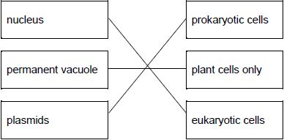
allow 1 mark for one or two correct links
2
(b)
vacuole | ribosome | cell wall
tick box takes precedence
if no tick is given, look at both the figure and the circling of words in the table
if writing is seen on the figure and in the table both must be correct
1
(c) turn the (fine focusing) knob until the cells are in focus
allow focus it
do not accept increase magnification
ignore decrease magnification
ignore clear
ignore references to resolution / illumination
ignore zoom in / out
1
(d) (rotate the) nosepiece / objective lens
allow change the (objective / eyepiece) lens
1
to a higher power (lens)
allow (to) increase the magnification
a comparator is required
ignore change / adjust the magnification
allow stronger or more powerful lens
ignore references to resolution / illumination unqualified
ignore zoom in / out
ignore references to an electron microscope
1
(e) conversion of units:
(112 mm ⟶) 112 000 (µm)
or
(280 µm ⟶) 0.28 (mm)
1
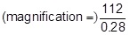
or
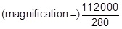
allow 1 mark for no conversion of units 112 / 280
or
incorrect value from step 1 correctly substituted
1
400 (×)
do not accept if units are given
if no other mark scored allow 1 mark for:
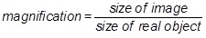
a triangle with words or letters in is insufficient, as the correct rearrangement is needed
1
an answer of 400 (×) scores 3 marks
[9]
Q9.
(a) nucleus
1
cell wall
1
(b) any one from:
• contain (many) chloroplasts
• positioned near the top surface of the leaf
• packed closely together
1
(c)
Structure | Tissue | Organ | Organ system
Leaf |  | ✔
Xylem | ✔
Roots, stem and leaves |  |  | ✔
additional tick in a row negates the credit for that row
allow 1 mark for two correct rows
2
(d) ×4
1
reason: any one from:
• gives the largest field of view
• easier to focus
1
(e) eyepiece lens: ×10
and
objective lens: ×40
or
eyepiece lens: ×5
and
objective lens: ×80
allow sensible suggestions that give a magnification of ×400
1
(f) 12.4 (mm)
allow 12 (mm)
1
(e) real width =
1
0.031 (mm)
an answer of 0.031 (mm) scores 2 marks
allow ecf from part (f)
1
[11]
Examiner reports
Q1.
This question was about cell structure and function, based on a drawing of some muscle cells from the wall of the stomach.
(a) Just over two-thirds of students scored at least one mark for describing the function of the muscle cells either in terms of their ability to contract or with respect to their use in the stomach for churning food. Relatively few gave both points. A large number spoiled their answer by stating that the muscles ‘contract and expand’, while others clearly knew nothing about muscle and suggested they might ‘secrete acid’ or, alternatively, ‘protect the body from acid’.
(b) The mathematical requirements given in section 3.7 of the Specification include the statement: ‘All students should be able to.......Understand number size and scale and the quantitative relationship between units’. A very common error in calculating the magnification of the drawing of the muscle cells was to mix units by measuring the scale bar as 4 centimetres (rather than 40 millimetres) and then dividing this by the 0.1 millimetres that it represented. This gave an answer of ‘40’ instead of the correct 400. Despite the instruction in the question to ‘use a ruler to measure the length of the scale bar...’, many students measured one or more of the cells in the diagram and scored no marks. Thus success in this question was limited, with only about a quarter scoring full marks.
(c) The function of mitochondria in respiration and in releasing energy was well known, although often only one of these points was made and many spoiled their answer by including the phrase ‘making energy’ which, of course, defies the fundamental physical law of conservation of energy. Another common error was to state that energy was released ‘for respiration’ rather than by respiration. Thus only one-third of students scored both of the marks available.
(d) (i) Around three quarters of students knew that ribosomes were the site of protein synthesis and that they were too small to be visible in a light microscope, although some suggested that they were merely ‘transparent’.
(ii) Around three quarters of students knew that ribosomes were the site of protein synthesis and that they were too small to be visible in a light microscope, although some suggested that they were merely ‘transparent’.
Q2.
(a) A considerable number of candidates made a good start to the paper, collecting all three marks. The most common error was to link ‘cytoplasm’ with ‘strengthens the cell’. A small number of candidates drew two lines from at least one of the cell parts, thus cancelling any credit they might have gained for that part. It is important that candidates read the instructions carefully, hence ‘a line from each part’, indicates that just one line is needed from each of the boxes on the left. Candidates should also be advised that if they need to cross out a line, then any crossing out along with a replacement line should be absolutely clear. Some candidates overcome this problem by numbering the boxes they want linked, in pairs.
(b) Although the most common answer was ‘energy’, a large proportion of those not giving this selected ‘oxygen’. There remains considerable confusion regarding the reactants and products of respiration and photosynthesis and the circumstances in which these two processes occur.
Q3.
This question was well answered by most students.
(a) Most students knew that structure A in the diagrams of the animal and bacterial cells was the cytoplasm and that structure B was the cell membrane although, inevitably, the latter was confused with the ‘cell wall’ by many. Around three-quarters of the students also knew that the genetic material in the animal cell was contained within the nucleus or in chromosomes, DNA or genes . Nucleus and DNA were the most common answers.
(b) Over half the students were able to assign all three cell structures (the cell membrane, a mitochondrion and a ribosome) to their functions.
Q4.
A high proportion of students were able to match the correct cells to the questions. Students appeared to be more comfortable with the role of chloroplasts, in cell ‘B’ for photosynthesis, than with the roles of cells D and A, but these too were correctly identified by about three-quarters of the students.
Q5.
(a) (i) Where errors occurred in this cell labelling question, it was mostly in mistaking the cell wall for a cell membrane and / or the plasmid for a chloroplast.
(ii) This question was very well answered with the vast majority of students gaining the 1 mark available. The most common answers were the idea that the bacterium cell had a cell wall (or converse for animal cell) or bacteria had no nucleus (converse for animal cell). Some students mentioned flagella in bacteria but this was ignored. Several students gave ribosomes as their answer but this was not acceptable.
(iii) This question was also well answered with nearly all students gaining the mark.
(b) This question on sperm cell adaptations was also very well answered with the majority of students gaining 3 or 4 marks. Almost all stated that the tail was used to swim or move and most followed this with the idea that it was going to the egg / ovum / female gamete / parts of the female reproductive system.
Many also gained the 2 marks for stating that mitochondria released energy for swimming and that it was supplied / produced / provided by / through / in respiration. A few students incorrectly stated that energy was produced for respiration so could not gain the last marking point.
Q7.
This question was about cell structure and function.
(a) Most students were able to correctly identify the function of the cell membrane and the nucleus. A common error was to link mitochondria to the site of protein manufacture.
(b) Although nearly all students were able to identify at least one of the labelled structures in the plant cell that is not present in an animal cell, less than half could correctly select two. A common error was the inclusion of the cell membrane.
Q8.
Foundation
(a) 57% of students demonstrated a good understanding of prokaryotic and eukaryotic cells and were awarded two marks. To achieve both marks all three structures had to be correctly linked to the type of cell where each structure is found.
When only one mark was awarded it was usually for identifying the nucleus as being found in eukaryotic cells.
(b) 59% of students were awarded the mark for identifying the vacuole, ribosome and cell wall in the plant cell.
Students were asked to tick one box, but some labelled the diagram, whilst others circled the names of the structures in the table.
(c) 17% of students achieved this mark. The cells on slide A appeared large, but blurred. The required response was a reference to focusing the image.
Many students referred to zooming in or out, to altering the magnification or using an electron microscope. All of these were ignored. However, if they said increase the magnification this was incorrect and negated a correct answer of focusing the image.
(d) The cells on slide B appeared small but in focus. The required response was a description of how to obtain a larger image. There were two marks available for this question:
• one was for reference to changing the lens
• one was for stating that the new lens would have a higher power or magnification.
3% of students achieved two marks, and 23% obtained one mark, usually for saying increase the magnification.
Changing or using a better magnification was insufficient. Many students referred to zooming in or out or said use an electron microscope, both of which were ignored.
(e) There were three marks available for this question.
• The first mark was for conversion of units. Many students did not attempt a conversion but could still go on to achieve two marks. A range of different errors were made which included multiplying or dividing by 10, 100 or 10 000, rather than by 1000. Some did not appreciate that a micrometre is smaller than a millimetre.
• The second mark was for correctly substituting into the rearranged equation to calculate magnification. This mark was allowed even if their initial conversion was incorrect.
• The final mark was for an answer of 400. Some students added a unit to their answer and this negated the mark.
33% of students achieved all three marks, and 33% achieved two marks. 24% of students scored zero. This was often for 280 ÷ 112 = 2.5
Higher
(a) Students demonstrated a good understanding of prokaryotic and eukaryotic cells. 87% of students achieved two marks. To gain both marks all three structures had to be correctly linked to the type of cell where each structure is found.
When only one mark was awarded it was usually for identifying the nucleus as being found in eukaryotic cells.
(b) Students demonstrated a good understanding of cell structure. 80% of students were awarded the mark for identifying the vacuole, ribosome and cell wall in the plant cell.
Students were asked to tick one box, but some labelled the diagram, whilst others circled the names of the structures in the table.
(c) 27% of students achieved this mark. The cells on slide A appeared large, but blurred. The required response was a reference to focusing the image.
Many students referred to zooming in or out, to altering the magnification or using an electron microscope. All of these were ignored. However, if they said increase the magnification this was incorrect and negated a correct answer of focusing the image.
(d) The cells on slide B appeared small but in focus. The required response was a description of how to obtain a larger image. There were two marks available for this question.
• One was for reference to changing the lens.
• One was for stating that the new lens would have a higher power or magnification.
45% of students obtained a mark. Where a mark was awarded it was usually for saying increase the magnification.
Changing or using a better magnification was insufficient. Many students referred to zooming in or out or said use an electron microscope, both of which were ignored.
(e) There were three marks available for this question.
• The first mark was for conversion of units. Many students did not attempt a conversion but could still go on to achieve two marks. A range of different errors were made which included multiplying or dividing by 10, 100 or 10 000, rather than by 1000. Some did not appreciate that a micrometre is smaller than a millimetre.
• The second mark was for correctly substituting into the rearranged equation to calculate magnification. This mark was allowed even if their initial conversion was incorrect.
• The final mark was for an answer of 400. Some students added a unit to their answer and this negated the mark.
22% of students achieved two marks. 56% of students scored zero marks. This was often for 280 ÷ 112 = 2.5

