Proteins

Proteins are a diverse group of large and complex polymer molecules, made up of long chains of amino acids (monomers).

[Background (does not need to be learnt for exams)

Proteins have a wide range of biological roles, including:

- structural: proteins are the main component of body tissues, such as muscle, skin, ligaments and hair.

- catalytic: all enzymes are proteins, catalysing many biochemical reactions.

- signalling: many hormones and receptors are proteins.

- immunological: all antibodies are proteins.

Fibrous Proteins

Fibrous proteins are formed from parallel polypeptide chains held together by cross-links. These form long, rope-like fibres, with high tensile strength and are generally insoluble in water.
e.g. collagen, keratin and silk. Collagen is the most abundant protein in the body (25%)

Globular Proteins

Globular proteins usually have a spherical shape caused by tightly folded polypeptide chains. diagram is myoglobin (1 haem group), oxygen store in muscles, not circulation

The chains are usually folded so that hydrophobic groups are on the inside, while the hydrophilic groups are on the outside. This makes many globular proteins soluble in water.

- transport proteins – such as haemoglobin, myoglobin and those embedded in membranes.

- enzymes – such as lipase and DNA polymerase.

- hormones – such as oestrogen and insulin.]

The General Structure of Amino Acids

There are 20 amino acids which occur in all organisms and all have the same general structure: the only difference between each one is the nature of the R group. The R group therefore defines an amino acid. (see fatty acids above) R group/H atom and/or amine/carboxyl group can be shown other way around

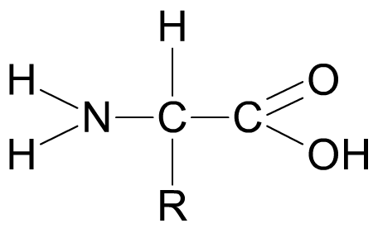
amine
group
(-NH₂)
carboxyl group
(-COOH)
R group

The R group represents a side chain from the central ‘alpha’ carbon atom, and can be anything from a simple hydrogen atom to a more complex ring structure.
no details of individual amino acids needed. Actually 22 but only 20 needed to make most organisms. 22nd only discovered in 2002 in single spp of Archaean, very obscure prokaryote

Peptide Bonds and Dipeptides condensation & hydrolysis as disaccharides but peptide (not glycosidic) bond formed
Two amino acids can join together to form a dipeptide linked by a peptide bond.  The peptide bond forms between the carboxyl (COOH) group on one amino acid and the amine (NH₂) group on the other amino acid.NB amine is NH₂ rather than H₂N  This produces a molecule of water, so the reaction is a condensation reaction. | 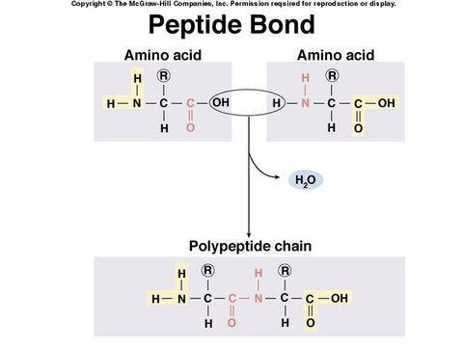  [Grab your reader’s attention with a great quote from the document or use this space to emphasize a key point. To place this text box anywhere on the page, just drag it.]
The dipeptide can be split back into two amino acids in a hydrolysis reaction.

Top tip: Note the importance of condensation reactions in synthesising biological molecules, many of which are polymers, and hydrolysis reactions in breaking them back down into their monomers. This is a recurring theme which you will be expected to apply time and again.

Polypeptides
When more amino acids are added to a dipeptide, a polypeptide chain is formed.  A functional protein consists of one or more polypeptide chains folded into a highly specific 3D shape.  There are up to four levels of structure in a protein: primary, secondary, tertiary and quaternary.  Each of these play an important role in the overall structure and function of the protein. | 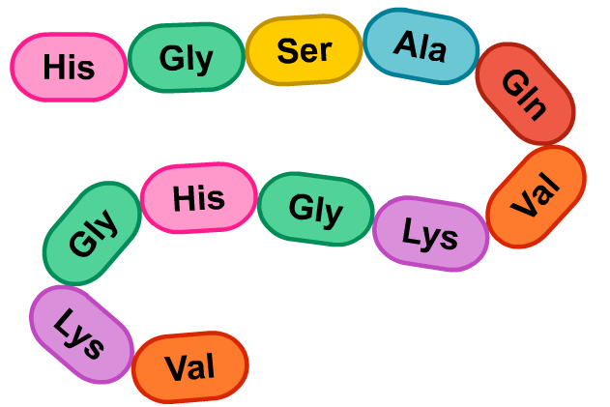

The Structure of Proteins e.g. collagen = 1055 amino acids

Proteins have a unique 3D structure that enables them to carry out specific functions.

Primary (1°) Structure - A protein’s primary structure is the sequence of amino acids in its polypeptide chain(s). If just a single amino acid is incorrect, the whole protein can be useless.
NB it is more than simply the number and type of amino acid - the order is essential.
importance of genetic code in determining the 1° structure.

Secondary (2°) Structure – Interactions between amino acids cause the chain to form localised 3D sections. This is the protein’s secondary structure and is maintained by hydrogen bonds.

A common type of secondary structure is the alpha helix.

Another type of secondary structure is the beta (-pleated) sheet.

Both alpha helix and beta sheet structures can co-exist in the same protein.

Tertiary (3°) Structure – A protein’s overall 3D shape is its tertiary structure.

Several types of bond may hold the structure in place: ionic bonds; hydrogen bonds, disulfide bonds, (and hydrophobic interactions).

Quaternary (4°) Structure – Some proteins have more than one polypeptide chain, and the arrangement of these is a protein’s quaternary structure.

Haemoglobin, for example, is made of four chains, also known as subunits.

[Prosthetic Groups – ‘Conjugated’ proteins contain a non-amino acid part called a prosthetic group. An example is haemoglobin, which contains four iron-containing haem groups to which the oxygen binds.]
Bonds in Proteins

The 3D shape of a protein is maintained by several types of bond, including:

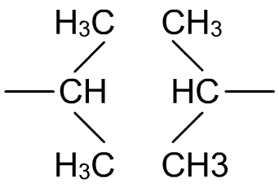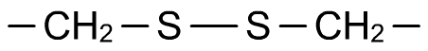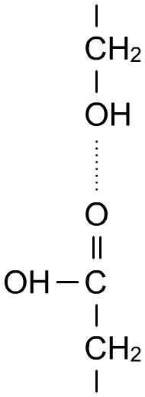
hydrogen bonds:
involved in all levels of structure.
[hydrophobic interactions:
between non-polar sections of the protein].
disulfide bridges: one of the strongest and most important type of bond in proteins. Occur between two cysteine amino acids which have an atom of sulphur in their R group.
Ionic bonds, which form between differently charged regions of the polypeptide chain, are not shown above but equally important – especially when considering how proteins are affected by pH.

Top tip: It is essential to recognise the biological importance of how the primary structure of a protein ultimately determines its function.
- the primary structure determines which bonds will form where
- this determines the secondary structure and further bonding
- which, in turn, dictates the tertiary structure
- the tertiary structure is what gives the protein its specific shape and therefore the ability to carry out its function.

- changes to the primary structure can lead to non-functioning proteins as they are not the correct shape to carry out their function. It all comes down to bonds and specific shape.

Biuret Test

Proteins can be detected by the biuret test.

Biuret reagent contains copper sulphate (Cu⁺ ions) and sodium hydroxide.

The solution will turn a purple/violet (mauve) colour in the presence of peptide bonds.

This does not conclusively prove protein is present, but protein is the most likely substance.

A more intense colour indicates more peptide bonds are present.

