Proteins

Proteins are a diverse group of large and complex ___________ molecules, made up of long chains of ___________ ___________ (monomers).

[Background (does not need to be learnt for exams)

Proteins have a wide range of biological roles, including:

- ________________: proteins are the main component of body tissues, such as muscle, skin, ligaments and hair.

- ________________: all enzymes are proteins, catalysing many biochemical reactions.

- ________________: many hormones and receptors are proteins.

- ________________: all antibodies are proteins.

Fibrous Proteins

Fibrous proteins are formed from ___________ polypeptide chains held together by cross-links. These form ______, rope-like fibres, with high tensile strength and are generally __________ in water.
e.g. collagen, keratin and silk.

Globular Proteins

Globular proteins usually have a ___________ shape caused by tightly folded polypeptide chains.

The chains are usually folded so that hydrophobic groups are on the inside, while the hydrophilic groups are on the outside. This makes many globular proteins ___________ in water.

- ________________ proteins – such as haemoglobin, myoglobin and those embedded in membranes.

- ________________– such as lipase and DNA polymerase.

- ________________ – such as oestrogen and insulin.]

The General Structure of Amino Acids

There are 20 amino acids which occur in all organisms and all have the same general structure: the only difference between each one is the nature of the ________________. The R group therefore defines an amino acid. (see fatty acids above)

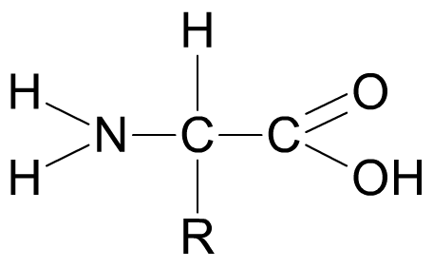
_______
group
(-NH₂)
_____________ group
(-COOH)
_group

The R group represents a side chain from the central ‘alpha’ carbon atom, and can be anything from a simple hydrogen atom to a more complex ring structure. [no details of individual amino acids needed].

Peptide Bonds and Dipeptides
Two amino acids can join together to form a ________________ linked by a ________________ bond.  The peptide bond forms between the _____________ (COOH) group on one amino acid and the _____________(NH₂) group on the other amino acid.  [NB amine is NH₂ rather than H₂N]  This produces a molecule of _______, so the reaction is a ________________ reaction. | 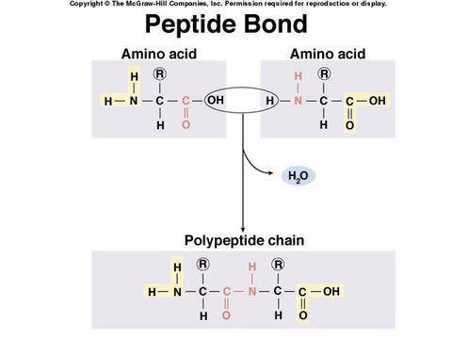  [Grab your reader’s attention with a great quote from the document or use this space to emphasize a key point. To place this text box anywhere on the page, just drag it.]
The dipeptide can be split back into two amino acids in a ________________ reaction.

Top tip: Note the importance of condensation reactions in synthesising biological molecules, many of which are polymers, and hydrolysis reactions in breaking them back down into their monomers. This is a recurring theme which you will be expected to apply time and again.

Polypeptides
When more amino acids are added to a dipeptide, a ____________________chain is formed.  A functional ________________ consists of one or more polypeptide chains ___________into a highly ___________ ______ shape.  There are up to four levels of structure in a protein: primary, secondary, tertiary and quaternary.  Each of these play an important role in the overall structure and function of the protein. | 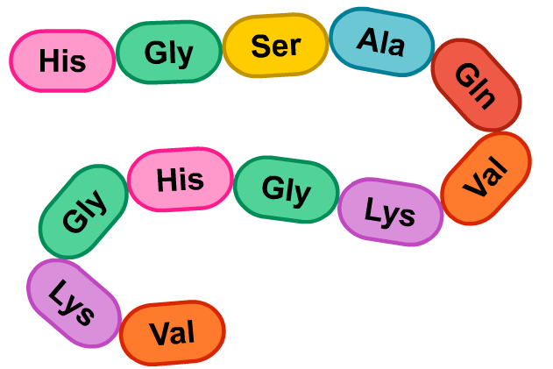

The Structure of Proteins

Proteins have a unique 3D structure that enables them to carry out specific functions.

________________ (1°) Structure - A protein’s primary structure is the ________________ of amino acids in its polypeptide chain(s). If just a single amino acid is incorrect, the whole protein can be useless. NB it is more than simply the number and type of amino acid - the ________ is essential.

Secondary (2°) Structure – Interactions between amino acids cause the chain to form ________________ 3D sections. This is the protein’s secondary structure and is maintained by ________________bonds.

A common type of secondary structure is the alpha helix.

Another type of secondary structure is the beta (-pleated) sheet.

Both alpha helix and beta sheet structures can co-exist in the same protein.

Tertiary (3°) Structure – A protein’s overall ______ __________is its tertiary structure.

Several types of bond may hold the structure in place: __________bonds; __________ bonds, __________ bonds, (and hydrophobic interactions).

Quaternary (4°) Structure – Some proteins have more than ______ polypeptide chain, and the arrangement of these is a protein’s quaternary structure.

Haemoglobin, for example, is made of four chains, also known as subunits.

[Prosthetic Groups – ‘Conjugated’ proteins contain a _____ - _________ _____part called a prosthetic group. An example is haemoglobin, which contains four iron-containing haem groups to which the oxygen binds.]

Bonds in Proteins

The 3D shape of a protein is maintained by several types of bond, including:

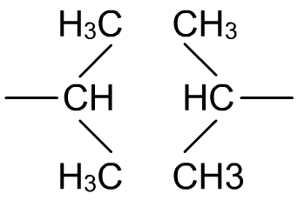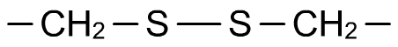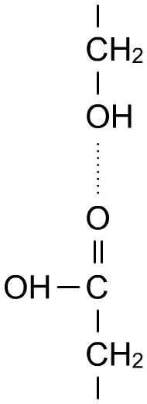
________________ bonds:
involved in all levels of structure.
[hydrophobic interactions:
between non-polar sections of the protein].
________________ bridges: one of the strongest and most important type of bond in proteins. Occur between two cysteine amino acids which have an atom of sulphur in their R group.
__________ bonds, which form between differently charged regions of the polypeptide chain, are not shown above but equally important – especially when considering how proteins are affected by pH.

Top tip: It is essential to recognise the biological importance of how the _____________ structure of a protein ultimately determines its _____________.
- the primary structure determines which bonds will form where
- this determines the secondary structure and further bonding
- which, in turn, dictates the tertiary structure
- the tertiary structure is what gives the protein its _____________ _____________ and therefore the ability to carry out its function.

- changes to the primary structure can lead to non-functioning proteins as they are not the correct shape to carry out their function. It all comes down to _____________ and _____________ shape.

Biuret Test

Proteins can be detected by the _____________ test.

[Biuret reagent contains ___________ ___________ (Cu⁺ ions) and ___________ ___________.]

The solution will turn a ________ / ___________ colour in the presence of _____________ bonds.

This does not conclusively prove protein is present, but protein is the most likely substance.

A more intense colour indicates more peptide bonds are present.

