Figure 1 represents the particles in a solid.
0 | 1
Figure 1
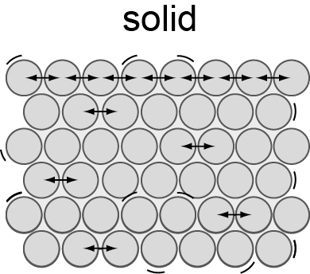
Describe what happens to particles when a substance
changes state.
You should refer to the arrangement, energy and movement of the particles in all three states of matter. [6 marks]

An ionic compound X₂Y contains two ions, X⁺ and Y^{2–}.
0 | 2
Which group is each ion in? [2 marks]
X⁺
Y²⁻

Complete Table 1. [3 marks]
0 | 3
Table 1
Substance | Melting point in °C | Does substance conduct electricity as a solid? | Does substance conduct electricity as a liquid? | Type of structure
A | 842 | Yes | Yes
B | 1610 |  | no
C | 772 |  |  | ionic

The equation shows the reaction between magnesium and chlorine to produce magnesium chloride.
0 | 4
Mg + Cl₂ → MgCl₂
Magnesium chloride consists of Mg²⁺ and Cl⁻ ions.
Describe, in terms of electrons, how magnesium chloride is produced from magnesium and chlorine. [6 marks]

Hydrogen sulfide is a gas at room temperature.
0 | 5 | . | 1
Figure 2 represents the outer energy levels of hydrogen and sulfur atoms.
Complete the diagram to show the bonding in hydrogen sulfide. Show the outer electrons only.
Hydrogen and sulfur are represented as ${}_{1}^{1}{}H$ and ${}_{\text{16}}^{\text{32}}{}S$in the periodic table. [2 marks]
Figure 2

The boiling point of hydrogen sulfide is low. Explain why. [3 marks]
0 | 5 | . | 2

Silver nanoparticles are included in the material sports socks are made from. Silver nanoparticles can kill bacteria.
0 | 6 | . | 1
A silver atom has a diameter of 2.8 × 10⁻¹⁰ m.
Give the maximum and minimum number of silver atoms in the thickness of a nanoparticle. [2 marks]

Some people disagree with the use of silver nanoparticles.
0 | 6 | . | 2
Suggest why. [1 mark]

Three oxides have the following melting points; −72 ºC, 1132 ºC, and 2572 ºC.
0 | 7 | . | 1
The three oxides are calcium oxide, CaO, sodium oxide, Na₂O, and Sulfur dioxide, SO₂.
Predict the melting point of each oxide. Give reasons for your answers. [3 marks]

Graphite is an excellent conductor of electricity.
0 | 7 | . | 2
Explain how graphite conducts electricity. [2 marks]

