Limestone is mainly calcium carbonate. The formula of calcium carbonate is CaCO₃.
0 | 1
Complete Table 1 to show the number of atoms in limestone. [3 marks]
Table 1
Element | Symbol | Number of atoms
 | Ca
carbon
oxygen

The mass number of an atom is the sum of two other sub-atomic particles.
0 | 2 | . | 1
What are these two sub-atomic particles called? [2 marks]

An atom with a mass number of 12 is used as the reference when calculating relative atomic masses.
0 | 2 | . | 2
Which element is this an atom of? [1 mark]
A carbon
B hydrogen
C lead
D oxygen
What is the relative atomic mass of an element? [2 marks]
0 | 2 | . | 3

Describe how you can calculate the relative formula mass of a compound.
0 | 2 | . | 4
In your answer you should use the terms: atoms, element, and relative atomic mass. [4 marks]

What is the concentration of a solution measured in? [1 mark]
0 | 3 | . | 1
A cm³/kg
B dm³/g
C g/dm³
D kg/dm³
A solution was made by dissolving a salt in water.
0 | 3 | . | 2
What is the correct term for the salt when dissolved in water? [1 mark]
A aqueous
B insoluble
C solute
D solvent
Sodium hydroxide and sulfuric acid react together to produce sodium sulfate and water.
0 | 4 | . | 1
Balance the equation for the reaction. [1 mark]
NaOH + H₂SO₄ → Na₂SO₄ + H₂O
What is the relative formula mass of sodium hydroxide?
0 | 4 | . | 2
Relative atomic masses, A_{r} : Na = 23, O = 16, H = 1 [2 marks]

In the reaction, how does the mass of the products compare with the mass of the reactants? [1 mark]
0 | 4 | . | 3

Potassium chloride can be produced by heating potassium and chlorine. The equation for the reaction is:
0 | 5
2K + Cl₂ → 2KCl
Describe this chemical reaction in terms of the number of atoms of each substance involved . [3 marks]

A student investigated the reaction of magnesium with oxygen.
0 | 6 | . | 1
The student calculated that 4.8 g of magnesium would make 8.0 g of magnesium oxide.
The equation for the reaction is:
2Mg + O₂ → 2MgO
What mass of oxygen is required to produce 8.0 g of magnesium oxide from 4.8 g of magnesium? [1 mark]

The student heated magnesium to produce magnesium oxide.
0 | 6 | . | 2
Figure 1 shows the apparatus the student used.
Figure 1
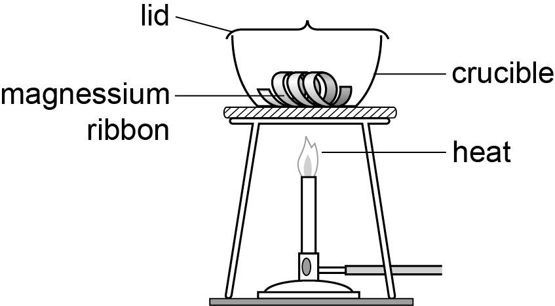
The student:
- weighed 2.40 g of magnesium
- heated the crucible and magnesium
- when heating, lifted up the lid slightly to let oxygen in but stopped magnesium oxide escaping
- heated until all the magnesium formed a white powder
- weighed the magnesium ribbon formed.
Table 2 shows the student’s results.
Table 2
 | Mass of magnesium in g | Mass of magnesium oxide in g
Trial 1 | 2.40 | 7.36
Trial 2 | 2.40 | 7.06
Trial 3 | 2.40 | 7.38
Trail 4 | 2.40 | 7.38

Calculate the mean mass of magnesium oxide produced. Give your answer to 2 decimal places. [3 marks]

The student produced less magnesium oxide than expected.
0 | 6 | . | 3
Suggest two reasons why. [2 marks]

A student made two solutions – solution A and solution B.
0 | 7
Solution A contained 5 g of copper sulfate in 50 cm³ of water.
Solution B contains 10 g of copper sulfate in 100 cm³ of water.
The student added solution B to solution A.
The student concluded that the new solution is more concentrated because it has more copper sulfate dissolved in it
Is the student correct? Explain your answer. [3 marks]

