Figure 1 shows a reaction profile.
0 | 1
Figure 1
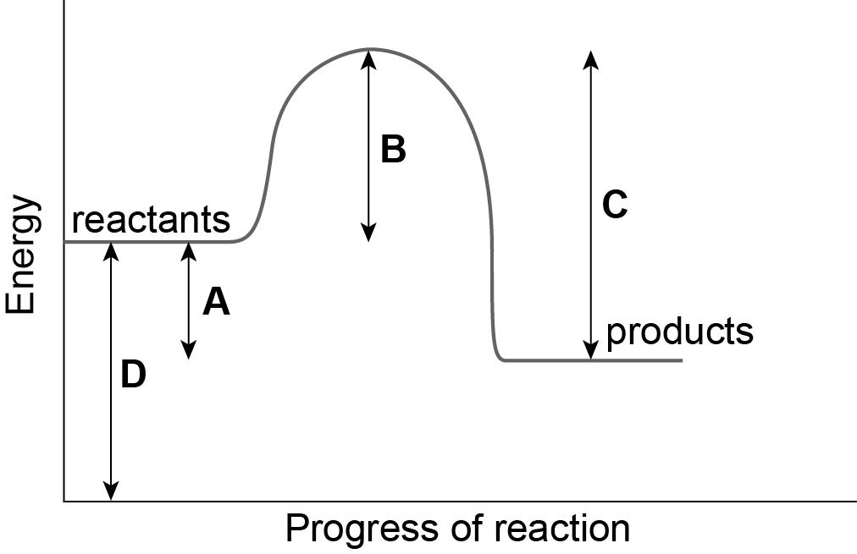
Which letter shows the overall energy change for the reaction? [1 mark]
0 | 1 | . | 1
A
B
C
D
Which letter shows the activation energy for the reaction? [1 mark]
0 | 1 | . | 2
A
B
C
D
Does the reaction profile shown in Figure 1 represent an exothermic reaction or an endothermic reaction?
0 | 1 | . | 3
Give one reason for your answer. [3 marks]

A student investigated temperature changes during a reaction.
0 | 2
Figure 2 shows the apparatus the student used.
Figure 2
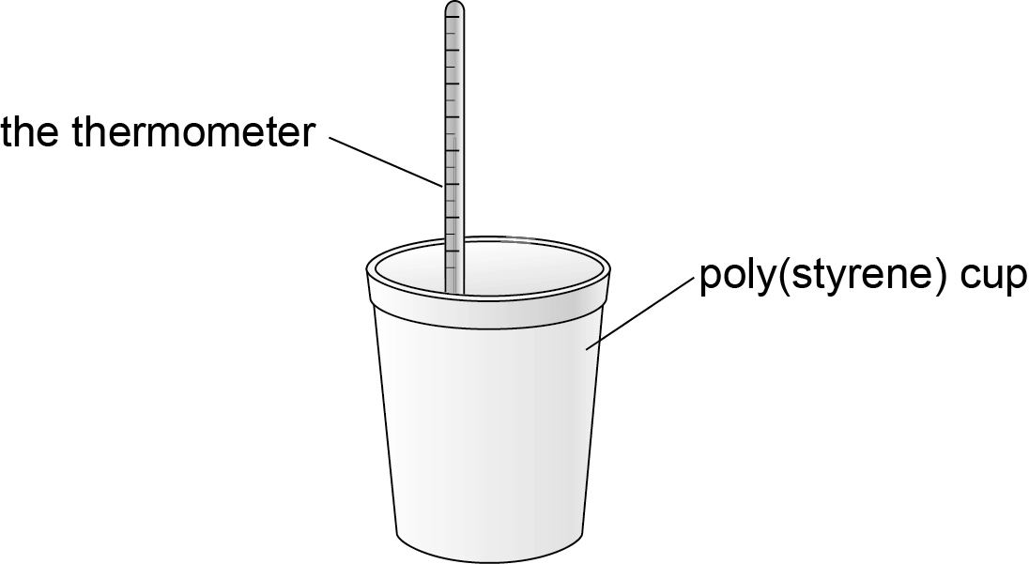
Heat loss to the surroundings is the biggest error in this experiment.
0 | 2 | . | 1
Suggest two improvements to the apparatus which would increase the accuracy of the experiment. [2 marks]

The student repeated the investigation three times.
0 | 2 | . | 2
Table 1 shows the student’s results.
Table 1
 | Trial 1 | Trial 2 | Trial 3
Maximum temperature decrease in °C | 6.9 | 6.7 | 6.9
Calculate the mean value.
Give your answer to 2 significant figures. [2 marks]

Name two variables the student should keep the same to make the investigation a fair test. [3 marks]
0 | 2 | . | 3

Give two advantages of repeating the investigation. [2 marks]
0 | 2 | . | 4
A able to calculate a mean
B can remove anomalous results
C gives a higher temperature increase
D keeps the apparatus warm
E use more chemicals
In the investigation the student added metal powder to copper chloride solution.
0 | 2 | . | 5
Describe how the student would carry out trail 1. [4 marks]

A different student investigated the reaction of ammonium nitrate with water.
0 | 2 | . | 6
The student recorded the temperature every five seconds.
Table 2 shows the student’s results.
Table 2
Time in seconds | Temperature in °C
0 | 22.0
5 | 19.0
10 | 16.6
15 | 15.0
20 | 14.8
25 | 13.2
30 | 13.0
35 | 13.0
40 | 13.0
Use the results in Table 2 to plot a graph of time in seconds against temperature in °C. Draw a line of best fit. [5 marks]

Which point on your graph is anomalous?
0 | 2 | . | 7
Suggest one reason why the anomalous point was obtained. [2 marks]

Energy is transferred from the surroundings to the reacting chemicals.
0 | 2 | . | 8
Name this type of reaction. [1 mark]

State one practical use of this type of reaction. [1 mark]
0 | 2 | . | 9

Some explorers take self-heating cans on their journeys.
0 | 3 | . | 1
Self-heating cans use a chemical reaction to heat up the food inside the can.
In the chemical reaction, calcium oxide and water react to produce calcium hydroxide.
Complete the word equation for the reaction. [1 mark]
Calcium oxide + ……………………….. → ………………………
Give one advantage of using a self-heating can to heat food. [1 mark]
0 | 3 | . | 2

Give one disadvantage of using a self-heating can to heat food. [1 mark]
0 | 3 | . | 3

State one safety feature needed when the can is used. [1 mark]
0 | 3 | . | 4

