Aluminium metal is extracted industrially by electrolysis.
0 | 1
Figure 1 shows the electrolysis cell used.
Figure 1
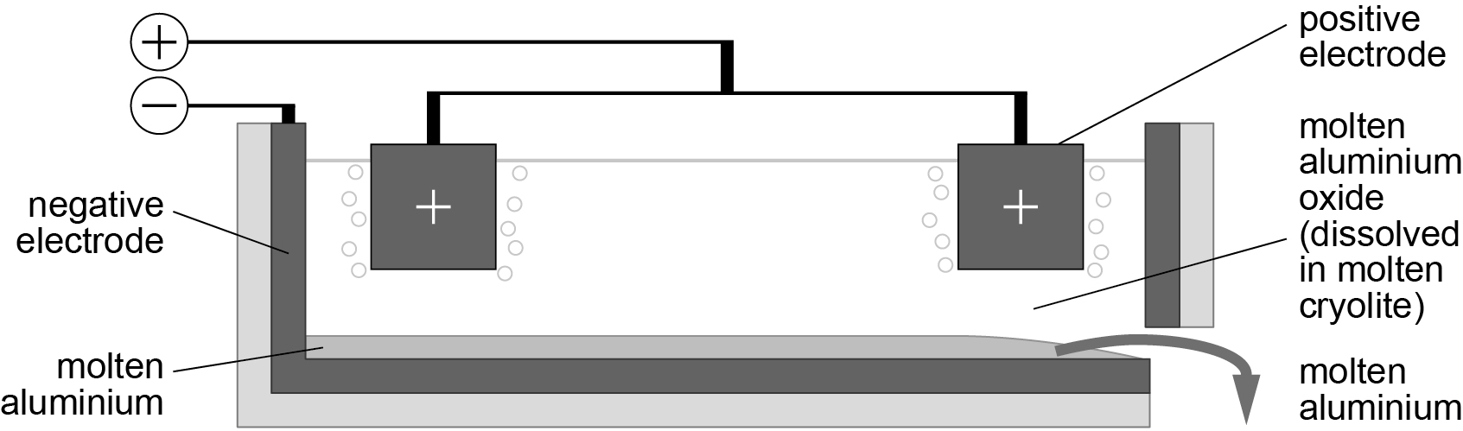
Balance the equation for the extraction of aluminium from
aluminium oxide. [2 marks]
0 | 1 | . | 1
2Al₂O₃ → ………...Al + ………..O₂
What is the electrolyte in this process? [1 mark]
0 | 1 | . | 2
A aluminium
B aluminium oxide
C cryolite
D oxygen
Aluminium oxide melts at 2050 °C.
0 | 1 | . | 3
Why is cryolite added to aluminium oxide? [1 mark]
A to decrease the melting point of the mixture
B to increase the boiling point of the mixture
C to solidify aluminium
D to vaporise aluminium oxide
Aluminium ions move to the negative electrode
0 | 1 | . | 4
Explain why. [2 marks]

The positive electrode is made of carbon.
0 | 1 | . | 5
Oxygen gas is produced at the positive electrode.
Oxygen gas then reacts with the carbon electrode.
Complete the word equation for the reaction of oxygen and the positive electrode. [2 marks]
+ oxygen →
The electrolysis of aluminium oxide is an expensive process.
0 | 1 | . | 6
Suggest two reasons why. [2 marks]

A student investigated the electrolysis of anhydrous zinc chloride.
0 | 2 | . | 1
Figure 2 shows the apparatus the student used.
Figure 2
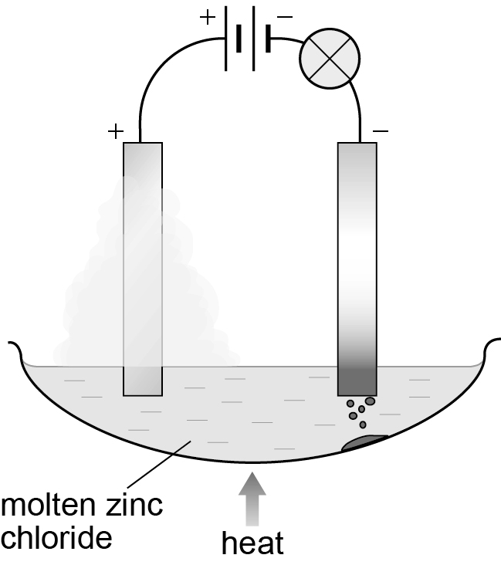
The student passed a current through molten zinc chloride.
The student observed a silvery metal at the negative electrode and a yellow green gas at the positive electrode.
What has happened to the zinc chloride?
State what is produced at each electrode. [3 marks]

When solid zinc chloride was used there was no reaction.
0 | 2 | . | 1
Explain why.
Make reference to movement of ions in your answer. [2 marks]

A student investigated the electrolysis of different concentrations of sodium chloride solution. The student measured the volume of hydrogen produced in 5 minutes.
0 | 3
Table 1 shows the student’s results.
Table 1
Concentration of sodium chloride in mol/dm³ | Volume of hydrogen in cm³ produced in five minutes
0.00 | 0.0
0.25 | 0.6
0.50 | 1.2
0.75 | 1.8
1.00 | 2.4
1.25 | 3.0
1.50 | 3.6

Use the data in Table 1 to plot a graph of concentration of sodium chloride against volume of hydrogen produced.
0 | 3 | . | 1
Draw a line of best fit. [5 marks]
What volume of hydrogen would be obtained at a concentration of
2.00 mol/dm³? Show how you obtained this value. [2 marks]
0 | 3 | . | 2

Give two conclusions you can make from your graph. [2 marks]
0 | 3 | . | 3

Describe how the student could use the electrolysis cell in
Figure 3 to investigate the volume of hydrogen collected
when sodium chloride is electrolysed. [6 marks]
0 | 3 | . | 4
Figure 3
