Figure 1 shows how the atoms are bonded in methane.
0 | 1
The dots and crosses represent a subatomic particle. Only the outer energy levels are shown.
Figure 1
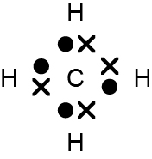
How many atoms are present in a molecule of methane?
0 | 1 | . | 1
[1 mark]
Complete the chemical formula for methane.
0 | 1 | . | 2
[1 mark]
What type of substance is methane? [1 mark]
0 | 1 | . | 3
A compound
B element
C metal
D polymer
What type of bonding is present in methane [1 mark]
0 | 1 | . | 4
A covalent
B double
C ionic
D metallic

Methane is a small molecule.
0 | 1 | . | 6
Which is a property of small molecules? [1 mark]
A conduct electricity
B form lattices
C high boiling point
D low melting point
Complete Table 1.
0 | 2
Table 1
Substance | Melting point in °C | Does substance conduct electricity as a solid? | Does substance conduct electricity as a liquid? | Type of structure
A | 842 | Yes | Yes
B | 1610 | No | No
C | 772 | No | Yes
[3 marks]
Barium fluoride is an ionic compound consisting of barium and fluoride ions.
0 | 3 | . | 1
Barium is in Group 2.
Complete the symbol for a barium ion. [1 mark]
Ba
Fluorine is in Group 7.
0 | 3 | . | 2
Write the symbol for a fluoride ion. [1 mark]

The diagrams in Figure 2 represent the outer energy levels of a magnesium atom, an oxygen atom, a magnesium ion and an
oxide ion.
0 | 3 | . | 2
Figure 2
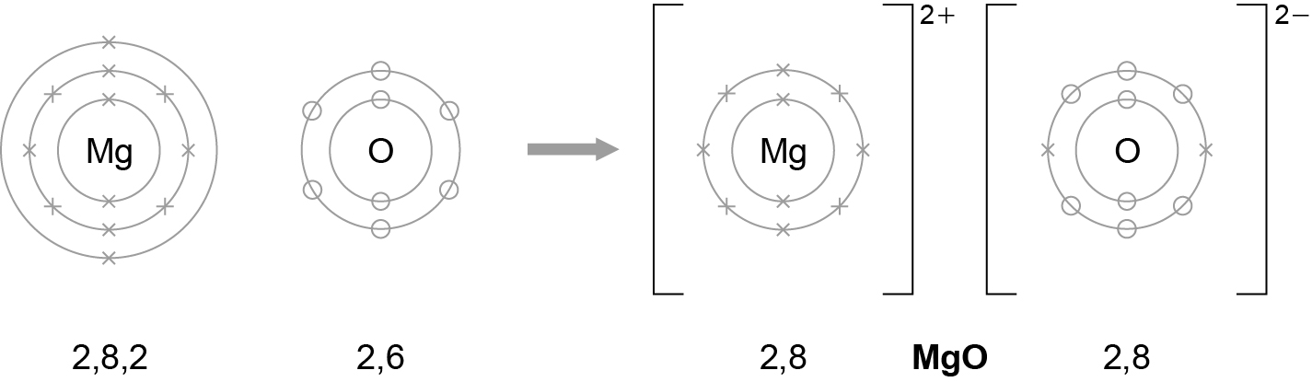
Describe, as fully as you can, what happens when magnesium reacts with oxygen to produce magnesium oxide.
You should use the words atom, electron, and ion in your answer. [6 marks]

Copper reacts with colourless silver nitrate solution to form blue copper nitrate solution and silver crystals.
0 | 4 | . | 1
Complete the word equation for the reaction. [2 marks]
copper + ……………………… → ……………………… + ………………………

Predict two observations you could make if you react copper with silver nitrate.
0 | 4 | . | 2

[2 marks]

Give one safety precaution you should take when investigating the reaction.
0 | 4 | . | 3
[1 mark]
Figure 3 represents the particles in a solid.
0 | 5
Figure 3
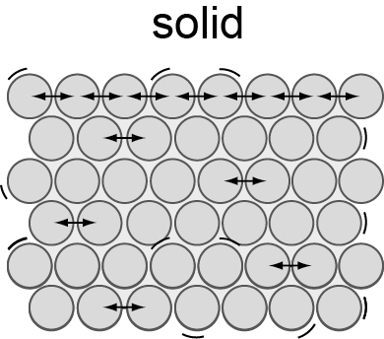
Describe what happens to particles when a substance changes state.
You should refer to the arrangement, energy and movement of the particles in all three states of matter. [6 marks]

Graphite and fullerenes are both forms of carbon.
0 | 6
Figure 4 shows the structures of graphite and a fullerene.
Figure 4
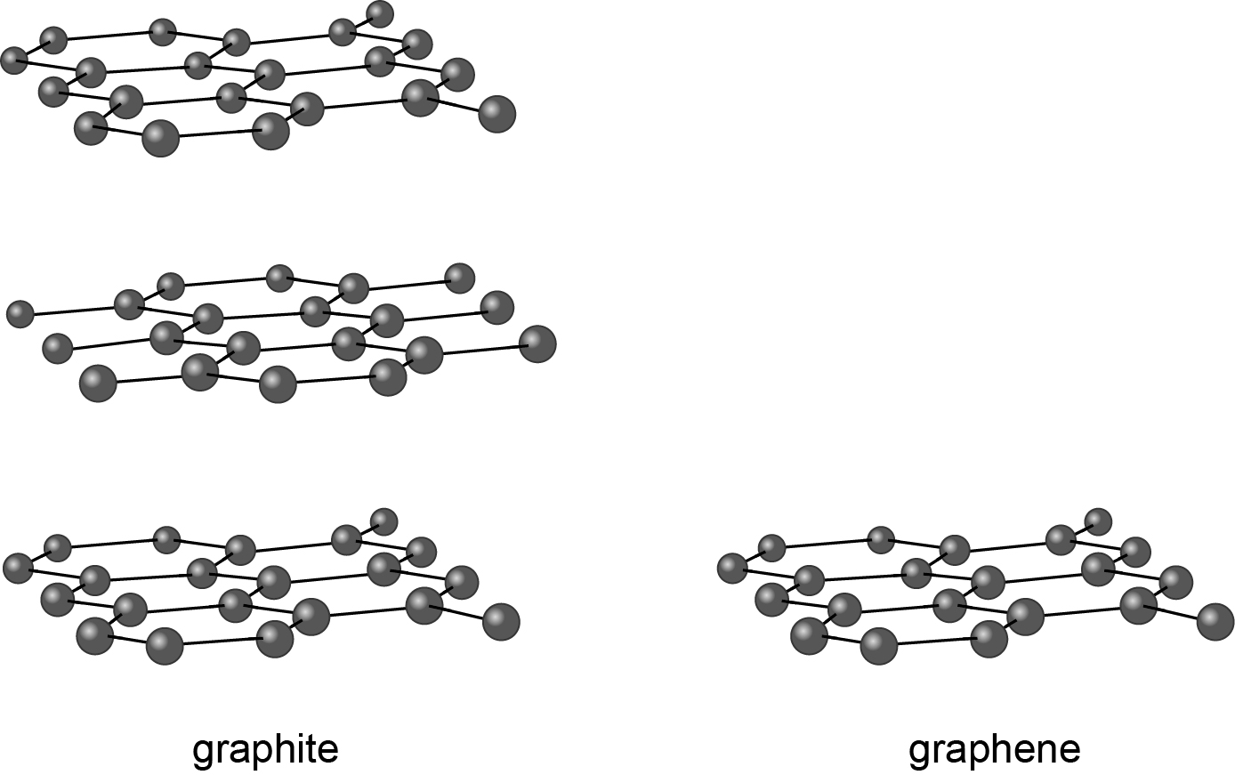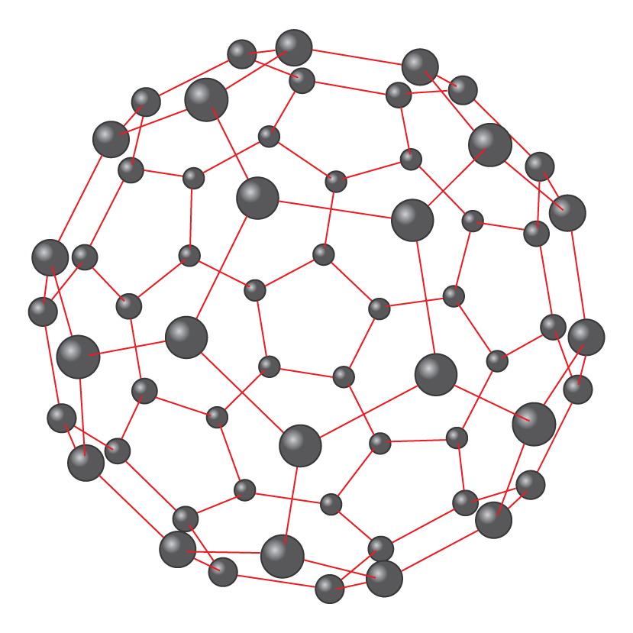
graphite
fullerene
Compare the structures of graphite and fullerenes. [3 marks]

