An atom of chlorine is represented as $\frac{\text{35}}{\text{17}}$ Cl.
0 | 1

What is the atomic number of chlorine? Tick one box.
0 | 1 | . | 1
17
18
35
52 (1 mark)

What is the mass number of chlorine? Tick one box.
0 | 1 | . | 2
17
18
35
52 (1 mark)

How many protons does the chlorine atom contain? Tick one box.
0 | 1 | . | 3
17
18
35
52 (1 mark)

The chlorine atom contains 17 electrons.
0 | 1 | . | 4
What is the electronic structure of the chlorine atom? Tick one box.
2,7,8
2,8,7
7,8,2
8,2,7 (1 mark)

Another type of chlorine atom is represented as $\frac{\text{37}}{\text{17}}$Cl.
0 | 1 | . | 5
How many neutrons does this chlorine atom contain? Tick one box.
17
20
35
37 (1 mark)

What name is given to different atoms of one element? Tick one box.
0 | 1 | . | 6
compounds
ions
isotopes
molecules (1 mark)

Ethanol and water can be separated using the apparatus shown in Figure 1.
0 | 2
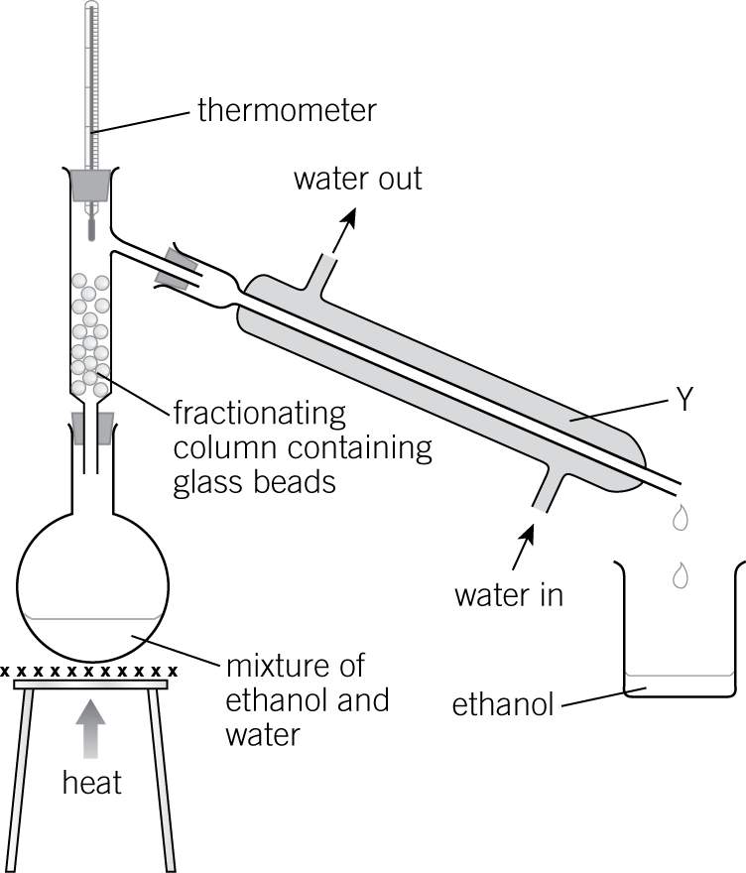
Figure 1

What is the name of the process? Tick one box.
0 | 2 | . | 1
crystallisation
fractional distillation
paper chromatography
water purification (1 mark)

Name the change happening at Y. Tick one box.
0 | 2 | . | 2
condensation
evaporation
freezing
melting (1 mark)

What is the boiling point of ethanol? Tick one box.
0 | 2 | . | 3
0 °C
78 °C
100 °C
278 °C (1 mark)

The structure in Figure 2 represents a beryllium atom.
0 | 3
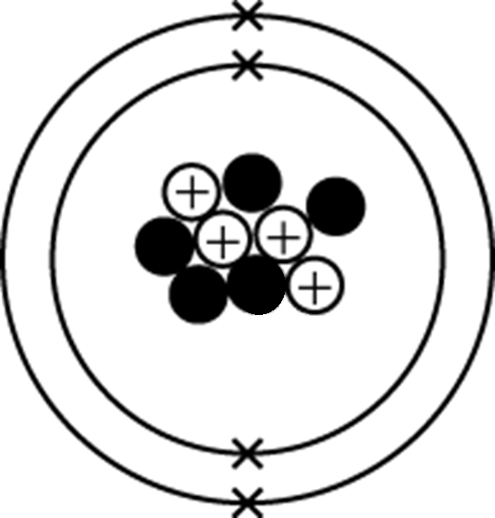
Figure 2
The atom contains three types of sub-atomic particles – protons, neutrons, and electrons.
Describe the structure of the beryllium atom.
You should include the number of each type of particle and where it is found in the atom.

(5 marks)

Ammonia is a compound. The chemical formula of ammonia is NH3
0 | 4

How many elements are in ammonia?
0 | 4 | . | 1
(1 mark)

What is the total number of atoms in ammonia?
0 | 4 | . | 2
(1 mark)

Dalton was a scientist in the early 19th century.
0 | 4 | . | 3
He gave each element a symbol.
Figure 3 shows some of Dalton’s symbols.

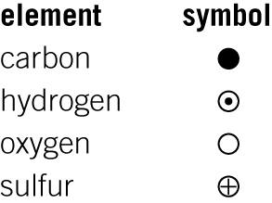
Figure 3

He wrote ammonia, NH3, as .
Which element is represented by the symbol ?
(1 mark)

Give two disadvantages of using Dalton’s symbols to represent elements and compounds.
0 | 4 | . | 4

(2 marks)

Dalton proposed the first model of an atom.
0 | 4 | . | 5
Figure 4 shows his model.

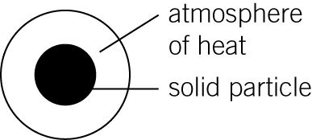
Figure 4

At the end of the 19th century, JJ Thomson proposed the plum pudding model.
Figure 5 shows the plum pudding model.

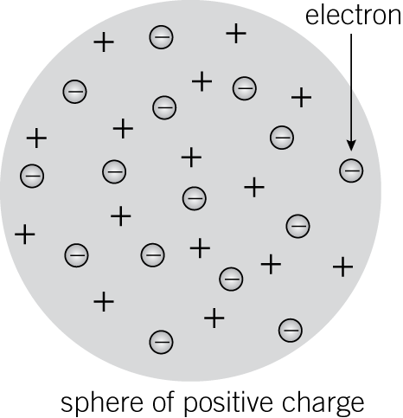
Figure 5

Describe three ways in which the plum pudding model is a more accurate representation of the atom.

(3 marks)

Sodium metal and chlorine gas react together to produce sodium chloride, NaCl.
0 | 5 | . | 1
Complete and balance the symbol equation for this reaction.
+ Cl2 → (2 marks)

Rock salt is a mixture of salt (sodium chloride) and sand. Describe how you would separate rock salt to obtain salt crystals and pure dry sand.
0 | 5 | . | 2

(6 marks)

