Enzymes
Every cell requires hundreds of biochemical reactions to survive and carry out its function.

Nearly all of these are catalysed large globular proteins called enzymes.

Enzymes can speed up reactions by a factor of many millions, but they cannot catalyse reactions that would otherwise not occur.

Enzymes catalyse both anabolic (building up) and catabolic (breaking down) reactions.

[All enzymes are globular proteins. They are soluble in water due to the presence of many hydrophilic side groups on their constituent amino acids.]

Most enzymes are very large molecules but only a small part of them is involved in catalysis. This is called the active site and it may consist of just a few amino acids.

The remainder of the amino acids maintain the precise 3D shape (tertiary structure) of the enzyme and the active site.

Substrates and Specificity

The active site of an enzyme binds the substrate molecule(s) of a biochemical reaction, and is critical to its specificity and catalytic activity.

Many enzymes are specific for just one reaction. [For example, catalase only catalyses the breakdown of hydrogen peroxide, a toxic by-product of metabolism.
hydrogen peroxide
water
oxygen
+
→
H₂O₂
H₂O
O₂
+
→
catalase

Other enzymes catalyse more general types of reactions. For example, some lipases can break down different lipids into fatty acids and glycerol.]

Location of Enzyme Action
Enzyme action occurs both intracellularly and extracellularly.

[DNA replication is an intracellular process that involves many enzymes, such as DNA polymerase and DNA ligase.

Some intracellular reactions occur on a membrane. The synthesis of ATP by ATPase during respiration, for example, occurs across the inner membrane of mitochondria.]

Digestion involves the extracellular action of enzymes such as pepsin and amylase. These hydrolyse polymers e.g. proteins and polysaccharides into small molecules, such as peptides and disaccharides.

Why Do Enzymes Increase the Rate of Reaction?

Enzymes can speed up the rate of reaction by a factor of many millions, but how do they do this? The answer is to do with the reaction’s activation energy.

All reactions require an input of energy before they start. This is called the activation energy (Ea) and is used to start breaking the bonds of the reactants.

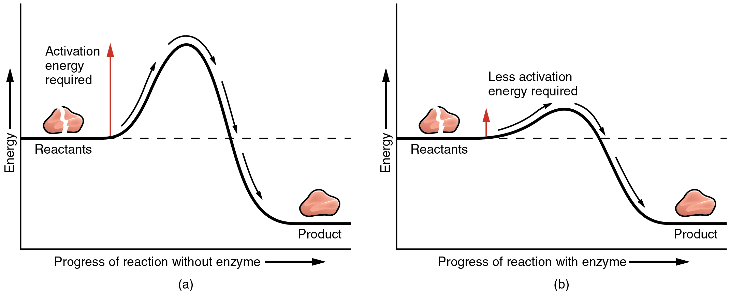

An enzyme lowers the activation energy required for the reaction by creating a transition state between the enzyme and the substrate that is more stable (it has less energy) than in the uncatalysed reaction.

Catabolic enzymes achieve this by the holding the substrate in such a way that stresses are placed on the substrate’s bonds in such a way that the minimum energy is required to break them.

Anabolic enzymes hold their substrates in such a way that the minimum energy is required for bonds to form.
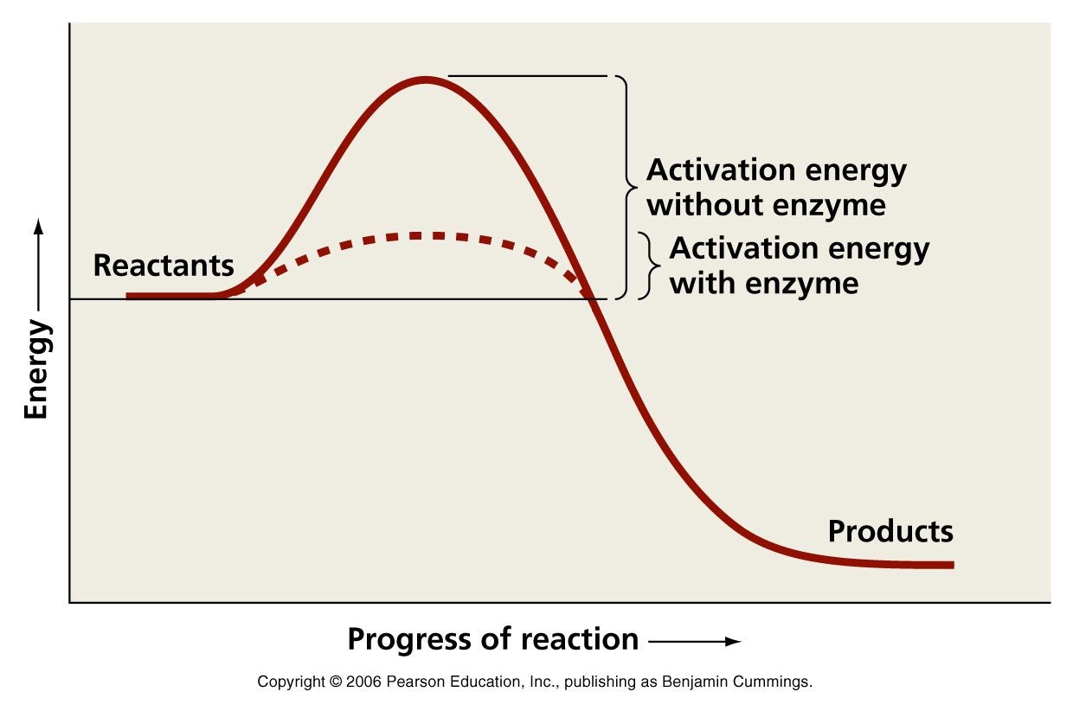
NB – the energy at the start and end points is the same regardless of whether the reaction is catalysed or not.

A catalyst, e.g. an enzyme only lowers the activation energy. It does not alter the overall reaction.

This is why enzymes only catalyse reactions which could occur – given sufficient energy (e.g. heat)
Models of Enzyme Action 1:

[Lock and Key catabolic reaction shown
The lock and key theory (hypothesis) of enzyme action was first proposed in 1894 by Hermann Fischer, a German chemist.

Most enzymes are very large globular proteins, but only a very small section – the active site – plays a direct part in biochemical reactions. The active site is a small cleft or pocket within the molecule.

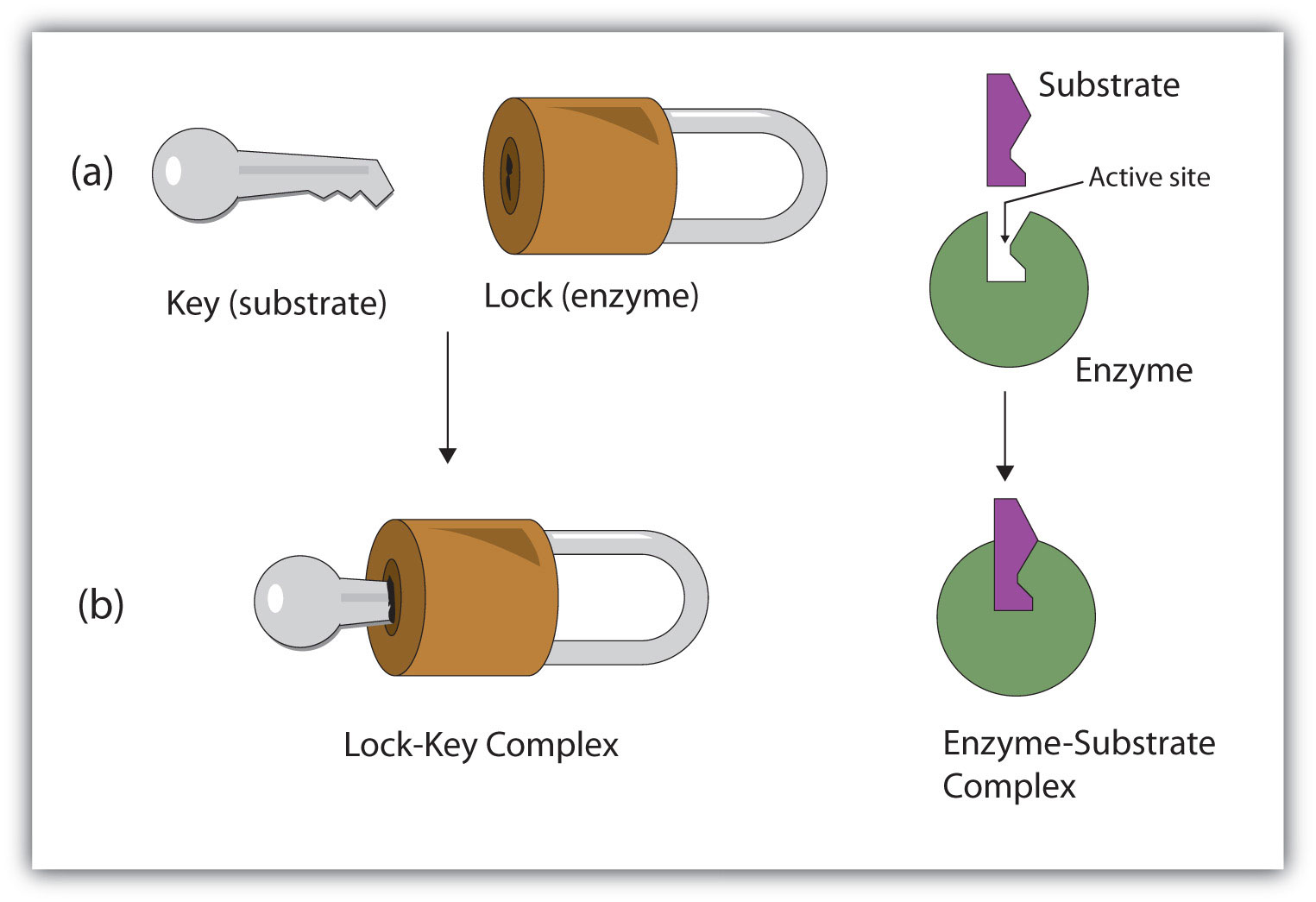

The shape of the active site is very precise and is maintained by the tertiary structure of the enzyme.

Molecules that do not have a complementary (ppt has ‘the same’!) shape as the active site cannot fit (into the active site) or bind to it.

The substrate molecule fits exactly into the active site like a key fitting into a lock, where it is held in place by various bonds (charge is also important in binding).]

This forms an enzyme-substrate complex. NB this is a very useful term for exams

The enzyme-substrate complex is such that it enables the reaction to take place more easily. Either ones substrate molecule splits into two or more products (catabolism) or two or more substrates are joined together (anabolism).

The enzyme-substrate complex only exists for a fraction of a second until the product(s) are formed.

The product(s) then leave the active site and the enzyme is free to take part in another reaction. (As catalysts, enzymes are unaltered by the reaction.)

Models of Enzyme Action 2:

Induced Fit
[In 1958, the US biochemist Daniel Koshland proposed a modification of the lock-and-key hypothesis of enzyme action: this led to the induced fit hypothesis.]

Unlike the lock-and-key hypothesis, the induced fit hypothesis proposes that the active site is not initially an exact fit for the substrate molecule.

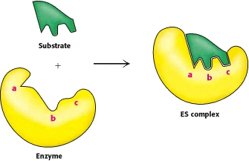

As the substrate moves into the active site, forces between the two molecules distort the enzyme and its active site so it tightly envelopes the substrate, like a glove fitting around a hand. An enzyme-substrate complex is formed.

The formation of an enzyme-substrate complex lowers the activation energy of the reaction. Once the reaction is complete, the products leave the active site and the enzyme changes back to its original shape.

Comparing the two models of enzyme action – induced fit is the most accepted hypothesis:

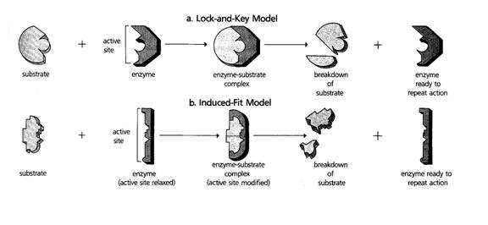
What Factors Affect Enzymes?

The rate of an enzyme-controlled reaction is affected by several factors:

- temperature - pH - enzyme concentration - substrate concentration

Each enzyme works best within a range of conditions (known as the optimum), and this range is different for each enzyme.

Enzymes are also affected by the presence of inhibitors.

Measuring the Initial Rate of Reaction

To be able to compare the rate of an enzyme-controlled reaction under different conditions, you must be able to measure the initial rate of reaction.

Stage 1: Plot the ‘amount’ of product created during the reaction against time. The amount of product will be measured in different ways (e.g. concentration or volume) depending on the type of reaction.

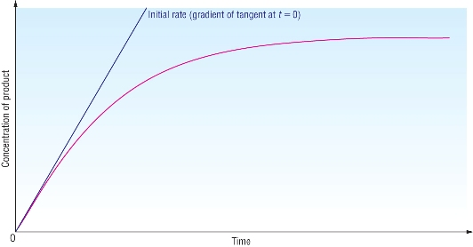

Stage 2: Draw a line at a tangent to the initial slope of the graph. Next choose a convenient time (e.g. 20s) and draw a vertical line up from this point to the tangent.

Stage 3: Where this line and the tangent meet, draw a horizontal line to the y-axis. The value represents the amount of product that would be created if the reaction continued at the initial rate after 20s.

Stage 4: Calculate the initial rate of reaction by dividing the amount of product by the time. In the reaction shown on the powerpoint, the initial rate of reaction is 1cm³s⁻¹ (20cm³/20s)

NB units used seconds = s not secs. Also ⁻¹ not/s
Effect of Temperature on Enzymes

The rate of enzyme controlled reactions increases with temperature up to a maximum called the optimum temperature.
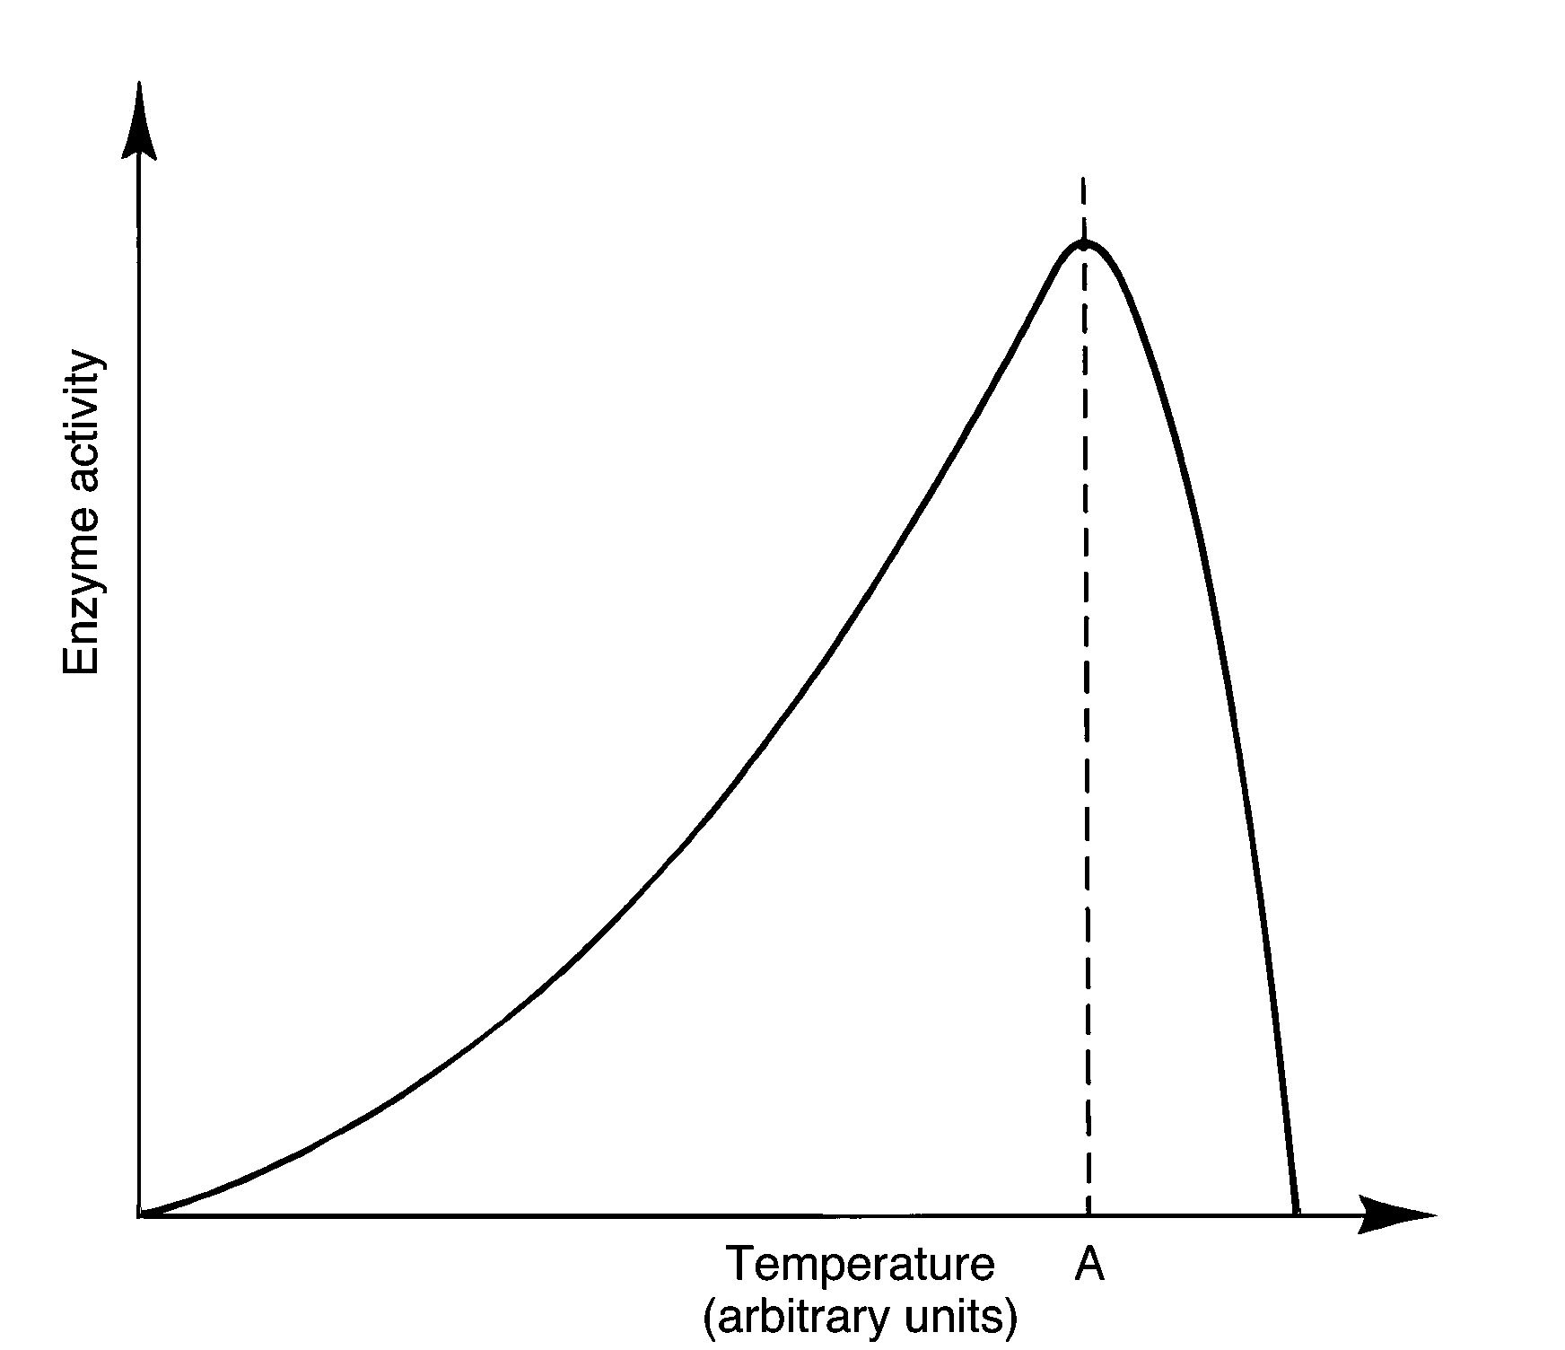

At sub-optimum temperatures, a rise in temperature increases the kinetic energy of the reactants.

They move faster so are more likely to collide and interact with each other and the enzyme.

[The change in the rate of reaction for every 10°C rise is called the temperature coefficient (Q10)

At sub-optimum temperatures, Q10 is approximately two: the rate doubles every 10°C.]

The rate of reaction peaks at the optimum temperature. In humans the optimum temperature is about 37°C – core body temperature.

Above the optimum temperature, the (hydrogen and disulfide) bonds that maintain the enzymes’ 3D shape (tertiary structure) start breaking down, irreversibly changing the shape of the active site.

(This means the substrate is no longer a complementary shape to altered active site so enzyme-substrate complexes cannot form as the substrate no longer fits into the active site)

This leads to a loss of enzyme activity – the enzyme starts to denature.

The decrease in rate caused by the enzymes denaturing overwhelms the increase in rate caused by the increased kinetic energy. This causes the overall rate of reaction to drop sharply above the optimum temperature.
(Not all enzyme molecules of a particular type will denature at precisely the same temperature so the decline is rapid but not instant).
Effect of pH on Enzymes

Most enzymes only work effectively within a narrow pH range, with one particular pH – the optimum – at which it is most effective.

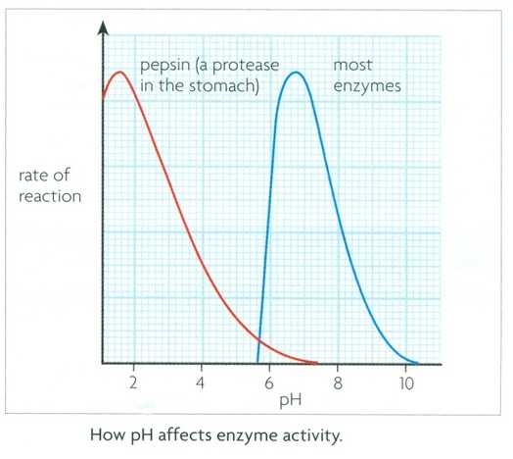

Most (intracellular) enzymes have a similar activity curve to amylase, with an optimum pH of 7-8 (i.e. approximately neutral). This is because extremes of pH are rare inside cells.

In (more) acidic or alkaline environments, H⁺ (acidic environments) or OH (alkaline environments) ions interact with amino acids in the enzyme, breaking (ionic) bonds and altering the (tertiary structure and) shape of the active site.

This causes the enzyme to denature.

(Slight changes can be reversed if pH re-established but more severe changes are irreversible as sufficient ionic bonds cannot reform in their original location).

Some (extracellular) enzymes work in extreme pH environments. Pepsin breaks down proteins in the stomach.
Due to its highly acidic environment, pepsin has an optimum pH of 1-2.

Effect of Substrate Concentration on Rate

How is the rate of an enzyme-controlled reaction affected by substrate concentration?

The rate of reaction is directly proportional to substrate concentration until it reaches a maximum value. Why does the rate not increase indefinitely?
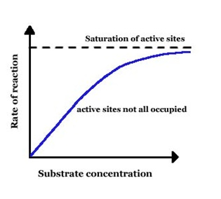
X
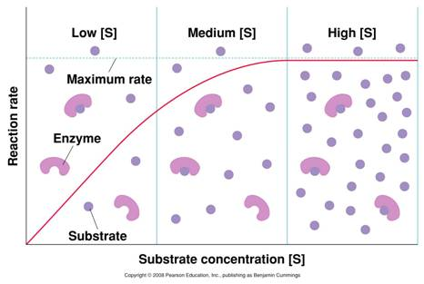
After a point (X), all the active sites will be in use (active site saturation), so increasing the amount of substrate will have no further effect on the rate.

What effect will a different enzyme concentration have on the rate?

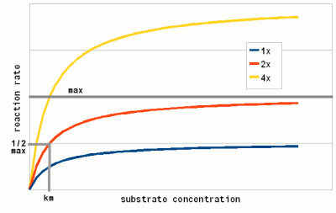

The overall rate of reaction will vary with enzyme concentration but, in each case, the rate will eventually reach a maximum once active site saturation occurs. at a higher level than before

Effect of Enzyme Concentration on Rate

How is the rate of an enzyme-controlled reaction affected by enzyme concentration?

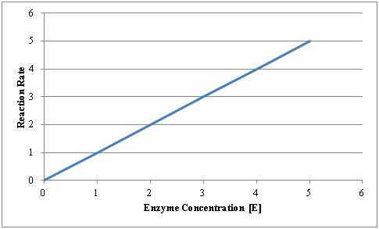

The rate of reaction is always directly proportional to enzyme concentration as long as there are no other limiting factors.

If the substrate is always in excess, why will the rate keep increasing?
Increasing the enzyme concentration will increase the rate of reaction because more active sites are available to bind the substrate
NB not the case in ‘sealed’ systems e.g. test tube.

What will happen if the amount of substrate is limited?

Increasing the enzyme concentration when the substrate is limited will increase the rate only up to a maximum because after a certain point, there will be a higher proportion of active sites than substrate molecules.

Enzyme Inhibitors
Substances can interfere with enzyme activity are called inhibitors. They can be classed in two ways, depending on their mode of action:

Inhibitors can be either competitive (active site directed) or non-competitive (non-active site directed), depending on whether they compete with the substrate for binding at the active site or not.

[Inhibitors can be either reversible or irreversible, depending on whether their inhibitory effect on the enzyme is permanent or not.]

Competitive Inhibitors
As their name suggests, competitive inhibitors compete with the substrate for position at the enzyme’s active site.
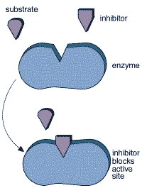

Competitive inhibitors usually have a shape that closely resembles that of the enzyme’s normal substrate molecule. Their chemical composition may differ by only a few atoms.

The competitive inhibitor binds to the active site, creating an enzyme-inhibitor complex, and blocking the substrate molecule.

This, therefore, prevents the normal reaction from taking place as an enzyme-substrate complex cannot form.

[Reversible inhibitors bind to the active site with relatively weak bonds, such as hydrogen bonds, which are easily broken. When the inhibitor leaves the active site, the substrate can bind as normal.
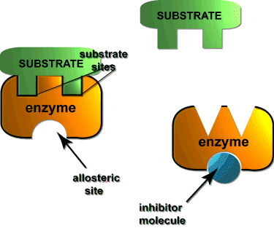

Non- Competitive Inhibitors
Non-competitive inhibits do not compete with the substrate for the active site.

Non-competitive inhibitors can have a completely different shape to that of the enzyme’s normal substrate molecule, because they do not bind to the active site. Instead they bind to an allosteric site.

When the non-competitive inhibitor binds to the allosteric site, the (shape of the) enzyme and active site become distorted so that the substrate no longer fits in the active site.

If the inhibitor is a reversible inhibitor, it can dissociate from the allosteric site. This causes the active site to revert to its normal shape and the substrate can bind as normal.

Effect of Inhibitors on Enzymes

Competitive and non-competitive inhibitors affect the rate of enzyme-controlled reactions in different ways due to their different modes of action.

For a given enzyme concentration, the rate of reaction increases to a maximum as the substrate concentration increases (see above). The maximum rate is reached when all available active sites are being used.

With a fixed amount of competitive inhibitor, the rate of reaction increases more slowly because the inhibitor and substrate compete for the active site.

Eventually, the substrate overwhelms the inhibitor and the same maximum rate is reached. (i.e. at high substrate concentrations there is a higher probability of a substrate molecule binding with the active site than an inhibitor molecule.)

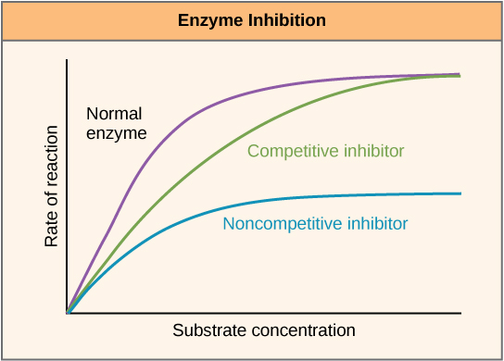

With a fixed amount of non-competitive inhibitor, the maximum rate of reaction is much lower. This is because increasing the amount of substrate has no effect on the inhibitor’s ability to bind to the enzyme.

Top tip: The ability to describe (what) and explain (why) which mechanism of inhibition is being discussed is often worth marks in questions.

This can be done either by information about the molecules (in text or diagrams) or by data showing rate of reaction at various substrate concentrations.

[Uses of inhibitors: natural poisons,
toxin = poison produced by organism
venom = a toxin(s) which is injected
poisonous organism = harmful if touched/eaten (distinct from venomous)
Many natural poisons are enzyme inhibitors.
Inhibitors in toxins/venom can irreversibly block enzymes such as acetylcholinesterase, causing paralysis and death.
Heavy metals such as mercury and cadmium are irreversible non-competitive inhibitors, blocking a range of metabolic reactions.
Cyanide is an irreversible inhibitor of an enzyme involved in respiration, preventing cells from producing ATP.
Uses of inhibitors: biocides
Biocides are chemicals that can kill a living organism, and are commonly used in agriculture, the food industry and medicine. Many are enzyme inhibitors.
4 groups of biocides in EU. Disinfectants, preservatives, pesticides, others (e.g. antifouling/taxidermist fluid)
For example, the insecticide malathion irreversibly inhibits acetylcholinesterase, while the common herbicide glyphosate blocks the synthesis of amino acids.

Triclosan is an antibacterial/antifungal disinfectant that inhibits an enzyme involved in fatty acid synthesis. It is used in toothpaste, soaps and other cleaning products.

Uses of inhibitors: drugs
The antibiotics penicillin and vancomycin inhibit enzymes involved in the production of bacterial cell walls. HIV can be treated using reverse transcriptase inhibitors, Alzheimer’s with acetylcholinesterase inhibitors etc

Methotrexate is used in the treatment of cancer and some autoimmune diseases. It inhibits the enzyme dihydrofolate reductase, which is involved with the metabolism of folic acid. New drugs developed by creating similar structure compounds and tested speeded up by analysing the 3D shape of the active site and using a computer to predict possible inhibitors
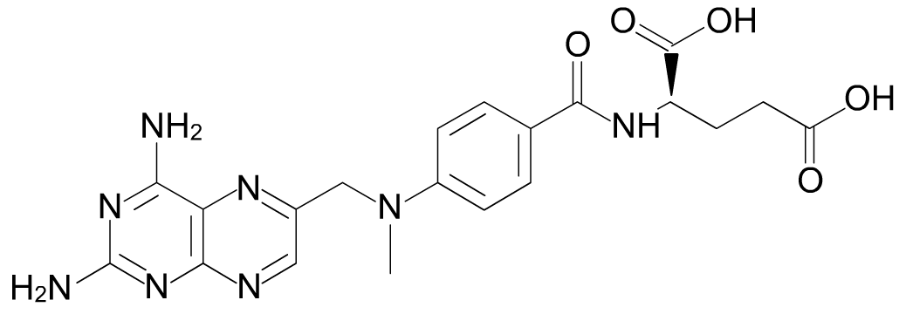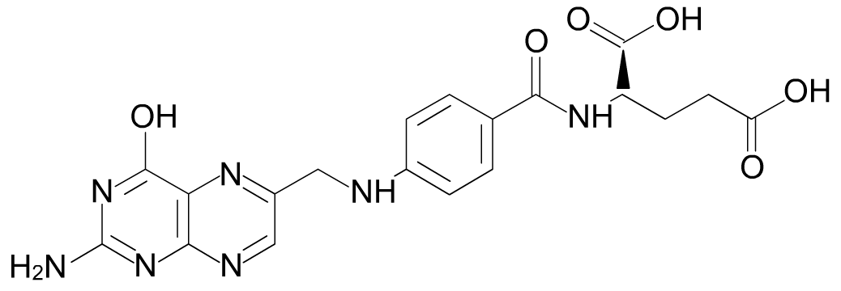Is methotrexate a competitive or non-competitive inhibitor of the enzyme?
What evidence is there for this assumption? competitive (similar not the same in structure)
folic acid
methotrexate

End-product inhibition example of negative feedback
Enzyme inhibition is important in regulating metabolic pathways. The final (end) product often acts as a regulator of the pathway in a process called end-product inhibition.
When the amount of end product is high, it binds non-competitively to an enzyme in the pathway, blocking further production of itself.
When the amount of end product falls, inhibition ends and the pathway restarts.
The synthesis of ATP is regulated in this way, with ATP acting as the inhibitor.

