A student investigated the reaction of magnesium with oxygen.
0 | 1 | . | 1
The student calculated that 4.8 g of magnesium would make 8.0 g of magnesium oxide.
The equation for the reaction is:
2Mg + O₂ → 2MgO
What mass of oxygen is required to produce 8.0 g of magnesium oxide from 4.8 g of magnesium? [1 mark]

The student heated magnesium to produce magnesium oxide.
0 | 1 | . | 2
Figure 1 shows the apparatus the student used.
Figure 1
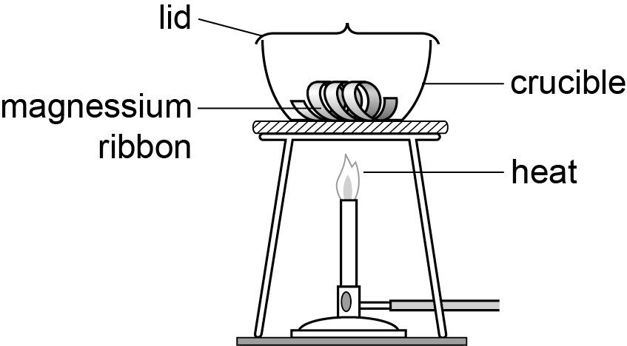
The student:
- weighed 2.40 g of magnesium
- heated the crucible and magnesium
- when heating lifted up the lid slightly to let oxygen in but stopped magnesium oxide escaping
- heated until all the magnesium formed a white powder
- weighed the magnesium ribbon formed.
Table 1 shows the student’s results.
Table 1
 | Trial 1 | Trial 2 | Trial 3 | Trial 4
Mass of magnesium in g | 2.40 | 2.40 | 2.40 | 2.40
Mass of magnesium oxide in g | 7.36 | 7.06 | 7.38 | 7.38

Calculate the mean mass of magnesium oxide produced. Give your answer to 2 decimal places [3 marks]

The student produced less magnesium oxide than expected.
0 | 1 | . | 3
Suggest two reasons why. [2 marks]

A student made two solutions – solution A and solution B.
0 | 2
Solution A contained 5 g of copper sulfate in 50 cm³ of water.
Solution B contains 10 g of copper sulfate in 100 cm³ of water.
The student added solution B to solution A.
The student concluded that the new solution is more concentrated because it has more copper sulfate dissolved in it
Is the student correct? Explain your answer. [3 marks]

Industrially ethanol can be produced by two different methods.
0 | 3
Reaction 1: C₂H₄ + H₂O → C₂H₅OH
Reaction 2: C₆H₁₂O₆ → 2CO₂ + 2C₂H₅OH
Explain why the atom economy in reaction 1 is equal to 100%. [2 marks]
0 | 3 | . | 1

Calculate the atom economy for reaction 2.
0 | 3 | . | 2
Use the equation.
Atom economy = $\begin{aligned}\frac{\text{ Relative formula mass of}}{\text{desired product from equation}}\end{aligned}\begin{aligned}\frac{\text{Sum of relative formula masses}}{\text{ of all reactants from equations}}\end{aligned}$ × 100
Relative atomic masses A_{r}: C = 12, H = 1, O = 16 [5 marks]

A student investigated the volume of sulfuric acid that reacted with 25 cm³ sodium hydroxide.
0 | 4 | . | 1
Describe a titration method the student could use in this investigation. [6 marks]

In the titration the student used 25.0 cm³ of sodium hydroxide.
0 | 4 | . | 2
This volume reacted with exactly 20.0 cm³ of 0.1 mol/dm³ of sulfuric acid solution.
The equation for the reaction is:
2NaOH + H₂SO₄ → Na₂SO₄ + 2H₂O
What is the concentration in mol/dm³ of the sodium hydroxide solution? [4 marks]

Describe how you can calculate the relative formula mass of a compound. [4 marks]
0 | 5

