Sodium metal and chlorine gas react together to produce sodium chloride, NaCl.
0 | 1 | . | 1
Complete and balance the symbol equation for this reaction.
+ Cl2 → (2 marks)

Rock salt is a mixture of salt (sodium chloride) and sand. Describe how you would separate rock salt to obtain salt crystals and pure dry sand.
0 | 1 | . | 2

(6 marks)

An atom of beryllium can be represented as${}_{4}^{9}{}\text{Be}$.
0 | 2
Describe the structure of the beryllium atom.
In your answer make reference to the number of sub-atomic particles and where they are found in the atom.

(5 marks)

Dalton was a scientist in the early 19th century. He gave each element a symbol.
0 | 3
Figure 1 shows some of Dalton’s symbols.
Figure 1

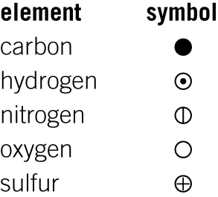
Figure 2 shows the symbol Dalton used for a substance.
0 | 3 | . | 1
Figure 2
What is the modern chemical formula for this substance?
(1 mark)

Give two advantages of using modern symbols rather than Dalton’s symbols.
0 | 3 | . | 2

(2 marks)

Dalton thought that the atoms of each element were the same. We now know that elements can have different atoms, for example, chlorine has two different atoms, ${}_{\text{17}}^{\text{35}}{}\text{Cl}$and${}_{\text{17}}^{\text{37}}{}\text{Cl}$.
0 | 3 | . | 3
What name is given to different types of atom of the same element?
(1 mark)

How are the structures of the chlorine atoms ${}_{\text{17}}^{\text{35}}{}\text{Cl}$ and ${}_{\text{17}}^{\text{37}}{}\text{Cl}$ different?
0 | 3 | . | 4

(1 mark)
Ethanol (boiling point 78 °C) and water can be separated using the apparatus shown in Figure 3.
0 | 4
Figure 3
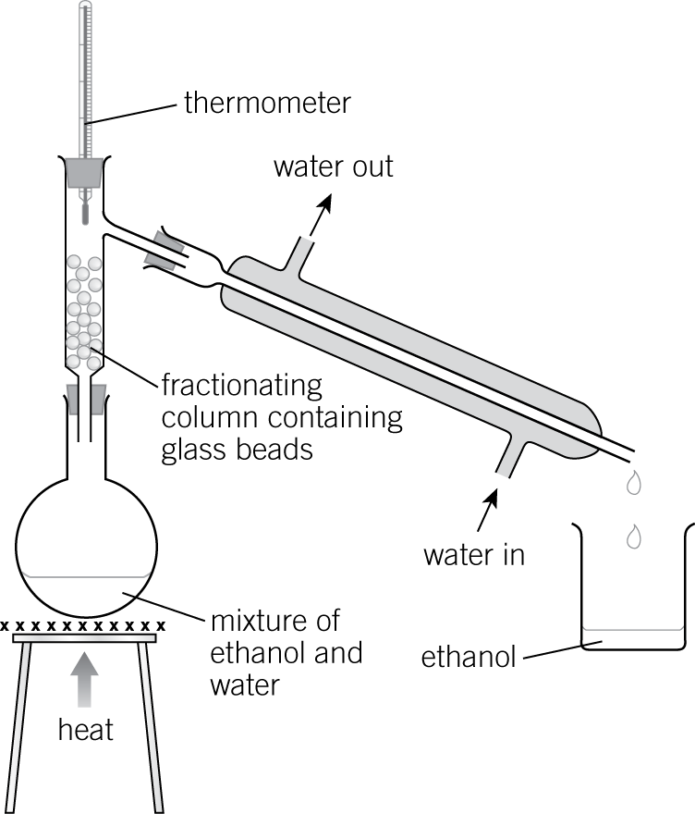

When the mixture of ethanol and water is heated, both liquids vaporise.
Explain why the liquids then separate.

(3 marks)

An alpha particle is a helium nucleus.
0 | 5 | . | 1
Which chemical symbol represents a helium nucleus? Tick one box.
${}_{2}^{4}{}$He+
${}_{2}^{4}{}$He2+
${}_{2}^{4}{}$He3+
${}_{2}^{4}{}$He4+ (1 mark)

Scientists used alpha particles to investigate models of the atom.
0 | 5 | . | 2
Figure 4 shows an alpha particle scattering experiment.
Figure 4
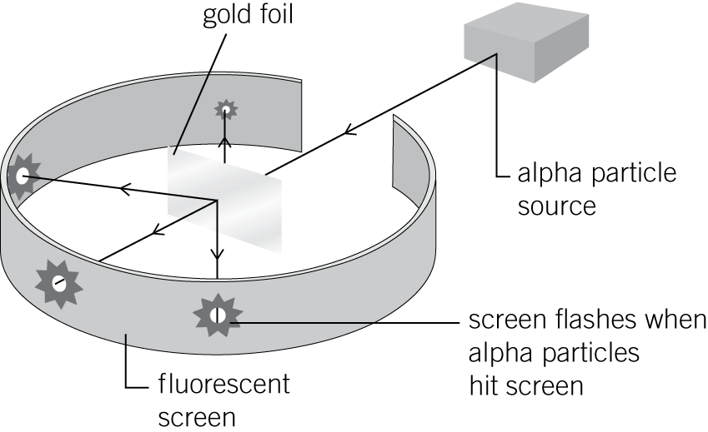

Explain how scientists used the results from the experiment to:
- disprove the plum pudding model
- give evidence for the new nuclear model.

(4 marks)

The radius of a magnesium atom is 0.160 nm.
0 | 6 | . | 1
The radius of a nucleus is about $\frac{1}{\text{10}\text{000}}$ that of an atom.
Calculate the radius of a magnesium nucleus.
Give your answer in standard form.

Radius of a magnesium nucleus = nm (2 marks)
The radius of a magnesium ion is 7.2×10−11 m.
0 | 6 | . | 2
Explain the difference in size between the magnesium atom and magnesium ion.

(2 marks)

