Figure 1 shows a reaction profile.
0 | 1
Figure 1
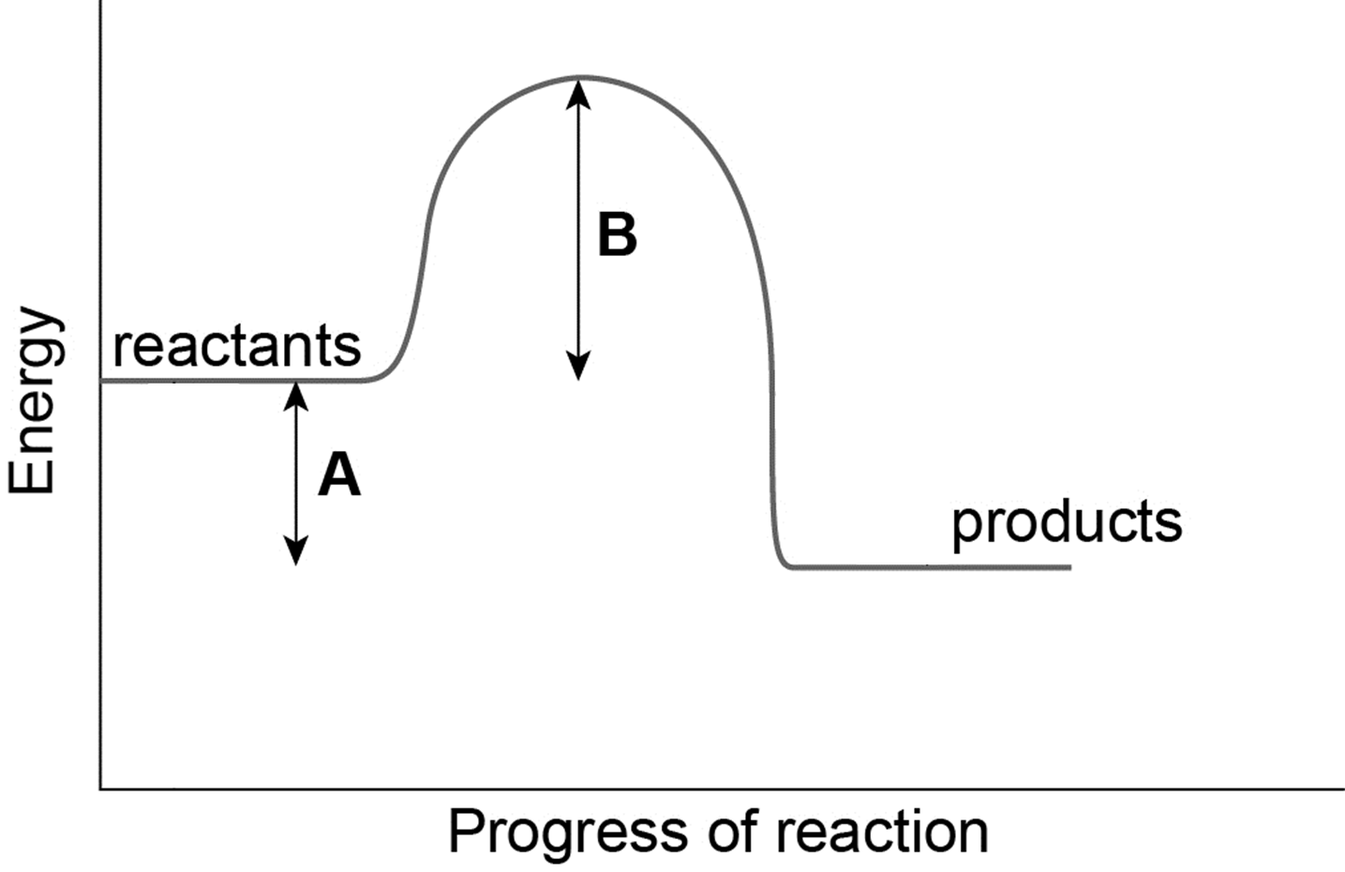
What do the letters A and B represent? [2 marks]
0 | 1 | . | 1

Sketch a reaction profile for an endothermic reaction. [2 marks]
0 | 1 | . | 2

A student investigated temperature changes during a reaction.
0 | 2
Figure 2 shows the apparatus the student used.
Figure 2
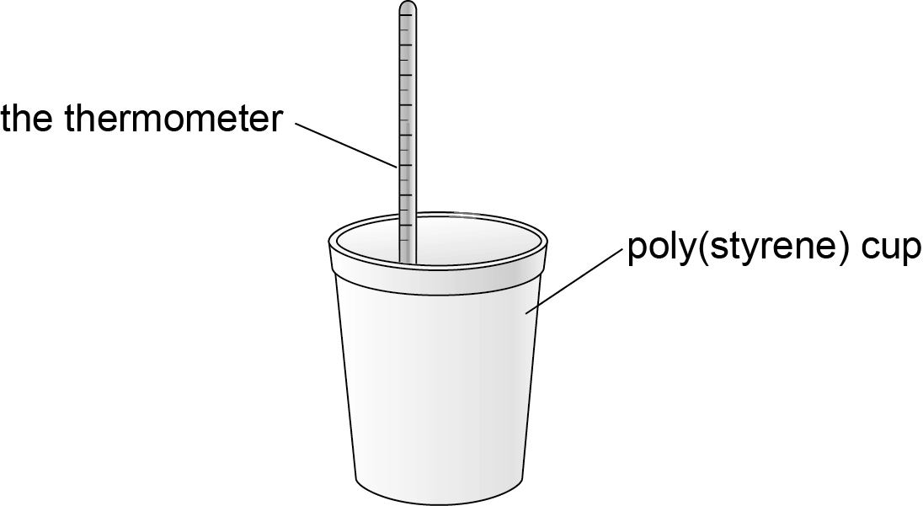
In the investigation the student added metal powder to copper chloride solution.
0 | 2 | . | 1
State three variables the student should control to make the investigation a fair test. [3 marks]

The student repeated the investigation three times.
0 | 2 | . | 2
Table 1 shows the student’s results.
Table 1
 | Trial 1 | Trial 2 | Trial 3
Maximum temperature decrease in °C | 6.9 | 6.7 | 6.9
Calculate the mean value.
Give your answer to 3 significant figures. [2 marks]

A different student investigated the reaction of ammonium nitrate with water.
0 | 2 | . | 3
The student:
- measured the temperature of the water
- added ammonium nitrate to the water
- stirred the mixture
- measured the temperature every 5 seconds
Table 2 shows the student’s results.
Table 2
Time in seconds | Temperature in °C
0 | 22.0
5 | 19.0
10 | 16.6
15 | 15.0
20 | 14.8
25 | 13.2
30 | 13.0
35 | 13.0
40 | 13.0
Use the results in Table 2 to plot a graph of time in seconds against temperature in °C. Draw a line of best fit. [5 marks]
Which point on your graph is anomalous?
0 | 2 | . | 4
Suggest one reason why the anomalous point was obtained. [2 marks]

Methane reacts with oxygen to produce carbon dioxide and water.
0 | 3 | . | 1
The equation for the reaction is:
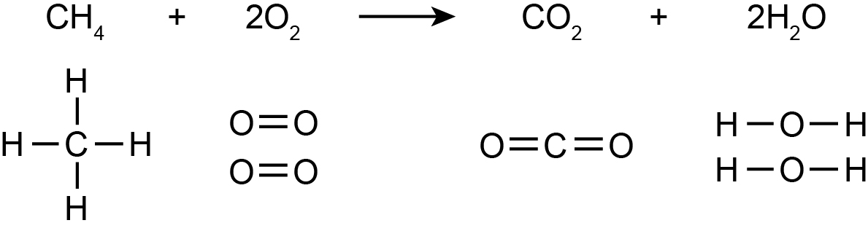
Calculate the energy change for the reaction. [5 marks]
Bond energies:
Bond | Bond energy in kJ/mol
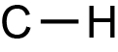 | 413
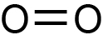 | 498
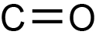 | 798
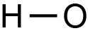 | 464

Energy change: unit:
Is this an exothermic reaction or an endothermic reaction?
0 | 3 | . | 2
Explain your reasoning. [3 marks]

Evaluate the use of vehicles powered by hydrogen fuel cells
and by petrol engines. [6 marks]
0 | 4

