A student investigated the electrolysis of different concentrations of sodium chloride solution. The student measured the volume of hydrogen produced in 5 minutes.
0 | 1
Table 1 shows the student’s results.
Table 1
Concentration of sodium chloride in mol/dm³ | Volume of hydrogen in cm³ produced in five minutes
0.00 | 0.0
0.25 | 0.6
0.50 | 1.2
0.75 | 1.8
1.00 | 2.4
1.25 | 3.0
1.50 | 3.6

Use the data in Table 1 to plot a graph of concentration of sodium chloride against volume of hydrogen produced.
0 | 1 | . | 1
Draw a line of best fit. [5 marks]
What volume of hydrogen would be obtained at a concentration of
2.00 mol/dm³? Show how you obtained this value. [2 marks]
0 | 1 | . | 2

Give two conclusions you can make from your graph. [2 marks]
0 | 1 | . | 3

Chlorine gas was produced at the positive electrode.
0 | 1 | . | 4
Complete the half equation for the reaction. [2 marks]
Cl⁻ → Cl₂ + ……………...

Explain why hydrogen not sodium is produced at the negative
electrode. [3 marks]
0 | 1 | . | 5

Describe a method you could use to investigate the volume of
hydrogen produced during the electrolysis of sodium chloride.
Include a labelled diagram in your answer. [6 marks]
0 | 1 | . | 6

A solution of sodium sulfate was electrolysed.
0 | 2 | . | 1
Predict the product obtained at each electrode. [2 marks]
positive electrode
negative electrode
Explain why the sodium sulfate solution becomes more concentrated during the elecetrolysis process. [3 marks]
0 | 2 | . | 2

Aluminium metal is extracted industrially by electrolysis.
0 | 3
Figure 1 shows the electrolysis cell used.
Figure 1
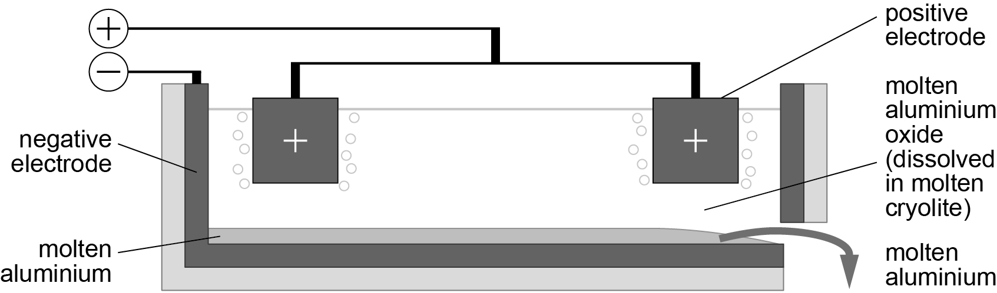
Aluminium metal is produced at the negative electrode. Oxygen is produced at the positive electrode.
0 | 3 | . | 1
Complete the half equation for the reaction. [2 marks]
Al₂O₃ → +
The positive carbon electrode has to be continually replaced during the process.
0 | 3 | . | 2
Explain why. [3 marks]

