 Drawing and naming organic compounds
Specification references
- C7.2.1 Structure and formulae of alkenes
- C7.2.2 Reactions of alkenes
- C7.2.3 Alcohols
- C7.2.4 Carboxylic acids
- MS 5b
Aims
This worksheet shows the students how to represent a range of organic molecules on paper by giving their structural or displayed formula.
Learning outcomes
After completing this worksheet, students should be able to:
- draw the structural and displayed formulae for the first four members of the alkenes and the products of their addition reactions with H2, H2O, Cl2, Br2, and I2
- draw the structural and displayed formulae for the first four primary alcohols and the first four carboxylic acids.
Teacher notes
The 3D nature of organic molecules can be shown to the students using molecular model kits. If possible, individual model kits can be made up containing a small number of hydrogen, carbon, and oxygen atoms together with a selection of single and double bonds. These allow all students to be actively involved in the learning and are something they enjoy. The students can model the step-by-step approach to drawing displayed formula outlined in the worked example by first connecting the carbon backbone, then adding the functional group, and then finally by filling any vacant ‘holes’ in the carbon atoms with single bonds to hydrogen.
The students often struggle to remember the prefixes to the names. Regular and repeated use of these in class will help. In addition, encouraging students to refer to molecules by their correct name when answering questions will help to develop the students’ knowledge.
Maths skills links
Students will also need to visualise and represent 2D and 3D forms when studying ionic and covalent compounds.
Answers
1 a i 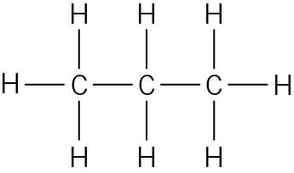 ii 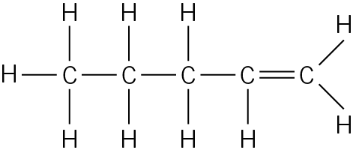
iii 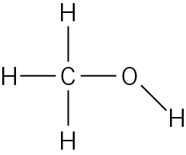 iv 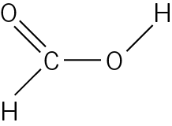 (4 marks)
b i CH3CH2CH2CH3 (1 mark)
ii CH3CHCH2 (1 mark)
iii CH3CH2CH2OH (1 mark)
iv CH3COOH (1 mark)
2 a 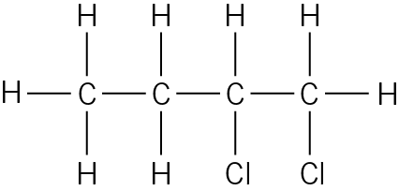 (1 mark)
b 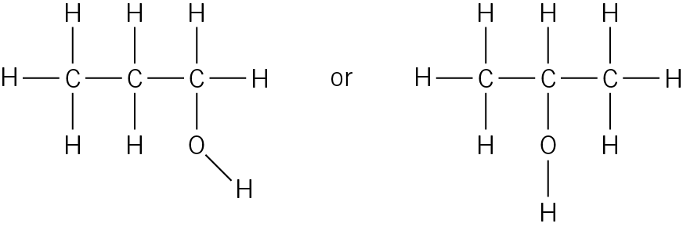 (1 mark)
c 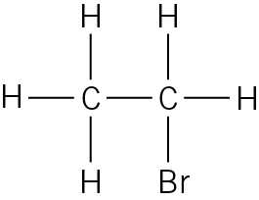 (1 mark)
d 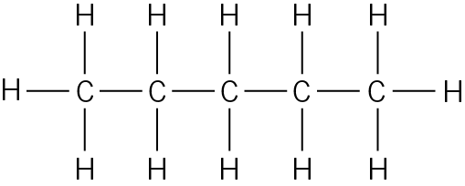 (1 mark)
3 a 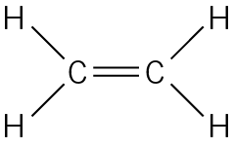 ethene (2 marks)
b 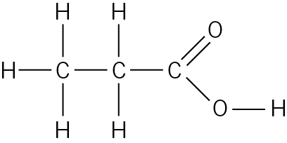 propanoic acid (2 marks)
c 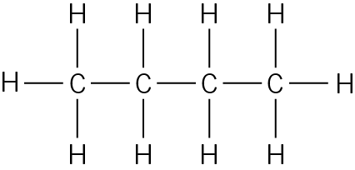 butane (2 marks)
d 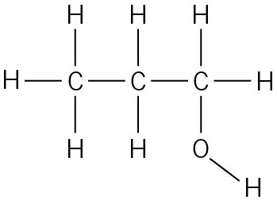 propanol (2 marks)
Student follow-up answers
1 a ethanoic acid + ethanol (2 marks)
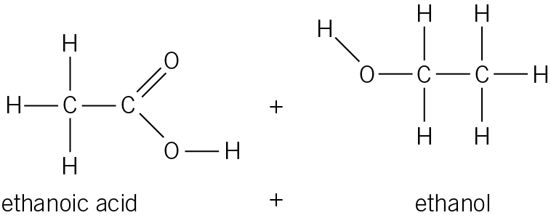 (2 marks)
b i The sulfuric acid acts as a catalyst / to speed up the reaction (1 mark)
ii To speed up the reaction. (1 mark)
c i A 100 cm3 beaker is the most suitable (to contain 5 cm3 ethanoic acid, 5 cm3 ethanol, and 30 cm3 sodium carbonate). (1 mark)
ii 2CH3COOH + Na2CO3 → 2CH3COONa + H2O + CO2
(1 mark correct reactants and products)
(1 mark balancing)
d Mass of ethyl ethanoate = 27.73 – 21.20 = 6.53 g (1 mark)
Percentage yield = × 100 = 78.7% (1 mark)

