 Drawing and naming organic compounds
Specification references
- C7.2.1 Structure and formulae of alkenes
- C7.2.2 Reactions of alkenes
- C7.2.3 Alcohols
- C7.2.4 Carboxylic acids
- MS 5b
Aims
This worksheet shows you how to represent a range of organic molecules on paper by giving their structural or displayed formula.
Learning outcomes
After completing this worksheet, you should be able to:
- draw the structural and displayed formulae for the first four members of the alkenes and the products of their addition reactions with H2, H2O, Cl2, Br2, and I2
- draw the structural and displayed formulae for the first four primary alcohols and the first four carboxylic acids.
Setting the scene
Organic molecules all contain carbon atoms. The carbon atoms tend to form the ‘backbone’ of organic molecules.
Organic molecules are named based on the number of carbon atoms in the backbone and the functional group within the molecule.
The first part of the name, the prefix, tells you how many carbon atoms are in the molecule:
Prefix (start of name) | Number of carbon atoms
meth- | 1
eth- | 2
prop- | 3
but- | 4
pent- | 5

The second part of the name, the suffix, tells you the functional group within the molecule:
Suffix (end of name) | Functional group | Homologous series
-ane | C–C | alkane
-ene | C=C | alkene
-ol | –OH | alcohol
-oic acid | 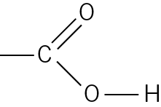 | carboxylic acid
Organic molecules are 3D but you need to be able to represent them on paper in a 2D form. There are a number of ways of doing this:
- molecular formula – gives the actual number of atoms of each element in a molecule
- structural formula – shows how the atoms are arranged in the molecule without showing all the bonds
- displayed formula – shows every atom and every bond in a molecule. A covalent bond between two atoms is shown by a line between the atoms.
For example, propanol would be represented as follows:
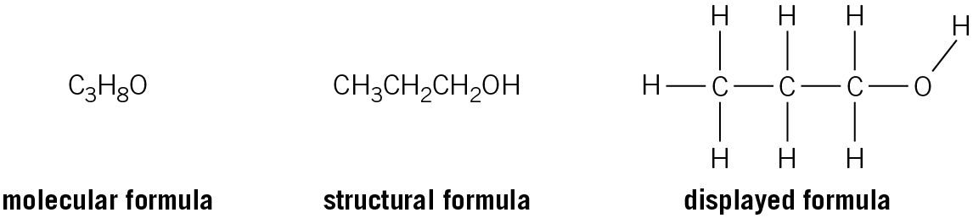
Worked example
Draw the displayed formula for butanoic acid. Write the structural formula for the molecule.
Step 1
Use the start of the name to determine the number of carbon atoms in the molecule’s backbone.
In this case the name starts with but- and so the molecule must contain 4 carbon atoms in its backbone.
Step 2
Use the end of the name to determine the functional group in the molecule.
In this case the name ends in –oic acid and so the molecule is a carboxylic acid.
Step 3
Draw out the 4 carbon atoms with a carboxylic acid group at the end carbon. Use single straight lines between the atoms to represent covalent bonds. There is a double covalent bond (two shared pairs of electrons) between the carbon and the oxygen in a carboxylic acid, shown with two lines.
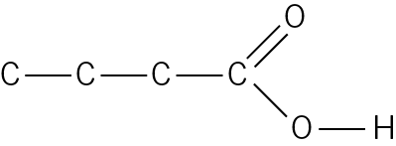
Step 4
A carbon atom has four electrons in its outer shell. To obtain the stable electronic configuration of a noble gas, it must gain four electrons from covalent bonds.
Complete the displayed formula of butanoic acid by adding the correct number of covalent bonds to hydrogen to each carbon atom, so that each carbon atom has four covalent bonds.
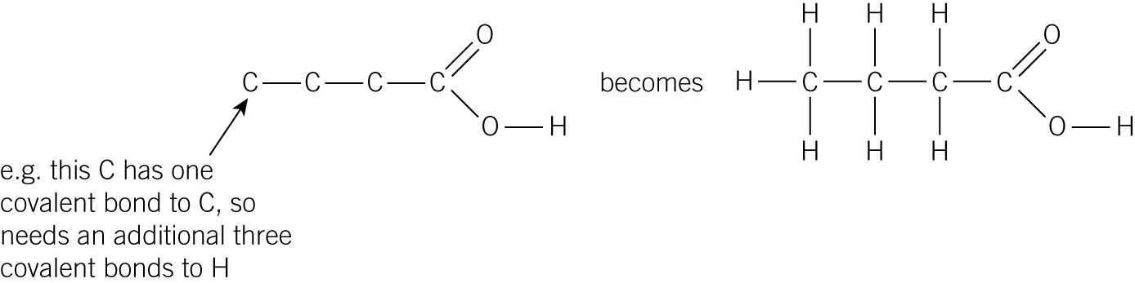
Step 5
In the structural formula of butanoic acid you need to show how the atoms are arranged in the molecule without showing the bonds.
To write the structural formula, take each carbon atom in turn and write the number of atoms attached to it. Repeat for each carbon atom, moving from left to right along the backbone.
The carboxylic acid group is usually written as –COOH instead of –CO2H to show that it is a C double bonded to an O and also attached to an OH group. So:
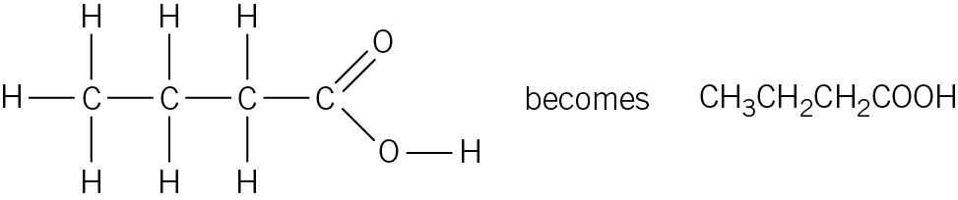
Questions
1 a Draw the displayed formula for each of the molecules named below.
i propane (1 mark)

ii pentene (1 mark)

iii methanol (1 mark)

iv methanoic acid (1 mark)

b Write the structural formula for each of the molecules below.
i 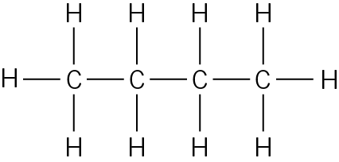 ii 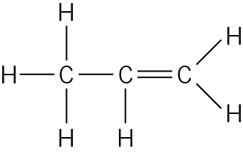
(2 marks)
iii 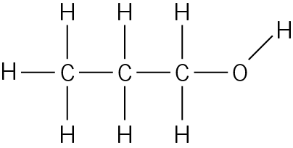 iv 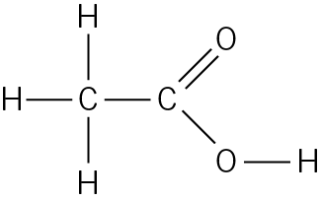
(2 marks)
2 Draw the displayed formula of the products from each of the following reactions.
a 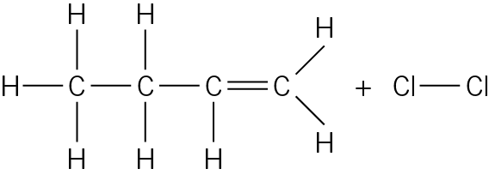 (1 mark)

b 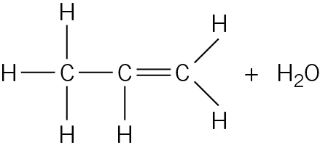 (1 mark)

c Addition of HBr to ethene. (1 mark)

d Addition of H2 to pentene. (1 mark)

3 George has made some molecules using a model kit. Grey balls represent oxygen atoms, black balls represent carbon atoms, and white balls represent hydrogen atoms.
Draw the displayed formula for each molecule and name it.
a 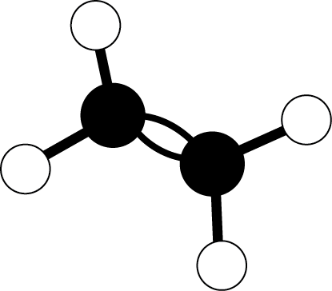 b 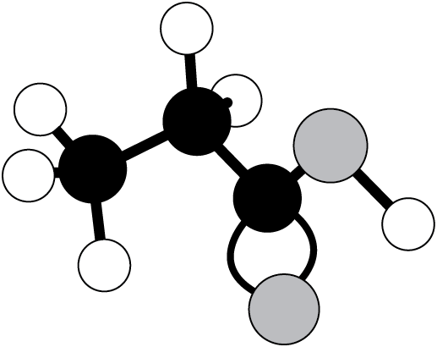
(4 marks)

c 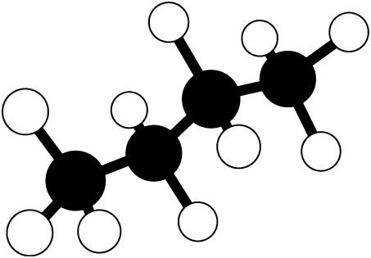 d 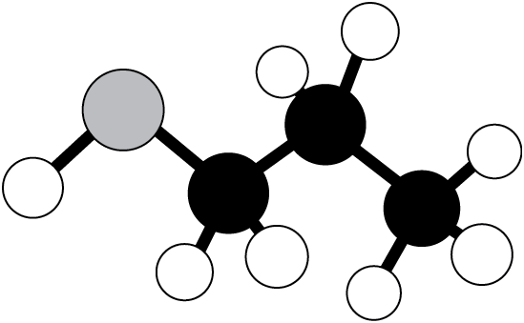
(4 marks)

Student follow-up
1 Kylanne carries out an experiment to make a sample of the ester ethyl ethanoate, CH3COOCH2CH3. She finds the method below on the internet.
Step 1 Put 5 cm3 of carboxylic acid into a boiling tube.
Step 2 Add 5 cm3 of alcohol and a few drops of concentrated sulfuric acid catalyst.
Step 3 Warm the boiling tube gently in a beaker of hot water.
Step 4 When the boiling tube is cool enough to handle, pour the reaction mixture into a beaker containing 30 cm3 of sodium carbonate solution.
Answer the following questions about the experiment.
a Ethyl ethanoate has a displayed formula as shown:
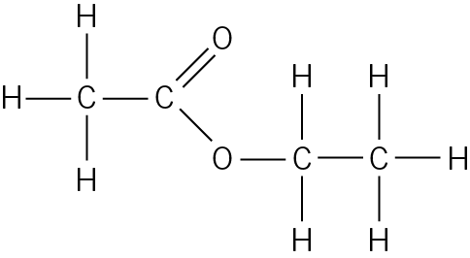
Name, and draw the displayed formula of, the carboxylic acid and the alcohol Kylanne will need to use to make this ester.

(4 marks)
b Explain the purpose of each of the following steps in the method:
i adding a few drops of sulfuric acid to the reaction mixture
(1 mark)
ii heating the reaction mixture in hot water.
(1 mark)
c Any unreacted carboxylic acid in the reaction mixture is neutralised in step 4.
i Which would be the most appropriate size of beaker for this final step, 100 cm3 or 250 cm3?
(1 mark)
ii Write a balanced symbol equation for the neutralisation reaction that occurs.
(2 marks)
d Kylanne calculates that she should make 8.30 g of ethyl ethanoate.
She separates the ester from the aqueous mixture in step 4, and places it in a pre-weighed vial.
She records the mass of the vial plus ester.
Use Kylanne’s results below to calculate the percentage yield for her reaction:
Mass of empty vial in g | 21.20
Mass of vial + ethyl ethanoate in g | 27.73

(2 marks)
Maths skills links
You will also need to visualise and represent 2D and 3D forms when studying ionic and covalent compounds.

