
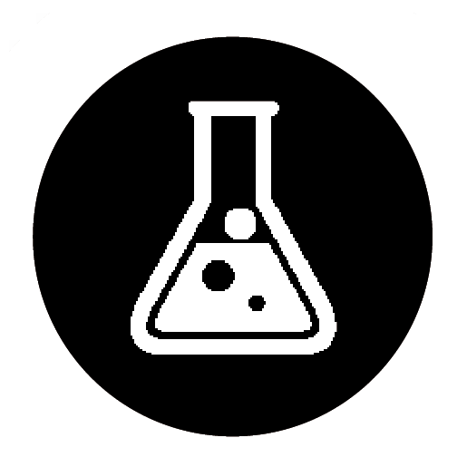 Comparing the reactions of alcohols
Specification references
- C7.2.3 Alcohols
Aims
This activity shows three important reactions of alcohols: combustion, reaction with sodium, and reaction with an oxidising agent. Students will record their observations and analyse the results. The follow-up questions aim to link students’ new knowledge to topics they have met earlier.
Learning outcomes
After completing this exercise, students should be able to:
- describe the reactions of alcohols, including using word equations
- explain the relationship between ethanol and ethanoic acid.
- explain why solutions of ethanol have a pH of 7
- describe complete combustion reactions of a range of alcohols using balanced symbol equations
- plan an investigation to determine the relative energy transferred to the surroundings by the combustion of different alcohols
- describe what is formed in the reaction of alcohols with sodium and when alcohols are oxidised
- describe how ethanol is manufactured
- describe some uses of alcohols.
Teacher notes
The practical demonstrations should be done once students have a good understanding of the structures of alcohols and carboxylic acids. Some teachers may wish to do the combustion as a class activity, but it is a lot of effort for little gain. The follow up questions involve the manufacture and uses of ethanol, plus ideas that students have met previously (energetics and equilibrium).
A useful video outlining the two methods of manufacturing ethanol is:
Manufacture of ethanol
Addition of water
Shake each alcohol in turn with an equal volume of water. Add a few drops of universal indicator. Ask students to record how well the alcohols mix with water and the pH of the solution.
Combustion of alcohols
Light each spirit burner and ask students to record the colour and cleanness of the flames and how easily they ignite. This can be done as a class practical.
Reaction with sodium
- Three small pieces of sodium are needed. Remove the oil from each piece using filter paper.
- Put 2 cm depth of methanol in a test tube and using tweezers add a piece of sodium.
- Ask students to record their observations.
- Repeat for the other two alcohols.
Add excess ethanol to remove any traces of sodium metal before clearing up the apparatus.
Reaction with an oxidising agent
- Prepare a beaker of hot water (it needs to be between 60 °C and 80 °C).
- Wearing chemical splash proof eye protection, put 1 cm³ of acidified potassium dichromate into each of the three boiling tubes and add about 1 cm3 of methanol to one, ethanol to another, and propanol to the third.
- Stand the boiling tubes in the beaker of hot water. (This is much safer than heating directly.)
- Ask students to note the colour change and the smell of the organic product in each case.
Student follow up Question 3 is for higher-tier students.
Task answers
Example data:
Test | Methanol | Ethanol | Propanol
Addition of water | completely mixes, pH 7 | completely mixes, pH 7 | completely mixes, pH 7
Combustion | burns easily with a clean blue flame | burns easily with a clean blue flame | burns easily with a clean blue flame
Reaction with sodium | gentle fizzing,  sodium slowly dissolves | gentle fizzing,  sodium slowly dissolves | gentle fizzing,  sodium slowly dissolves
Reaction with acidified potassium dichromate | colour change from orange to green | colour change from orange to green | colour change from orange to green
Answers to main questions
- Addition of water
  - The alcohols are soluble in water. (1 mark)
  - Ethanol is a useful solvent because it dissolves a range of different substances (both inorganic and organic). (1 mark)
  - The solutions are neutral because the solutions do not contain either H⁺ ions or OH– ions. (1 mark)
- Combustion
  - 2CH3OH + 3O2 → 2CO2 + 4H2O (1 mark)
C2H5OH + 3O2 → 2CO2 + 3H2O (1 mark)
2C3H7OH + 9O2 → 6CO2 + 8H2O (1 mark)
  - Ethanol burns with a clean flame and can be manufactured from renewable resources. (1 mark)
- Reaction with sodium
  - Hydrogen gas is produced when alcohols react with sodium. (1 mark)
  - sodium methoxide CH3ONa (2 marks)
  - methanol + sodium → sodium methoxide + hydrogen (1 mark)
- Reaction with an oxidising agent
  - Potassium dichromate changes colour during the reaction (orange to green) showing that a reaction has occurred. (1 mark)
  - i methanoic acid HCOOH (1 mark)
ii ethanoic acid CH3COOH (1 mark)
iii propanoic acid C2H5COOH (1 mark)
  - i Wine goes sour because in the presence of microbes; the ethanol is oxidised by the oxygen in the air. (2 marks)
ii ethanol + oxygen → ethanoic acid (1 mark)
  - i 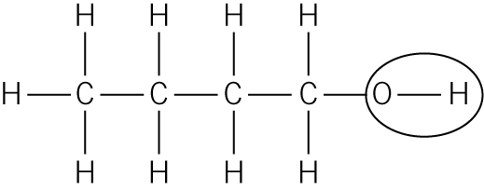 (1 mark)
ii 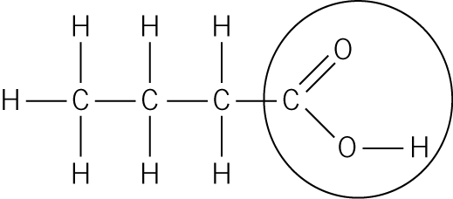 (1 mark)
iii oxidation (1 mark)
Student follow-up answers
1 • Use a known volume of water in metal can.
- Measure the initial mass of methanol and burner.
- Measure the initial temperature of water.
- Light the methanol and heat the water.
- After a suitable temperature rise (or after a suitable time) extinguish the flame.
- Stir the water and measure its final temperature.
- Measure the final mass of methanol and burner.
- Calculate the temperature rise.
- Calculate the change in mass of the methanol.
- Calculate the temperature rise per gram of methanol burnt.
- Repeat the experiment using an ethanol spirit burner, making sure the same amount of water is used in the metal can. ($\frac{1}{2}$ a mark per bullet point = 6)
2 a C6H12O6 → 2CO2 + 2C2H5OH (1 mark)
b The optimum temperature is 37 °C because above this temperature the enzymes in the yeast become denatured. (1 mark)
c Advantages: low temperature required so low fuel costs; sugars are a renewable source. (2 marks)
Disadvantages: the ethanol is an aqueous solution (so not pure); the reaction is slow. (2 marks)
d Ethanol is in alcoholic drinks; and is also used as a solvent for perfumes etc. (2 marks)
3 a i The amount of ethanol will decease because when the temperature is increased the equilibrium moves in the endothermic direction, which is to the left. (2 marks)
ii The amount of ethanol will increase because when the pressure is increased, the equilibrium moves to the side with fewer molecules, which is to the right. (2 marks)
Safety
- Wear eye protection.
- Methanol: TOXIC, HIGHLY FLAMMABLE- CLEAPSS Hazcard 40B
- Ethanol: HIGHLY FLAMMABLE, HARMFUL- CLEAPSS Hazcard 40A
- Propan-1-ol: HIGHLY FLAMMABLE, IRRITANT- CLEAPSS Hazcard 84A
- Potassium dichromate (vi): VERY TOXIC, OXIDISING- CLEAPSS Hazcard 78C
- Sodium: HIGHLY FLAMMABLE, CORROSIVE- CLEAPSS Hazcard 088

Remove all spare alcohols before lighting spirit burners
Equipment
- three spirit burners: one with methanol, one with ethanol, and one with propan-1-ol
- dropping pipettes
- six test tubes in test-tube rack
- universal indicator
- sodium metal (no more than 2mm sides), white tile, scalpel, filter paper, tweezers
- three boiling tubes
- 250 cm3 beaker
- acidified potassium dichromate solution

