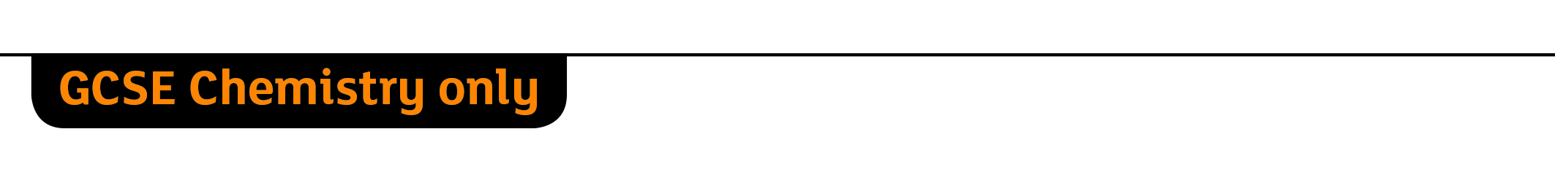
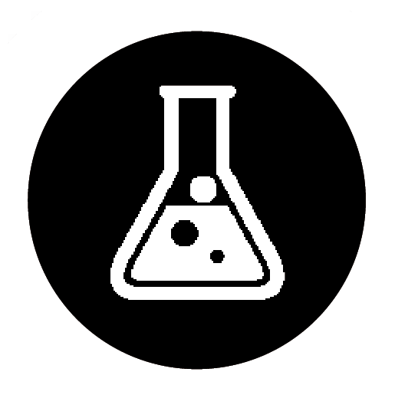 Comparing the reactions of alcohols
Specification references
- C7.2.3 Alcohols
Aims
In this activity you will look at three important reactions of alcohols: combustion, reaction with sodium, and reaction with an oxidising agent. You will record your observations and analyse the results. You will also link your new knowledge to topics you have met earlier.
Learning outcomes
After completing this activity, you should be able to:
- describe the reactions of alcohols, including using word equations
- explain the relationship between ethanol and ethanoic acid
- explain why solutions of ethanol have a pH of 7
- describe complete combustion reactions of a range of alcohols using balanced symbol equations
- outline an investigation to determine the relative energy transferred to the surroundings by the combustion of different alcohols
- describe what is formed in the reaction of alcohols with sodium and when alcohols are oxidised
- describe how ethanol is manufactured
- describe some uses of alcohols.
Task
You will see what happens when alcohols are added to water, and three important reactions of alcohols: combustion, reaction with sodium, and reaction with an oxidising agent.
Draw up a results table and record your observations. Then answer the questions that follow.
Questions
- Addition of water
  - What do your observations tell you about the solubility of alcohols in water?
(1 mark)
  - Why do you think ethanol is a useful solvent?
(1 mark)
  - Suggest why solutions of alcohols are neutral.

(1 mark)
- Combustion
  - All three alcohols burn in air to produce carbon dioxide and water. Write balanced equations for the combustion of each alcohol.

(3 marks)
  - Explain why ethanol is a good fuel.

(1 mark)
- Reaction with sodium
  - All three alcohols produce a gas when they react with sodium. What gas is produced?
(1 mark)
  - As the sodium dissolves in ethanol, sodium ethoxide (CH3CH2ONa) is produced. Predict the name and formula of the compound formed when methanol reacts with sodium.
(2 marks)
  - Write a word equation for the reaction of sodium with methanol.
(1 mark)
- Reaction with an oxidising agent
Potassium dichromate is an oxidising agent.
  - What suggests that a reaction occurred between an alcohol and potassium dichromate?
(1 mark)
  - An alcohol is oxidised to the corresponding carboxylic acid. Give the name and formula of the carboxylic acid formed when each of these reactions take place:
    - Methanol is oxidised.
(1 mark)
    - Ethanol is oxidised
(1 mark)
    - Propanol is oxidised
(1 mark)
  - i Wine contains ethanol. Explain why wine turns sour when left in the air for a few days.

(2 marks)
ii Write a word equation for this reaction.
(1 mark)
  - i Draw the displayed formula of butanol and circle the functional group. (1 mark)

ii Draw the displayed formula of butanoic acid and circle the functional group. (1 mark)

iii What type of reaction occurs when butanol is converted to butanoic acid?
(1 mark)
Student follow-up
- Methanol and ethanol are both used as fuels. You are provided with the following apparatus and two spirit burners, one containing methanol and the other containing ethanol.
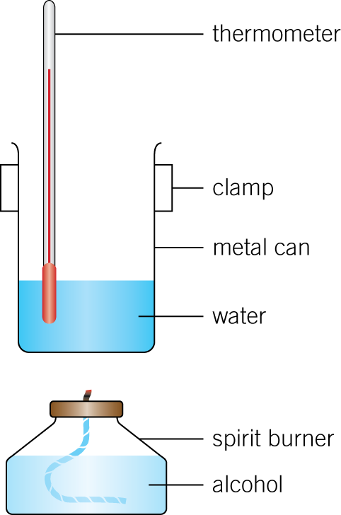
Describe an experiment you could carry out to find out which alcohol releases more energy per gram when it is burnt.

(6 marks)
- Aqueous solutions of ethanol can be made by the fermentation of sugar solutions using yeast.
  - Balance the equation for this reaction:
C6H12O6 → __CO2 + __C2H5OH
(1 mark)
  - Why do you think the optimum temperature for this reaction is 37 °C?
(1 mark)
  - Give two advantages and two disadvantages of using fermentation to produce ethanol.

(4 marks)
  - Give two uses of ethanol.

(2 marks)
- In industry ethanol is produced by the reaction of ethene and steam at 300 °C and 60 atmospheres pressure using a catalyst. The equation for the reaction is:
C2H4(g) + H2O(g) → C2H5OH(g)
a The forward reaction is exothermic. Use Le Châtelier’s Principle to predict the effect of increasing temperature on the amount of ethanol produced at equilibrium. Give a reason for your prediction.

(2 marks) b Explain how increasing the pressure of the reactants will affect the amount of ethanol produced at equilibrium.

(2 marks)

