
 Properties of ethanoic acid
Specification reference
- C7.2.4 Carboxylic acids
Aims
This activity is in two parts. In Part 1, you will carry out reactions that show the acidic nature of carboxylic acids. In Part 2 you will observe the reaction between a carboxylic acid and an alcohol to make an ester.
Learning outcomes
After completing this activity, you should be able to:
- list some chemical properties of carboxylic acids
- describe an ester and state some uses of this class of compounds
- describe why carboxylic acids are acidic
- use word equations to describe the reactions of carboxylic acids with metal carbonates and with alcohols
- describe how to make an ester
- explain, using ionic equations, why carboxylic acids are weak acids 
- predict the products of the reactions of a range of carboxylic acids with metal carbonates and with alcohols.
Part 1 The acidic nature of carboxylic acids
Safety
- 0.1 mol/dm3 ethanoic acid: LOW HAZARD
- Magnesium ribbon: FLAMMABLE
- Wear eye protection.
Equipment
- three test tubes, test-tube rack
- 100 cm3 beaker
- two graphite rods
- two crocodile clips, three wires
- low-voltage power supply
- lamp, ammeter, or multimeter
- spatula
- 1 cm length of magnesium ribbon
- potassium carbonate powder
- universal indicator solution/paper and colour chart
- 0.1 mol/dm3 ethanoic acid solution
Method
- Half fill three test tubes with ethanoic acid solution.
- Add universal indicator to the first, half a spatula of potassium carbonate to the second, and one piece of magnesium ribbon to the third. Record your observations in a table.
- Half fill a beaker with ethanoic acid solution. Submerge the ends of the two graphite rods in the solution. Then using the wires and crocodile clips, make a series circuit with the power supply and the lamp/ammeter/multimeter.
- Ensure that the carbon rods do not touch and turn on the power supply. Observe to see if any current is flowing and record your observations in the table.
Questions
- a i What gas is produced when magnesium reacts with ethanoic acid?
(1 mark)
ii Complete the word equation for the reaction:
ethanoic acid + magnesium → _____________+ _______________ (1 mark)
b i What gas is produced when potassium carbonate reacts with ethanoic acid?
(1 mark)
ii Complete the word equation for the reaction:
ethanoic acid + potassium carbonate → ___________+ _______ + _________ (1 mark)
- What does the conductivity experiment tell you?
(1 mark)
- a Ethanoic acid is described as a weak acid. Explain what this means in terms of ionisation.
(1 mark)
b Complete the following equations, which show what happens when ethanoic acid dissolves in water.

CH3COOH(aq) CH3COO–(aq) + ___________ (1 mark)
ethanoic acid ethanoate ions + ___________ (1 mark)

c Explain why the pH of 0.1 mol/dm3 hydrochloric acid is lower than the pH of 0.1 mol/dm3 ethanoic acid.

(2 marks)
d Explain why 0.1 mol/dm3 hydrochloric acid reacts faster with magnesium than 0.1 mol/dm3 ethanoic acid.

(2 marks)
Part 2 Making esters
You will observe how an ester can be made from a carboxylic acid and an alcohol.
Questions
- What is the role of sulfuric acid in this reaction?
(1 mark)
- Esters have distinctive sweet smells, and are volatile liquids. What does volatile mean?
(1 mark)
- The ester formed from ethanol and ethanoic acid is called ethyl ethanoate.
  - Write a word equation for this reaction.
(1 mark)
  - Below is the displayed formula for ethyl ethanoate.
Circle the functional group. (1 mark)
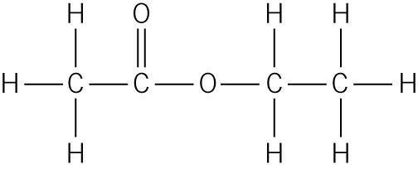

  - Give two uses of ethyl ethanoate.

(2 marks)
- The equation below shows the formation of methyl butanoate, an ester found in pineapples.
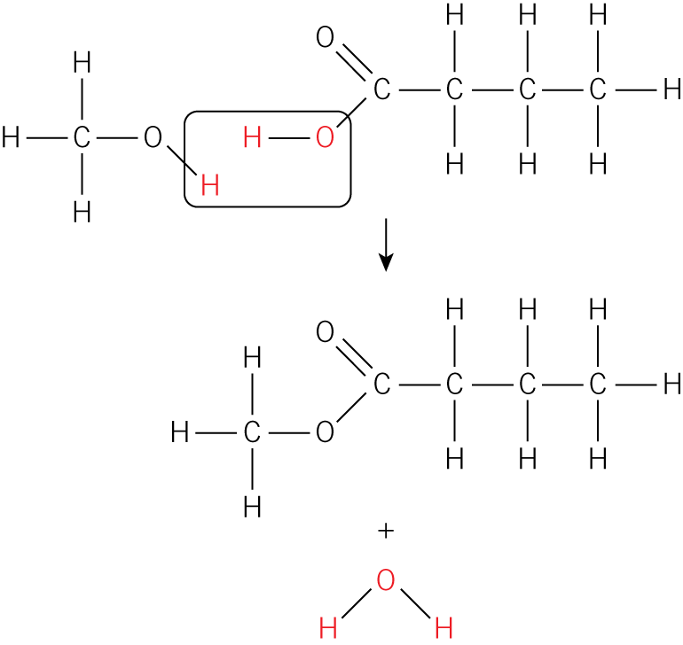
Give the names of the alcohol and carboxylic acid from which it can be made.

(2 marks)
- Esters occur naturally in a number of different fruits. Find out the name of the ester present in the following fruits:
  - Strawberries
(1 mark)
  - Pears
(1 mark)
  - Bananas
(1 mark)

