
 Addition Polymerisation
Specification references
- C7.3.1 Addition polymerisation
- WS 1.2
Aims
This lesson gives students the opportunity to study the chemistry of addition polymerisation.
Learning outcomes
After completing this activity, students should be able to:
- define a monomer and polymer
- state some uses of poly(ethene) and poly(propene)
- write a word equation for the formation of poly(ethene) and poly(propene)
- describe how monomers become polymers
- explain what is meant by addition polymerisation
- draw the monomer for an addition polymer when the structure of the polymer is given
- draw an addition polymer structure when the structure of the monomer is given
- explain why monomers for addition polymers must be unsaturated
- explain the process of addition polymerisation in detail, including using balanced symbol equations and the concept of atom economy
- explain how the repeating unit of a polymer relates to the monomer.
Teacher notes
After a quick recap of reactions of alkenes, the concept of addition polymerisation can be introduced. The use of molecular models is important here.
Students will need a molecular modelling kit to complete the activity task.
Answers
1 a ethene monomers → poly(ethene) (1 marks)
b i 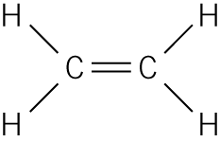

ii 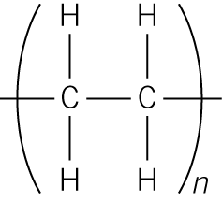 (2 marks)

c 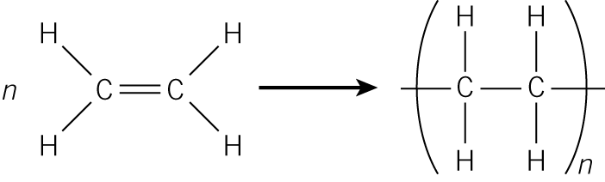 (1 marks)

d Uses of polyethene: carrier bags, drinks bottles, washing-up bowls (2 marks)
e It has an atom economy of 100% because there is only one product.
2 a propene monomers → poly(propene) (1 marks)
b i 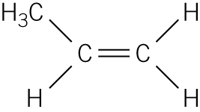

ii 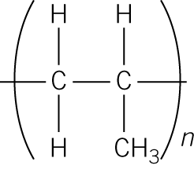

c 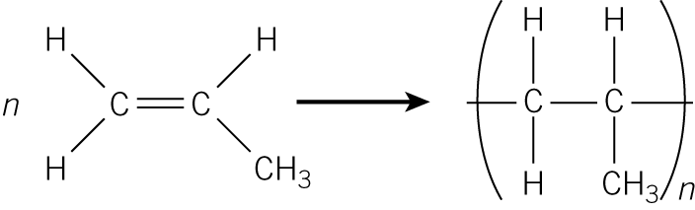 (1 marks)

d Uses of poly(propene): food packaging, furniture, carpets. (2 marks)

3 The reaction between alkene monomers to form a polymer is called ADDITION polymerisation.
In these polymers, the repeating unit has the same atoms as the MONOMER.
The monomer has a DOUBLE bond between the carbon atoms, but the polymer has a SINGLE bond between the carbon atoms. (4 marks)

4
Monomer name | Monomer  structure | Polymer  name | Polymer  structure
Ethene |  | Poly(ethene)
Propene |  | Poly(propene)
Butene | 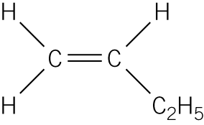 | Poly(butene) | 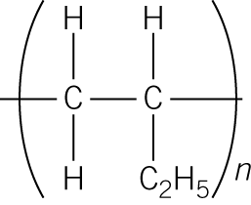
Vinyl chloride (chloroethene) | 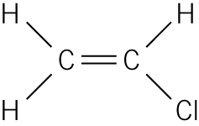 | Poly (vinyl chloride)  PVC | 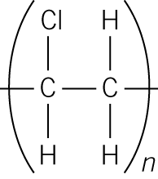
Tetraflouro-ethene | 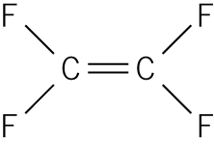 | Poly(tetrafluoro-ethene)  PTFE | 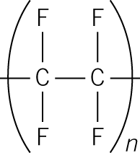
Styrene (phenylethene) | 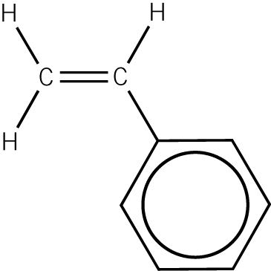 | Poly(styrene) | 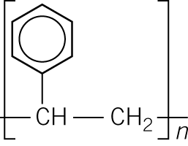
(14 marks)
Equipment
Molymod molecular models

