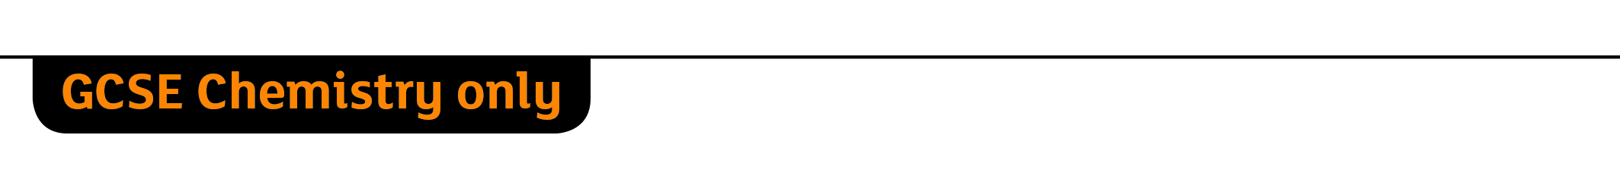
 Addition Polymerisation
Specification references
- C7.3.1 Addition polymerisation
- WS 1.2
Aims
In this activity you will find out what happens during addition polymerisation.
Learning outcomes
After completing this activity, you should be able to:
- define a monomer and polymer
- state some uses of poly(ethene) and poly(propene)
- write a word equation for the formation of poly(ethene) and poly(propene)
- describe how monomers become polymers
- explain what is meant by addition polymerisation
- draw the monomer for an addition polymer when the structure of the polymer is given
- draw an addition polymer structure when the structure of the monomer is given
- explain why monomers for addition polymers must be unsaturated
- explain the process of addition polymerisation in detail, including using balanced symbol equations and the concept of atom economy
- explain how the repeating unit of a polymer relates to the monomer.
Setting the scene
One of the most important ways that chemicals from crude oil are used is to make plastics. The plastics used in everyday life are made up of huge molecules made from lots of small molecules joined together. These small molecules are called monomers. The huge molecules they make are called polymers. By using different monomers, various types of polymers can be manufactured that have very different properties and uses.

Task
The starting monomer for addition polymerisation has a carbon-carbon double bond (C=C). Under high pressure and with a catalyst, one bond from the C=C breaks open and two monomers join together with single bonds. This process is repeated many times, so producing a polymer with single carbon-carbon bonds (C—C).
1 Use the molecular model kit to make a molecule of ethene.
2 Join this to your neighbour’s model, in the same way as would happen in polymerisation, until the whole class has made one long model.
3 Then repeat the process starting with propene.
Questions
1 a Write a word equation for the polymerisation of ethene (1 mark)
b Draw displayed formulae of:
i ethene
ii poly(ethene) (2 marks)
c Write an equation using displayed formulae for the polymerisation of ethene (1 mark)
d Give two uses of poly(ethene) (2 marks)
e Explain why this reaction has an atom economy of 100%. (1 mark)
2 a Write a word equation for the polymerisation of propene (1 mark)
b Draw displayed formulae of:
i propene
ii poly(propene) (2 marks)
c Write an equation using displayed formulae for the polymerisation of propene (1 mark)
d Give two uses of poly(propene). (2 marks)
3 Copy and complete the following sentences:
The reaction between alkene monomers to form a polymer is called _____________ polymerisation.
In these polymers, the repeating unit has the same atoms as the _____________
The monomer has a _____________ bond between the carbon atoms, but the polymer has a _____________ bond between the carbon atoms (4 marks)

4 The following table features some common polymers. Complete the table with the correct names and structures.
Monomer name | Monomer  structure | Polymer  name | Polymer  structure
Ethene
Propene
Butene |  |  | 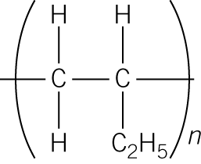
Vinyl chloride (chloroethene) | 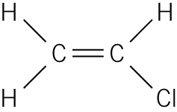
Tetraflouro-ethene |  |  | 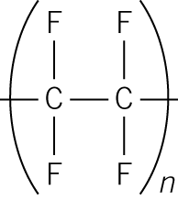
Styrene (phenylethene) | 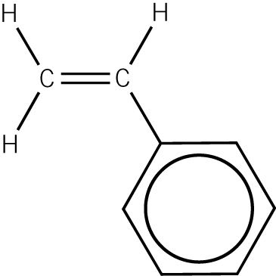
(14 marks)

