 Calculating R_{f} values
Specification references
- C8.1.3 Chromatography
- MS 1a, 1c, 1d, 2a
Aims
In this worksheet you will learn how to interpret chromatograms to decide if an unknown substance is pure or if it contains a mixture of substances. You will also find out how to determine R_{f} values from chromatograms.
Learning outcomes
After completing this worksheet, you should be able to:
- interpret a chromatogram to identify unknown substances
- calculate R_{f} values from given data
- calculate R_{f} values from chromatograms, using an appropriate number of significant figures .
Setting the scene
Chromatography involves a mobile phase and a stationary phase. The mobile phase moves through the stationary phase, carrying the components of the mixture under investigation with it. Each component in the mixture has a different attraction for the mobile phase and for the stationary phase. As a result, different components move different distances in the same time.
Substances on a chromatogram can be identified by calculating their R_{f} value. The R_{f} value or retention factor is a ratio calculated by dividing the distance the spot travels up the stationary phase (measured to the centre of the spot) by the distance the mobile phase, the solvent, travels:
R_{f} = $\frac{\text{distance travelled by component}}{\text{distance travelled by the solvent}}$

Worked examples
- Consider the chromatogram below.
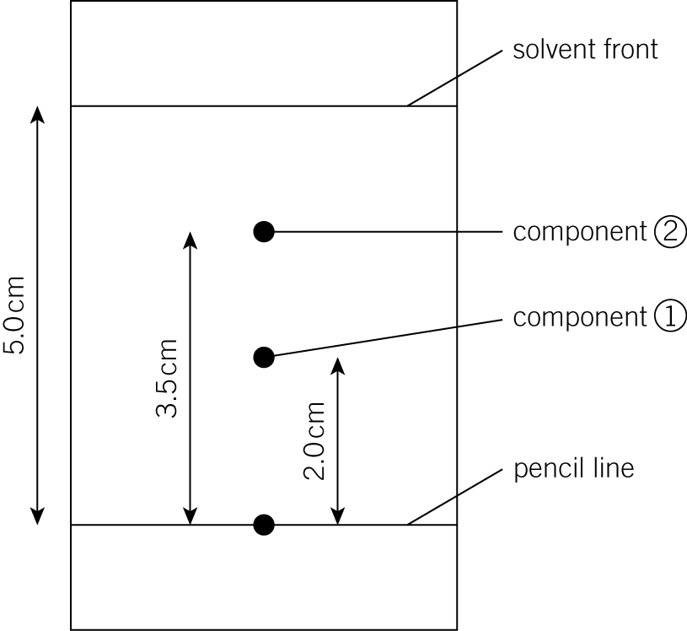

It was produced using a mixture that contained two components.
  - Use the chromatogram to calculate the R_{f} of component 1.
In this case the solvent front has moved 5.0 cm whilst component 1 has moved 2.0 cm
To calculate the R_{f} value use the formula:
R_{f} = $\frac{\text{distance travelled by component 1}}{\text{distance travelled by the solvent}}$
R_{f} = $\frac{2\text{.}\text{0 cm}}{5\text{.}\text{0 cm}}$ = 0.40
  - Use the chromatogram to calculate the R_{f} of component 2.
The solvent front has, once again, moved 5.0 cm whilst component 2 has moved 3.5 cm.
To calculate the R_{f} value use the formula:
R_{f} = $\frac{\text{distance travelled by component 2}}{\text{distance travelled by the solvent}}=\frac{3\text{.}\text{5 cm}}{5\text{.}\text{0 cm}}=0\text{.}\text{70}$

Tip – The R_{f} value does not have any units because it is a ratio.
Questions
You will need a ruler to complete this task.
- A chromatogram was produced from a blue ink and was found to contain just one component. The solvent front moved 10.0 cm whilst the component in question moved 7.0 cm. Calculate the R_{f} value of the component.

(1 mark)
- A chromatogram was produced from an orange food colouring and was found to contain two components. The solvent front moved 100 mm, the first component moved 25 mm, and the second component moved 50 mm. Calculate the R_{f} value of each component.

(2 marks)
- A chromatogram was produced from a purple ink and was found to contain three components. The solvent front moved 8.0 cm, the first component moved 2.0 cm, the second component moved 5.0 cm, and the third component moved 6.0 cm. Calculate the R_{f} value of each component.

(3 marks)
- This chromatogram was produced from a sample of blue ink.
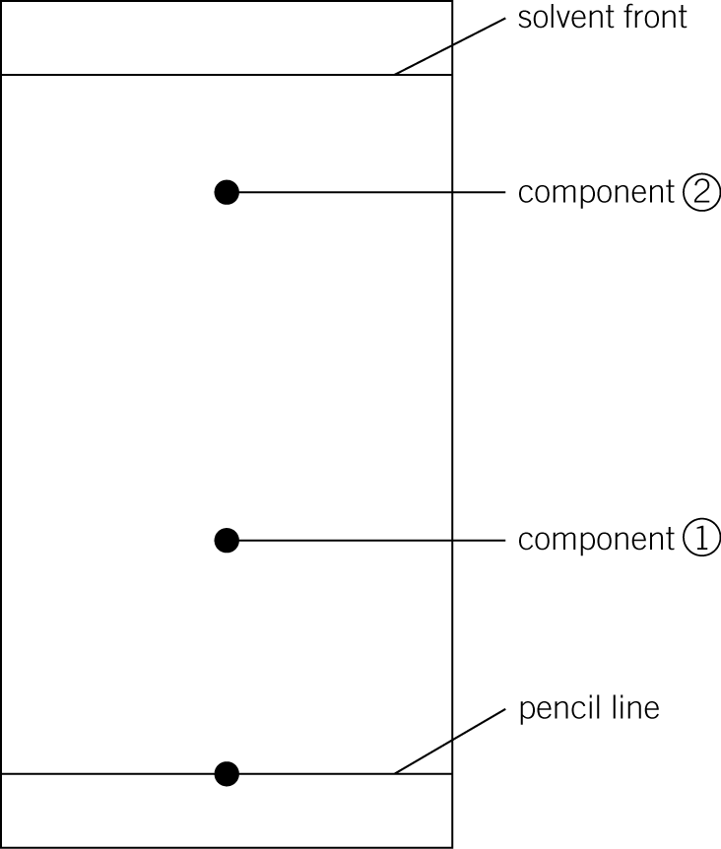
a Complete the table (3 marks)
Distance moved in cm
Solvent front
Component 1
Component 2

b Use the information in the table to calculate the R_{f} values of both components.

(2 marks)
- A student produced this chromatogram from a sample of fountain pen ink.
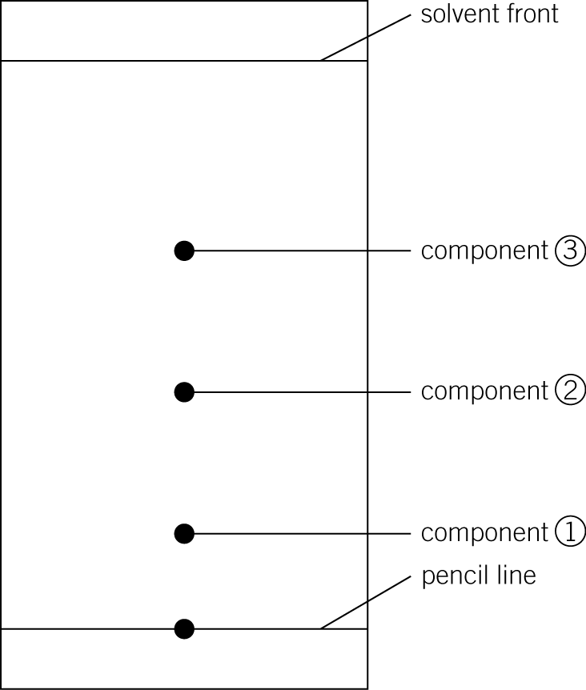
  - Complete the table. (4 marks)
Distance moved in cm
Solvent front
Component 1
Component 2
Component 3
  - Use the information in the table to calculate the R_{f} values of all three components.

(3 marks)
- New research shows that a red food colouring with an R_{f} value of 0.62 (when a particular solvent and temperature are used) could be dangerous to certain people. Samples of food colouring from two different red sweets were collected and the chromatogram below was produced. For each of the sweets, state and explain whether or not you would recommend that the sweets are taken off the market based on this research.
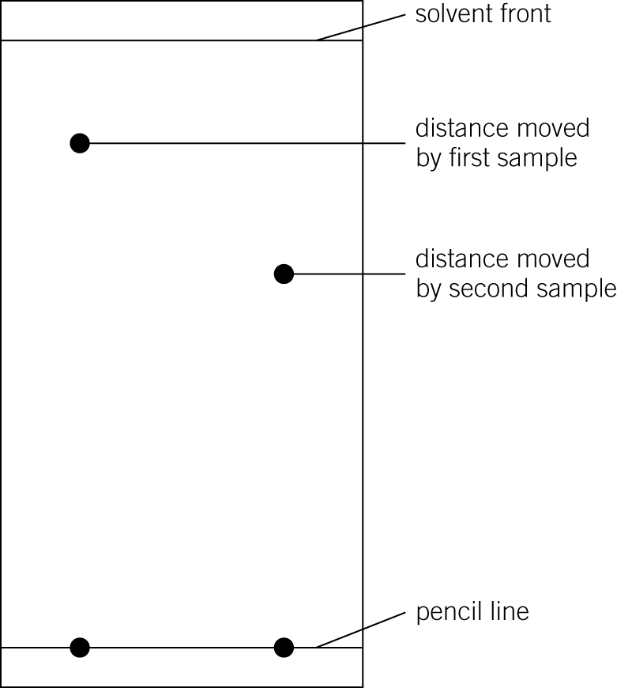

(6 marks)

