Practical skills past paper questions FT
Q1.
A student investigates the effect of concentration on the rate of reaction.
The student reacts sodium thiosulfate solution with dilute hydrochloric acid.
This produces a cloudy mixture.
(a) The cloudiness is produced by the formation of solid sulfur.
How should sulfur be written in the chemical equation for this reaction?
Tick (✔) one box.

S(aq) |  |  | S(g) |  |  | S(l) |  |  | S(s)
(1)
The diagram shows some of the apparatus the student uses.
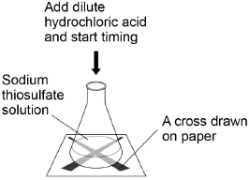
This is the method used.
1. Measure 40 cm ³ sodium thiosulfate solution into a conical flask.
2. Stand the flask on a piece of paper with a cross drawn on it.
3. Add 10 cm ³ of dilute hydrochloric acid to the flask.
4. Time how long it takes the cross to become no longer visible.
5. Repeat steps 1‒4 twice more.
6. Repeat steps 1‒5 with sodium thiosulfate solutions of different concentrations.
(1)
(b) Which apparatus could be used to measure 10 cm³ of dilute hydrochloric acid?
Tick (✔) one box.

Beaker
Boiling tube
Measuring cylinder
Test tube
(1)
(c) Draw one line from each type of variable to the description of the variable.
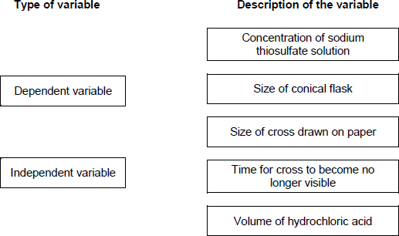
(2)
(d) The student draws a new cross for each experiment.
Suggest why this might give inaccurate results.
___________________________________________________________________
___________________________________________________________________
(1)
(e) The table shows the student’s results for sodium thiosulfate solution with a concentration of 12 g / dm³

Time for cross to become no longer visible in s
Trial 1 | Trial 2 | Trial 3 | Mean
43 | 78 | 41 | X
Calculate value X in the tabble.
Do not use any anomalous results in your calculation.
___________________________________________________________________
___________________________________________________________________
X = ____________________ s
(2)
(f) The graph shows some of the student’s results.
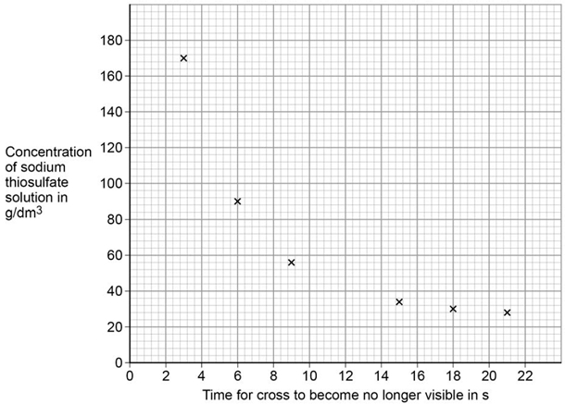
Draw a smooth curve of best fit on the graph above.
(1)
(g) Another student does the same investigation.
Both students have a similar pattern in their results.
Which word describes investigations performed by different students, which give a similar pattern of results?
Tick (✔) one box.

Accurate
Precise
Reproducible
Valid
(1)
(h) The more concentrated the sodium thiosulfate solution, the less time is taken for the cross to become no longer visible.
Give two reasons why.
Tick (✔) two boxes.

Particles are more spread out
Particles collide more frequently
Particles have more energy
Particles move more quickly
There are more particles in a fixed volume
(2)
(Total 11 marks)
Q2.
A student investigated the reactivity of different metals.
The student used the apparatus shown in the figure below.
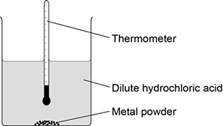
The student used four different metals.
The student measured the temperature rise for each metal three times.
The student’s results are shown in the table below.

Metal | Temperature rise in °C |  |  | Mean  temperature  rise in °C
Metal | Test 1 | Test 2 | Test 3 | Mean  temperature  rise in °C
Calcium | 17.8 | 16.9 | 17.5
Iron | 6.2 | 6.0 | 6.1 | 6.1
Magnesium | 12.5 | 4.2 | 12.3 | 12.4
Zinc | 7.8 | 8.0 | 7.6 | 7.8
(a) Give two variables the student should control so that the investigation is a fair test.
1. _________________________________________________________________
___________________________________________________________________
2. _________________________________________________________________
___________________________________________________________________
(2)
(b) One of the results for magnesium is anomalous.
Which result is anomalous?
Suggest one reason why this anomalous result was obtained.
Result _____________________________________________________________
___________________________________________________________________
Reason ____________________________________________________________
___________________________________________________________________
(2)
(c) Calculate the mean temperature rise for calcium.
___________________________________________________________________
Mean temperature rise = _______________ °C
(1)
(d) The temperature rose when the metals were added to sulfuric acid.
Give one other observation that might be made when the metal was added to sulfuric acid.
How would this observation be different for the different metals?
___________________________________________________________________
___________________________________________________________________
___________________________________________________________________
___________________________________________________________________
(2)
(e) Aluminium is more reactive than iron and zinc but less reactive than calcium and magnesium.
Predict the temperature rise when aluminium is reacted with dilute hydrochloric acid.
___________________________________________________________________
Temperature rise = _______________ °C
(1)
(Total 8 marks)
Q3.
When sodium thiosulfate solution reacts with dilute hydrochloric acid, the solution becomes cloudy.
The equation for the reaction is:
Na₂S₂O₃(aq) + 2 HCl(aq) ⟶ 2 NaCl(aq) + SO₂(g) + H₂O(l) + S(s)
(a) Why does the solution become cloudy?
___________________________________________________________________
___________________________________________________________________
___________________________________________________________________
___________________________________________________________________
(2)
Some students used this reaction to investigate the effect of concentration on rate of reaction.
The diagram shows the apparatus used.
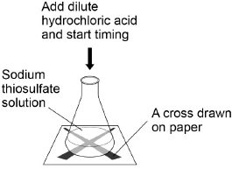
This is the method used.
1. Measure 25 cm³ sodium thiosulfate solution into a conical flask.
2. Stand the conical flask on a cross drawn on paper.
3. Add 10 cm³ of dilute hydrochloric acid.
4. Time how long it takes the cross to become no longer visible.
5. Repeat steps 1–4 with sodium thiosulfate solutions of different concentrations.
(b) The students used a measuring cylinder to measure 25 cm³ of sodium thiosulfate solution.
Suggest a more accurate way of measuring 25 cm³ of sodium thiosulfate solution.
___________________________________________________________________
___________________________________________________________________
(1)
(c) Name one control variable the students should use in this investigation.
___________________________________________________________________
(1)
The table shows the students’ results.

Concentration of sodium thiosulfate solution in mol / dm³ | Time for cross to become no longer visible in s
0.020 | 170
0.040 | 90
0.060 | 82
0.080 | 42
0.100 | 34
0.120 | 30
0.140 | 28
(d) Plot the data from the table above on the graph below.
Draw a line of best fit.
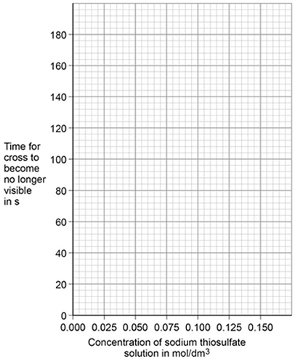
(3)
The students repeated the investigation two more times.
They obtained similar results each time.
(e) What word describes an investigation by the same students which gives similar results each time?
___________________________________________________________________
(1)
(f) Describe how the students can use their results to improve the accuracy of the investigation.
___________________________________________________________________
___________________________________________________________________
___________________________________________________________________
___________________________________________________________________
(2)
(g) The students analysed their results to give a conclusion and an explanation for their investigation.
Conclusion: ‘The higher the concentration, the lower the rate of reaction.’
Explanation: ‘At higher concentrations, the particles have more energy, so they are moving faster. Therefore the collisions are more energetic.’
The students are not correct.
Give a correct conclusion and explanation for the results of the investigation.
Conclusion _________________________________________________________
___________________________________________________________________
___________________________________________________________________
Explanation _________________________________________________________
___________________________________________________________________
___________________________________________________________________
___________________________________________________________________
___________________________________________________________________
(3)
(h) A solution containing 0.18 g of sodium thiosulfate reacts with dilute hydrochloric acid in 2 minutes.
Calculate the mean rate of reaction in g / s.
Give your answer in standard form.
___________________________________________________________________
___________________________________________________________________
___________________________________________________________________
___________________________________________________________________
Mean rate of reaction = ____________________ g / s
(3)
(Total 16 marks)
Q4.
A student makes a hypothesis:
‘When different salt solutions are electrolysed with inert electrodes, the product at the negative electrode is always a metal’.
(a) Describe how you would test this hypothesis in the laboratory.
You should:
• draw a labelled diagram of the apparatus
• give the independent variable
• describe what you would see at the negative electrode if the hypothesis is true.
Diagram

Independent variable _________________________________________________
___________________________________________________________________
Observation _________________________________________________________
___________________________________________________________________
(5)
(b) The student’s hypothesis is only partially correct.
Explain why the product at the negative electrode is not always a metal.
___________________________________________________________________
___________________________________________________________________
___________________________________________________________________
___________________________________________________________________
(2)
(c) Predict the product at the positive electrode in the electrolysis of:
• sodium chloride solution
• copper sulfate solution.
Sodium chloride solution _______________________________________________
Copper sulfate solution ________________________________________________
(2)
(Total 9 marks)
Mark schemes
Q1.
(a) S(s)
1
(b) measuring cylinder
1
(c) 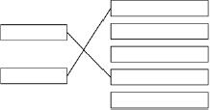
1
allow for 1 mark an answer of dependent variable --- concentration of sodium thiosulfate solution and independent variable --- time for cross to become no longer visible
1
(d) cross might be darker or paler
allow cross may not be the same size / shape
1
(e) 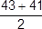
an answer of 42 (s) scores 2 marks
1
= 42 (s)
an answer of 54 (s) scores 1 mark
1
(f) smooth curve through all points
must touch all crosses
do not allow straight lines between points
ignore attempt to plot X
1
(g) reproducible
1
(h) particles collide more frequently
1
there are more particles in a fixed volume
1
[11]
Q2.
(a) any two from:
• concentration / volume of dilute hydrochloric acid
• mass of metal powder
• surface area of metal powder
• stirring (of any) / rate of stirring
allow reacted for the same length of time
2
(b) 4.2 °C
allow Magnesium Test 2
1
and any one from:
• lower mass of magnesium added
• surface area of magnesium too low
• magnesium coated in magnesium oxide (so took a while to start reacting)
• not stirred
• not stirred as quickly as the other metals
• not reacted for as long a time as the other metals
allow reason for break in circuit
1
(c) 17.4(°C)
1
(d) bubbles of gas
1
more (bubbles) seen with calcium than other metals
allow any correct comparison between two metals
1
(e) any value between 7.9 °C and 12.3 °C
1
[8]
Q3.
(a) sulfur
1
precipitate
allow solid
1
(b) any one from:
• (volumetric) pipette
• burette
1
(c) any one from:
• concentration of hydrochloric acid
• volume of hydrochloric acid
• volume of sodium thiosulfate solution
• temperature (of solution)
• darkness of cross
allow same cross
• same stirring / swirling
1
(d) 7 points plotted correctly
allow tolerance of ± half a small square
allow 5 or 6 points plotted correctly for 1 mark
2
line of best fit
must avoid anomalous point
1
(e) repeatable
do not accept reproducible
1
(f) discard any anomalous results
1
calculate a mean
1
(g) conclusion:
the higher the concentration, the higher the rate of reaction
1
explanation:
(at higher concentrations) there are more particles in a fixed volume
1
(therefore the) collisions are more frequent
1
allow converse
(h) 120 (s)
1
0.18 / 120
allow 0.0015
1
= 1.5 × 10⁻³ (g / s)
an answer of 9 × 10⁻² scores 2 marks
allow an answer of 0.09 for 1 mark
1
an answer of 1.5 × 10⁻³ (g / s) scores 3 marks
[16]
Q4.
(a) (diagram)
complete circuit with power supply
1
test solution in beaker or other appropriate apparatus
1
electrodes
allow carbon, platinum or inert electrodes
1
(independent variable)
salt solutions (with different metal ions)
1
(observation)
solid / metal deposit on the negative electrode
1
(b) (sometimes) hydrogen is produced
1
(because) the metal is more reactive than hydrogen
1
(c) chlorine
1
oxygen
1
[9]

