The Heart
Like all mammals, humans’ hearts have ……………… chambers:
- two ……………… -walled ……………… (sing.atrium) on top

- two ……………… -walled ……………… underneath

The atria receive blood from the ……………… circulation
this is mostly …………………… with the exception of the …………..…… vein which carries …………………… blood from the …………..…… to the ……… atrium

The ventricles pump blood into the …………..…… circulation.

this is mostly …………………… blood with the exception of the ……………… artery which carries …………………… blood from the …………… ventricle to the …………
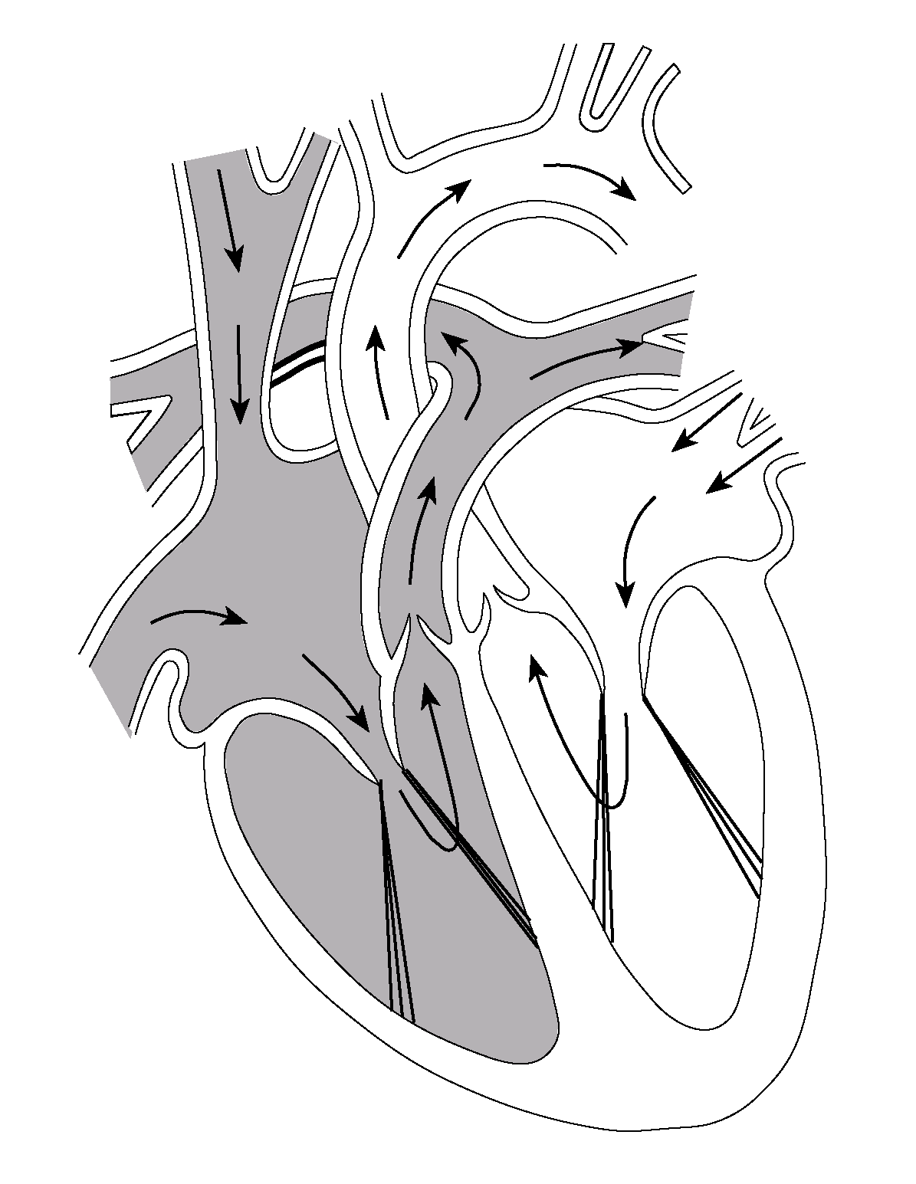

The valves between the atria and ventricles are the ………………………… valves
the atrioventricular valve on the right side has …………….. flaps and is sometimes referred to as the tricuspid valve

the valve on the left has ………… flaps and is therefore referred to as the bicuspid valve (or even the mitral valve)

To prevent the valves inverting …………….. ………….. (‘heart strings’) hold them in place

As the aorta and pulmonary artery leave the heart there needs to be another set of valves

These are the ………-…………….. valves and are the only valves found in arteries anywhere in the body

The ventricles are separated by the ………-…………….. …………
often abbreviated to just ………… when it is clearly referring to the heart

The walls of the heart are composed of muscle tissue

The heart is composed of ………………… muscle

Since they are constantly active the cells have a huge requirement for ……………… and ……….……

The heart possesses its own circulation called the ………………… system
This necessary to supply blood directly to the ………………… …………………
The blood supplies ………………… and ………………… and removes …………………

If these become ………………… the cardiac muscle can no longer ………………… as efficiently e.g. by plaques of …………………

The muscle of the ……. ventricle is approx ……….. times …………… than that on the right

This allows the ……. ventricle to impart a greater ………………... pressure than the …….
NB not to withstand greater pressure.

This is because:

the blood of the pulmonary circulation does not need to travel as …………. so has less …………… resistance to overcome.

if the hydrostatic pressure was too …………… in the pulmonary capillaries too much …………… would seep into the lungs’ alveoli

