Translocation

Translocation is the movement of solutes (dissolved substances) in the phloem as sap
- the solute is mainly sucrose

Translocation can occur either up or down the stem
- from a source e.g. a leaf
- to a sink e.g. the root cortex/fruit/flowers

Different tissues can be sources or sinks at different times

e.g. when a plant is photosynthesising the leaves are sources and the roots are a sink

however in the spring many plants use reserves stored in the roots to grow leaves. In this case the roots are a source and the developing leaves are a sink

Key Features of Phloem
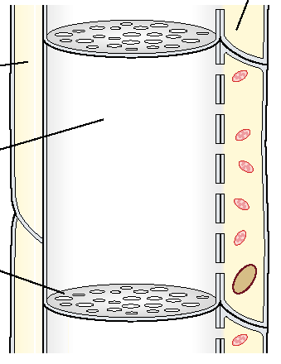
The phloem is actually composed of two different types of cell:
- sieve tube elements
- companion cells

Sieve tube elements are living
They have strands of cytoplasm (but lack nuclei)

Sieve tube element cell walls are not lignified
They remain permeable to water and solutes

They are separated by sieve plates which have holes in

Companion cells are associated with sieve tube elements and possess many mitochondria

Movement around the phloem:

The exact mechanism of translocation is not yet clearly understood but it is certainly too rapid to rely on simple diffusion alone.

Evidence includes:
Ringing trees in summer causes swellings above the ring and reduced growth below it

No swellings occur if this is done in winter

Chen’s work showed most substances were transported down the phloem
He separated the xylem and phloem with pieces of waxed paper them
- this prevented movement of water between them
- this also prevented the movement of any dissolved substances

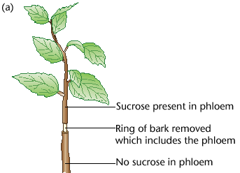
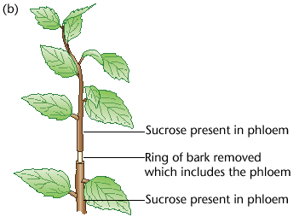

Additional evidence is provided by ringing If the leaves are left intact below the ringing
shoots and removing leaves then sucrose is found in the lower phloem

If the leaves below the missing phloem are
removed no sucrose is found lower down

Sucrose is found above the ringing

Stylet experiments can be used to sample the extremely thin phloem

Aphids fee by inserting their hypodermic syringe-like mouth-parts into the phloem

Since the contents of the phloem are under pressure they are forced out and can be sampled

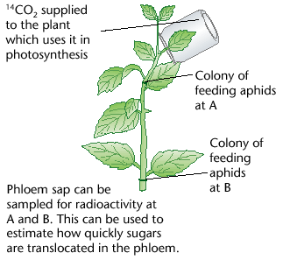

By using aphid stylets the movement of
solutes around the phloem can be investigated

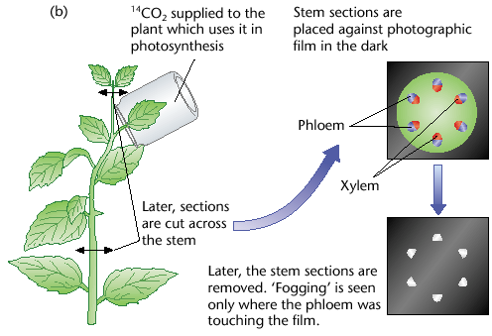

A more aphid friendly alternative is to use
autoradiographs taken of the ends of the stems

The Mass Flow Hypothesis
This seeks to explain how solutes are moved around the plant

Relies on evaporation (energy from the Sun)
and active transport (energy from ATP but also the result of
solar energy via photosynthesis)

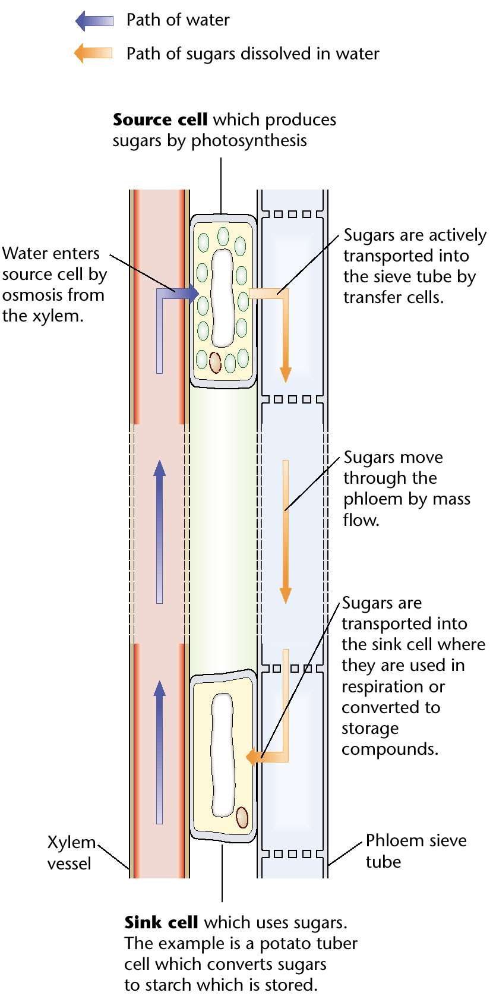

At Source:
1. Companion cells actively pump sucrose into
the sieve tubes

2. This causes the water potential in the phloem
to decrease

3. Therefore water diffuses in from the nearby
xylem by osmosis

4. The influx of water increases the hydrostatic
pressure in the phloem

5. The hydrostatic pressure forces the sap
downwards (this is mass flow)

At Sink:
6. Sucrose is actively pumped out of the phloem

7. This causes the water potential in the phloem
to increase

8. At the same time ions are being actively pumped into the xylem of the root

9. Therefore the xylem has a much lower water potential than the phloem

10. Water diffuses by osmosis from the phloem into the xylem

11. This creates hydrostatic pressure which pushes water and ions up the xylem
Aided by evaporation from the leaves (also mass flow)

12. This replaces the water moving out of the xylem at the source

Munch’s Experiment
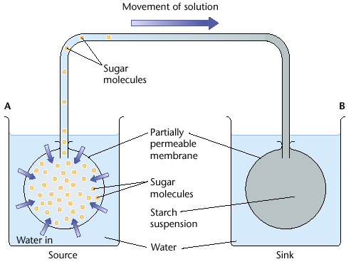

Two beakers containing water represent the source and sink

Partially permeable membranes are placed in both
at the source (e.g. leaf cell) it holds sucrose solution
at the sink (e.g. root cell) it holds starch

At the source the low water potential causes water to diffuse in by osmosis

The increase in the content’s volume forces the contents along the top tube (the phloem) by mass flow

This forces the contents into the ‘sink cell’

The increased volume increases the pressure within the membrane

Thus water is forced out and into the surroundings

If the two beakers were joined by another tube (the xylem)
water would flow between them from sink to source

Inconsistencies

This hypothesis can explain the speed of translocation but it has several flaws:
it can not explain how different solutes can move at different speeds or even in different directions in the phloem at the same time
it does not explain why sucrose does not only flow to the greatest sink
it does not explain the presence of sieve plates, they seem to be barriers

Cytoplasmic streaming must play an important. This is the movement of molecules (by active transport) and small organelles around and between cells on the cytoskeleton

