Stomata

The tiny pores on leaves are called stomata (sing. stoma).

They are necessary to allow gaseous exchange of carbon dioxide into the leaf for photosynthesis.

However, by doing so, they also let water molecules escape. The water potential of the surrounding air is almost always lower than that of the leaf cells.

If the plant cannot replace this water then it begins to suffer water stress and can wilt (lose turgor pressure in its cells).

Each stoma is surrounded by two guard cells; these allow the stoma to open and close.

The guard cells have thickened inner walls, as they take in water they become turgid but cannot expand sideways because of the thicker inner walls.

Any change is in the thinner, outer walls – this causes the guard cells to separate, forming the stoma.

Factors that affect transpiration are:

Temperature:
As temperature increases so does the kinetic energy of water molecules.
They are more likely to evaporate from the stomata.

Also, increasing temperature increases the capacity of the atmosphere to hold water vapour.

Humidity:
Describes the concentration of water vapour in the atmosphere (linked to its water potential).
As humidity increases so does the water potential of the air.
This reduces the water potential gradient between the sub-stomatal air space and the air and so slows transpiration.

Air movements:
If the air is still then a layer of saturated air builds up around the stomata.

If this ‘diffusion shell’ is disrupted by air movements the water potential gradient between the sub-stomatal air space and the atmosphere is maintained as drier air replaces it.

Thus the windier it is the faster transpiration happens.

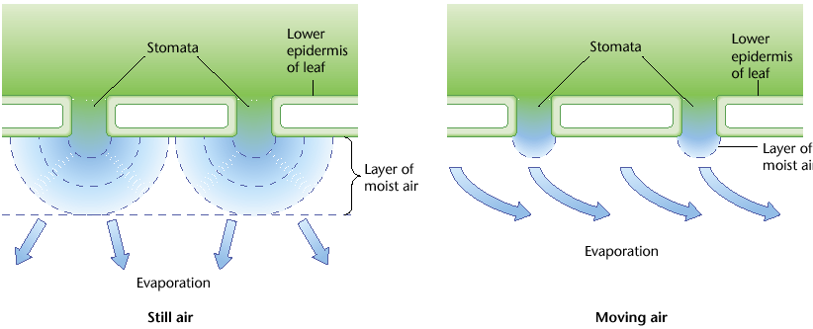
Although very high winds can cause the stomata to close and transpiration to slow.

Light Intensity:
Linked to photosynthesis and the plant’s need for CO₂ rather than physical factors.

As light intensity increases so does transpiration as the stomata need to open wider and wider to take up CO₂ they need to make use of the light energy by fixing it into glucose.

Once the stomata are fully opened increasing the light intensity will not cause further increases in the transpiration rate.
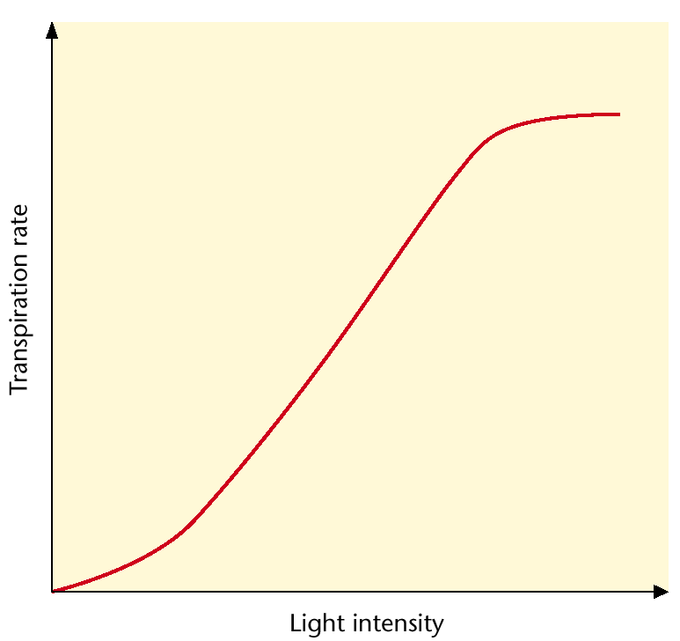

Water Stress:
Regardless of other environmental conditions if the plant begins to suffer water stress (i.e. if water loss exceeds water uptake) the stomata will close and transpiration slow in order to conserve water.

Potometers

The rate of water uptake by a stem can be measured by a potometer, this can be used to indicate the rate of transpiration (although it does not measure transpiration directly).

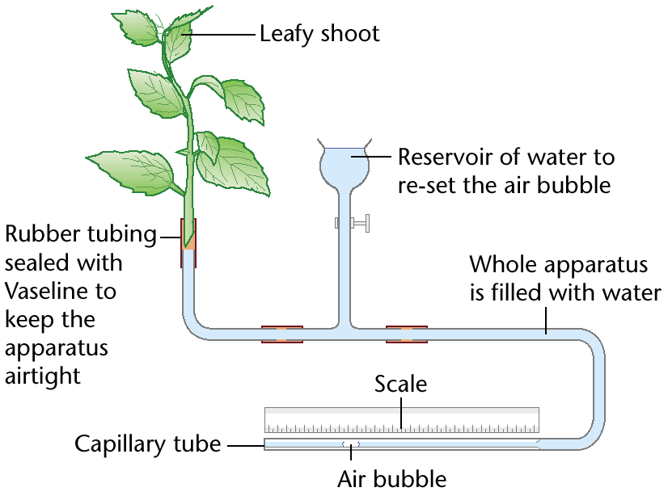

Rate of uptake (mm³s⁻¹) = distance moved by bubble (mm) x cross-sectional area (mm²)
Time (s)

The shoot must be cut under water to avoid disrupting the water column.

The capillary tube’s small diameter allows even small volume change to move the marker bubble a measurable distance.

The diameter must be known to calculate the cross-sectional area (using π x r²).

