Stomata

The tiny pores on leaves are called stomata (sing. ________ )

They are necessary to allow gaseous exchange of carbon dioxide into the leaf for photosynthesis.

However, by doing so, they also let water molecules escape. The water potential of the surrounding air is almost always lower than that of the leaf cells.

If the plant cannot replace this water then it begins to suffer water stress and can wilt (lose turgor pressure in its cells).

Each stoma is surrounded by two ________ ________ ; these allow the stoma to open and close.

The guard cells have thickened inner walls, as they take in water they become turgid but cannot expand sideways because of the thicker inner walls.

Any change is in the thinner, ________ walls – this causes the guard cells to ________ , forming the stoma.

Factors that affect transpiration are:

Temperature:
As temperature increases so does the ________ energy of water molecules.
They are ________ likely to evaporate from the stomata and transpiration ________ .

Also, increasing temperature increases the capacity of the atmosphere to ________ water vapour.

Humidity:
Describes the ___________ of water vapour in the atmosphere (linked to its water potential).
As humidity increases so does the ________ ________ of the air.
This reduces the water potential ________ between the sub-stomatal air space and the air and so ________ transpiration.

Air movements:
If the air is still then a layer of ________ ________ builds up around the stomata.

If this ‘diffusion shell’ is disrupted by air movements the water potential gradient between the sub-stomatal air space and the atmosphere is ________ as drier air ________ it.

Thus the it is the transpiration happens

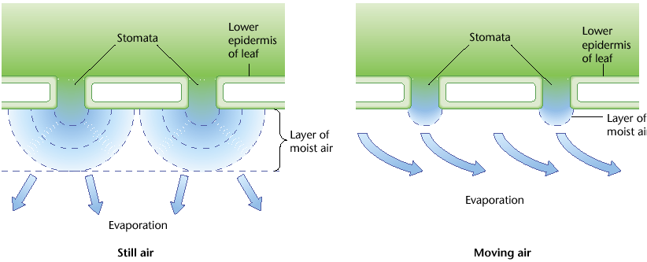

Although very high winds can cause the stomata to ________ and transpiration to ________ .

Light Intensity:
Linked to photosynthesis and the plant’s need for CO₂ rather than physical factors.

As light intensity increases so does transpiration as the stomata need to open ________ and ________ to take up the extra CO₂ they need to make use of the light energy by fixing it into glucose.

Once the stomata are ________ opened increasing the light intensity will not cause further increases in the transpiration rate.

Water Stress:
Regardless of other environmental conditions if the plant begins to suffer ________ ________ (i.e. if water loss exceeds water uptake) the stomata will ________ and transpiration ________ in order to ________ water

Potometers

The rate of water uptake by a stem can be measured by a ________________ , this can be used to indicate the rate of transpiration (although it does not measure transpiration directly).

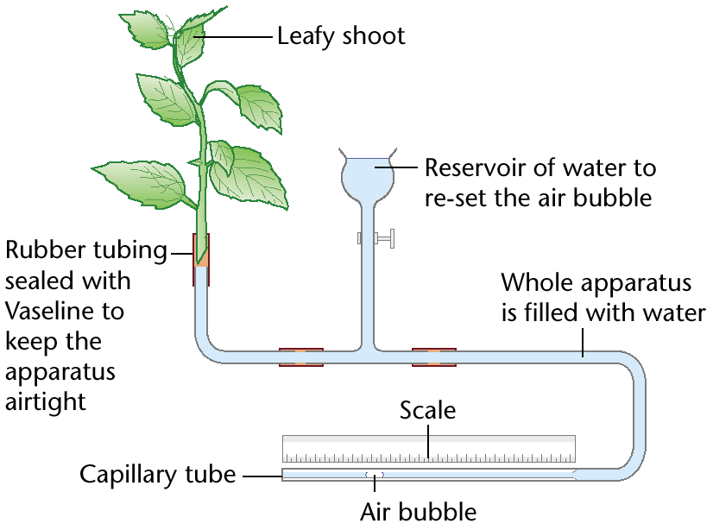

Rate of uptake (________ ) = ( ) x ( )

_______________ ( )

The shoot must be cut ________ ________ to avoid disrupting the water column.

The capillary tube’s ________ ________ allows even small volume change to move the marker bubble a measurable distance.

The diameter must be known to calculate the cross-sectional area (using π x r²).

