The Cardiac Cycle

The heart is constantly either filling with blood or pumping it out.

The sequence of events is known as the cardiac cycle.

The pressure changes which bring about each event in the cardiac cycle can be shown on a graph
- this is for the left side of the heart and aorta.

The pattern is the same for the right side of the heart and the pulmonary artery, although the values are typically lower.

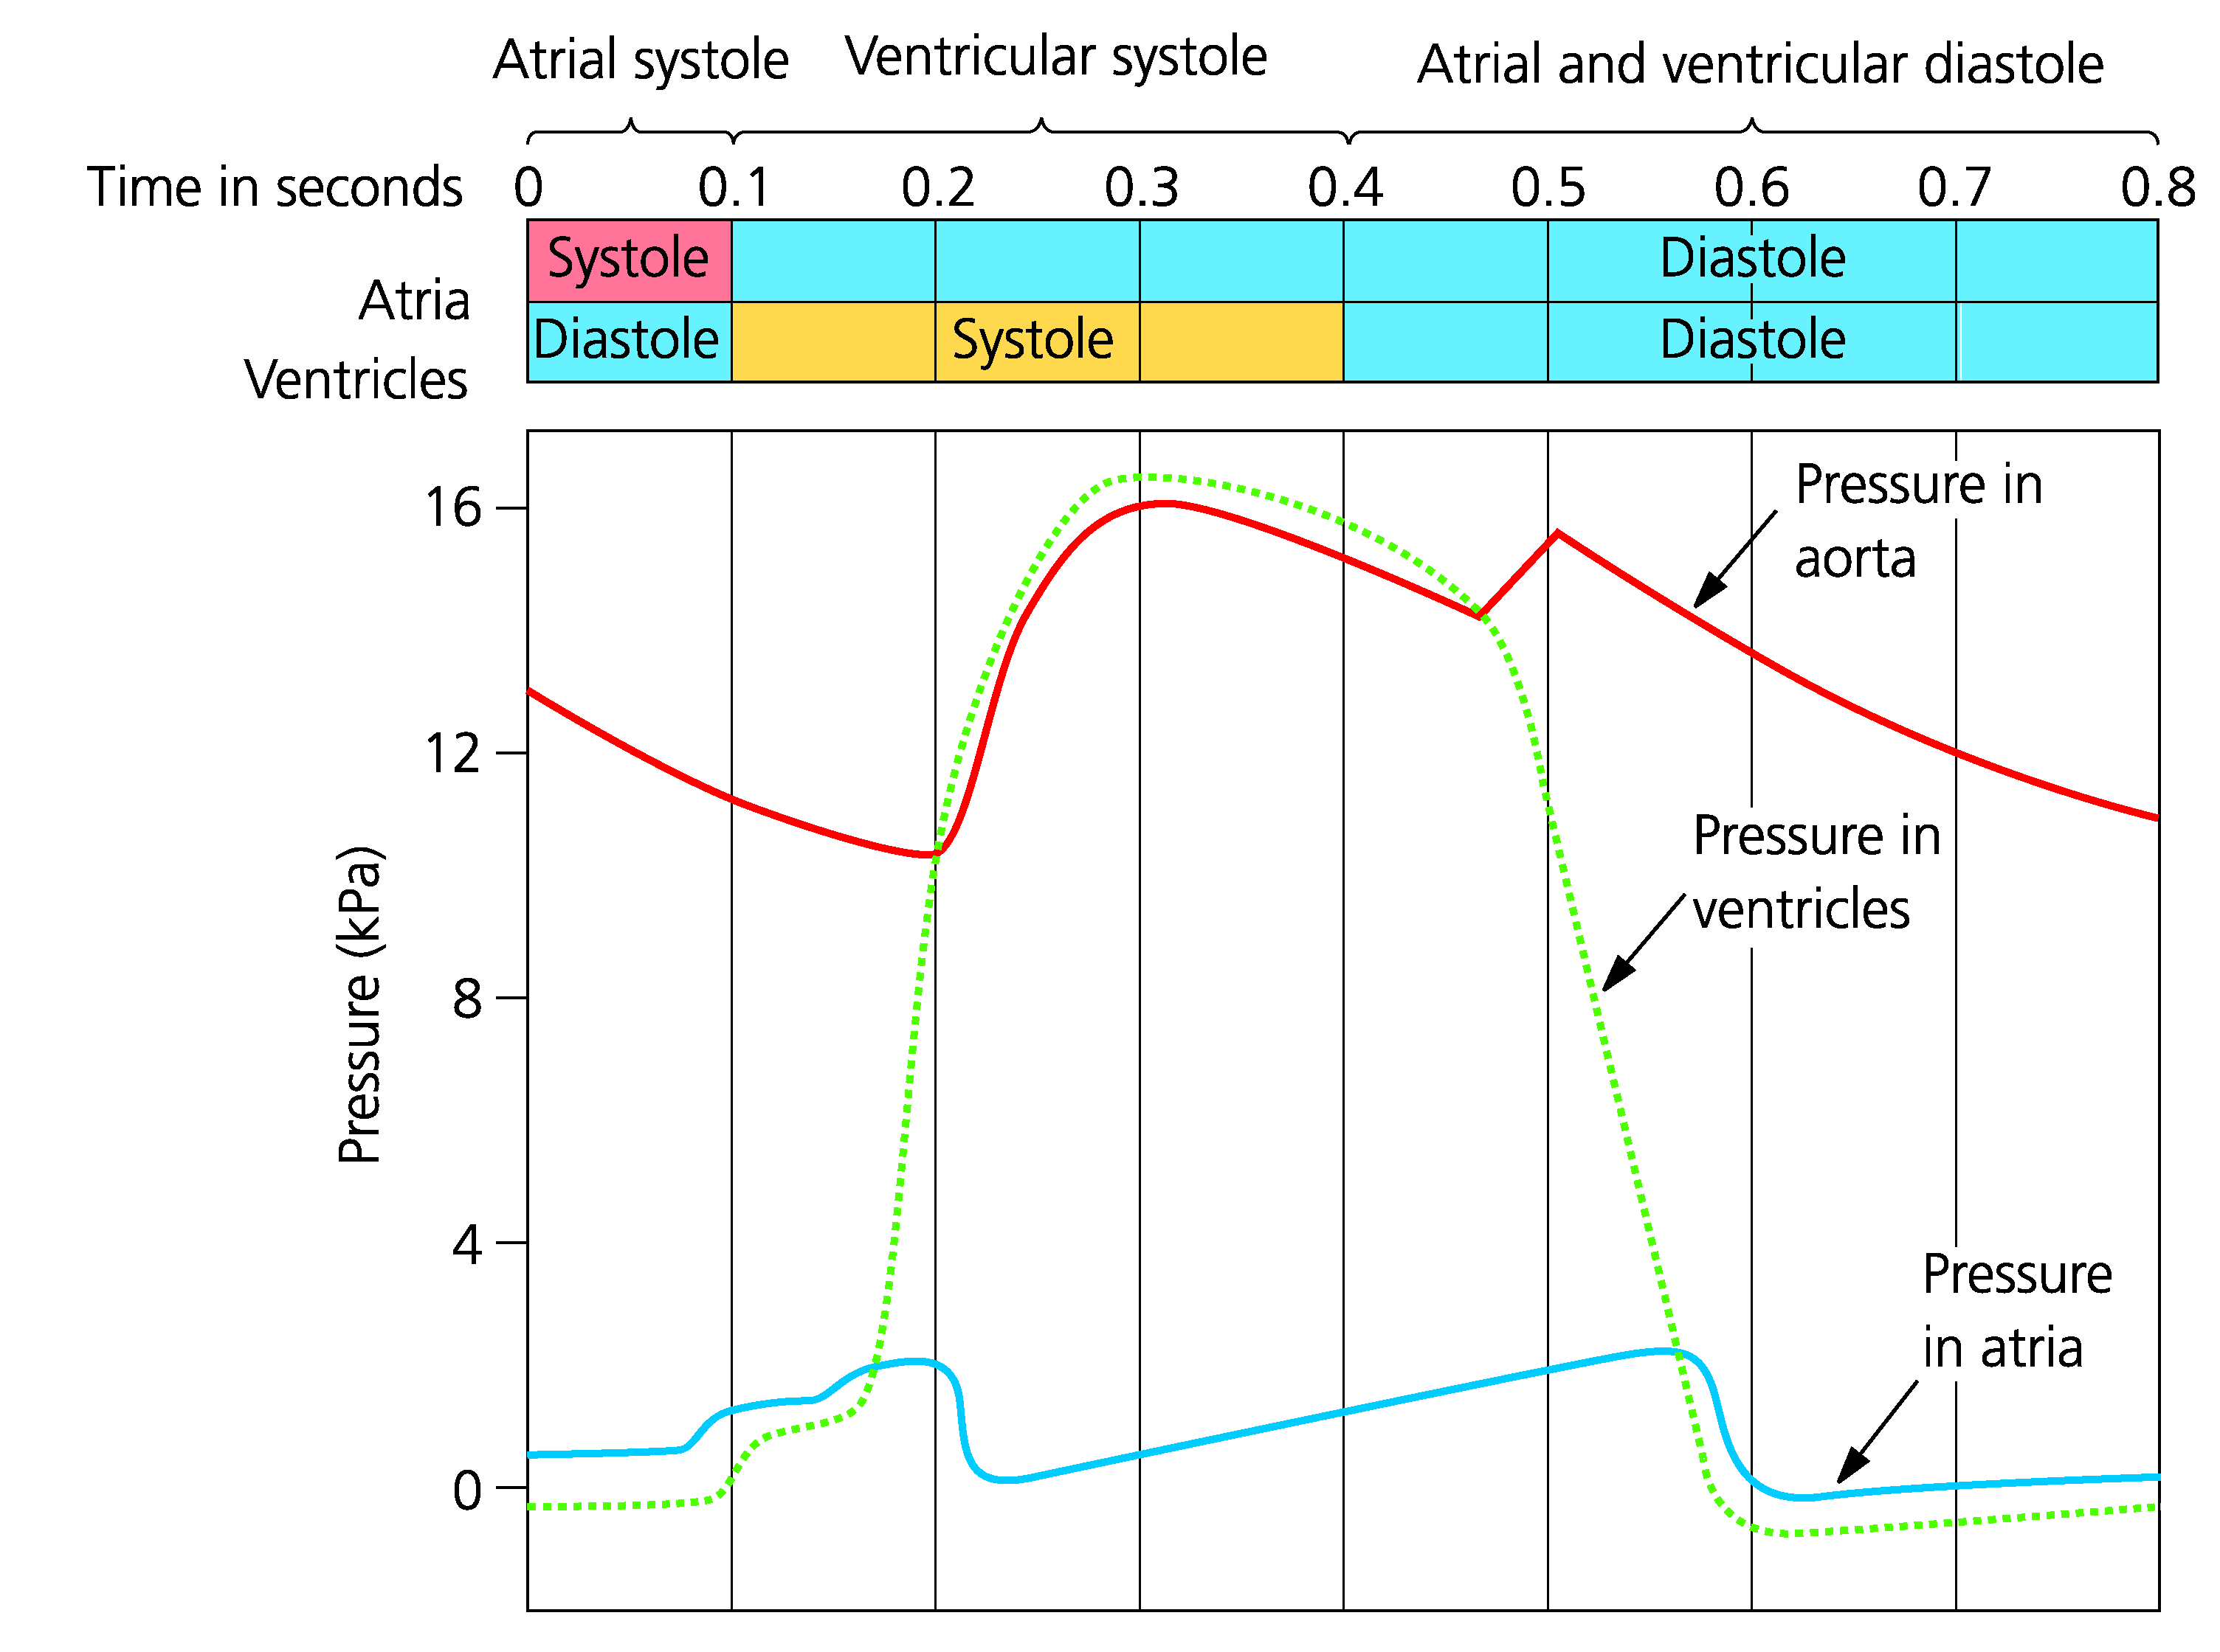

Each stage of the cardiac cycle can be explained using this graph.

Atrial Systole

the atria contract, as their internal volume decreases the hydrostatic pressure increases.

this forces blood to move into the ventricle (the atrioventricular valves are open).

Ventricular Systole

The atrioventricular valve closes when the pressure in the ventricles exceeds that of the atrium (‘lub’ sound of heart beat).

Contraction of the ventricle increases hydrostatic pressure until it is greater than that of the artery this forces the semi-lunar valves to open and blood flows into the artery.

Meanwhile the atrium is filling from the venous circulation so its pressure increases.

Diastole

Both chambers relax and fill with blood.

The ventricular pressure drops below that of the artery and the semi-lunar valves are pushed closed.

This makes a ‘dup’ noise, the second sound of the heartbeat.

The pressure rises slightly in the artery due to elastic recoil.

The atrium fills with blood increasing its pressure as ventricular pressure drops the atrial pressure exceeds that of the ventricle.

The atrioventricular valve opens and blood flows from the atrium into the ventricle.

NB All of the valves are passive, they are opened or closed by the relative pressure of the blood on either side.

Being a fluid blood will always flow from a region of higher hydrostatic pressure to lower, if it can.

