The Cardiac Cycle

The heart is constantly either filling with blood or pumping it out.

The sequence of events is known as the ………………. ………………..

The ………………. changes which bring about each event in the cardiac cycle can be shown on a graph
- this is for the left side of the heart and aorta.

The pattern is the same for the …………. side of the heart and the pulmonary artery, although the values are typically ………………. .

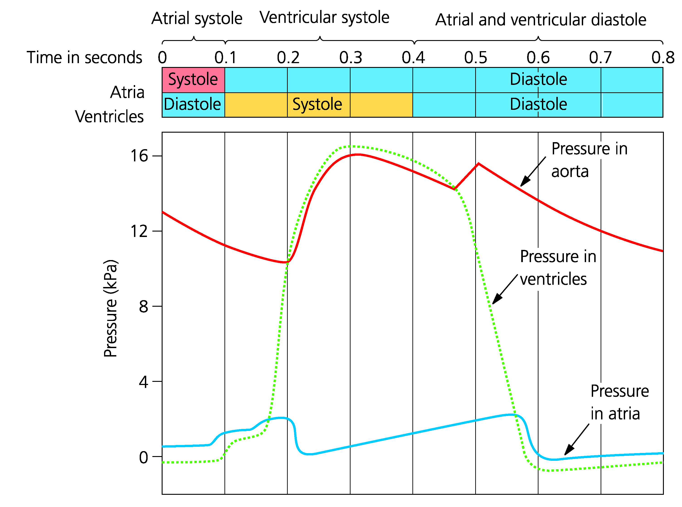

Each stage of the cardiac cycle can be explained using this graph.

Atrial Systole (sis-toe-lee)

the atria ………………., as their internal volume ………………. the hydrostatic pressure ………………. .

this forces blood to move into the ………………. (the atrioventricular valves are …………).

Ventricular Systole

The ………… - ………………………… valve ………………. when the pressure in the ventricles exceeds that of the atrium (‘lub’ sound of heart beat).

Contraction of the ventricle increases hydrostatic pressure until it is greater than that of the artery this forces the ………… - ………… valves to …………. and blood flows into the artery.

Meanwhile the atrium is filling from the venous circulation so its pressure increases.

Diastole (die-as-toe-lee)

Both chambers …………………. and fill with blood.

The ventricular …………………. drops below that of the artery and the ………… - ………… valves are pushed ………… .

This makes a ‘dup’ noise, the second sound of the heartbeat.

The pressure rises slightly in the artery due to …………… …………..… .

The atrium fills with blood ………………… its pressure as ventricular pressure drops the atrial pressure exceeds that of the ventricle.

The ……… - …….………… valve ……..... and blood flows from the atrium into the ventricle.

NB All of the valves are passive, they are opened or closed by the relative ………………… of the blood on either side.

Being a ………………… blood will always flow from a region of ………………… hydrostatic pressure to ………………… , if it can.

