The Heart
Like all mammals, humans’ hearts have four chambers:
- two thin-walled atria (sing.atrium) on top

- two thick-walled ventricles underneath

The atria receive blood from the venous circulation
this is mostly deoxygenated with the exception of the pulmonary vein which carries oxygenated blood from the lungs to the left atrium

The ventricles pump blood into the arterial circulation.

this is mostly oxygenated blood with the exception of the pulmonary artery which carries deoxygenated blood from the right ventricle to the lungs
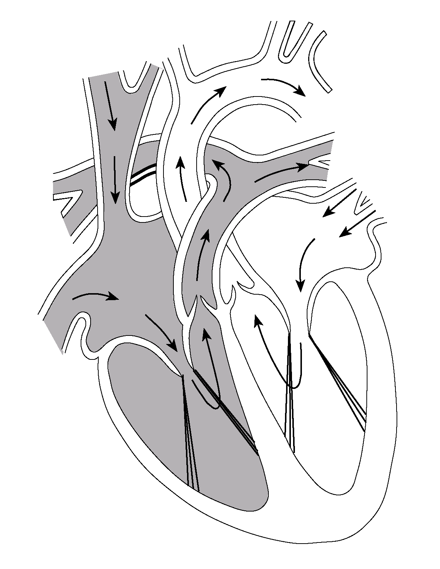

The valves between the atria and ventricles are the atrioventricular valves
the atrioventricular valve on the right side has three flaps and is sometimes referred to as the tricuspid valve

the valve on the left has two flaps and is therefore referred to as the bicuspid valve (or even the mitral valve)

To prevent the valves inverting valve tendons (‘heart strings’) hold them in place

As the aorta and pulmonary artery leave the heart there needs to be another set of valves

These are the semi-lunar valves and are the only valves found in arteries anywhere in the body

The ventricles are separated by the inter-ventricular septum
often abbreviated to just septum when it is clearly referring to the heart

The walls of the heart are composed of muscle tissue

The heart is composed of cardiac muscle

Since they are constantly active the cells have a huge requirement for oxygen and glucose

The heart possesses its own circulation called the coronary system
This necessary to supply blood directly to the cardiac muscle
The blood supplies glucose and oxygen and removes CO2

If these become blocked the cardiac muscle can no longer contract as efficiently e.g. by plaques of cholesterol

The muscle of the left ventricle is approximately three times thicker than that on the right

This allows the left ventricle to impart a greater hydrostatic pressure than the right
NB not to withstand greater pressure.

This is because:

the blood of the pulmonary circulation does not need to travel as far so has less frictional resistance to overcome.

if the hydrostatic pressure was too high in the pulmonary capillaries too much fluid would seep into the lungs’ alveoli

