Gas Exchange 2
Fish
Gas exchange is more difficult for fish than for mammals because the concentration of dissolved ___________ in water is ______, compared to ______ in air.

Fish have developed specialised gas-exchange organs called ___________, which are composed of thousands of ___________.
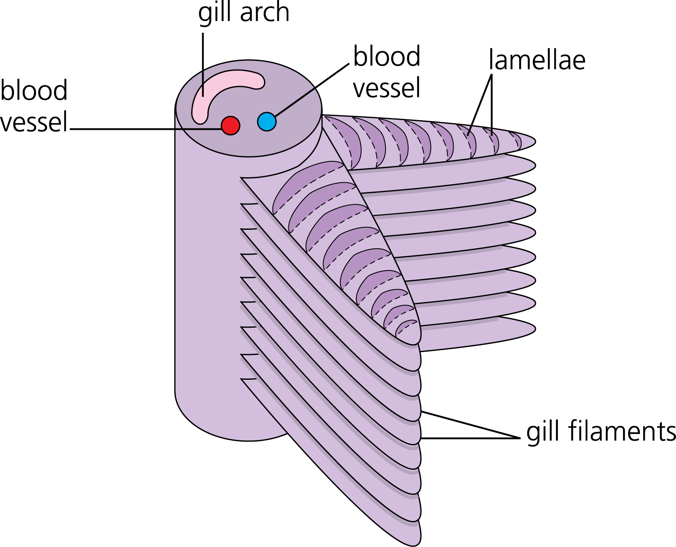
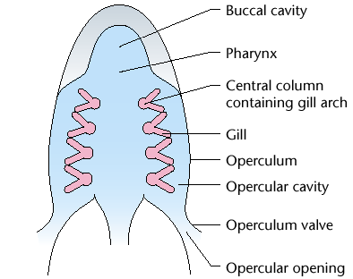

The filaments in turn are covered in feathery ___________each only a few cells thick containing ___________ ___________. This structure gives a large ___________ ___________and a short ___________ ___________for gaseous exchange.
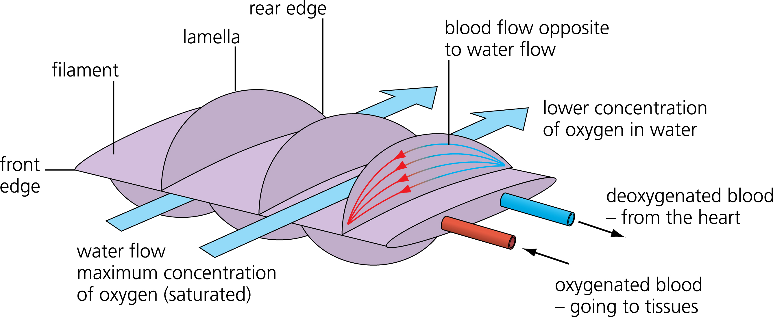
___________flows over the filaments and lamellae, and oxygen can diffuse down its concentration gradient the short distance between water and blood.
Carbon dioxide diffuses the opposite way down its own concentration gradient.

The gills are covered by muscular flaps called ___________ (sing. ___________) on the side of a fish's head.

The gills are so thin that they cannot ___________themselves without ___________, so if a fish is taken out of water the gills ___________reducing the surface area for gaseous exchange so much that the fish ___________.
Ventilation in Fish
Fish ___________their gills with sea water to ___________the gas ___________ _________.

Unlike humans, fish ventilation is one-way rather than ___________.
Water __________through the ___________but ___________through the ___________valves.
This one-way ventilation is necessary because water is ___________and more _________than air, so it would take too much __________to change its __________every breath.

Some fish (like tuna, mackerels and anchovies) ________ constantly with their mouths ______, using their swimming movement to ventilate their gills, but most fish use their mouth ___________for ventilation, which means they can ventilate even when not ___________.

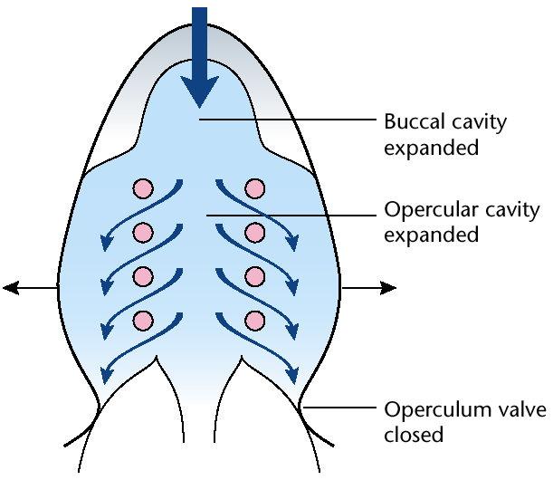
Inspiration

1. The mouth ___________.

2. The muscles in the mouth ___________, ___________the floor of the mouth, and the opercula muscles ___________, pushing the opercula ___________.

3. This ___________the ___________of the buccal cavity (mouth), and the opercular cavity.

4. This ___________the ___________of water in the buccal cavity ___________the outside water pressure.

5. The outside water pressure _________ the opercular valve.

6. Water flows ______ through the open mouth and over the gills from ____ pressure to ____ pressure.
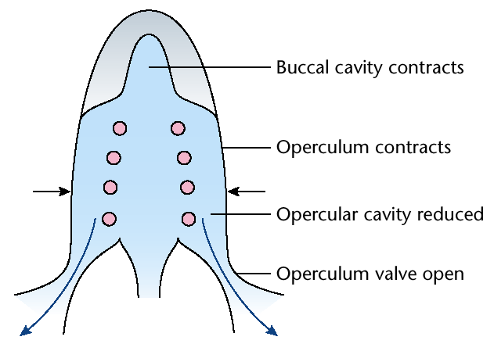
Expiration
1. The mouth ___________.

2. The mouth and opercular muscles ___________, ___________the floor of the buccal cavity.

3. This ___________the ___________of the buccal cavity.

4. This ___________the ___________of water in the buccal cavity ___________the outside water pressure.

5. This pressure forces the opercula values ___________.

6. Water flows ____ over the ____ and through the opercula valve from ____ pressure to ____.

Counter-Current Exchange
Because fish have a one-way flow, they can make use of another trick to improve their efficiency of gas exchange: a counter-current system.

If water and blood flowed past each other in the _______ direction (parallel or concurrent flow) then the oxygen concentration in the water and blood quickly becomes the _______, so no further ________ can take place, and only ____ of the oxygen can be extracted from the water.

In the counter-current system the ________flows towards the ________of the fish in the gill lamellae while the ________flows towards the ________.

This means that there in always a ________concentration of ________in the ________than in the ________, so oxygen continues to ________into the blood along the whole ________of the lamellae.

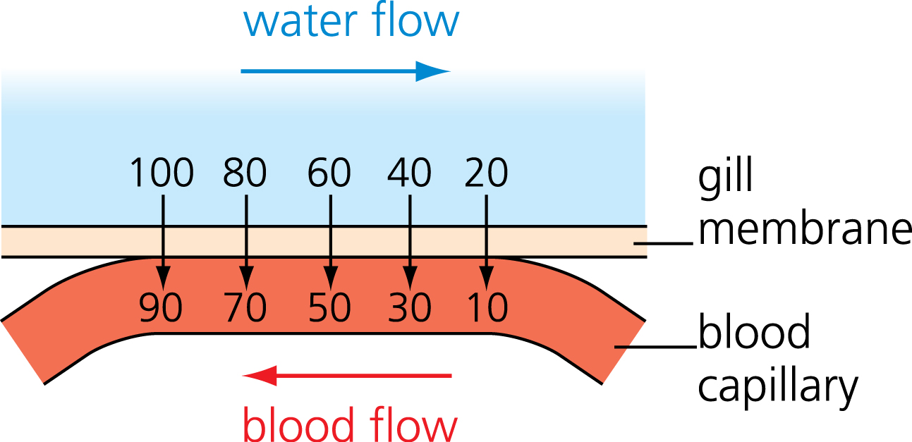

Using this system fish gills can extract about _____ of the dissolved oxygen from the water:
