Gas Exchange 3
Plants
Plant cells respire constantly, and during the day many plant cells also photosynthesise so plants also need to exchange gases.

The main gas exchange surfaces in plants are the spongy mesophyll cells in the
leaves. Leaves have a huge surface area, and the irregular-shaped, loosely-packed spongy cells increase the area for gas exchange still further.
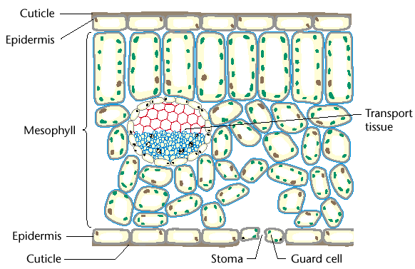

Leaves therefore have a large internal surface area:volume ratio.

Gases enter the leaf through stomata (singular stoma), which are usually in the under surface of the leaf. There are often several thousand stomata per square centimetre of leaf surface.
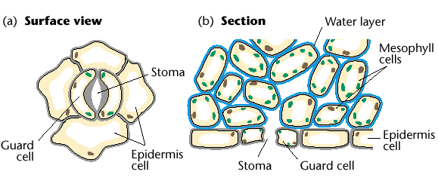

Stomata are enclosed by guard cells, which can close the stomata to reduce water loss.

Since leaves are so thin, gases can quickly diffuse through the intercellular air spaces inside the leaf, which are in direct contact with the spongy and palisade mesophyll cells.

Like terrestrial animals, plants have a problem of water loss. Water diffuses down its concentration gradient from the xylem vessels and mesophyll cells into the air spaces in the leaves.

Plants have a number of strategies for reducing this loss:

- the upper surface of the leaf is covered in a waterproof cuticle, made of lipids secreted by the upper epidermal cells.

- the sub-stomatal air space remains moist (like the alveolar air space in lungs) to reduce the water concentration gradient so less water evaporates from the spongy cells.

- the guard cells can close the stomata to stop water loss when conditions are very dry. Unfortunately, this also prevents gas exchange, stopping photosynthesis and respiration. So plants cannot close their stomata for very long.

Plants do not need a ventilation mechanism because their leaves are highly exposed, so the air surrounding them is constantly being replaced in all but the stillest days.

In addition, during the hours of daylight photosynthesis increases the oxygen concentration in the sub-stomatal air space, and decreases the carbon dioxide concentration. These increase the concentration gradients for these gases, speeding up the rate of diffusion.

The cells in leaf tissues are highly adapted to their functions:

The palisade mesophyll cells are adapted for photosynthesis:

- they have a thin cytoplasm densely packed with chloroplasts.

- the chloroplasts can move around the cell on the cytoskeleton to regions of greatest light intensity.

- the palisade cells are closely packed together in rows to maximise light collection.

- in plants adapted to low light intensity there may be two rows of palisade cells.

The spongy mesophyll cells are adapted for gas exchange:

- they are loosely-packed with unusually large intercellular air spaces where gases can collect and mix.

- they have fewer chloroplasts than palisade cells, so carry out less photosynthesis.

