Gas Exchange 4
Plants
Plant cells __________ constantly, and during the _______ many plant cells also ________________, so plants also need to exchange gases.

The main gas exchange surfaces in plants are the __________ __________ cells in the leaves. Leaves have a _______ surface area, and the __________ -shaped, ________ -packed _______ cells increase the ______ for _____ ________ still further.
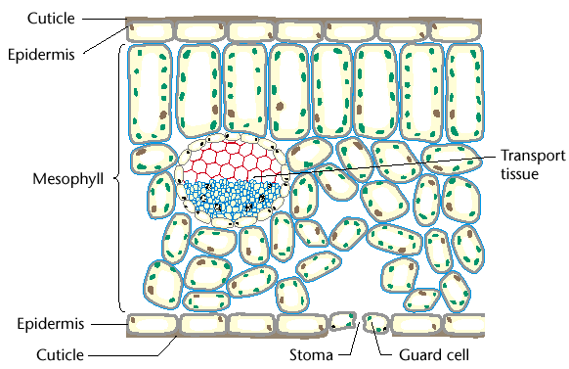

Leaves therefore have a large __________ surface area:volume ratio.

Gases enter the leaf through __________ (singular __________), which are usually in the __________ surface of the leaf.
There are often several __________ stomata per square centimetre of leaf surface.
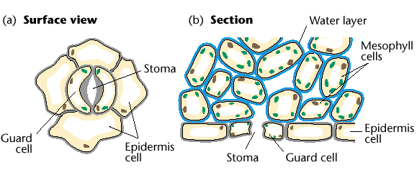

Stomata are enclosed by __________ _______, which can __________ the stomata to reduce __________ _______.

Since leaves are so _______., gases can quickly _______, through the __________ ______ _______ inside the leaf, which are in __________ contact with the __________ and __________ mesophyll cells.

Like terrestrial animals, plants have a problem of __________ _______. Water __________ down its __________ __________ from the __________ vessels and __________ cells into the ________ __________ in the leaves.

Plants have a number of strategies for reducing this loss:

- the __________ surface of the leaf is covered in a __________ cuticle, made of __________ secreted by the upper __________ cells.

- the ______ - __________ air space remains __________ (like the alveolar air space in lungs) to __________ the water __________ __________ so less water __________ from the __________ cells.

- the __________ ________ can ________ the stomata to ________ water loss when conditions are very _____ . Unfortunately, this also prevents _____ ________ , stopping __________ and __________ . So plants cannot close their stomata for very _____ .

Plants do not need a __________ mechanism because their leaves are highly __________ , so the _____ surrounding them is constantly being __________ in all but the stillest days.

In addition, during the hours of daylight __________ increases the __________ concentration in the sub-stomatal air space, and decreases the _________ ________ concentration. These increase the __________ __________ for these gases, speeding up the rate of __________ .

The cells in leaf tissues are highly adapted to their functions:

The __________ mesophyll cells are adapted for __________ :

- they have a thin __________ densely packed with __________ .

- the chloroplasts can __________ around the cell on the cytoskeleton to regions of greatest __________ __________ .

- the palisade cells are __________ __________ together in __________ to maximise __________ __________ .

- in plants adapted to ________ light intensity there may be _______ rows of palisade cells.

The __________ mesophyll cells are adapted for __________ __________ :

- they are __________ -packed with unusually large __________ air spaces where gases can __________ and __________ .

- they have fewer __________ than palisade cells, so carry out less __________ .

