 |  | FACT FILE
FACT FILE 1: Tim Booth | Age: 45 Height: 1.85 m (6' 1")
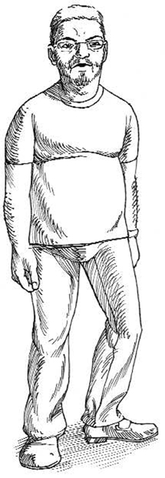 | BMI: 30.4 Weight: 102 kg (16 stone)
 | Non-smoker
Tim's father died of a heart attack in his early
forties, which worries Tim. He lives in Manchester.
His favourite food is fish and chips. He often has
cheese sandwiches and a beer for lunch in the
pub as well as a meal in the evening with his wife
and family. He works with computers and enjoys
his job but gets very little exercise.

  FACT FILE 2: Miyuki Sato | Age: 75 Height: 1.52 m (5' 0")
  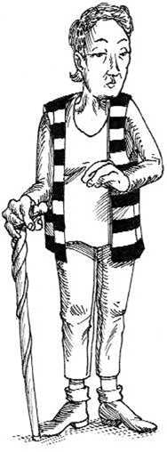 | BMI: 19.1 Weight: 44.5 kg (7 stone)
   | Non-smoker
  Miyuki lives in Okinawa in Japan. Her diet is
  based on soya, fruit, and vegetables.
  In Japan it is considered rude to eat big portions.
  Miyuki has always worked hard physically and
  walked for pleasure. She has a close family and
  is very content with her life.
  FACT FILE 3: Gus Brown | Age: 60 Height: 1.85 m (6' 1")
  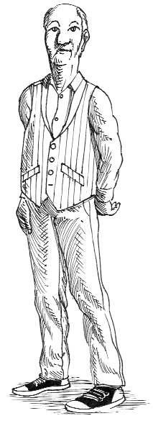 | BMI: 24 Weight: 82.6 kg (13 stone)
   | 20 cigarettes a day
  Gus has no heart disease in his family. However, at a recent check up his GP found that his blood pressure is a little high and his blood cholesterol LDL and HDL ratio is not good.
  Jesse, Gus's wife, makes sure he
  eats plenty of fruit and vegetables, but he does like
  to have plenty of meat every day. Gus goes to the
  gym twice a week and always walks to work.

 |  | FACT FILE
FACT FILE 4: Angie Nesbitt | Age: 30 Height: 1.67 m (5' 6")
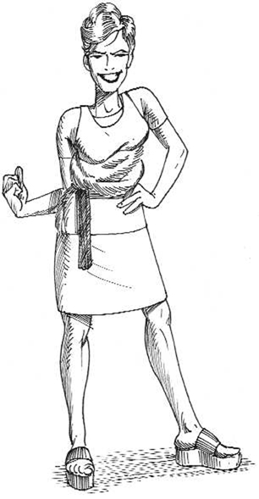 | BMI: 21.9 Weight: 61.1 kg (9 stone 10 Ib)
 | 5 cigarettes a day
Angie's mum and her grandma both had heart
problems so Angie has her blood pressure and
blood cholesterol levels checked regularly. They
are both quite normal. Angie goes swimming
twice a week. She indulges in a cappuccino and a
cake at lunchtime every day. She smokes in the
evenings when she goes out with friends.

  FACT FILE 5: Darren Crosby | Age: 18 Height: 1.88 m (6' 2")
  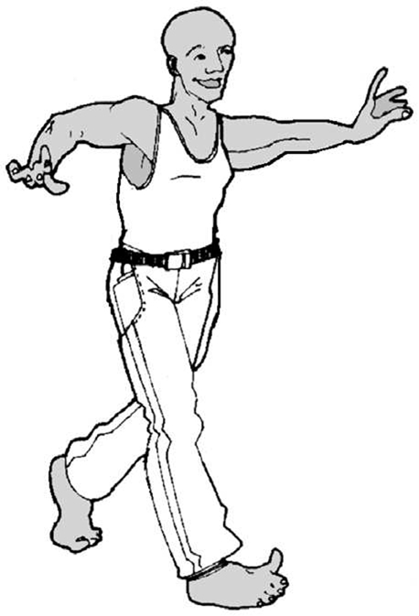 | BMI: 25.2 Weight: 88.9 kg (14 stone)
   | 10 cigarettes a day
  Darren’s grandfather had heart problems but
  his father seems healthy. Darren plays rugby
  for a local team and trains twice a week.
  He drinks quite heavily after the Saturday match.
  FACT FILE 6: Deidre Reeves | Age: 16 Height: 1.63 m (5' 4")
   | BMI: 18.5 Weight: 48 kg (7 stone 9 lb)
   | 20 cigarettes a day
  Deidre’s grandma has high blood pressure.
  Her mother’s blood pressure is normal.
  Deidre smokes instead of eating breakfast
  and lunch. She has recently become a
  vegetarian and is trying to lose weight.

