Roll of Service
of
Old Elizabethans
who served and died
in World War One
1914-1918

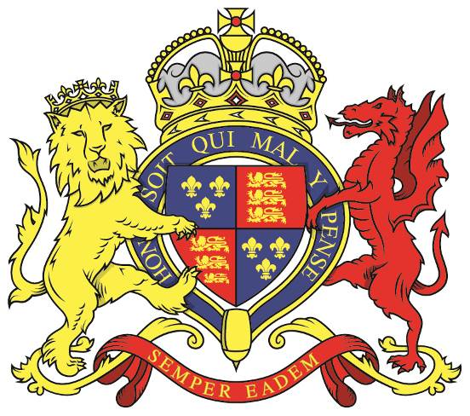

Qui procul hinc de patria
iam optime merentur
Quotquot ubique militant
Memoria foventur

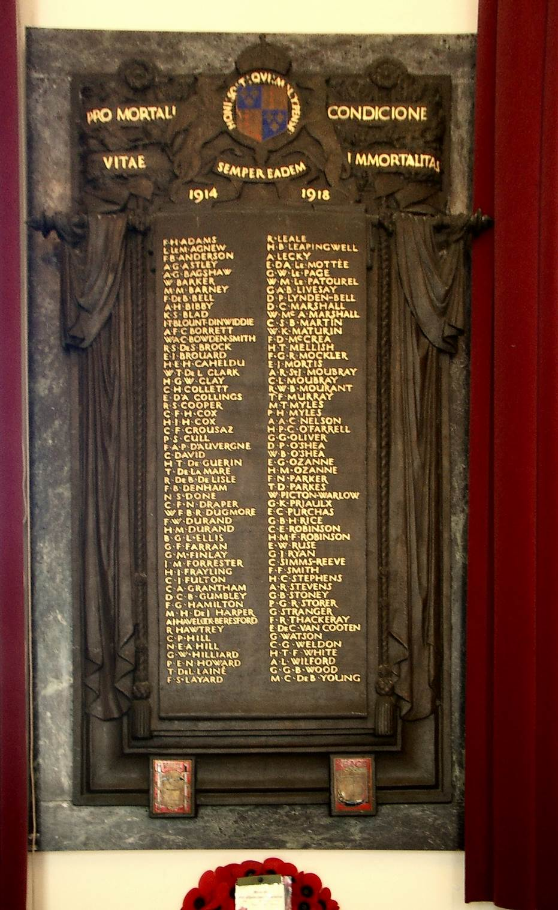

Contents
Frank Herries Adams (3213) 6
Lloyd Le Mesurier Agnew (3169) 7
Frank Barclay Anderson (2717) MiD 8
Aston Giffard Astley MC, MiD (3093) 9
Adair Grey Bagshawe (2896) 10
Sir Henry de Beauvoir de Lisle, a Guernseyman, was General Officer Commanding 29th Division at Krithia. Bagshaw on CH memorial.William Barker (2359) BA 10
Montagu Middleton Barney (2891) 12
Francis de Beauvoir Bell (2018) BA, MiD 13
Arthur Hilgrove Bibby (2827) 14
Kenneth Sven Blad (3193) 15
James Travers Blount-Dinwiddie (2882) M I D (2) 16
Alfred Frank Cyril Borrett (2966) 17
Walter Adrian Carnegie Bowden-Smith (2705) 18
Ranulf Steinthal de Saumarez Brock (3155) 19
Ernest James (Laddie) Brouard (2972) 20
Horace Edwin Herbert Cabeldu (2915) 21
Wilfred Thomas de Lacey Clark (2721) 22
Henry George Walter Clay (3188) 23
Charles Herbert Collet (2872) R.M.A. DSO, MID (3) 24
Robert Stanley Cooper (3211) 27
Cecil Francis Hamilton Cox (3071) 28
Howard Jack Hamilton Cox (3072) 29
Cecil Francis Crousaz (2949) 30
Percival Steward/t Cull (3125) MiD 32
Francis Arthur Payn d’Auvergne (3201) 33
Charles David (3187) 34
Howard Thomas de Guerin (2605) 35
Thomas de la Mare (2980) 36
Richard de Beauvoir de Lisle (3134) MID 37
Francis Barden Denham (3241) 38
Arthur Hugh Dobbs (3003) 39
Elizabethan has different regiments - confusion with brother?Neville Savage Done (2713) 39
Cecil Frederick Napier Draper (3229) 41
William Francis Brougham Radclyffe Dugmore (2175), DSO, MiD (3) 42
Francis William Durand (2517) 43
Havilland Montague Durand (2727) 44
Bryan Grogan Langley Ellis (3298) 45
George Francis Farran (2743) 46
George Malcolm Finlay (3012) 47
John Mathieson Forrester (2656) 48
Cap Badge of the 1st South African Brigade Herbert Joseph Frayling (3206) 48
Cecil John Fulton (3087) 50
Charles Alpe Grantham (2865) 51
Donald Charles Beric Gumbley (3082) 52
Frank Gordon Hamilton (2848) 53
Maurice Henry de Jersey Harper (2990) MB. BSc. 54
incorrectly shown on the College Memorial as Arthur Jardine Havelock- Beresford 55
Ralph Hawtrey (2555) 56
Charles Percy Hill (2631) 57
Norman Ernest Albert Hill (2830) 58
Gerald Williams Hilliard (2726) 59
Percy Edgar Napier Howard (3246) 60
Frank de Mouilpied Laine (3008) MC, MiD (2) 61
Thomas de Jersey Laine (3124) 62
Frank Stanlie Layard (3133) MID MC 63
Edward d’Albert Le Mottee (2314) DSO, MiD (2) 64
George William Le Page (2473) 65
Wallace Mackenzie Le Patourel (1962) MA 66
Roy Leale (3068) 67
Henry Byng Leapingwell (2627) 68
Averall Lecky (2765) 69
George Augustus Bligh Livesay (2211) 70
Donald Perceval Lynden-Bell (3287) 71
Douglas Cargill Marshall (3039) 73
William MacAndrew Marshall (2875) MiD (2) 74
Cecil Stephen Bignold Martin (2898) 75
William Kyle Maturin (2775) 76
Francis Dobree McCrea (3066) 77
Henry Tupper Mellish (3055) 78
Francis George Ross Mockler (2951) MC,MiD. 79
Eric John Mortis (3279) 80
Arthur Russell St John Moubray (2917) MC MiD 81
Cyril Lloyd Moubray (3074) M.C. MiD 82
Rowland Walter Blundell Mourant (2354) 83
Thomas Francis Murray (2315) 84
Ireland. By kind Permission of Catherine Watson.Maurice Trevor Myles (3091) 84
Philip Henry Myles (3089) 86
Abercrombie Anson Craven Nelson (1413) DSO,MiD. 87
Howard Patrick Curtis O’Farrell (1991) MiD 88
Dermot Patrick O’Shea (3158) 89
Wilfred Bernard O’Shea (3157) 90
Guy Giffard Oliver (2745) MiD (2) 91
Edward Graeme Ozanne (2687) 92
Henry Marquis Ozanne (2621) 93
Frederick Neville Parker (3063) 94
Theodore David Parkes (3099) 95
Wilfred Picton-Warlow (3015) 96
George Kendall Priaulx (2461) DSO MiD (4) 97
Ernest Charles Purchas (3172) 98
Gerard Beechey Howard Rice (2330) MiD (2) 99
Charles Edward Robinson (2962) 100
Henry Mark Fector Robinson (2788) 101
Edward Wallace Ruse (3167) 102
George Julian Ryan (2433) DSO, Order of the Medjidie, (Turkey), MiD (2). 103
Charles Simms Reeve (2904) 104
Frederick Fieldhouse Smith (3174) 105
Howell Charles Stephens (3266) 107
Antonio (Anthony) Rodovask Hodgson - Stevens (2660)FRGS,MIME,MSE 108
George Butler Stoney (2544) DSO, MiD 109
Patrick George Rawlings Storer (3215) 110
George Stranger (3231) 111
Frederic(k) Rennell Thackeray (1601) MiD 112
Edwin de Clonard(e) Van Cooten (2428) 113
Geoffrey Watson (3104) 114
Cyril George Weldon (2818) 115
Hans Thomas Fell White (1468) OBE RN 116
Arthur Lucius Wilford (2815) DSO. MiD 117
George Gilbert Beaton Wood (3150) 118
Martin Courtland de Bude Young (3199) 119
Acknowledgements

Frank Herries Adams (3213)

Vol. II Pg 284

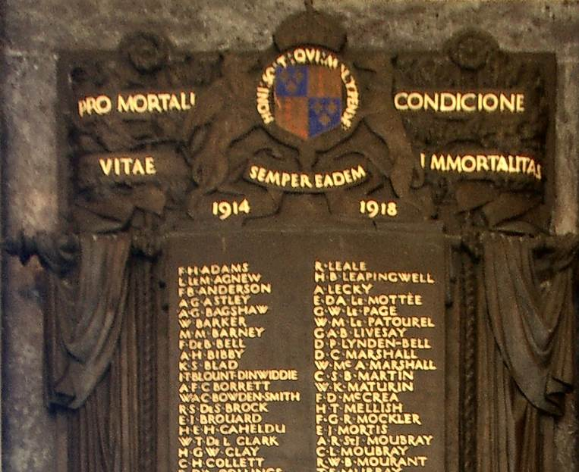
Top Section of the College Hall Memorial.

Born: 30 January 1896 Born in Guernsey
Son of builder James Adams and his wife Mary Ann Hubert of L’Aumone, Catel, Guernsey

Joined Elizabeth College in 1909 and left in 1914. He was in the Dramatic Society. Won the Mainguy Scholarship and Miller Prize. Distinction in German and Scripture in Higher Certificate.
Passed the Intermediate Civil Service Exam 1914.

War Service
On December 15th 1915 he attested for four years service with the Territorials, Inns of Court OTS based at Gillingham, Kent, where he worked as Assistant Naval Stores Officer, Chatham.
Stayed until 1 June 1916 and passed into Woolwich 16th out of 125 as a Gentleman Cadet.

Commissioned 2nd Lieutenant in Royal Engineers. Contracted measles in camp, which proved fatal.

Died: 01 August 1916 aged 20

Decorations: None.
Memorials:
- College Hall

Lloyd Le Mesurier Agnew (3169)
Service No. 92890

Vol. II Pg277

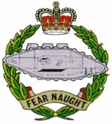
Born: 9 February 1896 in Guernsey
Son of Mary Jane Agnew nee Lloyd, and the late Gerald William Agnew

Joined Elizabeth College in 1907 and left in 1914
He shot for the VIII in the Ashburton in 1914. Equal top score with Keith Le Cheminant. The team finished 37th.
Attributed to Hammersfan

War Service
1914 Enlisted at the outbreak of War, just after leaving school, he went into the Royal North Devon Hussars at Barnstaple, Devon.
Transferred to the Machine Gun Corps. The heavy MGC became the Tank Corps and Lloyd was at Central Stores R Depot.
Served in France 1916 - 18 for 15 months and died of wounds.

Died: 27 July 1918 aged 22

Decorations: War Medal and Victory Medal
Memorials:
- College Hall
- Terlincthun British Cemetery Wimille Nord de Pas de Calais

Frank Barclay Anderson (2717) MiD
Vol. II Pg 185

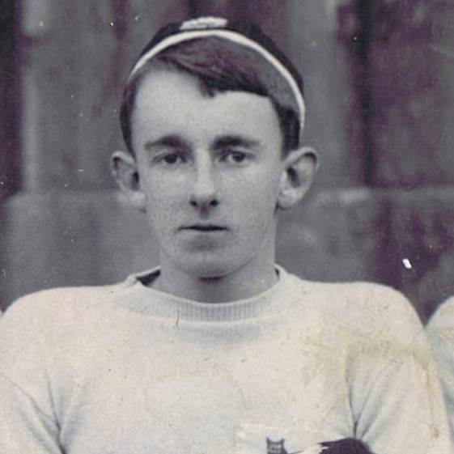

Picture of Frank Barclay Anderson from the School's Rugby XV photograph of 1900.

Born: 28 May 1883 in Chiswick, the son of Charles John and Kate Barclay Anderson of Chiswick.
Brother of 2715 and 2716 Charles Ernest.

Joined Elizabeth College in 1893 and left in 1901
Played cricket and rugby. 1900 Literary & Drama Society. Miller Prize and 2nd in Drawing.
Married Marion Louise Menhinnick in 1918.
Royal Naval College Greenwich Passed out 6th in 1902. 2nd in the Gymnasium Competition.
Appointed 2nd Lieutenant Royal Marines L.I. in 1902, Lieutenant in 1903, promoted Captain in 1912.
Served on HMS Terrible, Cressy, Aphrodite, Astrea 1904 – 06. HMS Donegal 1907, Warrior 1907 – 8, Shannon 1909 - 11.
I/C Physical Drill 1st Cruiser Squadron. HMS Lion 1912, Centurian 1913 – 15.
Appointed Physical Training Officer 1st & 2nd Cruiser Squadrons 1909 - 12.
War Service
Placed on half pay due to medical unfitness 5th January 1916, and appointed to Reserve of Officers 1917
Assistant Instructor of Musketry Plymouth Division 1917.
R.M. Camp Tavistock Jan 1918 with temporary rank of Major Royal Marines. Reverted to retired list due to ill health Nov 1918.
Whilst at RM Tavistock received an expression of appreciation from the Lords Commissioners of the Admiralty for action in picking up an ignited bomb and throwing it over the parapet during bombing instructions thus saving many lives. Also brought to notice of the Lords Commissioners for valuable service during the Great War.

Died: 14 June 1919 at Chiswick after the end of the war aged 36
Decorations: Mentioned in Despatches, 1914 - 15 Star, Victory and British War Medals.

Memorials:
- College Hall

Aston Giffard Astley MC, MiD (3093)

Vol. II Pg 268
Born: 5 October 1887 in Niana Tal, India to Capt. Spencer Byng Astley (Paymaster Norfolk Regt.) and Rose Astley (nee Hall) of Wiltshire

Joined Elizabeth College in 1904 and left in 1907. Prefect and Senior House Prefect. Ist XI Cricket 1906 -7. 2nd. XI Football 1905,6,7 Dramatic Society.Miller and Bishop's Prize 1907.

Employed in the East Indies. Spoke French, Latin and Greek.
Member of the Masonic Lodge Middlesex No 3534.

War Service
17/11/10 Lt. 2nd/6th Battalion Royal Fusiliers. Entered Army 1911 - Register
Wounded in Nov 1911
14 July appointed temp Major
Maj. 8th Royal Fusiliers. Seconded to 34th Coy.Machine Gun Corps

Died: 01 October 1916 aged 28, KIA at Flers in France.
Decorations: Military Cross, Medal, Victory Medal, 1914 – 15 Star, Mentioned in Despatches.

Memorials:
- College Hall
- Dantzig Alley British Cemetery Mametz Somme Grave I E 13
- Everleigh Plaque in St Peter's Church, Wiltshire.

Adair Grey Bagshawe (2896)
Vol. II Pg 223
Born: 12 December 1884 born in Anerly, Middlesex - near Crystal Palace.
Son of Lucy Bagshawe nee Alexander of 51 Albert Bridge Rd. Battersea and the late Frank Theodore Bagshawe (Commissoner of Police Madras, India).
Brother to Brian Francis 2895 and Norman Hugh 2897

Joined Elizabeth College in 1898 and left in 1900.
Passed to Britannia December 1899.
Training Ship Worcester. Passed out with two Ist Class Certs 1902. Joined Mercantile Marine.
1906 2nd Officer’s Cert. Gazetted to Indian Marine Service 1907.
Later resigned his commission for family reasons and took up farming in Suffolk.

War Service
“Enlisted as an ordinary Seaman in Nov 1914 and gazetted as Sub Lieutenant in the Royal Navy Volunteer Reserve and sent to 6th Depot Battalion at Crystal Palace . He joined HMS Collingwood Bn. RN Div. at Blandford on March 31st 1915.”
Gallipoli 1915
“He was wounded in the attack during the 3rd Battle of Knithia on June 4th 1915, but remained with his men until he was ordered to retire. At that point he was hit again and was unable to join the retreat”
www.greatwarci

Died: 04 June 1915 aged 30 presumed KIA
Memorials:
- College Hall
- Helles Memorial Panel 8 to 15

Decorations: Medal, 1914 -15 Star, Victory Medal

Sir Henry de Beauvoir de Lisle, a Guernseyman, was General Officer Commanding 29th Division at Krithia. Bagshaw on CH memorial.
William Barker (2359) BA
Vol. II Pg 106
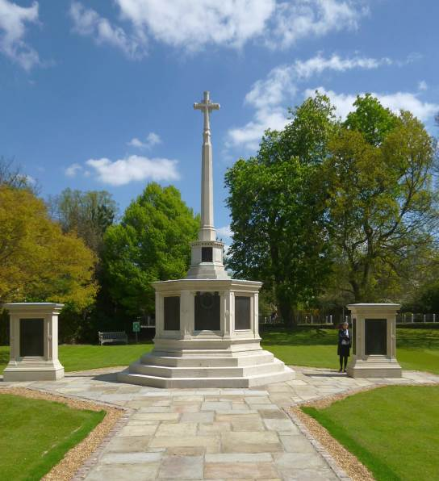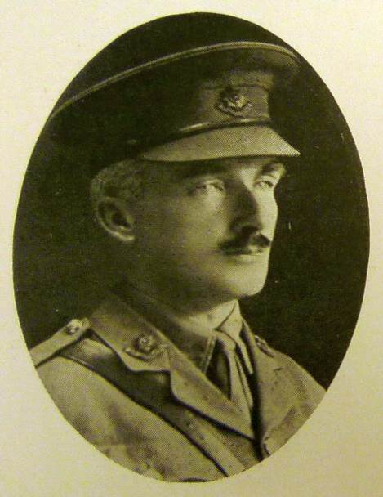
Dulwich College Memorial 1914 - 18, on which the William Barker by kind permission of
names of William Barker and Charles Herbert Collet the Governors, Dulwich College.
appear. (May 2016).
Born: 24 November 1873 in Bombay, India , son of Kathleen Anna of Charlton Marshall, Blandford Forum and the late Surgeon Lt. Colonel Frederick Charles Barker of Rajkote – Kattiarwar, Bombay - Indian Military Service.

Joined Elizabeth College in 1883 and left in 1889 to go to Dulwich College. Left Dec 1891.
In 1894 he went up to Corpus Christi, Cambridge. Obtained a BA in 1897.

Entered the army 23 May 1900 as 2nd Lieutenant, 4th Battalion the Worcester Regiment;
1901 Lieutenant, 5 Sept.1908 promoted Captain serving in Bermuda, Barbados, Malta and Egypt. Promoted Major in 1910 – Adjutant to Standing Camp, Ranikhet, India.
War Service
1914 – 15 - he was attached to 9th Service Bn. Worcester Regt. going with them to the Dardenelles in June. William was severly wounded in the Landing at Suvla Bay on 10th August.
He was placed on board the Hospital Ship Gascon bound for Malta, but died and was buried at sea.

Died: 15 August 1915 of wounds aged 41.
Decorations: Medal, 1914-15 Star, Victory Medal.
Memorials:
- College Hall
- Helles Memorial Panel 104 to 113
- Dulwich College.

Montagu Middleton Barney (2891)
Vol. II Pg 222
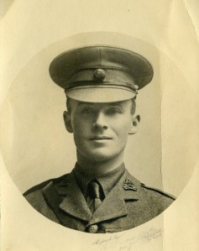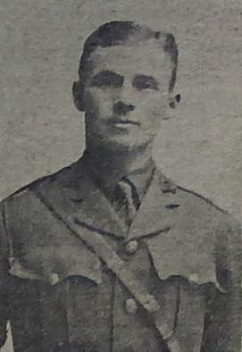
Taken from Gloria 28 Website Guernsey Weekly Press May 1916
Born: 24 May 1889 in California, son of Montagu Thomas and Gertrude Elizabeth Barney nee Middleton of Pacific Grove California. Mother and father separated about 1896 . Brother of Winifred Gertrude Leapingwell (Nee Barney) See Henry Byng Leapingwell.
Husband to Phyllis Honor Barney (Nee Le Brun) a teacher. Married at St John the Divine Kennington 1915. Lived at 108 Vassal Rd., Stockwell and later The Rectory Alderney. In 1915 he was living at 23 High Street, St Peter Port, Guernsey with his mother.
Joined Elizabeth College in 1898 and left in 1904. Joined St John’s College, Hurstpierpoint School in Sept 1904 until Easter 1906. He played football for the school in the two years he was at Hurstpierpoint. He went to the Mining School at Camborne.
On 4th May 1908 he was awarded the Royal Humane Society's medal for saving a six year old boy called Paul from the sea near the Queen's Hotel, Penzance.
"When his training was finished he went out to Mexico, and did so well that by the time he was twenty-one he was a mine manager! He was stronger than most men, and in 1911 he survived an accident which would have killed almost anyone, falling 65 feet down a mine-shaft, and receiving terrible injuries, from which he all but completely recovered." Obituary from Hurstpierpoint School .
War Service
2nd Lt. Royal Berkshire Regt. 1914. Bugler and Sapper. Transferred to 253rd Coy R.Es. iand went to France in February 1916.
From the Hurstjohnian Magazine "April 27th, 1916: "I am writing with regret and sympathy to tell you of the gallant death of your husband. There was an attack this morning with gas by the enemy, and your husband had charge, with his miners, of a section of the trench. He was killed by a shell, with two other men, on the firing-step, gallantly holding the Germans back. Though so short a time in my Company, my appreciation of his value as an officer and man was shown by my making him one of my four section commanders. In his short time he took over a section which had rather fallen to pieces, and in a few days by his personality pulled it together and did splendid work. I can ill afford to lose him as an officer, and from my selfish point of view I lose a friend as well......He will be buried tomorrow in Vermelles among hundreds of other brave fellows who have given their lives for their country and their ideals." Letter to his wife from Commanding Officer.
Died: 27 April 1916 aged 26 KIA
Decorations: Medal, 1914 -15 Star , Victory Medal
Memorials:
- College Hall
- Vermelles British Cemetery II G 32
- St Stephens Church Memorial.

Francis de Beauvoir Bell (2018) BA, MiD
Vol II Pg 38

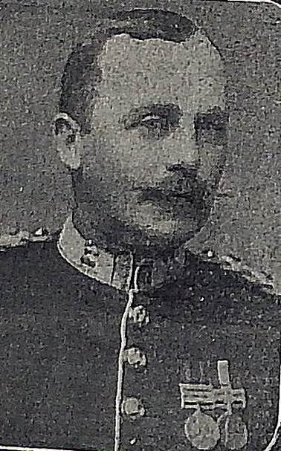

Picture taken from the Guernsey Weekly Press 1st May 1915.

Born: 7 May 1866 in Guernsey, elder son of the late Col. Bell ADC to the Lt. Gov. of Guernsey (1899) (716) CB and Rosina Carey of Swissville St Peter Port Guernsey.
Husband of Mabel Grace Daunt of Templenoe, Fermoy County Cork.

Joined Elizabeth College in 1875 and left in 1884.

Exeter College Oxford 1885 . BA 1887

Royal Military College, Sandhurst 1888
Gazetted May 1890 from RMC as 2nd. Lieutenant to Norfolk Regt.
Fought in Africa 1899-1902, Capt 1900;
2i/c and Major 1906 of 4th Battalion Norfolk Regiment 1902 – 09
India 1909 – 14. 2i/c 2nd Bn Norfolk Regt.
War Service
In South Africa 1899 – 1902. Operations in Orange Free State. Battle of Paardeburg 17 – 25 Feb 1900. Actions in Poplar Grove, Waree Siding, Vet and Zand Rivers 1900. Mentioned in Deapatches by Lord Roberts. At Bloemfontein, Johannesburg and Pretoria. Joine Colonel Kekwich's Columnin pursuit of Delarey and Kemp. Queen’s medal and one clasp, King’s medal and two clasps.
1914-15 Operations in Mesopotamia. Wounded at battle of Shaiba (12 -14 April)

Died: 24 April 1915 aged 48 of his wounds
Decorations: Queen’s Medal and Clasp, Kings Medal 2 clasps.

Memorials:
- College Hall
- Basra War Cemetery III A 14

Arthur Hilgrove Bibby (2827)
Service No. 58
Vol. II Pg 208

Born: 5 August 1884 at Pilton Barnstaple Devon.
Son of Rev. Isaac and Mary Bibby, St Saviour’s Rectory Guernsey.
Husband of Avis Emily Bibby of Lloydmaster Saskatchewan living in Guernsey at the time of his enlistment father of a son born 1913 and a daughter b. 1915.

Joined Elizabeth College in 1896 and left in 1899. Boxed. Certificate in Divinity.
Kimbolton College for 4 years.
Enlisted at Valcartier Quebec.
War Service
Served 1900 – 1902 as private and Sgt. In 2nd Royal Guernsey Light Infantry.
His fine shooting as part of the RGLI attracted notice and he was offerd a commission as 2nd Lt. in 3rd South Staffs. at 17 (1901). Went to South Africa at close of War landed at Cape Town 28th May 1902 to join his regiment at Clanwilliam.
Returned home - Farmer in Saskatchewan
At out break of war he enlisted at Valcartier Quebec aged 30 on 24 Sept 1914 and came to England
With the 7th Bn. British Columbia Regt. Canadian Expeditionary Force. Sent back to Canada to train recruits.
Arrived in England for the second time in Oct. 1916 was offered the choice of returning to Canada to train troops or go to the Front. He chose The Front.
He published a book on the Lewis Gun for practical field work.
Captain in Canadian Infantry 1917. Commissioned serving with 100th Winnepeg Grenadiers.
Killed on attack on Hill 70 Lens prior to battle of Lens.

Died: 15 August 1917 aged 33

Decorations:
Memorials:
- College Hall
- Loos British Cemetery III A 7 on road from Loos to Bethune.
- Lloydminster War Memorial Saskatchewan. (Right Face).
- St Saviours Church (on line)
- Canadian Great War Project.

Kenneth Sven Blad (3193)
Vol. II Pg 281
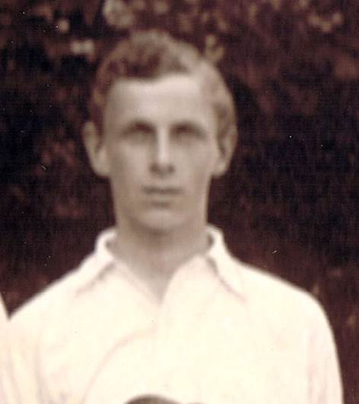
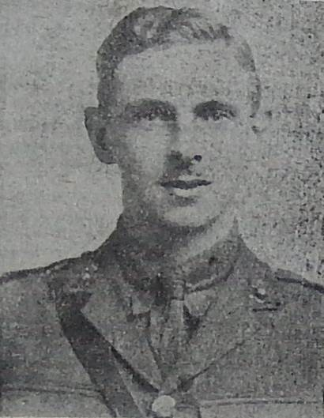
Picture taken from the School's 1st XI Photo 1915. Picture from Guernsey Press 1919

Born: 31 July 1898 in Brighton Sussex. Son of Caspar Andreas Valdemar and Annie Gertrude Blad of Dunlery, Ville au Roi, Guernsey. Father Danish, an ex Broker/Banker who worked for twenty years in Yokohama.
Joined Elizabeth College in 1908 and left in 1917
Wireless student 11 Aug 1916.
Appendectomy. Played cricket for the school.
Went to the Cardon London Telegraph Training College at Earl’s Court passed Junior Wireless, Senior Wireless. Passed 1st Class Operator Post Master General’s exam for Marconi and Telefunken 3rd April 1917.
Passed as high speed. Joined the Cadet Battalion R.E.
War Service Details
Joined Royal Signals Nov 1917 commissioned in Dec 1917 as 2nd Lt. Royal Engineers. France 1918 4th Tank Brigade Signals. Wireless Officer to a Brigade of Tanks. Flew over enemy lines to select suitable areas for Wireless Stations
Died: 26 November 1918 aged 20 in hospital from injuries received in a Road Traffic Accident in service, on Dollan Arras road, but after the end of the war. A French car, that did not stop, hit him on his motorcycle earlier in the evening as he was returning to Head Quarters. He continued and later he hit a lorry during very heavy fog. The court of inquiry found that the lorry driver was not to blame and that Kenneth had been probably shaken or was suffering from concussion by the earlier accident, and did not see the lorry.
He was a most popular officer, and loved by his men, not only for his unfailing cheerfulness and good spirits, but also for his coolness when in action and unfailing devotion to duty. In Vol. 30 of the Elizabethan the editor wrote, "Many of us will remember K. S. Blad's very recent visit when he lectured to the O.T.C. on Tanks. He was in command of about a dozen wireless instalments in various tanks, and his experiences were most interesting to young and old. He was one of the boys about whose profession there is no doubt or difficulty. Electrical engineering was almost a passion with him."

Decorations:
Memorials:
- College Hall
- Fillievres British Cemetery B 26
- Yokohama Motomachi “Foreigners Cemetry”
- Island War Memorial

James Travers Blount-Dinwiddie (2882) M I D (2)
Service Number 30144
Vol. II Pg220
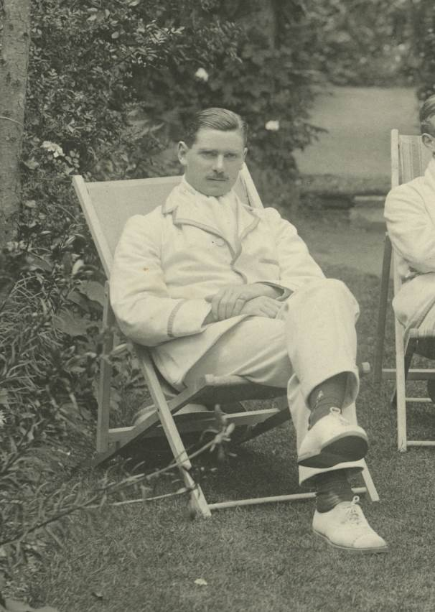
James at the Henley Rowing Tour 1912.
“Photograph attributed to Gillman & Soame, reproduced by kind permission of the Master, Fellows & Scholars of Pembroke College, Oxford”.

Born: 25 April 1891 at Glencaple, Dumfries. The second son of James, soliciter and a writer to Signet, and Agnes Ellen Currie Blount – Dinwiddie, daughter of Thomas Dickson Currie.
His brother 2881 survived the war.
Joined Elizabeth College in 1898 and left in 1908
Classical scholar. Won many przes and distinctions and three scholarships to Pembroke, matriculating at Pembroke College Oxford in 1908 on a King Charles Scholarship. Passed his mods with a 3rd Class in 1910, obtained a 2nd Class B.A. in Jurisprudence in 1912. Captain of College Boat Club, member of the O.T.C., football and Cricket XI
Practised Law in Johanesburg until Great War joined up in July 1913.
War Service
1914 Lt. in Transvaal Scottish - in German South Africa, landing at Luderichtbucht. Served under Sir Duncan Mackenzie until December, when he left for England and was commissioned into 1st Border Regt as 2nd Lt in 1914, made up to Lt in same year and Temporary Captain in 1915. Went to Gallipoli in March 1915 and was wounded on landings on April 25th. Rejoined his unit after two months and was fatally wounded on 21st Aug., while leading his Company up Hill 70 at Anafarta. Died of wounds at the Empire Hospital Vincent Square, Middlesex, London 13 Sept.

Died: 13 September 1915 aged 24
Family sent plaque and scroll

Decorations: Medal, 1914 Star Victory Medal. Mentioned in Dispatches by Gen. Sir Ian Hamilton, for gallant and distinguished service in the field.

Memorials:
- College Hall
- Amberley Church Cemetery Gloucester.
- South African Roll of Honour

Alfred Frank Cyril Borrett (2966)
Vol. II pg238
Born: 31 July 1888. in Ceylon. Elder son of Alfred Charles Henderson Borrett of Wyesham, Monmouth, and Gertrude Augustus Homfreys.
Husband of Frances M Savage.
Brother of George Kemyon Foster (2967), who went to England in 1908 to study law. Passed and became a soliciter. 1914 joined the RGLI and went to France i/c Lewis Guns. Taken prisoner at battle of Cambrai and sent to Heidleberg Camp. Grower 1919-27. Died 14 th May 1927.

Joined Elizabeth College in 1900 and left in 1906. Prefect 1st XI Football 1905-06, 1st XI Cricket 1906
Grower in Guernsey. Went to Vancouver as a grower in 1912. Returned at the out break of war.

War Service
Joined R.G.L.I. 1914
Captain (Adjt) in the Royal Guernsey Light Infantry.
Went from Southampton to Le Havre, France on 26th September 1917 as Adjt. to the Battallon. KIA.
The Battle of Cambrai took place from 20th November 1917
"..... the RGLI's role was to go through the Hindenburgh Line after the first wave and take 'Nine Wood' to the north of Marcoing.^{[2]} This went according to plan, with few casualties and they then moved into Marcoing and on to the front line at Masnières. The Guernseymen found themselves defending the small town of Les Rues Vertes against a huge and determined German counter-attacks on 30 November, pushed back they retook the village twice in heavy hand to hand fighting that lasted two days. They suffered heavy casualties, with nearly 40% of the regiment either killed, injured or missing during the battle, but only withdrew when ordered to by the high command." Quote from Wikipedia.
After that the RGLI only could muster 50% of the men from Guernsey.
Died: 24 November 1917 aged 29 KIA.

Decorations: Medal and Victory Medal.
Memorials:
- College Hall
- Cambrai Memorial Louverval

Notes Pic in Weekly Press 1917??

Walter Adrian Carnegie Bowden-Smith (2705)
Vol. II Pg 181.
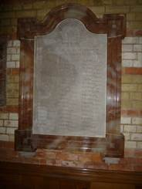
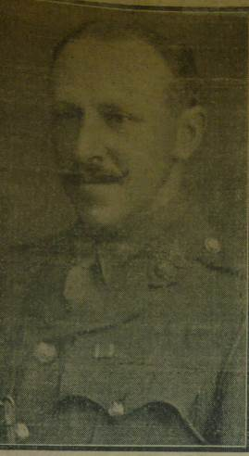
First World War Memorial, St Michael and All Angels, Walter Bowden Smith Weekly Press 1914
Lyndhurst, Hants. (2016)

Born: 25 September 1881 in St Peter Port Guernsey. Son of Walter Baird Bowden – Smith, High Sherrif of Hampshire and Julie Wiggett (Nee Humphrys) of Vernalls, Lyndhurst, Hants.

Joined Elizabeth College in 1893 and left in 1894
Rugby September 1894 - 1899, 3 Dickinson. Member of the shooting VIII in 1899.
Went to Sandhurst 1899.
War Service
Gazetted 1900 to the Royal Fusiliers. 2nd Lieutenant 1904. Served in Tibet 1903 – 04. Saw action in Niani Capture of Gyantse Jong Wounded on 6th July 1904 and by August was back on duty. Promoted Lieutenant 1904 and marched to Lhassa. He was promoted Captain in 1909 in the Royal Fuseliers 4th Battalion, City of London Regiment on 28 Nov 1909.
France 1914, Mons retreat, wounded and died of wounds at Mazieres Belgum. Left as a prisoner with the Germans because of his wounds, but died at St Joseph’s Convent Maisieres Belgium.
Letters from his brother officers state that " he was very gallantly bringing up reinforcements at Mons under fierce fire, when he was wounded in the right arm and abdomen". Out of the 50 men he led up all but three were shot down.

Died: 28 August 1914 aged 32
Decorations: Tibet Medal and Clasp Niani. Medal, 1914 Star and clasp, Victory medal.
Memorials:
- College Hall
- Cement House Cemetery. (CWGC does not have a hyphen),Langemark Poelkapelle, West Flanders.
- St Michael’s and All Angels War Memorial Lyndhurst

Ranulf Steinthal de Saumarez Brock (3155)
Service No. 36622

Vol. II Pg275
Born: 19 February 1895. Son of the late Stuart Nicholas Brock and Mrs Lena Sussana Steinthal of 3A Vicarage Mansions , Abbotsford, Ave., West Green, North London.
Brother to Joan.

Joined Elizabeth College in 1906 and left in 1914. Played 1st XI Hockey.

War Service
Enlisted as a private in Royal Field Artillery in August 1914. He received his commission in January 1915, originally attached to the D.A.C. He volunteered for service with Y23 Trench mortars in April 1916.
Short Service commission 1914 – 15, Temporary 2nd Lt. 16 Jan. 1915, Lieutenant 1917.
Captain in the Royal Field Artillery

Died: 24 May 1917 aged 22 KIA
Decorations: Medal, 1914 – 15 Star, Victory Medal
Memorials:
- College Hall
- Brandhoek Military Cemetery

Notes
(cwgc has de Saumarez-Brock)

Ernest James (Laddie) Brouard (2972)
Service No. 2465
Vol. II Pg 240

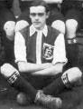

Born: 29 June 1892 in Guernsey. Son of Adolphus a grocer and Mathilda Elizabeth Foote of Millbrook , King’s Rd Guernsey. Sister Florence Marion Brouard.

Joined Elizabeth College in 1900 and left in 1909.
1st XI football, 1st XI cricket, Junior Champion of Sports 1908.

Image extracted from 1908 1st XI Football Photo.

Entered service with Capital and Counties Bank at Warminster and transferred to the Coleford Branch Gloucester.
Captain of West Wilts Football Club 1912 – 13.

War Service
Private in the 1st Royal Gloucester Hussars
Trooper in the Royal Gloucester Hussars in Gallipoli & Egypt. Returned from Egypt suffering from jaundice and dysentry and had to stay in a convalescent home in Luxor. Whist there he was placed on the Staff as an Assistant Paymaster.
He served several months in the Sinai Desert and took part in the attack on El Arish.

Died: 09 January 1917 aged 24 KIA during attack on El Ariish (Sinai Palestine Campaign)
Decorations: Medal , Victory Medal and 1914 – 15 Star.

Memorials:
- College Hall
- Kantara War Memorial Cemetery Grave F 94
- Island War Memorial ?
- Catel Church ??

Notes Memorial Catel church in Catel Matters booklet

Horace Edwin Herbert Cabeldu (2915)
Service No. 20301
Vol. II Pg 227

Born: 12 July 1883 in Jersey. Youngest son of Philip Samuel and Letitia Antoine Cableldu of Kobe, Japan.

Old Victorian, although he does not appear on their Register.
Joined Elizabeth College in 1899 and left in 1900.
Athletics won u16 High Jump 1899.
On the 2nd. October 1902 Horace went to Japan on the SS Malacca to work in his father's Company, Taylors and Outfitters, which he did until 1903.

War Service
He enlisted as a private with the 1st Canadian Contingent at Valcartier on 22nd Sept. 1914, being sent to 10th Battalion (Infantry) of the Alberta Regiment.
2nd Battle of Ypres. Following the first German gas attack he was involved in an action to capture Kitchener’s Wood, and was reported missing as the Battalion had to retire leaving its dead and wounded who fell into the hands of the Germans.

Died: 22 April 1915 aged 32 KIA in 2nd battle of Ypres. Died in the vicinity of St Julien.

Decorations: Medal, Victory Medal, 1914 – 15 Star.
Memorials:
- College Hall
- Menin Gate (Ypres) Memorial Belgium Panel 24-28-30
- Foreigners Cemetery in Motomachi , Yokohama
- Old Victorians.

Notes
No trace on cwgc site. Caheldu on CH memorial

Wilfred Thomas de Lacey Clark (2721)
Vol. II Pg 186
Born: 26 April 1884 in Guernsey eldest son of Rev Henry Clark (C of E Minister) vicar of St John’s, Guernsey and Ada Blanche Smithard.
Vide 2770, 2855, 2969, 3002, 3035.
Married Kathleen Ethel Foote at the Catel Church Jan 1919.

Joined Elizabeth College in 1893 and left in 1902.

War Service
Royal Marine Light Infantry, commissioned 2nd Lt. 1/9/02, Lieutenant 1/7/03 and Captain 1/9/13.
Served on board HMS Victorious, Magnificent, Egmont, Ariadne.
On board HMS Russell 31/8/13 – 30/4/15. Took part in the bombardment of Zeebrugge Oct 1914.
Also served on Victory.
Landed with the Deal Battalion at Helles 16/6/15 Gallipoli, wounded in action in Dardanelles 13 Jul 1915 with a gunshot wound in the leg and went to Hospital in Alexandria.
Rejoined 1st RM Bn 15/10/15 but invalided to UK 1/12/15 (Neurasthenia).
Adj. 3rd Bat. R.M. 1916.
Major in the Royal Marine Light Infantry 1/9/18.
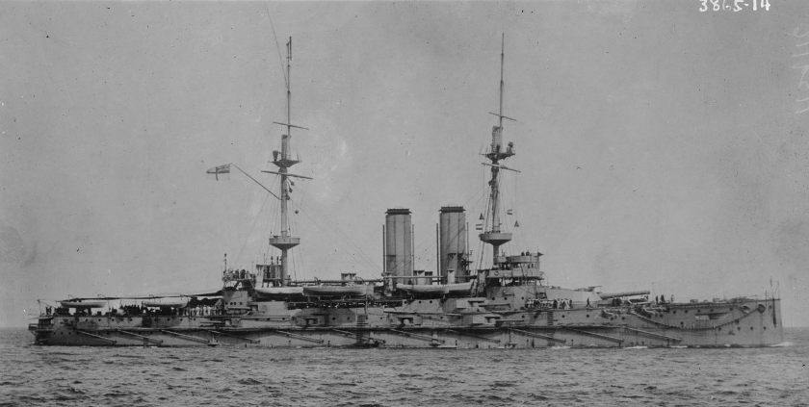 HMS Russell

Died: 22/24 February 1919 aged 35 in Guernsey at Jacqueline, Les Rocquettes, whilst on leave with septic pneumonia.

Decorations: 1914-15 Star,Victory and British War Medal
Memorials:
- College Hall
- St Peter Port (St John’s) Churchyard
- St Peter Port War Memorial

Henry George Walter Clay (3188)

Vol. II Pg 280
Born: 4 February 1895 in Malta. Son of Col. Henry and Mrs Ada Maria Clay, (nee Body) of 281 Hing’s Rd., Kingston Hill, Surrey. Had two sisters Olive and G.

Went to the Modern School Mussoorie, India for four years and
Joined Elizabeth College in 1908 and left in 1910
Cpl Clay served in the OTC for two and a half years.
War Service
Enlisted Autumn 1914. Served in the 1st Bn. East Surrey Regiment in Flanders in 2nd Battle of the Ypres , 2/12/14 – 20/4/15.
April 1915 severely wounded at Hill 60. In this short action 113 men killed and 165 wounded
Recommended for a commission in the field 6/12/15, by Lt. Col. Shipley Commanding Officer 3rd East Surrey.
Received his commission 11/1/16 2nd Lieutenant East Surrey Regt.

Died: 29 July 1916 aged 21. KIA Battle of Somme.
Decorations: Medal and Victory Medal
Memorials:
- College Hall
- Thiepval Memorial Pier and Face 6B and 6C.

Notes
(in CH, but not on EC list)

Charles Herbert Collet (2872) R.M.A. DSO, MID (3)

Vol. II Pg 218
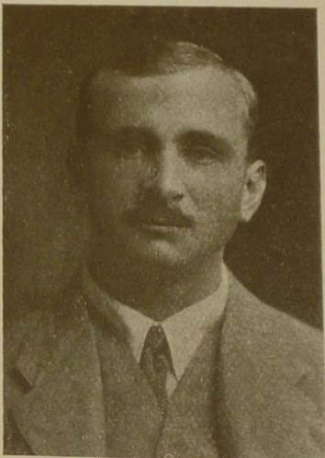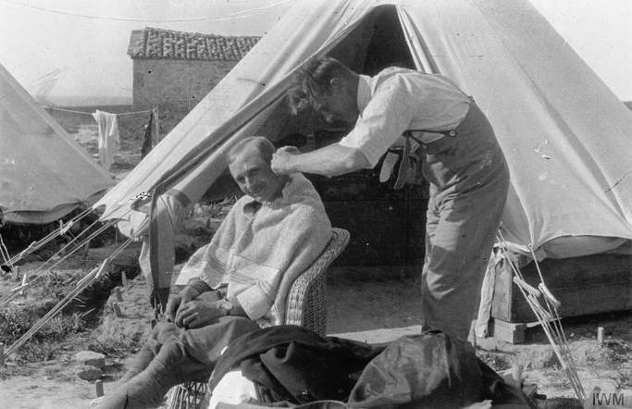
Charles , by kind permission of the Having a haircut in Tenedos, Dardenelles by Lt. Cdr. Preston
Governors, Dulwich College. RN. March 1915 (IWM Q44296).
Born: 4 February 1888 in Calcutta, India. Second son of an egineer James Francis Herbert Collet, late PWD India, and Teresa (Nee Pilley) lived in Guernsey. At time of death he lived at Woodleigh, West End, Southampton. Brothers 2871 and 2873.
Joined Elizabeth College in 1898 and left in 1901. Boxing. Went to Dulwich College and on to the Royal Naval College at Greenwich, and joined the Royal Marine Artillery and promoted Lieutenant in July 1906.
Commissioned into Royal Naval Air Service 1st. September 1905. 2nd Lt 1908, Lieutenant 1909 and appointed to HMS Duncan. 21/10/13 awarded Aviator’s Certificate No. 666 after flying Avro biplane at Central Flying School, Upavon and was promoted Flying Officer. He was sent to Leipzig, Germany in 1913 to collect a biplane - a Deutsche Flugzeug Werke for the Admiralty.
Before the war he boxed and shot to a high standard. Winning the Navy and Marine Light Weight Boxing Championship in 1907. Charles was runner up in the Army and Navy Championships at the same weight. In 1912 he was in the HMS Duncan shooting team which won the Pembroke Camp Challenge Cup.
"He was regarded as one of the best naval airmen". Dulwich Book of Remembrance 1914 - 15*.
On 10th Aug 1914 he took part in the Daily Mail Circuit of Britain Race in the DFW Arrow 154, which developed a technical problem near Scarborough and he had to land on the Race Course. The problem was fixed and he finished second in the Race.
"To see him descend for a thousand feet or so in a closely-wound spiral, with the machine standing vertically on one wing tip was an education in the handling of big aeroplanes". *
He was the first Naval Officer to "Loop the Loop", which he did in a Caudron Biplane. It is said that he could play chess blindfolded.
War Service
Led the first British air raid of WWI attacking the Dusseldorf Zeppelin sheds. Became first man to carry out a bombing raid, when he descended from 6000 feet to 1500 feet in mist and low cloud and dropped his two 20lbs bombs making a direct hit from 600 feet. His aircraft was damaged in the attack, and he won a DSO.
He also served in the defence of Antwerp on the first occasion he had to land between the firing lines and on the second the engine was hit by shrapnel and he just managed to make the Belgian line. He was mistaken for a German pilot and was made prisoner.
In Feb 1915 he was promoted Flight Comodore in the Royal Naval Air Service, and Captain in the Royal Marine Artillery and was sent to the Dardenelles. . He was the first pilot to down an enemy aircraft in the Dardenelles. He is said to have felt more highly of the Turkish than the German pilots.
"One of his favouite stunts was to descend suddenly on a Turkish trench and skimming along the trench quite low to deliver his bombs and make off before the Turks could recover from their surprise". *
He died whilst taking a strange machine to another airfield. His aircraft stalled as he took off from a cliff top, crashed, burst into flames. His observer CPO Keogh dragged him free, but he died. Keogh won the Albert medal later exchanged for the George Cross for his bravery.

Died: 19 August 1915 aged 28 KIA in Gallipoli and buried at Imbros.
Decorations: DSO, Medal, Victory Medal and 1914 – 15 Star and Bar. Mentioned in Despatches three times.
Memorials:
- College Hall
- Lancashire Landing Cemetery C49 or K 49
- Southampton Cenotaph
Notes Fleet Air Arm Museum hold artefacts and a picture of a Sopwith S2 piloted by Charles flying over Barge Creek near Sheerness, Isle of Sheppey going to RNAS Eastchurch. Painted after his death as a tribute.

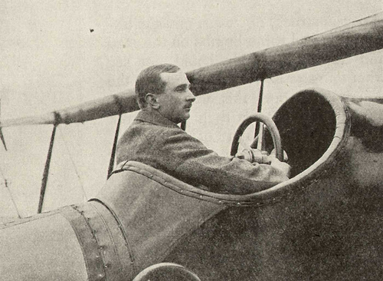
Charles in his plane DFW Arrow at Brooklands?
Eric d’Auvergne Collings (3127)
Vol.II Pg 269

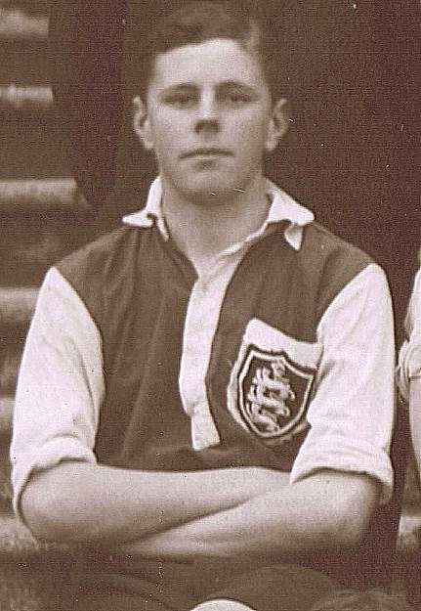
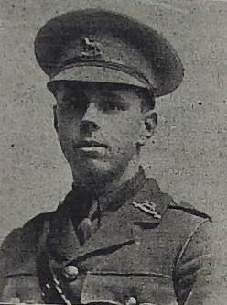
Photo taken from the Guernsey Weekly Press Sept 2nd 1916

Picture left of Eric taken from the School's 1st XI Football 1913 – 14 Team Photo.

Born: 30 November 1896 in Guernsey. Son of Dr. Charles d’A Collings, Surgeon Lt Col Royal Guernsey Militia, and Laura Josephine of The Grange, St Peter Port.
Had five brothers and a sister. (Basil - Lt Cmdre HMS Maidstone, Grant - Lt. Sikhs TA, Wilfred - Capt ASC, Rev Herbert Charles, Edith and Bernard Stanley University College Hall, Ealing

Joined Elizabeth College in 1905 and left in 1914. 1st XI Football , Cricket and Hockey 1913 – 14.

Sandhurst 14 May 1915
War Service
2nd Lt R.G.L.I. January 1915, 2nd Lieutenant in the The Queen’s (Royal West Surrey) Regiment 1916. 1st Bn East Surrey transferred to 1st Bn West Surrey. 3rd Battalion Jan 1916

Died: 23 August 1916 aged 19 . KIA 23 Aug 1916
Decorations: Medal, Victory Medal.
Memorials:
- College Hall
- Quarry Cemetery Montauban Somme 1.D.C.
- Town Church St Peter Port
- Brother’s Cemetry?

Robert Stanley Cooper (3211)
Service No 15529

Vol. II Pg 284
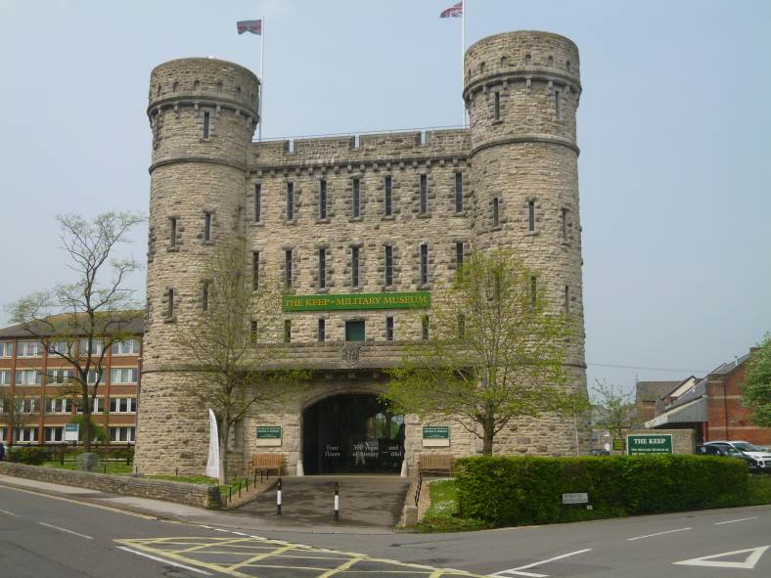

Born: 24 August 1898 in Wimborne Dorset. Son of George Chester Cooper, grower and Elizabeth nee Davies of Hill Crest, Forest, Guernsey.

Joined Elizabeth College in 1909 and left in 1915
No Profession
The Keep Museum of the Devon and Dorset Regiment (May 2016)
War Service
Lance Corporal in the 2nd Battalion of 3rd Dorset Regiment. He took a course on Lewis Gun instruction and passed out as a first class Instuctor with 98%
Served in Mesopotamia

Died: 25 March 1917 aged 18 KIA
Decorations: Medal and Victory Medal.

Memorials:
- College Hall
- Basra Memorial Panel 22 & 63
- Guernsey War Memorial by Charles Sackville West
- Forest Tablet
- The Keep Museum of the Devon and Dorset Regiments.

Cecil Francis Hamilton Cox (3071)

Vol. II Pg 258

Born: 15 May 1893 in Gosport (Fort Elson). Elder son of Maj. later Col. Arthur Francis Hamilton Cox
R. A.P.D. and Susan Josephine Hamilton Cox (Nee Vander Riet) of Alverstoke Hants .
Brother of 3072.

Joined Elizabeth College in 1903 and left in 1906.
War Service
1st South African Inf. Temp 2nd Lt 13/3/16. Then went to France.
2nd Lieutenant in the Duke of Wellington’s Regiment, (8th West Riding Regiment).
Severe gunshot wound to head 15/9/16 and taken to Boulogne Hospital.

Died: 22 August 1917 aged 24 KIA Sep 1917. Ypres salient.

Decorations: Medal Victory Medal.

Memorials:
- College Hall
- Tyne Cot Cemetery,Belgium, Panel 82 to 85 and 162a

Notes
(cwgc has Hamilton-Cox).

Howard Jack Hamilton Cox (3072)

Vol. II Pg 259
Born: 16 October 1894 in Gosport (Fort Elson). Son of Maj. Later Col. Arthur Francis Hamilton Cox
R. A.P.D. and Susan Josephine Hamilton Cox (Nee Vander Riet) of Alverstoke, Hants .

Joined Elizabeth College in 1903 and left in 1906,
Haileybury , United Services College 1908 - 1912. Later known as Imperial Service College.

War Service
Commissioned in the Royal Marine Artillery 10 October 1912.
Captain on 23 July 1917.
Served in th Great War in Gallipoli, H.M.S.Neptune, attached to Royal Naval Siege Guns.

Died: 22 October 1917 aged 23 . KIA.
Decorations: Medal, Victory Medal and 1914 – 15 Star.
Memorials:
- College Hall
- Coxyde Military Cemetery West Vlaanden Belgium IV. H. 17
- Haileybury College Memorial Hertford Heath
- Haileybury College Chapel Roll of Honour
- Roll of Honour Royal Marines Museum, Portsmouth

Notes
(cwgc has Hamilton-Cox) Brother of 3071 above Other details in notes don’t make sense

Cecil Francis Crousaz (2949)
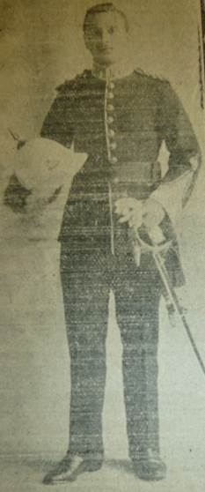
Vol. II Pg 235

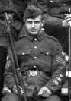
Image extracted from 1908 Shooting VIII Photo Cecil Francis Crousaz from the Weekly Press 1914

Born: 7 December 1888 son of Jurat William de Prelaz Crousaz of 8 Beauvoir Terrace, Les Gravees. Brother 2603.
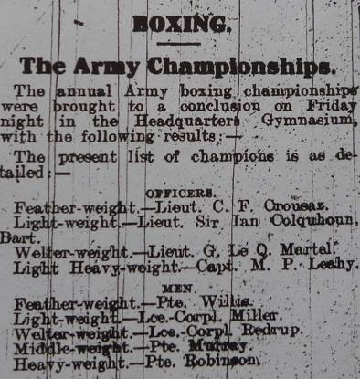
Joined Elizabeth College in 1900 and left in 1908
He was very athletic; Senior Swimming Champion 1907 - 8, also won Boxing and Gymnastic cups. Shot in the Ashburton at Bisley in the first team to shoot the match in 1906 - team placed 30th., also shot in 1907 and in 1908.
Went to the RAMC Woolwich and Sandhurst 1908. Topped the Gymnastics and 2nd in Musketry competitions.
Commissioned 2nd Lt. in 1909 into the South Staffs Regiment, where he undertook gymnastics, and boxing to a high standard. He was in the swimming championships.
Stationed in Pretoria for one year and then two years in Gibralter 1912.
Won the Army Officers Featherweight Boxing Championships at Aldershot on 5th April 1913. See article on the right.
Aldershot News 11th April 1913 (2016)
War Service
Lieutenant in the South Staffordshire Regiment France 1914. He joined 7th Division.
1st Bn and 2nd Bn S Staffs Div disembarked at Zeebrugge 7/10/1914.
Killed leading his men into action at Zonnebecke near Ypres 31st Oct. Supposedly buried at Hooge, but the grave lost.
Died: 13 October 1914 aged 25 KIA
Decorations: Medal, Victory Medal, 1914 – 15 Star and clasp. Plaque and scroll.
Memorials:
- College Hall
- Ypres (Menin Gate) Memorial Panel 35 & 37.

Percival Steward/t Cull (3125) MiD

Vol. II Pg 269

Born: 26 March 1897 in St Martins, Guernsey. Elder son of Edward Percival Stebbings Cull (Grower) and Ellen Cull (Nee Prince) of Moritana, Church Rd., Gurnard, Cowes, Isle of Wight.

Joined Elizabeth College in 1905 and left in 1911.
Went to Canada fruit growing in Feb. 1912 and settled in Ontario.
Enlisted at St Catherine's Ontario 26 th. October 1914. For active service in Toronto on 7 Nov in the 19th Bn Canadian Infantry.
War Service
Went to France on 14 Sept. 1915 and returned to England to take up his commission in Nov. 1916. Gazetted 2nd Lt. and returned to France in June 1917.
2nd Lieutenant in the 3rd (Reserve) Bn. attached to 1st Bn. Northumberland Fusiliers.
Killed at La Conture near Bethune . Mentioned in Despatches for for gallant and distinguished service by Field Marshall Sir Douglas Haigh.

Died: 14 April 1918 aged 21 KIA

Decorations: Medal , Victory Medal, Mentioned in Despatches.
Memorials:
- College Hall
- Canadian No 2 Cemetery Neuville-St Vaast
- St Peter Port War Memorial

Notes Check greatwci and Canadian Check mothers name as differ in de Ruvigny's roll

Francis Arthur Payn d’Auvergne (3201)

Vol. II Pg 282
Born: 23 February 1894 in Jersey. Son of Mr Francis Owen and Mrs. Alice Jane D’Auvergne, (Nee Payn) Northdale,St. Ouen Jersey.

Joined Elizabeth College in 1908 and left in 1912
Played cricket

War Service
2nd Lt 15/9/14
Lt. Royal Jersey Militia, was transferred to the R.G.L.I. on 22 March 1917.
Lieutenant in the Royal Guernsey Light Infantry. France 1917.

Died: On 11 April 1918 aged 24. KIA at Salis-sur-Lys and buried there (Red Cross Letter). The RGLI suffered 80% casualties during the Battle of Lys.
Decorations: Medal and Victory Medal.

Memorials:
- College Hall
- Trois Arbres Cemetery, Steenwerck II.K.22
- St Ouen Jersey

Charles David (3187)
Service No. 2224
Vol. II Pg280
Born: 20 May 1899 in Guernsey. Son of the late John David, Clerk to the Board of Directors, and Annie Margaret Le Pelley.

Joined Elizabeth College in 1908 and left in 1916
War Service
Officer Cadet in the Royal Guernsey Light Infantry
Private R.G.L.I. , promoted to L/Cpl. recommended for commission and sent to Officer's Cadet Battalion 1918. Attached to 15th Artists Rifles. Died at Warley Military Hospital.

Died: 06 December 1918 aged 18 of Influenza

Memorials:
- College Hall
- St Peter Port (Foulon) Cemetery

Howard Thomas de Guerin (2605)
Service No. 116483
Vol. II. Pg161
Born: 28 December 1880 in Guernsey and brother of 2604. Son of the late Frederick Guerin and Hannah of tLe Friquet St Martin’s.

Joined Elizabeth College in 1890 and left in 1893
Three years in Royal Guernsey Light Infantry.
Fruit grower in Los Angeles, California. Later in partnership with his brother as a Grower in Vashon Island off the coast of Washington USA.
War Service
At out break of war enlisted as a trooper in the Canadian Mounted Rifles which was subsequently turned into an Infantry Regt. Probably the 29th Battalion, Vancouver, British Columbian Regt , as Cavalry not needed at the Front.
1914 -18 Battle of Vimy Ridge wounded at Lens.

Died: 21 August 1917 aged 34 KIA at Lens. Hill 70.
Decorations: War Medal, 1914 – 15 Star, Victory Medal.

Memorials:
- College Hall
- Vimy Memorial

Notes
(cwgc has Guerin) So has Elizabethan

Thomas de la Mare (2980)
Service No. 89301
Vol. II Pg 241

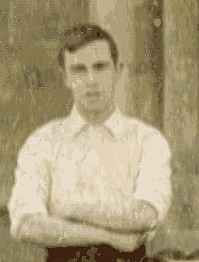
Thomas extracted from 2nd XI Football Team photo of 1903.

Born: 7 January 1887 in Guernsey. Son of Thomas H de la Mare and Nancy (Nee Hamon) of Les Messuriers, Forest.

Joined Elizabeth College from the Intermediate school after winning a scholarship in 1900 and left in 1903.
He was a well known preacher both on the French Methodist Circuit and off it.
War Service
Corporal in “C” Battery, 53rd Brigade, Royal Field Artillery
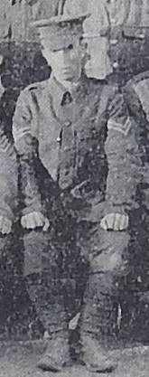
Died three days after being promoted Sgt. In R.F.Artillery, he was killed by a gas shell, possibly a phosgene gas, after leaving his gun and before he could get into the dugout.

Died: 19 December 1915 aged 28 . KIA
Decorations: War Medal 1914 – 15 Star Victory Medal.

Picture of Thomas de la Mare extracted from a picture in the Guernsey Press of the Artillery Overseas
Contingent N0 1 Company April 1915

Memorials:
- College Hall
- Ypres Reservoir Cemetery West Vlanderen Belgium Plot 1. B. 58
- Forest Gate Memorial
- St Peter Port Memorial.

Richard de Beauvoir de Lisle (3134) MID
Vol. II Pg271

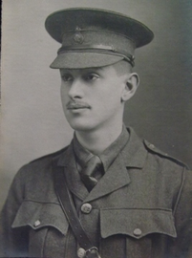
Photo of Richard by kind permission of Alan Cross and the Sports Club.

Born: 23 December 1896 in Saltara India. Son of Brig. Gen. G. de Saumarez (I.A. retd) and Mrs. Florence de Saumarez de Lisle (Nee Smith- Ainsley) of Saumarez Street, Guernsey.

Joined Elizabeth College in 1905 and left in 1914
Shot at Bisley in the Ashburton in 1913 when the team finished 22nd. and 1914 when the school placed 37th.

Sandhurst direct from College in 26th place 1914.
War Service
Great War - North West Frontier of India,
2nd Lt. Indian Army Deccan Infantry appointed 15 December 1914 .
At Tank & Dera Ismail Khan 1915
Promoted to Lieutenant in 1915. 97th Deccan Infantry of the 35th Indian Brigade under Brig. Gen. B.H. Rice. Action at Sheikh Sa'ad (Tigris).
KIA at El Hanna, Mesopotamia (Iraq), 1916.

Died: 21 January 1916 aged 19
Decorations: MID, War Medal, 1914 – 15 Star, Victory Medal.

Memorials:
- College Hall
- Basra Memorial Panel 56.
- St Peter Port War Shrine (Parish)

Francis Barden Denham (3241)
Service No 5992.
Vol. II Pg289

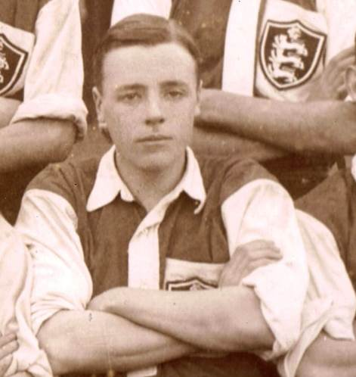

This image taken from the 1913 1st XI Football Team photo is probably Francis

Born: 12 October 1896 in Mysore, India. Younger son of T Denham MA Profesor of History and Principal of the Maharajah’s College Mysore and Helen Duncan.
Elder brother Arthur 3240 R.N. Sub. Lt R.N.V.R. Surgeon survived war.

Joined Elizabeth College in 1910 and left in 1914.
1st XI Football 1912/13
1st XI Hockey 1912/13
Shooting VIII: Fired in the Ashburton at Bisley in 1912, 13, and 14. Team finished 52nd, 22nd, 37th respectively.

Sandhurst 1914.
War Service
2nd Lt. 5th Bn. Worcestershire Regt 1915
Lieutenant in the 5th Worcester Regiment 1916
Battle of Guillemont - Somme 1916
“ Lt. Denham was in my Company. He was killed in the attack at Fricourt on July 7th. I saw him killed by a bullet from a rifle. We were crossing “No Man’s land”, when he was hit and fell dead. We had to leave him there and I do not know if he was found”. Henry Dickens, "B" Company, 1st Worcester.

Died: 07 July 1916 aged 19.
Decorations:
Memorials:
- College Hall
- Thiepval Memorial

Notes
(cwgc has Bardon) So does Kew

Arthur Hugh Dobbs (3003)
Vol. II Pg 245

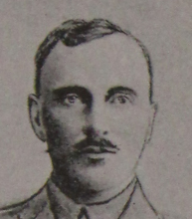
Picture by kind permission of "Our Heroes" South Dublin Libraries.

Born: 16 July 1887 in Hyderabad India. Elder son of the late Lt Col. Alexander Hugh Dobbs (IA) and Mrs. Florence Clementine Dobbs (Nee Fleischer) late of Bray, Co Wicklow.
Brother 3004 served in France, Gallipoli, Mesopotamia & Egypt and survived the war

Joined Elizabeth College in 1901 and left in 1905.

Entered Liverpool Militia. Gazetted 2nd Lieutenant 1905 King’s Own Liverpool Regiment.
Transferred to the Shropshire Light Infantry on 27th May 1908

Sandhurst 1909, University of London.

War Service
2/3 Gurkha Rifles.
Transferred to Indian Army and the 76th Punjabi in the latter part of 1911.
9/9/11 appointed Lieutenant to rank from 27 August.
1914-16 Mesopotamia .
Capt. 92nd Punjaubis.

Died: 22 April 1916 aged 28 KIA near Kut el Awara in an attempt to relieve Kut under General Gorringe
Decorations: War Medal, 1914 -15 Star and Victory Medal

Memorials:
- Basra Memorial Panel 47 & 66

Not on the College Memorial

Elizabethan has different regiments - confusion with brother?
Neville Savage Done (2713)
Formerly Service No. 553634
Vol. II Pg 184
Born: 22 June 1881 Elder son of Rev. William Done Weslyan Minister and Mrs Maria Ellen Done (Nee Savage) of Hillcroft, Groombridge, Royal Tunbrige Wells, Kent.
Brother 2714
Married to Hilda Doris (Nee Woodward) of 14 Rednal Rd, King's Norton, Birmingham, Warkshire.

Joined Elizabeth College in 1893 and left in 1896.
Rydal Mount School, Colwyn Bay 1896 – 1900. (Called Rydal Penrhos School since 1995).
Enthusiastic Alpine climber and a member of the Alpine Club
1904 Solicitor prctising at Lincoln's Inn.
London University OTC 1916 Sergeant in London Regiment promoted to 2nd Lt. 25th Jan 1917.
War Service
Went to France as 2nd Lieutenant in the 6th (Reserve) Bn. Royal Fusiliers City of London Regimentt attached to 22nd (Service) Battalion in January 1917.
He was killed after only three days in action near the village of Irles, Somme, and laid to rest at Pys, but the grave was susequently lost.
His Captain wrote;- "When the battalion went into action he had a job in organizing ' carrying-up parties,' which were perfectly managed, and we have been congratulated on the work done and the way it was done. So there is just this, that however long he had lived with us, he would never have done finer work than he did on the very first day." Elizabethan April 1917.

Died: 10 March 1917 aged 35 KIA
Decorations: War Medal Victory Medal.

Memorials:
- College Hall
- Thiepval Memorial Somme Pier and Face 8 C 9 A and 16 A
- Groombridge Royal Tunbridge Wells
- Beckenham, Kent civic war memorial

Notes His medal index card would tend to suggest that he had originally served on the Western Front, whilst serving as a Private in the 16th (County of London).

Cecil Frederick Napier Draper (3229)

Vol. II Pg 287

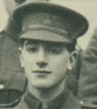
Extract from "A" Coy Photo RMC Nov. 1913.
(See also PEN Howard)

Born: 11 October 1894 son of the late C. N. Draper and Mrs Mary Stewart Wells of Belfast.
Step son to Frederick Neville Wells (Old Radlein) of the Hermitage St Martin’s.

Educated at Framlingham 1906 - 1908
Joined Elizabeth College in 1910 and left in 1912. 1st XI Football 1910 (moved from goal keeper to right back and showed great promise, 1st XI Cricket 1911.

Radley College Oxford OTC Jan 1912 – Dec 1912 as a private and sapper.
Entered RMC Sandhurst July 1913
War Service
2nd Lt. 1st Bn Duke of Cambridge Own , Middlesex Rgt. 1914. Took part in the early phases of the War Battles of Mons, Le Cateau, Marne & Aisne, wounded in the head at Herlies 21/10/1914 and taken to Casualty Staation 33..
Rejoined Regtiment in France again. April 1916 wounded again.
Lieutenant in the Middlesex Regiment

Died: 17 June 1916 aged 21 died of wounds.

Decorations: War Medal, 1914 – 15 Star and clasp, Victory Medal. Plaque and Scroll

Memorials:
- College Hall
- Bethune Town Cemetery Grave III K. 23
- Old Framinghamians
- St Peter Port?
- St Stephens Church Memorial

William Francis Brougham Radclyffe Dugmore (2175), DSO, MiD (3)

Vol. II Pg 67
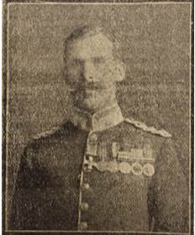
Photo from the Guernsey Weekly Press (1917)
Born: 1 October 1869 in Kingston, Ontario, Canada. Eldest son of the late Captain Francis Sandys Dugmore and the Hon. Evelyn Mary Dugmore daughter of the 2nd. Baron Brougham and Vaux
Husband of Phyllis Dugmore (Nee Usher).
Joined Elizabeth College in 1879 and left in 1880 and the Oratory and St Mary’s Oscott Colleges Edgbaston 1880 – 86.
Enlisted in the 17th Lancers 1887, 2nd Lt. Prince of Wales, North Staffordshire Regt. in June 1894. 2nd class Assistant Uganda 1895.
War Service
He was employed in the Uganda Protectoate 1899 – 1902 serving with the King’s African Rifles in East Africa Operations against the Mazrui Rebel Areda Medal. In Bunyoro 1896 – 97 Medal and in the Uganda Mutiny in 1897 -8. Promoted Lieutenant 1897. He was mentioned in despatches, received Medal and Clasp and DSO - Jan 1899.
In a Parliamentary Paper on Events in Uganda 1899 it was said " Lieutenant W.R. Dugmore, North Staffordshire Regiment. This officer had, perhaps, the most trying time of all, as for over four months he had, practically single-handed, and part of the time in peril of his life, to restrain and look after 500 doubtful Soudanese in Unyoro. That he succeeded shows that he possesses exceptional qualities, great tact, coolness and self resource. Had these 500 Soudanese revolted during the siege of Lubwals the Protectorate would have been placed in the gravest danger, and the very greatest credit is due to this officer for his devoted and successful work in Unyoro." from the Elizabethan 1899.
“ In recognition of services during the recent operations in Uganda". The Insignia were presented by the Queen at Osborne 1 February 1899. Also saw service in Central Africa.
Served in the South African War (Boer) 1899 – 1902 (on special service May to Aug 1901). Promoted Captain Jan 1901. Queen’s Medal and five clasps. Local Major in 2nd Bn. Kitchener Fighting Scouts 1901. Engagements at Heilbron, Kroomspruit,Victoris Spruit, Paardekraal and Klerksdorp. Two months in Johannesburg hospital. East Africa 1902 – 04. Operations against the Mullah in Somaliland - Special Service Officer. Medal and Clasp. Fought in the Uganda Mutiny
He was employed under the Liberian Development Company 27 March 1906 to 17 September 1907. Retired in 1909 and went to Vancouver, B.C. and second in commanded of Canadian 72nd Highlanders.
Rejoined for service in the Great War 1914 – 18. Commanded the Oxfordshire and Buckinghamshire Light Infantry 3/5/15 – 28/12/15. In 1916 became temporary Major.
Transferred to his former Regt., the North Staffordshire in 1917. Mentioned in Despatches twice. Lieutenant Colonel in the North Staffordshire Regiment 1st Bn Prince of Wales.
Died: 12 June 1917 aged 47 KIA at the Assault on Messines - Wytschaele Ridge.
Decorations: DSO, MID, East & West Africa Medal and Clasp, Uganda Mutiny Medal and clasp, Queen’s Sudan Medal, Queen's South African Medal ( Boer War) and five clasps, East Africa Medal and clasp, Great War: MID twice. War Medal, 1915 -15 Star, Victory Medal.
Memorials:
- College Hall
- Railway Dugouts Burial Ground

One of four brothers, three survived . Need s checking

Francis William Durand (2517)

Vol.II Pg 140
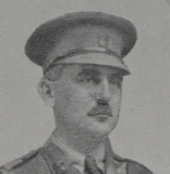
Photo by kind permission of "Our Heroes" South Dublin Libraries

Born: 29 January 1875 in Early Reading. Elder son of the late Rev. Havilland Durand and Mrs Mary Durand (Nee Hawtry) of Moulin Huet.
Married to Geraldene Vesey daughter of Rev. John W. Hawtry of Aldin House, Slough

Joined Elizabeth College in 1888 and left in 1891.
In 1891 gazetted in 3rd Royal Guernsey Light Infantry.
In 1895 joined Rhodesian Horse and served with Gwelo field force in the Matabele Campaign of 1896 and Mashona Campaign of 1897 awarded medal and clasp. Promoted Lieutenant in 1897.

From 1899 - 1902 served with African Transcontinental Telegraph Survey as an assistant surveyor, through German East Africa.
He otained his Company and gazetted into the Royal Munster Fusiliers in 1906. He was employed under both military and civil administration in Zanzibar until 1913 when he retired.
Awarded the El Alijeh 4th Class and Brilliant Star of Zanzibar 3rd Class by the Sultan of Zanzibar. Appointed First Secretary of the Legation at the court of the Sultan of Zanzibar 1906. Retired in 1913 .
Returned to England and joined up for war in 1914.
War Service
Captain in the 2nd Bn. and 3rd Royal Munster Fusiliers. At Aisne, Marne and Ypres.

Died: KIA at Festubert 22 Dec 1914 aged 39
Decorations: British South Africa Company Medal and Mashona Clasp, El Alijeh 4th Class, Brilliant Star of Zanzibar 3rd Class, Medal, Victory Medal, 1914 Star and Clasp.

Memorials:
- College Hall
- Le Touret Memorial Pas de Calais Panel 43 & 44
- St Martin's Memorial

Notes Check wife, mother and Hawtry family as well as Durand Hugenots GWCI Info

Havilland Montague Durand (2727)
Service No. 720
Vol. II Pg 187
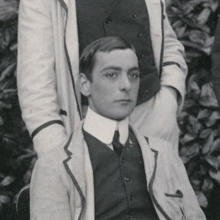
H. M. Durand, 1905 (Ref: UND/F1/FB1905S)
From www.dur.ac.uk/library

Born: 21 December 1882 in Early near Reading. Son of the late Rev. Havilland Durand and Mrs Mary Durand (Nee Hawtry) of Moulin Huet.
Joined Elizabeth College in 1893 and left in 1902. Rugby 1899. Literary Socierty 1899/90. O.C. Lower Certs 1899.
University of Durham, took BA in 1904, Lic Theology 3rd Class 1905, MA in 1907.
Ordained Dean in 1905, priest in 1906 and appointed Curate of St Stephen’s Upton Park E 1907, St Chad’s Longton 1908 – 10, St John’s Kennington 1910 – 11.
Emigrated to Australia where he became a Roman Catholic on 28 Jan 1913 at Greenwich near Sydney.
War Service
Enlisted at the out break of war in New South Wales in the Australian Imperial Forces as a private and went to the Dardenelles with the 13th Infantry Bn., G Company travelling in HMS Ulysses.
“ His comrades having expended all their ammunition, volunteers were called for to go to the beach for more. The path led down to a fire swept gulley and on to a fire swept beach. He volunteered for this dangerous service and got to the beach and returned with ammunition, but was shot dead and fell into the trench. By accomplishing this , he saved the line for had he not arrived with the ammunition his comrades would have beem annihilated and the line broken. “
Died: 27 April 1915 aged 32 KIA in the Dardanelles
Decorations: Medal, Victory Medal 1914 – 15 Star.
Memorials:
- College Hall
- Lone Pine Memorial Gallipoli peninsular Turkey - Panel 69
- St Martin's Memorial

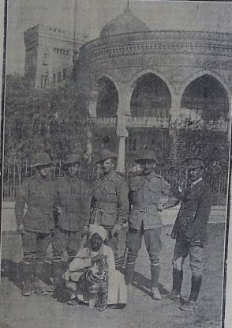

Havilland second from the right in Cairo 1915 from the Guernsey Press.

Notes Check Mothers name

Bryan Grogan Langley Ellis (3298)
Service No. 46618
Vol. III Pg 27
Born: 29 May 1897 in Guernsey son of Mr Langley Fraeburn Ellis and Rose Emily Ellis (Nee Robertson) of 3 Addison Gardens Kensington.

Eastbourne College, Wargrave House 1911 - 1913.
Joined Elizabeth College in 1913 and left in 1914. (He was an O.E. twice over!!!)
Shot for both schools in the Ashburton at Bisley.
In 1913 the Eastbourne VIII placed 39th in the Ashburton.
In 1914 for Elizabeth, he had equal top score with LW Agnew and K Le Cheminant (Capt). The VIII finished 37th.
2nd XI Football 1913.
War Service
2nd. Lt. R.G.A & E 1914. Gazetted Lieutenant and went to France May 1915 R. F.A. wounded 1915.
Attached to Royal Flying Corps at the end of 1916 and promoted to Capt R.F.C.1917 in 50th Balloon Section, Military 5th wing in Egypt. Admitted with a fever and discharged on 6 Oct 1917.
He was flying a BE2e aircraft No. A1836, with 2nd Lt. GS Sawyer, when, as a result of a plane accident at 0945, he sustained a fractured skull at Bilah Abbassia (North East of Cairo).
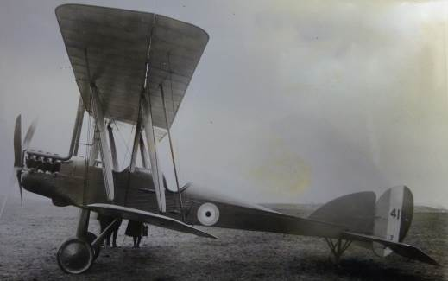
A BE2e similar to A1836. (2016) with thanks to FAST

(The BE2e (Bleriot Experimental) was built in Bristol by de Havilland some time after 1912 and was a development of the BE2. It was a two seater bi plane and A1836 was sent to RNAS. The BE2e was called the "Quirk" as it did not perform as well as it was expected to do.)

Died: 13 October 1917 in Egypt aged 21.
Decorations: Plaque and Scroll
Memorials:
- College Hall
- Cairo War Memorial Cemetery
- Eastbourne College Roll of Honour
Notes Quote from Commanding Officer in Greatwarci.

George Francis Farran (2743)
Service No. 48229
Vol. II Pg 191
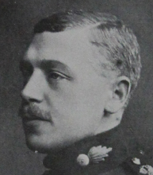

Photo by kind permission of "Our Heroes" South Dublin Libraries.

Born: 7 March 1882 in Rahevy, Co. Dublin. Elder son of Mr George Haughton Farran of Georgeville, Highfield Road, Dublin, late Commissioner of the High Court, Bombay and Mrs. Francis Farran (Nee Ward)

Joined Elizabeth College in 1894 and left in 1896

Entered Woolwich 1899. Commissioned in Woolwich 1900.
2nd Lt. in Royal Field Artillery, Lieutenant 1901 and served for several years in India.
1910 promoted to Captain.
War Service
Promoted Major Oct 1914 and went to France in Nov. 1914 with the Royal Field Artillery, returning to England in February to help in training recruits. Returned to France in July 1915 with his battery 98th Brigade Royal Field Artillery, which he commanded until 1916

Died: 18 July 1916 aged 34 KIA in the Battle of the Somme.

Decorations: Medal, Victory Medal and 1914 – 15 Star.

Memorials:
- College Hall
- Becourt Military Cemetery Becordel-Becourt Somme Plot 1. T. 20

George Malcolm Finlay (3012)
Service No. 37807
Vol. II Pg 247

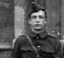
Born: 15 July 1891 in Aldershot son of Surgeon Major William Finlay AMS and Mrs. Amy Blanche Finlay (Nee Cargill) of Monte Belle Beaumont, Jersey.
Husband of Beatrice Maud Farmar Finlay of San Stefano, Mannamead, Plymouth.
Joined Elizabeth College in 1901 and left in 1908. Senior Elocution Cup 1907, Prefect, 1st XI Football 1908, Shooting VIII - shot for the School in 1907 and 1908 at Bisley.

Image extracted from the 1908 Shooting VIII photograph.

1909 Sandhurst.
2nd Lieutenant Leinster Regiment from which he resigned after serving some time.

War Service
Joined up for the great war and commissioned as Captain in the 14th Bn. (Formerly 1st Bn. Leinster Regt.) of the Hampshire Regiment

Died: 05 November 1917 KIA in France aged 26
Decorations: Medal, Victory Medal, 1914 – 15 Star.

Memorials:
- College Hall
- Elzenwalle Brasserie Cemetery
- St. Peter’s Parish Memorial, Jersey.

Notes
(cwgc has Malcome)

John Mathieson Forrester (2656)

Vol. II Pg 171
Born: 1 October 1875 in Sydenham, London. Son of William and Florence Fraser Forrester (Nee Penney).
His brother 2657 was also in France in the Royal Artillary he was invalided out with shell shock.
Husband of Vera Forrester (Nee Henderson) of Briar Ghyll, Pietermaritzburg, Natal.

Joined Elizabeth College in 1891 and left in 1893
1st XI Cricket v Victoria in 1892.
Brighton College.

Accountant and Insurance Agent in Transvaal 1897.
War Service
South African War (Boer War) 1899-1902 with the Imperial Light Horse. Queen’s South Africa Medal and Clasp.
Lieutenant in "C" Company of the 2nd South African Infantry Regiment in France 1914-16.
Wounded in Delville Wood in July 1916.
On 12th October 1916 his unit attacked the German trenches, but were caught by machine gun nests that had been prepared in advance.

Died: 12 October 1916 KIA , aged 41
Decorations: Queen’s South African Medal and Clasp, Medal, Victory, S?????

Memorials:
- College Hall
- Warlencourt British Cemetery, Grave I J 10
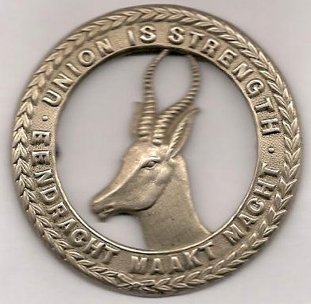

Cap Badge of the 1st South African Brigade
Herbert Joseph Frayling (3206)

Vol. II PG 283

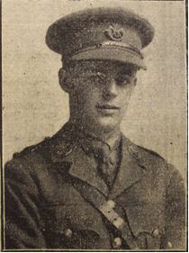

Photo from Guernsey Weekly Press Sep. 7 1918.

Born: 12 April 1899 in St. Peter Port, Guernsey at Hadsley House Le Febre Street. Son of Frederick G Frayling Bank Manager of 9 Yarborough Rd., Southsea and Mrs. Catherine Frayling of Clifton, St Peter Port.
Brother 3128 2nd Lt. R.F. Frayling of the Machine Gun Corps severely wounded in chest and arm in 1916 & wounded again in 1918, but survived the war. Also Doris, Raymond, Bernard and Olive.

Joined Elizabeth College in 1909 and left in 1917.

Cadet in Officer’s training Corps 1917.
Joined Royal Guernsey Light Infantry 5 Nov 1917 (No. 2624).
Gazetted to 2nd Lt. 30 April 1918 and appointed to Hampshire Regt.
War Service
2nd Lieutenant in the Duke of Cornwall’s Light Infantry

Died: 30 August 1918 KIA aged 19
Decorations: Medal and Victory Medal.

Memorials:
- College Hall
- Achiet-le-Grand Communal Cemetery Extension
- St Peter Port Memorial.

Notes
Father Managing director of Le Riches from press report.

Cecil John Fulton (3087)

Vol. II Pg 261

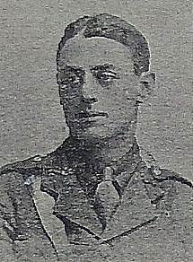
Picture from Guernsey Weekly Press May 1916.

Born: 8 October 1895 in Ealing, London.Son of Lt. Col. Carre Fulton and Mrs Mathilda Anita Fulton of Ivy Gates Guernsey.

Joined Elizabeth College in 1904 and left in 1910
1912 Lieutenant in the 2nd Bn. Royal Guernsey Light Infantry.
War Service
Capt. 1916. 1st R.G.L.I. attached to 6th R. Irish Fusiliers .`

Died: 29 Apr 1916 of gas poisoning and wounds, aged 20
Decorations: None ??

Memorials:
- College Hall
- Bethune Town Cemetery
- St Stephen's Church Memotial

Notes
(Register gives brother's number 3046) Mother could be Anita Mathilda. Could be 7th RI Fusiliers.

Charles Alpe Grantham (2865)

Vol. II Pg 216

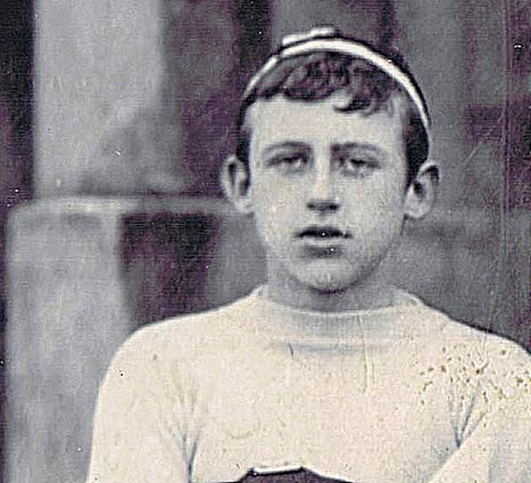
Charles, from the School's 1900 - 1 Rugby XV Photo.

Born: 5 January 1887 in Quetta, India. Elder son of Charles Fulford Grantham (late 33 QVOLC) and Margaret Rosalind Grantham (Nee Alpe) of The Bijou, Thames Ditton Surrey.
Joined Elizabeth College in 1898 and left in 1904.
1st XV Rugby 1900 - 1, 2nd XI Football 1902 -3. 1st XI Cricket 1904, Shooting McCrea Medal 1904,Athletics.
Brother Vincent Alpe Grantham No. , banker in Bombay, Manager London Voluntary Hospitals before NHS. Founder of Guernsey Society 1943. Born Henley on Thames and lived in Surrey.
RMA Sandhurst 1905 – 06. Passed 10th. Awarded 1st XI Colours for football and Captain of his Company Football Team at Sandhurst.
2nd. Lt. in 87th Royal Irish Fusiliers won the 100 yds and 440 yds races for Offivers in the All Ireland Army Athletic Meetin at the Curragh 1907. Passed higher Standard Hindustani 1909.
1909 Lieutenant in the 33rd Queen Victoria’s Own Light Cavalry as Squadron Officer.
Indian Army 1907 to 1914. Captain 1911.
Adjutant Lt. Gov. Bengal’s Bodyguard 1913. ADC to Gov. of Bengal 1914.
War Service
Mesopotamia, Battle of Shaiba.

Died: 03 March 1915 KIA at this battle aged 28

Decorations: Medal, Victory Medal, 1914 – 15 Star.

Memorials:
- College Hall
- Basra War Cemetery III. C. 20

Donald Charles Beric Gumbley (3082)

Vol. II Pg 261

Born: 19 September 1894 in the Isle of Wight. Son of William Gumbley AMICE Civil and Electrical Engineer, and Rosina Edith Gumbley (Nee Mew) of The Den, Melville, Johanesburg, South Africa.

Joined Elizabeth College in 1904 and left in 1906
Joined St John’s College Hurstpierpoint in 1906 and was in Star House. Played 1st XI Football.
Left Hurstpierpoint in 1911 to go into business in Johannesburg.

Went to South Africa and employed as a clerk in the Central Mining Company Johanesburg, then moved to 1st Transvaal Scottish for one year in German south west Africa Campaign .
Then in the 3rd attached to 1st Wiltshire Regt as 2nd Lieutenant.
War Service
In German South West Africa Campaign.
Gazetted 26 Jan 1916 2nd Lieutenant in the 3rd. Battalions of the Wiltshire Regiment (Duke of Edinburgh). First reported wounded and confirmed killed.

Died: 03 September 1916 . KIA France aged 21 and has no known grave.

Decorations: Medal, Victory Medal, 1914 – 15 Star.

Memorials:
- College Hall
- Thiepval Memorial Pier and Face 13 A
- Hurstpierpoint School Memorial.
- South African War Graves Project.

Frank Gordon Hamilton (2848)
Vol. II Pg 212

Born: 16 July 1884 in England. Elder son of Mr Gerald Francis William Hamilton (late Royal Scots) and Mrs Grace Kathleen Hamilton (Nee de Montmorentcy) of Devonia, Carmel, St Martin’s, Guernsey.
Brother to 2849 and 3040

Joined Elizabeth College in 1897 and left in 1900
1901 Ranching in California.
Came home to enlist.

War Service
Lance Corporal in the Manchester Regiment
Served in Dardanelles. Accidently drowned while bathing 1 Aug 1915

Died: 01 August 1915 aged 31
Decorations: Medal, Victory Medal, 1914 – 15 Star.

Memorials:
- College Hall
- Lancashire Landing Cemetery, Turkey.

Notes Some confusion about father’s name and rank needs checking.

Maurice Henry de Jersey Harper (2990) MB. BSc.

Vol. II Pg 242
Born: 1 April 1890 in Jersey. Son of the Rev. Henry Barrett Harper, Naval Chaplain, and latterly C. of E. clergyman of St Martin’s, Guernsey and Mrs. Emily de Montburn Harper.

Joined Elizabeth College in 1901 and left in 1903.
Cricket XI at Trent College and Durham University 1903 – 08 (Wisden).
Packlington School, Durham University, Studied for Medical Profession.
War Service
Surgeon in the Royal Navy on HMS Queen Mary.
At the Battle of Jutland at 4.26 pm on 31 May 1916, H.M.S Queen Mary was attacked by Derfflinger and Seychutz.
" a plunging salvo crashed upon her deck forward. In a moment there was a dazzling flash of red flame where the salvo fell, and then a much heavier explosion rent her amidships. Her bows plunged down, and as the Tiger and New Zealand raced by her to port and starboard, her propellers were still slowly revolving high in the air. In another moment, as her two consorts were smothered in a shower of black debris, there was nothing of her left, but a dark pillar of smoke rising stem like till it spread hundreds of feet high in the likeness of a vast palm tree." " Naval Operations" by Sir Julian S. Corbett. 1923. She lost 57 Officers and 1209 men. See Le Patourel (1962).
Died: 31 May 1916 KIA aged 26
Decorations: Medal, Victory Medal, 1914 – 15 Star.
Memorials:
- College Hall
- Portsmouth Naval Memorial, South Sea, Hants.
- Plaque 1914 – 18 at St Luke’s Chapel Newcastle
- Durham University College of Medicine forerunner of Newcastle University.

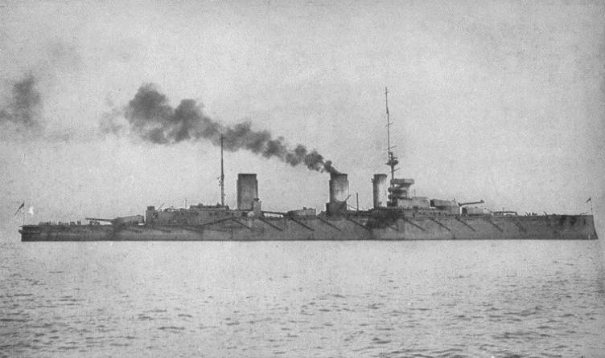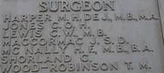
HMS Queen Mary battle cruiser, by courtesy of Maritime Quest. RN Memorial, South Sea, 2016

Beresford Arthur Jardine Havelock (3056) MiD

incorrectly shown on the College Memorial as Arthur Jardine Havelock- Beresford
Vol. II Pg 255
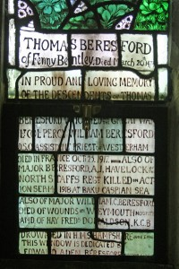

The Beresford panel in the South Chancel window Hoby.

Born: 10 October 1889 in Bankura, India. Son of George Broadfoot Havelock late Bengal Police and Annie Helen Beresford.
Married Kathleen Margaret Smith 6.3.1916. Had two children Patricia Margaret Helen and Beresford Aileen

Joined Elizabeth College in 1903 and left in Dec.1906. He was a prefect in 1906 and a member of the Dramatic Society 1904 - 1906.
Sandhurst
War Service
Lt. 1908, Capt 1915, Major 1917 in the 2nd Battalion Prince of Wales 98th. North Staffordshire Regiment.
1914-18 Mesopotamia then to Baku, Azerbaijan.

Died: 14 September 1918 KIA covering the evacuation of Baku aged 28

Decorations: Medal, Victory Medal, 1914 – 15 Star.

Memorials:
- College Hall
- Haidar Pasha Memorial
- All Saints Church Hoby with Rotherby. Beresford Window in the South Chancel.

Ralph Hawtrey (2555)
Vol. II Pg 149
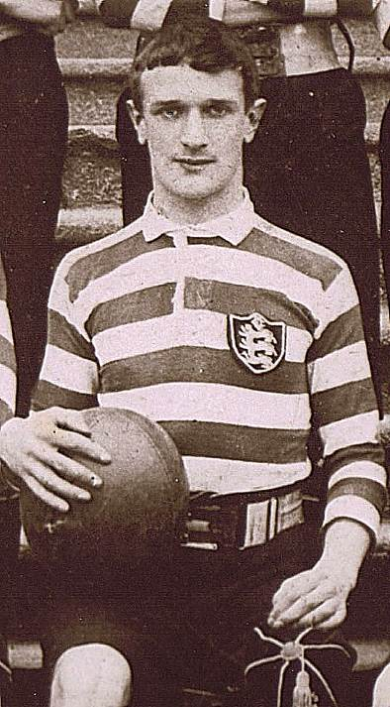
Ralph when Captain of 1st XV, 1897 taken from the School Photograph.

Born: 18 July 1879 in Richmond Surrey. Son of Montague Hawtrey (A tea merchant) and Constance Maud Hawtrey (Nee Parr). Montague died 7 Oct 1879 and his mother re-married Rev. William Penney at Bedminster later to become Principal of Elizabeth College. She died Nov 1915 - a descendant of Catherine Parr wife of Henry VIII.
Husband of Doreen Errol Stopford and they had a son.

St Mark’s School Windsor 1886 - 89
Joined Elizabeth College in 1889 and left in 1898, 1st XI Rugby 1896, 1897
and 1898 when he was Captain " consistingly good example" Elizabethan. Also boxing. Silver Star Royal Drawing Society and Prefect.
Became a Colliery Surveyor in Wales in 1901 aged 21.
Mining in Serbia. Returned at the out break of War and joined the 28th Bn. Of the London Regt (Artist’s Rifles)
War Service
2nd Lieutenant in the 3rd Bn., and transferred to the Royal Engineers in 1916.
179th Tunnelling Coy. At La Boiselle. Account in Elizabethan Dec. 1915. "Ralph Hawtrey is in the Tunnelling Company which works its nefarious plots in this sector, and our first encounter took place at a dramatic moment after the explosion of a German mine. We are inclined to envy these Tunnellers, for their spells in the trenches are brief and their billets permanent, while the luxury of their dug-outs is one of the seven wonders of this new world. Hawtrey's Coy. has just constructed a veritable subterranean Ritz some thirty feet below the surface, lined and wainscotted with wood and with sleeping bunks, and stoves and lights and 'phones" le dernier cri " in luxury."
On 3rd March 1916 went to hospital. Promoted Lieutentant on 15 March 1916.
Sent on a special duty with a brother Officer on Sept. 3rd. They were both found dead having accomplished their task. Both probably killed by exploding shell

Died: 03 September 1916 aged 37 KIA
Decorations: Medal and Victory Medal
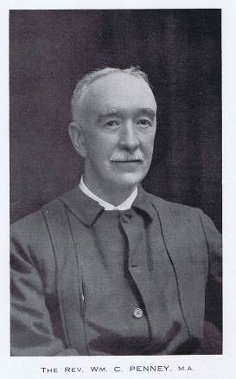
Memorials:
- College Hall
- Albert Communal Cemetery Extension

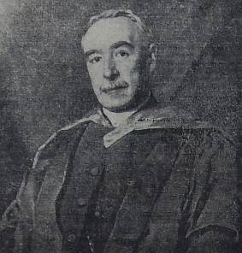 Painting of W C Penney MA
Principal Of Elizabeth College Feb 1916.

Charles Percy Hill (2631)

Vol. II Pg 166

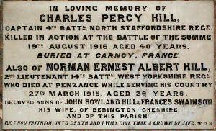

Memorial in St Martin's Church (K Pike)

Born: 15 March 1876 in Lower Bebington, Birkenhead,Cheshire. Son of Mr. John Rowland Hill and Mrs Frances Hill (Nee Swainson)

Joined Elizabeth College in 1891 and left in 1892
Haversham Grammar School 1893 – 96.
Open Mathematics Scholarship at Balliol College Oxford. Also Dallam Lower Exhibition 2nd Class Maths.
Mods 1898 3rd Class in Finals BA Hons. 1896.
Captain of Balliol College Rugby.

Oxford University Volunteer 1899.
Entered Transvaal Civil Service, Education Dept. 1902. Vice Principsal King Edwards Sch., Johannesbburg 1908.

UK leave on outbreak of war. Volunteered and commissioned in Special Reserve. In Sept 1914 as captain in the Special Reserve. He had served on the front since May 1915.

War Service
Captain in the 4th Bn., North Staffordshire Regiment and attached to 1st N. Staffs.

Died: 19 August 1916 KIA aged 40
Decorations: Medal, Victory Medal 1914 – 15 Star.

Memorials:
- College Hall
- Carnoy Military Cemetery,Somme
- St. Martin’s Church & War Memorial
- Bailliol College Chapel West Passage wall.

Notes ?? about birth date Reg gives 1st B. Cert in Kew give 15.

Norman Ernest Albert Hill (2830)

Vol. II Pg 209

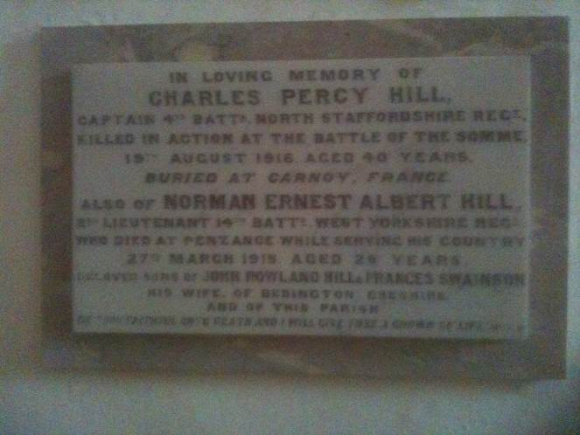

Picture of Memorial in St Martin's Church, Guernsey. (2015)

Born: 6 April 1886 in Lower Bebington, Birkenhead,Cheshire. Son of Mr. John Rowland Hill and Mrs Frances Hill (Nee Swainson)

Joined Elizabeth College in 1896 and left in 1904

2nd Lt. RGLI 1906, Lieutenant in 1908
Tea planter in Ceylon. Came home to enlist in 14th Bat. W. Yorkshire Regt

War Service
2nd Lieutenant in the West Yorkshire Regiment

Died: 27 March 1915 of pneumonia at Penzance aged 28
Decorations: None

Memorials:
- College Hall
- St Martin’s New Cemetery
- St Martin's War Memorial

Gerald Williams Hilliard (2726)

Vol. II Pg 187
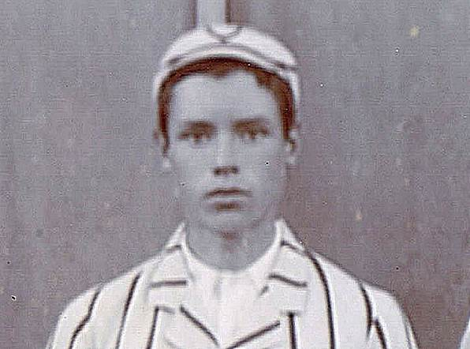
Gerald in the 1st XI Cricket team in 1901

Born: 19 May 1885 in St Peter Port Guernsey. Son of William Edward Hilliard an army officer and Lydia Hilliard (Nee Glasse).
Had a brother Bertram 2725.
Joined Elizabeth College in 1893 and left in 1903
Played 2nd XV Rugby 1900 - 1 and 1st XI Cricket 1901.
Literary Society 1900.
Entered Great Western Railway workshops.
In the Royal Aero Club records he was member No. 1079 and qualified to fly a Graham White biplane at the Graham White School, Hendon, Feb 1915.
War Service
Flight Sub Lieutenant in the Royal Naval Air Service. Killed by too rapid descent in darkness after reporting Zeppelins over Gt. Yarmouth 8 Sep 1915
Died: 08 September 1915 aged 30 KIA
Decorations
Memorials:
- College Hall
- Great Yarmouth (Caistor) Cemetery

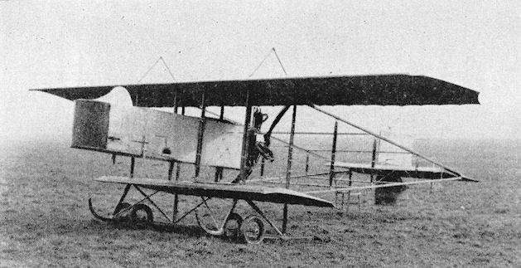

Graham White Bi Plane. Gerald used a similar plane in training and to pass his Certifcate. Thanks to Ian Fagg and FAST Museum.

Notes Check mothers surname. All Bailiwick airmen were OE’s.

Percy Edgar Napier Howard (3246)
Vol. II Pg 290

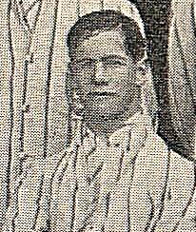
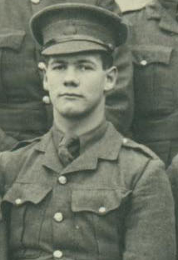
Taken from 1912 - 13 1st XI Cricket photograph Photo Extracted from RMC Sandhurst Nov. 1913
(See CFN Draper)
Born: 23 November 1894 in Darjeeling. Son of William Irvine Kelland Howard and Letitia Howard (Nee Brouckes).

Joined Elizabeth College in 1910 and left in 1913. 1st XI Football 1911 – 12, 1st XI Cricket 1912 – 13.

1913 Sandhurst. "A" Company Royal Military College. ( In the picture he and another cadet are holding the Physical Training Challenge Shield). Gazetted 2nd Lt. Royal Irish Regiment August 1914.
War Service
2nd Lieutenant in the Royal Irish Regiment 1914. Killed in a particularly brilliant charge on evening 19th August in which the Royal Irish took the position at Le Pilley near Lille. In fighting on 18,19,20 only eighty men survived out of a battalion of six hundred most including Howard were killed by shrapnel
KIA near Lille 27th October 1914

Died: 27 October 1914 KIA aged 19
Decorations: Medal, Victory Medal, 1914 Star and Clasp

Memorials:
- College Hall
- Le Touret Memorial

Notes
(cwgc has Edward) Register List has 3240 Conflict on date of death.

Frank de Mouilpied Laine (3008) MC, MiD (2)

Vol. II Pg 268

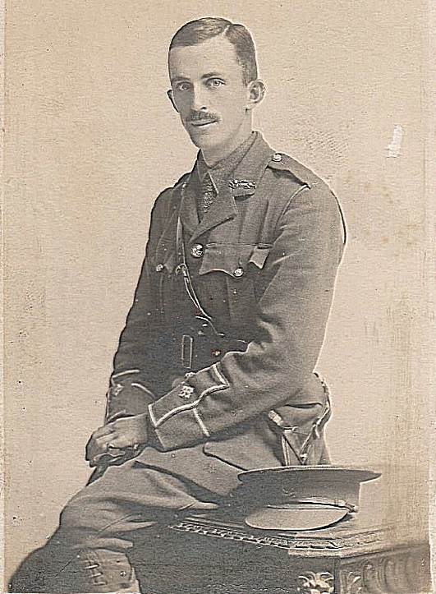

Born: 28 August 1887 in Guernsey.
Eldest son of Eugene Thomas, Manager of the Old Bank, Guernsey and Alice M Laine nee Bourgaize of Les Bourgs St. Andrews.
Brother of Eustace 3123, who survived the war.
Thomas 3124 next page and Norman 3176 who survived the war.
Married Elaine Bichard and had two daughters Elaine and Isobel.

Joined Elizabeth College in 1901 and left in 1905.

Frank by kind permission of his grandson, Paddy O’Sullivan (OE 5385).

Joined the Old Bank Guernsey and later the London & Brazilian Bank, Paris.

2nd. Lieutenant Royal Guernsey Militia May 1910.
War Service
Transferred to the 1st Service Battalion Royal Guernsey Light Infantry, December 1916. Went to France with the Battalion September 1917. Severely wounded on 13 April 1918 at Neuf Berquin in the Battle of Lys.
Battle of Paschendale and Retreat from Lys. Mentioned in Dispatches twice.
Demobilised August 1919 owing to ill health caused by wounds to his right arm.

Died: 7 October 1922 from wounds received 13 th. April 1918, aged 35 years.

Decorations: Military Cross, Medal, Victory Medal.

Memorials:
- St Andrews Church

Thomas de Jersey Laine (3124)

Vol. II Pg 268

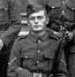
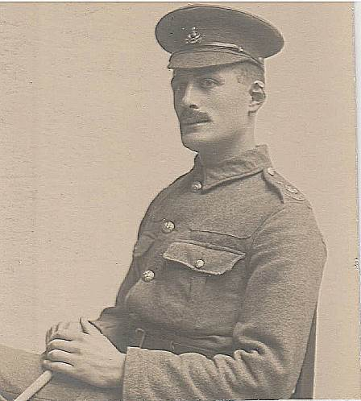
Image taken from 1909 photo of the Shooting VIII. Thomas by kind permission of Paddy O' Sullivan.

Born: 11 June 1892 in Guernsey. Son of Eugene Thomas and Alice M Laine of Les Bourgs St. Andrews.
Joined Elizabeth College in 1905 and left in 1909. Shooting VIII 1909.
After leaving school he worked as a fruit grower at Ashburn Vineries in the Catel.
War Service
Volunteered for war service. Private (3250) in the RGLI in 1914. Cpl. in D Coy. 6th Royal Irish Fusiliers with the Guernsey contingent.
He left Guernsey with the first contingent and arrived in France in December 1915.
Wounded in the back at the Battle of Hulloch.
Gazetted 2nd Lieutenant in the 1st Royal Guernsey Light Infantry 22nd November 1916
Killed at the Battle of Cambrai.

Died: 21 November 1917 KIA aged 25 near Cambrai
Decorations: Medal, Victory Medal,1914 – 15 Star.

Memorials:
- College Hall
- Grammar and Intermediate School Roll of Honour
- Bailiwick Memorial
- Cambrai Memorial Louverval
- St Andrews Church

Frank Stanlie Layard (3133) MID MC
Vol. II Pg 270
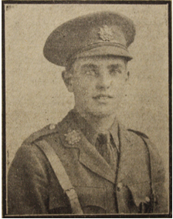
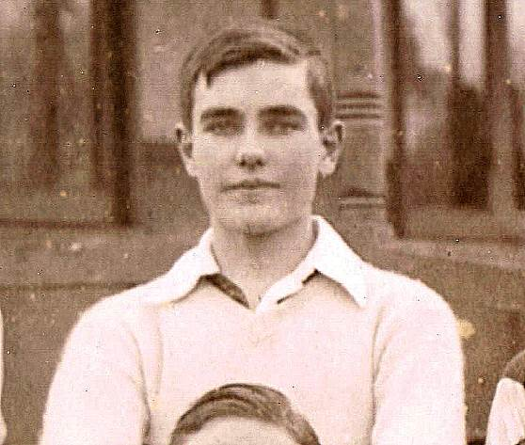
Picture taken from 1913 Football Team (Above)
Left Picture from Guernsey Weekly Press.
Born: 23 February 1897 in Ceylon. Elder son of Frank Henry Layard and Annie Davenport Layard (Nee Noone) of Colombo, Ceylon. Brother of 3139
Joined Elizabeth College 1906 and left 1914. 1st XI Football 1913 - goalkeeper and 1st XI Cricket 1913 -14. Noted in the Ceylon Press in July 1913 for a "strong hit" of 41 not out in a college match.
War Service
Joined as 2nd Lt. the R.G.L.I. in 1914 and went RMC Sandhurst 2 Jan 1915. Played hockey for Sandhurst. Gazetted 15 June 1915 as 2nd Lt. 1st Border Regt. Took part in the attack on Beaumont Hamel 1st July 1916. The regiment lost 75% of the men and 20 of the 23 Officers. In January 1917 he was attached to Brigade Headquarters
He won the MC for clearing an enemy trench at Arras in April 1917 and was given the command of "B" Company. In May of that year he was involved in the attack on Monchy-le-Preux. His company came under heavy fire and he was wounded in the leg and possibly taken prisoner, died and was buried by the Germans as his family thought (noted in July 1917 Elizabethan). It is more likely that he died and was buried by earth thrown up by shell explosions, he was eventually found (1920) by the War Graves Commission, who reburied him. His mother in 1922 visited Stanlie's grave - "With permission from the War Graves Commission, she planted 'Guernsey Lilies' on the grave 'so that all who came will know here lies a Guernsey boy' ".(Transcription copyright Dr.Frances Hurd)
Died: 19 May 1917 KIA in France 1917 aged 20
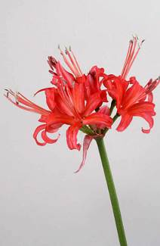
Decorations: Military Cross, MID, Medal and Victory Medal.
Memorials:
- College Hall
- Dury Crucifix Cemetery III. E. II
- Bailiwick Memorial
- St. Peter Port Memorial
- Sandhurst Memorial
Guernsey Lilly

Edward d’Albert Le Mottee (2314) DSO, MiD (2)
Vol. II Pg 96

Born: 20 October 1873. Eldest son of Col. John Edward Le Mottee (1066) (AAG of Royal Guernsey Militia) and Laura Amelia Le Mottee (Lukis) of Le Vauquiedor, St Peter Port, Guernsey.
Brother of 2454, 2455, 2613.

Husband of Charlotte M Le Mottee (Nee Watts). Daughter born in February 1914.

Joined Elizabeth College in 1882 and left in 1883
Twyford School 1883 – 1886
Rugby School 1886 – 1890

RMC Sandhurst 1892.
2nd Lt 1893 Gloucester Regt., Adj. 1898. Passed Staff College 1906 and attached to 2nd, Battalion of the Black Watch for India. Re joined 1st. Battalion Gloucester Regiment 1908 and appointed Deputy Assistant Adjutant General in the Sailkote Brigade, India. 1914 Appointed Company Commander Royal Military College Sandhurst.
War Service
South Africa (Boer War) 1899 – 1902 Operations in Cape Colony OR. Colony Relief of Kimberley, Capture of Cronje, Kronstel, Prtoria and Paardeburg – mentioned in despatches DSO.
1908 DAAG Sialkote Brigade
1914 Major in the Gloucester Regiment attached as GSO2 to 9th Division.
Battle of Loos MID DSO.

Died: 25 September 1915 KIA in the battle of Loos 27 Sep 1915 aged 41
Decorations: MID, DSO, Queen’s South African Medal and three clasps (Relief of Kimberley, Cape Colony, and Paardeburg). King’s South African Medal and two clasps . DSO, MID, Medal, Victory Medal, 1914 – 15 Star.

Memorials:
- College Hall
- Rugby School Memorial Chapel
- Loos Memorial
- Town Church
- St Martin’s Parish Church??? and War Memorial
- St. Mary’s Parish Church Sussex not on Main Sussex Memorial.

Notes Daughter of Col Osmond Francis Le M (976) founded Essay 1934.

George William Le Page (2473)
Service No. 125129

Vol. II Pg 131
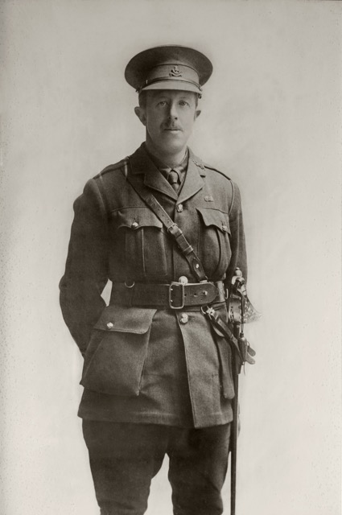
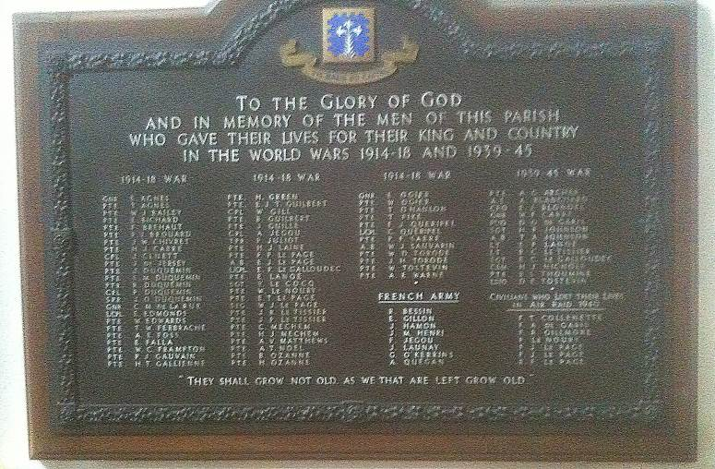
Catel Memorial (2015)

Major George Le Page with thanks to Alan Cross of the Sporting Club.
Born: 24 August 1876 in St Peter Port Guernsey. Son of George William Le Page and Susan Louise (Nee Robiliard)
Husband of Lilian Le Page (Nee Le Feuvre) Strathmore House, The Grange, St Peter Port. Married in Oct 1907. Daughter Marjorie Florence Le Page b. 13 Nov 1908
Joined Elizabeth College in 1887 (5) and left in 1893. Otained Naval Engineer Studenship (38th) 1899.
Fruit Grower in Guernsey
2nd Lt 1893, Capt 1896, Major 1906 in 2nd RGLI.
He commanded the Royal Guernsey Militia Contingent at the Coronation of George V.
War Service
1914 I/C 1st Service Coy Royal Guernsey Militia attached to 1st Royal Irish Regt. as 6th Bn. D Coy (Guernsey contingent)
Died: 26 January 1916 KIA at Loos aged 39
Decorations: Medal, Victory Medal.
Memorials:
- College Hall
- Noeux-le-Mines Communal Cemetery 1.K.21
- Catel Church

Wallace Mackenzie Le Patourel (1962) MA
Vol. III Pg 26????

Born: 19 February 1865 St. Peter Port, in Guernsey. Elder son of the late Messurier and Elizabeth Harrison Le Patourel (nee Mackenzie)
Husband of Eva Beatrix Le Page of High Chimneys, Hurst, Berks.
(Son Herbert won the VC in WWII Hampshire Museum.)

Joined Elizabeth College in 1874 and left in 1882
Balliol College Oxford 1886. BA (4th Class Lit. Hum.) 1890. MA 1895. President of the Oxford University Chess Club 1890.
Ordained Deacon 1891, Priest 1892.
Curate and Precenter of Holy Trinity Sloane Square 1891 – 1907. Vicar of St Dunston East Acton 1907 – 1916. Chairman of the East Acton Dramatic Club.
Owing to ill health he was advised to rest and change to wishing to unite war service with compulsory holiday. He volunteered for work with the Navy and was appointed to HMS Defence as Naval Chaplain..
War Service
Chaplain in the Royal Navy. HMS Defence flagship of the 1st Cruiser squadron.
At 6:05 the German battle cruiser Defflinger spotted the Defence, which was less than 7,300 m away. The Defence was hit by two salvoes from the German ships that caused the aft 9.2-inch magazine to explode. The explosion detonated ammunition in the nearby magazines and she exploded at 6:20 with the loss of between 893 and 903 men who were on board.
Killed on board at Battle of Jutand 31 May 1916. (See Harper 2990)

Died: 31 May 1916 KIA aged 51
Decorations: Victory Medal ?????

Memorials:
- College Hall
- Plymouth Naval Memorial
- Balliol College Oxford Chapel Passage.

Roy Leale (3068)
Service No. 140176??
Vol. III Pg 258

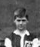
Born: 9 June 1894 in Guernsey. Son of Jurat and Mrs. Leale of Hawthorns St. Sampsons.

Husband of Annie Burton Leale (nee Hall). Daughter born 30th March 1918.

Joined Elizabeth College in 1903 and left in 1909.
1st XI Football, Junior Sports Champion 1909.

Image extracted from the 1908 1st XI Football Photograph.

Secretary of Leale Ltd.
Lieutenant RGLI 1911.
Played football for Northerners and a Muratti team member.

War Service
Volunteered in 1915 for the Front in France and went with the Royal Guernsey Light Infantry contingent attached to the Royal Irish Fusiliers.
On 18th March 1916 at 12.15 at La Bourse, France, he was with a party of men undertaking grenade training exercises,when a Mills Bomb exploded in the hands of one of the men, who was about to throw it. At the Court of Enquiry it was determined that the soldier had not released the lever. It was quoted that Roy Leale had observed premature detonations during the practice. Three officers and seven men were wounded and four men killed in the accident. Roy suffered damage of the right hand and had a cartillage removed from the wrist which meant his hand was fully extended permanently.
Appointed to Reserve Bn. RGLI and promoted Captain.

Died: 21 April 1919 at home after war - aged 24 after 6 weeks of an undiagnosed illness.(Hodgkin’s Disease?)

Decorations : ??????

Memorials:
- College Hall
- Memorial headstone in Vale Independent Cemetery
- Memorial Headstone Vale Independent Cemetry.

Henry Byng Leapingwell (2627)
Vol. III Pg 165

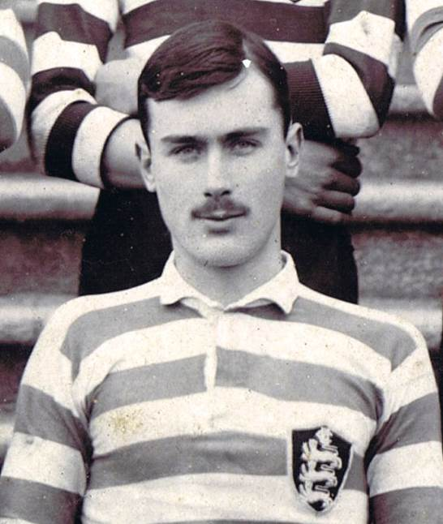

Extract from the school's 1st XV Rugby Team of 1900 when he was Captain

Born: 19 October 1882 in Berhampur, Madras. Youngest son of Lt Col. Arthur and Susan Leapingwell
Elder brother survived the war in the Royal Engineers(R.E.)
Husband of Winifred Gertrude Leapingwell (nee Barney) (See 2891 his brother in law) of Perelle, St Kilda Rd., Belmont, Perth, Australia.
Married 25 July 1908 at Westminster.

Joined Elizabeth College in 1890 and left in 1901.
1st XI Cricket 1898, 1899, 1900 Captain. He was a regular bowler and achieved nine wickets in one game and finished 2nd in bowling averages for 1899 and again in 1900 and second in the batting averages. In 1900 he top scored in the Victoria Match 132 and took ten wickets in the two innings in Jersey and nine wickets in the return match - two innings in Guernsey. (Elizabethan). Elizabeth won both matches.
1st XV Rugby 1897,1898,1899,1900 Captain. Sports Champion - Dobree Belt. Gymnastics. Senior Heavy Weight Boxing Champion 1900 & 1901, Sports Secretary.
O.C. Lower Certs. July 1899
December 1899 Sandhurst direct from Elizabeth in 28th place. Where he placed first in putting the shot and 200 yards in 1902.

Gazetted 2nd Lt. Border Regt. 1902. Transferred to 97th Deccan Regiment 1904. 1907 reached the Final of the Officer's Middleweight Boxing Contest held in Poonah.
War Service
Appointed to 97th Deccan Infantry Gazetted 22 Oct 1911 to Captain

Died: 21 January 1916 KIA at the Battle of Hanna in Mesopotamia aged 33
Decorations: Medal, Victory Medal, 1914 – 15 Star.

Memorials:
- College Hall
- Basra Memorial

Averall Lecky (2765)
Service No.14440/6
Vol. III Pg ????
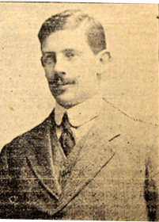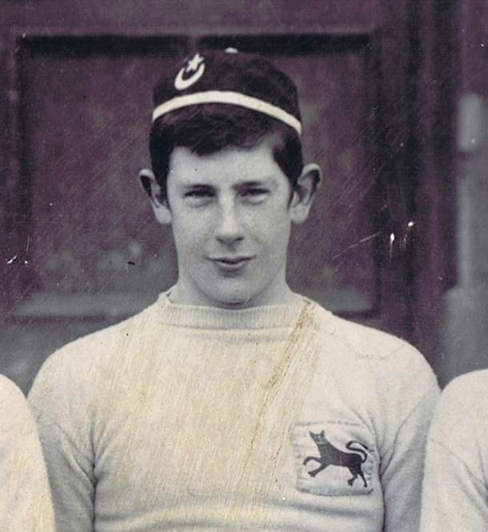
From Guernsey Weekly Press Extract from the school's 2nd XV Rugby photo 1901

Born: 31 March 1885 in Guernsey. Son of Lt. Col J. George (Retd). and Mrs . Amelia Mary Ozanne of Village de Putron.
Joined Elizabeth College in 1894 and left in 1903. Played 2nd XV Rugby 1900 - 1, 1st XI Cricket and 1st XI Football 1903. Gymnastics and Boxing.
Tea Planter in Ceylon. Returned to Guernsey.
Obtained commission as 2nd. Lieutenant in the Prince of Wales Leinster Regiment from R G M 1909. Served in India.
Seconded for West Africa in 1912 with 2nd Bn. Serving on the frontier suppressing cannibalism until 1913. Rejoined Regiment at out break of war 1914 and went to France.
War Service
Died: 20 October 1914 he received a gunshot wound to the head and taken to “C” Section of No. 17 Field Ambulance at Armentieres, where he died of his wounds aged 29
Decorations: Medal, Victory Medal, 1914 Star and Clasp.

Memorials:
- College Hall
- Chapelle d’Armentieres Old Military Cemetery A 10

George Augustus Bligh Livesay (2211)
Vol. II Pg 74
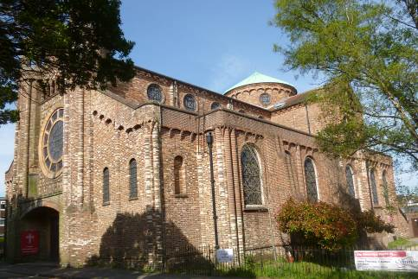
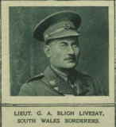
St Osmund's Church Parkstone (May 2016). From Ancestry .com

Born: 15 May 1867 Ventnor Isle of Wight. Son of John Gillet Livesay and E Sophia Henrietta Bligh.
Family of Archetects. Brother of 2212. Married Elizabeth Susan Leyborne - Popham in 1899 in the Isle of Wight.

Joined Elizabeth College in 1880 and left in 1884 for Old Trafford School Manchester.
Archetect and Surveyor. Architect to Royal West Hants and Boscombe Hospital. Illustrated an important Treatise on Sanatoria and open air treatment by Dr A Ransome FRS and some of the designs exhibited at the Royal Academy. Worked on the Church of St Osmund 1904 , Parkstone, erected a temporary nave and aisles based on the church of San Zeno, Verona, but did not complete the work as he enlisted. Church completed in 1914.
War Service
Appointed Temp Lieutenant in the 5th South Wales Borders (Pioneers).
1914 – 16. On 16th July 1915 the regiment landed at Le Harvre and were attached to the 19th Divisional Royal Engineers at St Omer. In 1916 they were in action during the Battle of the Somme.
Died while laying smoke bombs close to the German trenches, which our troops were to pass through as a screen during an attack on 29th May.
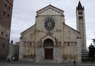
His Commanding Officer wrote:- " the success of the advance in July in that section was mainly due to the very great care and attention given to it by Mr. G. A. B. Livesay. He was working close to the first line of German trenches on the laying of the smoke bombs, forming a curtain of smoke, through which, and under cover of which, the Infantry charged" Elizabethan Dec 1916,

Died: 28 May 1916 KIA aged 51
Decorations: Medal, Victory Medal, 1914 -15 Star.

San Zeno Verona Italy
Where Romeo and Juliet are supposed to have been married.
Memorials:
- College Hall
Holybrook Memorial, Southampton. Originally going to be commemorated on the Brookwood (1914-18) Memorial, however the Hollybrook Memorial was subsequently chosen as the more appropriate location.

Donald Perceval Lynden-Bell (3287)
Vol. III Pg 26

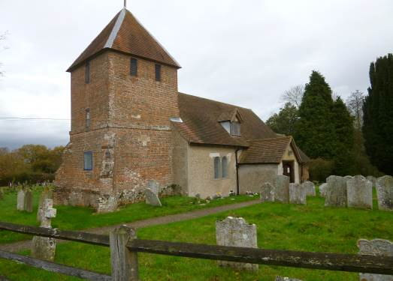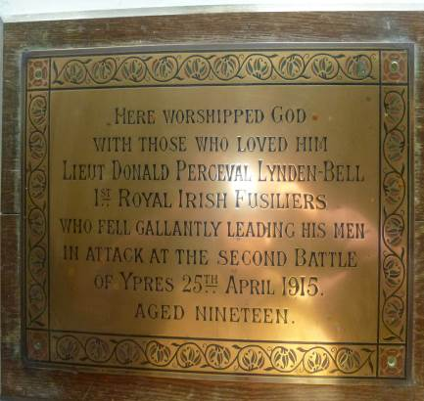
St Peter's Church Tadley (2015) Donald's Memorial Plaque (2015)

Born: 21 November 1895 in Ravelston Terrace, Edinburgh. Elder son of Col. Charles Perceval Lynden – Bell and Helen Geraldine Rate. His father was Adjutant in 4th Royal Scots Regiment, and later (1923) JP for Hampshire. They lived at Baubigny Arsenal and later, Fairlawn House and Hawley House, Tadley, Basingstoke Hants. Donald had three sisters Constance, Geraldine, Helen Winifred and a brother Lt. Col. Lachlan Arthur (3318) Seaforth Highlanders who survived the War. Lt Col Lachlan Arthur short paper about Mesopotamia and Kut. His son, Donald became an eminent astrophysicist winning many awards for theories on the Galaxy.
In the 1901 Census he and his younger brother Lachlan were "boarders" with Mrs Annie Lipscombe in Twickenham nearby to their maternal grandparents, while their mother was at Weston -Super-Mare.
Joined Osborne College 1908 – 09, Clifton College 1909 – 11, Tutor at Reading May 1911 – July 12 and then in Switzerland Sept. 1912 – Dec. 12.
Joined Elizabeth College in 1913 and left in 1913
Sandhurst 27th June 1913
War Service
Princess Victoria’s - Gazetted 14 Aug 1914. Lieutenant in the Royal Irish Fusiliers 1914 1st Battalion, 10th Brigade 4th Div. He was engaged in several actions on the Western Front including the Battle of Le Cateau, the Battle of the Marne, the Battle of the Aisne, the Battle of Messines.
Died: 25 April 1915 . KIA in a charge in front of St Julien at 2nd. Battle of Ypres, aged 19. Buried East of Steinbeck and North of Langemarck Ypres.
Decorations: Victory, War medal and 1915 Star.
DS 2015
Memorials:
- College Hall
- New Irish Farm Cemetery V. B. 14 . Leper West – Vlaanderen Belgium.
- Tadley Memorial, The Green, off Fairlawn Rd. and a plaque and brass memorial in St Peter's Church
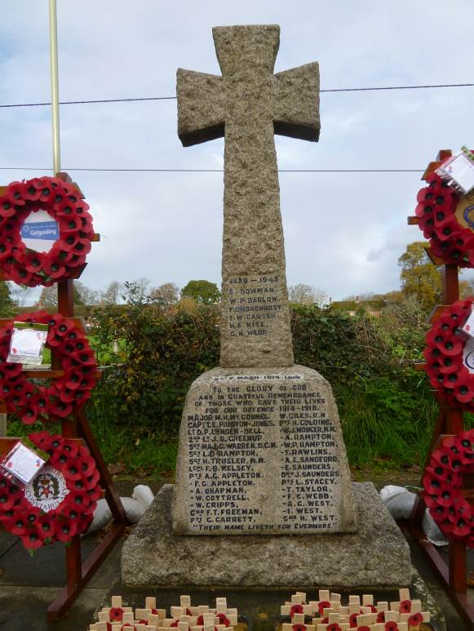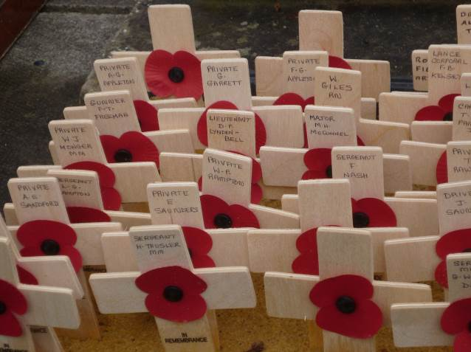
Tadley Memorial The Green (2015) Poppies placed by Tadley school children (2015)

Douglas Cargill Marshall (3039)
Vol. III Pg 252???

Photo by kind permission of Barrie Bertram
Victoria College, Book of Remembrance

Born: 24 September 1893 born in Murree India. Younger son of Col. WS , O/C East Bn., and Mrs M.A. Marshall of Villa Regime, Vue Pietra Kritta, Menton, France.

Joined Elizabeth College in 1902 and left in 1904
Went to a private school in Bournemouth and joined Victoria College 1908.
Shot in the VIII in 1912.
Went to Sandhurst in 1912, and commissioned 2nd Lt 1912 in the 1st. Bn. Lancashire Fusiliers.
War Service
He was given six months sick leave from 4 Quetta Division as he had contracted rheumatic fever 21st Sept 1914. (An illness he had had when nine years old). He went to Jersey from Karachi on HT Dilwara. Promoted Lt. Dec. 1914.
Left Jersey for the Dardenelles May 1915, and joined his Regiment in Gallipoli, which played a gallant part in the Peninsular.

Died: 26 June 1915 KIA aged 21
Decorations: Medal, Victory Medal, 1914 – 14 Star.

Memorials:
- College Hall
- Helles Memorial
- St Saviour’s Parish Jersey
- Old Victorian’s Memorial

Notes
Register says died Nov 1915 See Jersey Evening Post 12 July 1915. Dates of commission need checking

William MacAndrew Marshall (2875) MiD (2)
Vol. ??? Pg 218

Born: 6 February 1889 in Sialkote, India Elder son of Col. William Simpson Marshall ,O/C East Bn Ind Army, and Mrs Mary Augusta Cargill of Villa Regime, Vue Pietra Kritta, Menton, France.

Joined Elizabeth College in 1898 and left in 1906. Senior House Prefect, 1st Xi Cricket,2nd XI Football, Shooting VIII 1906, Editor of the Elizabethan 1904,5,6. Dramatic Society.

Sandhurst 1906 – 7 (25th). In the Shooting VIII. Passed out 3rd.
2nd Lt unattached list Indian Army 1908. Appointed to 37th Dogras 1909. Lt Aug 1909 .
1910 Passed Higher Proficiency Persian Ezam.
War Service
Indian Army 1908-16. Gazetted Captain 1915. Having passed the Higher Proficiency Persian Examination was anxious to do political work and transferred to Political Dept. and posted to Hunza- Nagar district, Gilgit. Rejoined unit at outbreak of war, and served at the Depot for a time.
Rejoined unit at the Front. In 1916 as Adj. Assistant Political Officer of a large District near Baghdad.
Capt. Mesopotamia 1916, the fall of Kut and entry into Baghdad.

Died: 19 March 1918 KIA or possibly assassinated aged 29
Decorations: Mentioned in Despatches twice

Memorials:
- College Hall
- Baghdad (North Gate) War Cemetery
- Halkett Place Primary School Memorial.

Cecil Stephen Bignold Martin (2898)
Vol. III Pg 223

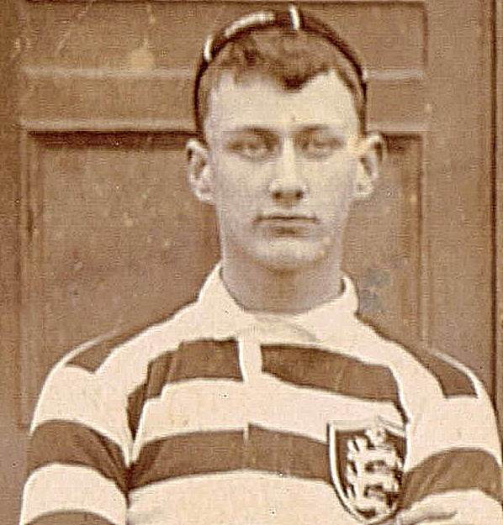

Picture of Cecil extracted from the school 1st XV Rugby photo of 1899 - 1900.

Born: 20 August 1883 in Belgaum, India. Eldest son of Stephen Joseph Martin and Margaret Bignold of Chittagong.
Brother of 3013 and 3070.
Husband of Maud Edith Martin of 65 Goldington Ave., Beds.

Joined Elizabeth College in 1898 and left in 1902
Rugby 2nd XV 1898 - 9, 1st XV 1899 -1900

Sandhurst 1902 – 03.
2nd Lt South Lancashire Regiment, Lieut 1904,
Transferred to Indian Army (46th Punjabis) 1906. 44th Merwaras 1906 . 90th Punjabis 1907.
Burma Military Police 1911 – 12, rejoined 90th Punjabis 1912. Gazetted Captain 28 Nov 1912.
War Service
1914 Captain in the 90th Punjabis - Commanded Depot.
Rejoined unit in Mesopotamia 1915. Severely wounded 6 Feb 1916 and had his left leg amputated. Moved from hospital in Basra to make room for others. Died Mar 1916

Died: 02 March 1916 aged 32
Decorations: Medal, Victory Medal, 1914 – 15 Star.

Memorials:
- College Hall
- Kirkee 1914-1918 Memorial Face G

William Kyle Maturin (2775)
Vol. III Pg 197 - 8

Born: 13 October 1885 in Norbiton Surrey. Brother of 2757

Joined Elizabeth College in 1894 and left in 1895
Tonbridge School.
Joined Transvaal Mounted Police. On retirement from police received a commission in the British East Africa police, served as Staff Officer to the Inspector General of Police in B.E.A. and Uganda. Also as ADS Police in BEA, Uganda and Nile.
War Service
Joined British Expeditionary Force against German East Africa, where he was killed in action.

Died: 29 January 1915 aged 29
Decorations: Medal, Victory Medal, 1914 – 15 Star.

Memorials:
- College Hall
- Mbarara (St James) Churchyard

Notes
(cwgc has the initial K and states ‘K (Kay)’)

Francis Dobree McCrea (3066)
Service No. 05904
Vol. III Pg 257

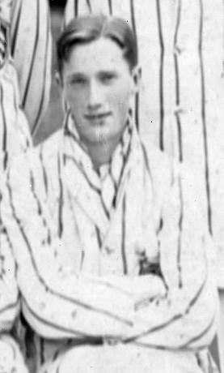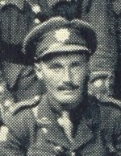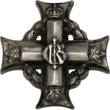
Picture extracted from the school 1st XI Cricket photo 1912.

Born: 16 November 1894 in Jamaica S.I. son of John Henry McCrea,Dep. Inspector General Police Jamaica and Olive McCrea (Nee McDonald) of Minho Bank, Chapelton, Jamaica.
Joined Elizabeth College in 1903 and left in 1913
1st XI Football 1910 – 12, (Goalkeeper),1st XI Cricket 1910 – 12, Senior Sports Champion 1911 – 12
Gazetted Royal Guernsey Artillery (Militia) March 1912, attached to 2nd. Bn. Royal Irish Rgt for duty April – Dec 1912.
Provisional Lt. 1st Regt. Canadian Garrison Artillery April 1913. Attached for duty RCGA, Halifax Apr – Nov 1913. Long course Royal Military College, Kingston November 1913 – May 1914.
War Service
Appointed Lieutenant 30 June 1914 served in Bermuda 1914 – 15 with Royal Canadian Regiment . Evacuated to England sick 1916.
Promoted Capt. 1 Feb 1916 . Appointed on 12 May 1916, Adj. to Canadian Record Office, London.
Overseas (France) 14 Oct 1917 and rejoined CCRC 5 Nov 1917. Wounded.
Temp. Capt. to be Adjt 5 June 1918. Captain in the Royal Canadian Regiment (Nova Scotia)
Died: 28 September 1918 KIA Somme, France aged 23
Decorations: Medal, Victory Medal,
Memorials:
- College Hall.
- Crest Cemetery Fontaine-Notre Dame C25.
- Bailiwick Memorial.
- Memorial Peace Tower Ottawa on certain days.

Notes John Frederick McC VC Basuto Gun War McCrea shooting Medal???? Grandson of Rear Admiral JD McCrea

Henry Tupper Mellish (3055)
Vol. III Pg 255

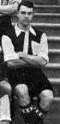

Born: 11 April 1891 in Plymouth. Son of Capt. Robert Walter Mellish, late Cameronians, and Ethel Gertrude Tupper.
Married on 1st Jan 1914 Doris May Atkinson of St Peter’s Baywater.

Joined Elizabeth College in 1903 and left in 1908.
Prefect, 1st XI Football 1906 – 08, 1st XI Cricket 1907 – 08.

Image extracted from 1907 1st XI Football Photo.

1910 Sandhurst
Gazetted to Royal Army Service Corps 1911.
Temporary Captain 1914.
War Service
Temp. Capt. R.A.S.C. France 1914-17, invalided home in 1917. 4 Oct. died of wounds at 17 Craiglea Place Morningside Rd., Edinburgh

Died: 04 October 1917 aged 26
Decorations: Medal, Victory Medal, 1914 Star and Clasp.

Memorials:
- College Hall
- Edinburgh (Morningside) Cemetery
- Bailiwick Memorial St Peter Port.
- St Peter Port Parish Memorial
- Alderney War Memorial

Francis George Ross Mockler (2951) MC,MiD.
Service No. 15382/2
Vol. III Pg 236
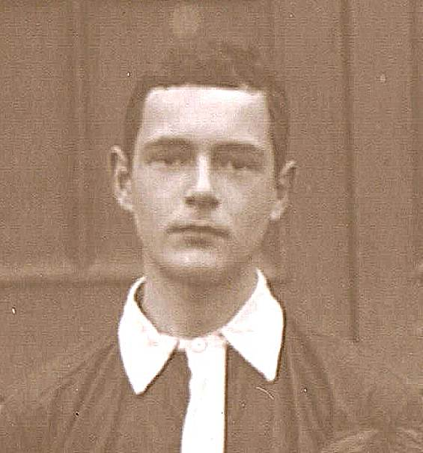
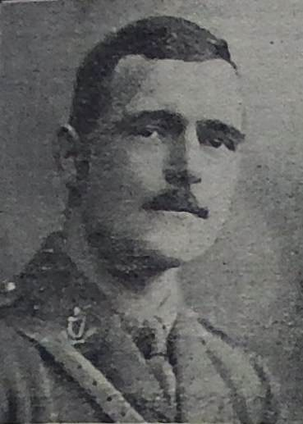

Picture from 1st XI Football Team 1906 Guernsey Weekly Press July 1916

Born: 1 May 1890 in Penge Lewisham, Norwood??.
Son of Maj. Gen. Mockler Indian Army and Mrs Mockler of Rochford The Grange Guernsey.
Brother 2950 Capt. Ghurka Rifles survived the war.

Joined Elizabeth College in 1900 and left in 1908.
Prefect, 1st XI Football 1905 – 08, (his brother and he were Capt. and Secretary in 1907 and he was Captain in 1908), 1st XI Cricket 1905 – 08 Capt. 1908 topping the batting and bowling averages by a long way. Juniot Sports Champion 1907,Boxing. An Artist.

Sandhurst 1908 – 09. Played cricket for the Aldershot Garrison. Passed out 38th.
2nd. Lieutenant Royal Irish Regt. 1910, Lieutenant 1912.
War Service
France 1915-16. 2nd. Bn. Machine Gun Corps. Gazetted Captain in the Royal Irish Regiment 14 Jan 1916. Mentioned in Dispatches. Military Cross Dec 1915

Died: 01 July 1916 KIA Battle of the Somme aged 26
Decorations: Mentioned in Despatches, Military Cross Medal, Victory Medal, 1914 – 14 Star.
Memorials:
- College Hall
- Thiepval Memorial Pier and Face 3A
- Foulon Cemetry

Eric John Mortis (3279)
Vol. III Pg 24

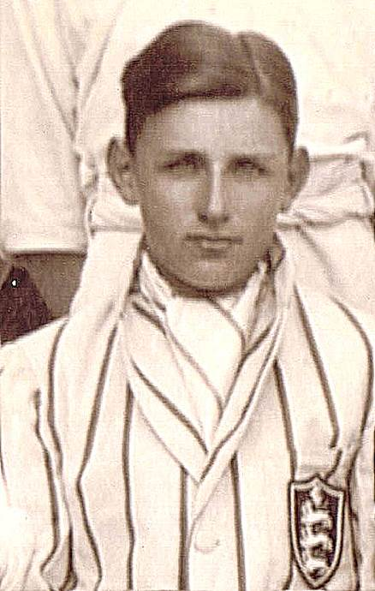
Picture taken from 1915 1st XI Cricket Team photograph.

Born: 23 August 1898 in Kinnerley, Oswestry. Younger son of the late Dr. Harold Edward Mortis and Amy Florence Wright of Mark field Leicester.

Joined Elizabeth College in 1912 and left in 1916
1st XI Cricket 1914, 1915, Captain 1916, 1st XI Football 1914, 1st XI Hockey 1915 - 16. Took part in the 1915 Concert to raise funds for footballs for the troops.
War Service
2nd Lieutenant in the Royal Guernsey Light Infantry
2nd Lt. R.G.L.I. “C” Coy 1st Bn. Commissioned aged 18, 1916.
Front line 1917.

Died: 11 April 1918 KIA at Le Doulieu, while leading his platoon, aged 19
Decorations: Medal, Victory Medal

Memorials:
- College Hall
- Trois Arbres Cemetery Steenwerck Plot II Row O Grave 26
- St Peter Port Parish Memorial ???

Arthur Russell St John Moubray (2917) MC MiD
Vol. III Pg ???

Born: 15 March 1891 in Lake Co, Florida USA. Eldest son of the late Arthur Rolland Moubray RN , grower and Amy Louise Russell.
Brother of 2959, 3074 below

Joined Elizabeth College in 1899 and left in 1906
Served Caledonia Railway for 3 .5 years. Joined Bombay Baroda and Central India Railway 1913.
At out break of war returned to Glasgow and joined Clyde Artillery

War Service
Major in the Royal Garrison Artillery
France 1916 With Seige Battery. Gazetted 27 Sept 1917 Lieut. (Act) Captain.
Captain 1917 Actg. Maj at Cambrai in command of No. 354 Siege Battery 1917 at the Battle of Cambrai. Given another command No. 200 Siege battery.
Mentioned in Despatches and Military Cross 1917.
Wounded on the night of 29 Jun 1918 by a stray shell, died in hospital 2 Jul 1918.

Died: 02 July 1918 aged 27
Decorations: Military Cross (1917), Mentioned in Despatches, ????

Memorials:
- College Hall
- Crouy-sur-Somme British Cemetery III. B. I

Notes
(in CH, but not on EC list

Cyril Lloyd Moubray (3074) M.C. MiD
Service No. 628009
Vol: ?? Pg 259
Born: 19 May 1894 in Viola, Florida. Son of the late Arthur Rolland Moubray RN , grower and Amy Louise Russell.

Joined Elizabeth College in 1903 and left in 1906.
Sir Roger Manwood’s School, Sandwich 1906 – 10.
After three year's training in civil engineering he passed hie exams in 1913.
Civil Engineer and went to British Columbia in 1914 and, at out break of war, was with the Pacific Great Eastern Railway which was being built from Vancouver to Prince George.

Enlisted in 74th 47th Canadian Bn. And went to France.
War Service
2nd Lieutenant in the Royal Engineers.
Commissioned in R.E. 1917, and posted to 76th Field Company R.E.

Died: 09 October 1918 in CWGC aged 24 KIA (Final Advance on Artois?). 20 Oct 1918 ?????
Decorations: M.C., Mentioned in Despatches, Medal, Victory Medal,.

Memorials:
- College Hall
- Forenville Military Cemetery

Rowland Walter Blundell Mourant (2354)
Service No. 2355
Vol II Pg 105
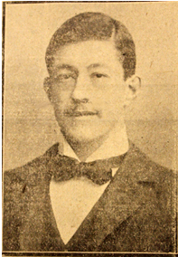

Picture from Guernsey Weekly Press.

Born: 29 June 1874 in Guernsey. Son of James Mourant (1207) Draper and Louisa Jane Waters.
Husband of Alice Maud Mourant of 12 Claremont Rd.,Teddington Middlesex.
Joined Elizabeth College in 1883 and left in 1887.
Brighton Grammar 1887 - 1890
Business in London ,Freeman of City of London (1st OE after Adm Lord de Saumarez).

War Service
South Africa 1899 - 1902. Trooper in the City of London Imperial Volunteers (BloomsburyRifles). Operations in Thaban'chu, Houtnek, Vet river, Zand river, Ventersburg, Pretoria, Doon Kop Johanesburgh. Diamond Hill, Frederickstadt, Belfast, Machadorp and Crocodile Poort . Queen’s Medal and three Clasps. Volunteer Long Service Medal.
1914 Lance Corporal in the London Regiment (Queen Victoria’s Rifles) 1st 9th. Bn. Refused commission .
Wrote an account of Life on the Front for the Elizabethan 1900.

Died: 01 January 1915 KIA at Ypres aged 40
Decorations: Queen’s South African Medal and Johannesburg clasp, Diamond Hill clasp and one other clasp, (presented by the King 11 June 1901), Long Service Medal, Medal, Victory Medal, 1914 Star and Clasp.

Memorials:
- College Hall
- Ypres (Menin Gate) Memorial Panel 54
- Bailiwick Memorial St Peter Port.
- St Peter Port Parish Memorial

Thomas Francis Murray (2315)
Vol. III Pg 98
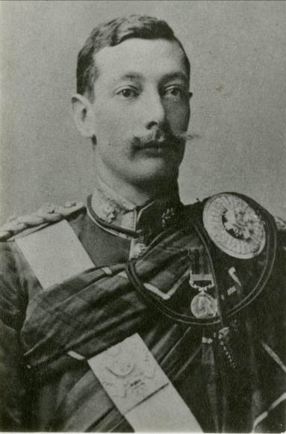
Thomas by kind permission of Sherborne School.

Born: 26 July 1873 in Berhampur, Bengal, India. Eldest son of the late Thomas James Murray (Bengal Civil Service) ICS and Alice Louisa Gaussen of 52 Hautville, Guernsey. She was the sister of Charles Edward, (1642), Edgar (1707) and Frederick Curtis Gaussen (1825).
Father died while on leave at home in Edenderry in 1885 at the age of 39.
Thomas was the eldest of five children. Brother of 2430 and 2591.
Mother remarried in 1887, Sir Charles Alfred Elliot and she became Lady Elliot of Coombe, Wimbledon Park.
Joined Elizabeth College in 1882 and left in 1887 at the age of 14 and went to Sherborne School entered 3rd term of 1887 and left Dec. 1891 from 6th form. He was in School House.
Appointed Lieutenant Highland Light Infantry 1894,
War Service
Awarded India Medal in 1895 with Clasp for Punjab Frontier - North West Frontier 1897 – 98.
Malakand 1898 – 99. Post Orderly Capt to the General Commanding (1898)
South African War. Battle of Diamond Hill near Pretoria and Operations in the Orange River Colony. (Second Boer War). Taken prisoner at Heilbron 4th June 1900. “ He beguiled his captivity in Pretoria by rewriting Tacitus’ Annals from memory in the best Latin he could muster”. "Fourscore Years" by G.G. Coulton.
Awarded the Queen's South African Medal and Clasp for 1901.
As a Captain served in the Egyptian Army 1909, and rejoined his regiment and posted to 2nd Battalion at Fort George N.B.
Major in the 1st Bn. Highland Light Infantry, Indian Expeditionary Force. (Arrived in Marseilles 1.12.14)

Died: 20 December 1914 KIA at the Battle of Festubert aged 40.
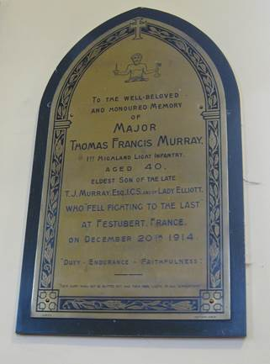
Decorations: The India Medal and Clasp, the Queen's South African Medal and Clasp, Medal, Victory Medal, 1914 – 15 Star.
Memorials:
- College Hall
- Le Touret Memorial Panel 37 and 38
- Sherborne School
- Sherborne Book of Remembrance
- Old Shirburnians Roll of Honour
- Edenderry, Co Offaly (King’s Co)

Memorial Plaque, Castro Petre Church, Edenderry,

Ireland. By kind Permission of Catherine Watson.
Maurice Trevor Myles (3091)
Service No. 180508
Vol. III Pg 262

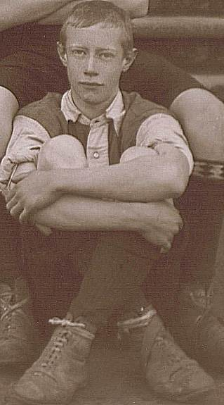

Born: 16 October 1893 in Neemuck, Bombay India. Son of Major Edmund Henry Myles (RAMC) and Alice Caroline Myles (nee Watts).

Joined Elizabeth College in 1904 and left in 1911
1st XI Football and Hockey.

Image is an extract from the school photo of 1st XI Football Team in 1909.

At outbreak of war he was living at Ganges, Salt Spring Island, British Columbia. Tried to enlist four times but was rejected. Eventually succeeded on 15th Dec 1915 at Victoria, British Columbia, and joined 88th Canadian Fusiliers as a private, transferred to 3rd Canadian Pioneers.
War Service
Private in the 3rd. Battalion Canadian Pioneers
Wounded in the buttock and died 20 Apr 1917 at St John's Ambulance Brigade Hospital, Etaples France.

Died: 20 April 1917 aged 23
Decorations: Medal, Victory Medal.

Memorials:
- College Hall
- Etaples Military Cemetery Pas de Calais (Largest CWGC Cemetry in France) XIX E 143
- Honour Roll St John’s Church, Sardis, British Columbia.

Philip Henry Myles (3089)
Vol. III Pg 262

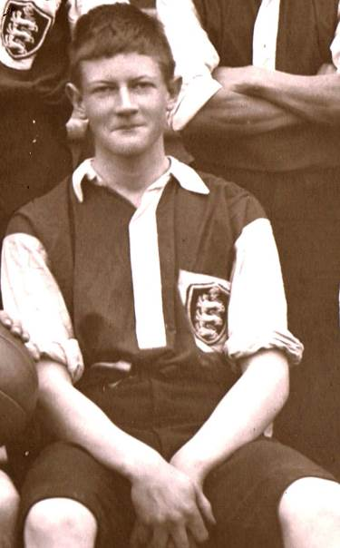
Photo of Philip extracted from the 1st XI Football Team photo of 1906

Born: 18 July 1888 in Murree , India. Son of Maj Edmund Henry Myles (RAMC) and Alice Caroline Watts.
King’s North Gardens Folkestone.
Brother 3090 survived the war, Maurice (3091) see above died.

Joined Elizabeth College in 1904 and left in 1906. Prefect, 1st XI Football 1905-06,1st. XI Cricket 1905 - 06, Dramatic Society.
He was awarded the Vellum of the Humane Society, while at College, for saving with his father, a man from drowning in a rough seas at Havelet Bay in August 1905.

Sandhurst 1907 passed in 4th on the list. Played football.
Unattached list for the Indian Army.1908
1909 41st Dogras, Kashmir Valley. Passed Lower standard Hindustani. Appointed Qtr,-Mr before the out break of war
War Service
1915 Captain in the 41st Dogras
Served in France, Belgium, Oct 1915 - Aug 1915.
Egypt Suez Canal Sept - Dec 1915 and then Mesopotamia wher he took part in Operations near Sheikh Saad on the Tigris. .

Died: 13 January 1916 KIA aged 27 during action at Sheikh Saad Mesopotamia.
Decorations: Medal, Victory Medal, 1914 – 15 Star.

Memorials:
- College Hall
- Amara War Cemetery XIX C 9

Abercrombie Anson Craven Nelson (1413) DSO,MiD.

Vol. ??? Pg 217

Born: 31 January 1853/4 in Plymouth. Younger son of Lt. Gen Sir Alexander Nelson KCB
Brother of 1408

Joined Elizabeth College in 1861 and left in 1866

War Service
Sub Lieut. 61st Regt. 1872, 12th Lancers 1876, 20th Hussars 1880.
ADC to General Officer Commanding in Ceylon 1879.
Promoted to Captain into 5th Dragoon guards 1882. In command of the Berkshire Yeomanry (late 5th Dragoon Guards) Retired as a Capt. in 1883.

Rejoined in Reserve of Officers, Commanding the Berkshire Yeomanry. Operations around Bethlehem and mentioned in Dispatches by Lord Roberts, and promoted as Major in rcognition of his work.
Acting Lt. Col. in Royal Scots 2nd/10th Bn.

Died: 20 May 1916 KIA aged 63
Decorations: DSO in S Africa.

Memorials:
- College Hall
- Edinburgh (Comely Bank) Cemetery F 162

Notes
DSO South Africa Check this Brother 1408 Facts confused.

Howard Patrick Curtis O’Farrell (1991) MiD
Vol. I(I Pg 33 ???

Born: 22 May 1861 Boyle County Roscommon , Ireland. Son of the late Dr. Harward O’ Farrell JP, Dep. Lieut. Of Boyle and Kathleen Rose Curtis.

Joined Elizabeth College in 1875 and left in 1880

Applied for the Connaught Rangers 1881, 6th Dragoon Guards (The Caribineers) 1883.
Lieut. Bengal Staff Corps 1887 attached to 18th Bengal Lancers.
War Service
Saw service as Capt. in Burma 1889
2nd in Command Myotta Flying Column with local rank of Captain. Mentioned in Despatches Medal and two clasps. Retired with gratuity owing to disease contracted on active service 1889.
Became military tutor at York House Gosport 1899

1914 – 16 . 28 April 1915 Lt. Col. 15th/16th Hampshire Regt. Transferred from 15th to another Active Bn. 18 Aug 1915.

Died: 15 December 1916 . Died 6 Dec 1916 Nuneaton aged 55.
Decorations : Mentioned in Despatches, Medal and Two clasps.

Memorials:
- College Hall
- Portsmouth (Eastney or Highland Road) Cemetery Horan Div A I 18.

Notes Cannot find out anything re medals Myotta Flying Column or York House

Dermot Patrick O’Shea (3158)
Vol. III Pg 275

Born: 30 January 1898 Lahore India. Younger son of Frank Bernard O’ Shea, Deputy Postmaster C.P India, and Winifred Ellen Kelly (Widow).
Brother ofWilfred Bernard 3157 below.

Joined Elizabeth College in 1906 and left in 1908
1914 Sandhurst
1915 School of Musketry Pachmarhi

War Service
2nd Lt. Indian Army. Served in Mesopotamia 1914-17.
18th November 1915 Gazetted to join the 69th Punjabis.
Gazetted Lieutenant 17 August 1917 in 69th Punjabis.

Died: 11 September 1917 aged 19 KIA in Aden
Decorations: Medal, Victory Medal, 1914 – 15 Star

Memorials:
- College Hall
- Maala Cemetery, Yemen Sp Plot 1.4
- Kelly College Memorial
- Wanganui New Zealand

Notes Father died in 1927 and buried at Wanganui N.Z.

Wilfred Bernard O’Shea (3157)
Vol. III Pg 275

Born: 12 February 1896 Lahore India. Elder son of Frank Bernard O’ Shea Deputy Postmaster Behar Circle, C.P India, and Winifred Ellen Kelly.
Brother of Dermot 3158 above.
(Living at Sudley Rd. Bognor in 1901 and Oakbank, Newton Abbot 1911.)

Joined Elizabeth College in 1906 and left in 1908.
Kelly College

Sandhurst 1914.
2nd Lt. unattached list of Indian Army 30 Sept 1914.
War Service
2nd Lieutenant in the 1 Battalion of 8th Gurkha Rifles.
Served in Mesopotamia 1914-16. .
Died: 23 May 1916 KIA, aged 20
Decorations: Medal, Victory Medal, 1914 – 15 Star.

Memorials:
- College Hall
- Basra Memorial Panel 55
- Kelly College Memorial
- Wanganui New Zealand

Guy Giffard Oliver (2745) MiD (2)
Vol. III PG 192

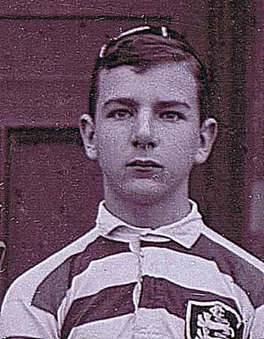
Picture extracted from the school's 1st XV Team Photograph of 1899.

Born: 9 July 1883 in Orlestone. Resided at Burnt Oak, Orlestone Ashford Kent.
Son of Edmund Ward Oliver and Eliza Dunieve Giffard (Sister of 906)
Uncle was Sir Roland Oliver of Capel House Orlestone, Lord Chief Justice during the Great War.

Joined Elizabeth College in 1894 and left in 1899. 2nd & 1st XV Rugby 1898 - 9 " hard working forward with plenty of dash" Elizabethan 1899. Also Boxed and was Middle weight Champion 1899. Miller Prize in uIV.
OCEB Lower Certs. Cricket colours 1900.

1902 Sandhurst passing out in 10th place with honours.
1903 2nd Lt. unattached for Indian Army, Lieut. 1904, 1903-4, Aden hinterland.
Appointed to 102nd (Now 4th) Bombay Grenadiers.
War Service
1912 Captain in the 102 King Edward’s Own Grenadiers. In June 1915 he took part in resisting a night attack by some 8000 tribesmen. 1915 - 16 Mesopotamia.
France 18 Jul 1916 ?????
Died: 21 January 1916 KIA, while gallantly trying to save an Indian Officer in which he was successful though he lost his own life, aged 32
Decorations: Mentioned in Despatches twice, Medal, Victory Medal, 1914 – 15 Star.

Memorials:
- College Hall
- Amara War Cemetery IV B 19
- Church of the Good Shepherd,Orlestone Kent
- St Mary the Virgin Hamstreet

Notes
(cwgc has inits as G C) Check Memorials. Vide 2746

Edward Graeme Ozanne (2687)

Vol. III Pg 178

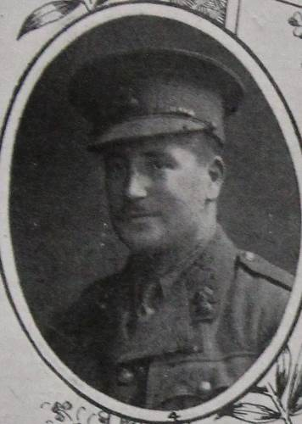
Image by kind permission of the "Our Heroes", South Dublin Libraries.

Born: 5 April 1883 in Guernsey. Only son of Sir Edward Chapmell Ozanne (1445) KBE, and Lady Ozanne ( nee Francis Hinde Boyde). Bailiff of Guernsey appointed 1915. He was a Mason of Doyle Lodge No. 84
Husband of Aline H Ozanne (nee Cloete), daughter of Lt. General Cloete Indian Army of 14 Queen St., Mayfair.

Father was H.M. Bailiff of Guernsey 1915 - 22

Joined Elizabeth College in 1892 and left in 1896. Football XV
Rugby School
Wrote a book???
War Service
2nd Lt. 7th. Royal Fusiliers (City of London Regt.) in May 1901,
Went to South Africa in January 1902 in the Mounted Infantry of the Fourth Battallion..
Saw operations in the Transvaal, Orange River and Cape Colony 1902 under Colonel Dawkins in Sir H. Rawlinson's column. Took part in the drives in Western Transvaal against Delarey.
Queen’s Medal and 4 clasps. Promoted Lieutenant 19 Oct. 1904.
1908 Captain in the 7th Royal Fusiliers, (City of London Regt.) serving in India with 2nd Bat. R. F. at outbreak of war.
18 January 1914 – 14 Feb. 1915 Capt. with the 3rd Bat. KIA in France when a shot came through the parapet.

Died: 14th February 1915 aged 31. Second Battle of Ypres.
Decorations: Queen’s South African Medal and Transvaal clasp, Orange River clasp?, Cape Colony clasp and a fourth clasp. Medal, Victory Medal, 1914 – 15 Star.
Memorials:
- College Hall
- Ramparts Cemetery Lille Gate, Ypres C 17
- St John's Churchyard
- Foulon Cemetry
- Town Church
- Bailiwick Memorial
- St Peter Port Memorial
- Rugby School Memorial Chapel

Henry Marquis Ozanne (2621)
Service No. 114755
Vol. III Pg 164
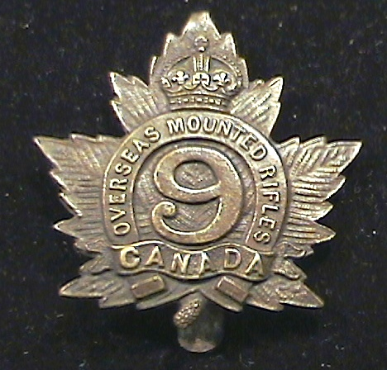
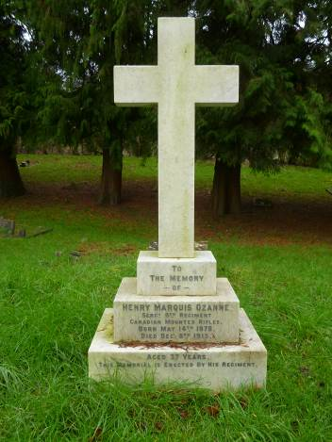

Regimental Cap Badge Grave at Guildford Old Mount 10 Dec.2015
Born: 14 May 1878 in St Peter Port, Guernsey. Son of Henry Ozanne and Louisa Gavet of Valnord.
Vide 2886
Joined Elizabeth College in 1890 and left in 1893
1894 Business in London with Messrs Hunter Craig and Co Ltd. Agent for Southampton District 1898
Served 17 Months with London Rifle Bde, and six years with Hampshire Regt.
Went to live in Canada. 22 Dec 1914 at Swift Current, Saskatchewan. Enlisted in 9th Canadian Mounted Rifles at out break of war 22nd Dec 1914.
War Service
Henry was Canteen Seargent at the Bramshott Camp, Grayshot Village, England for the Canadian Troops. He asked Lt. Georges Codere, acting adj. for the 41st Canadian Infantry Bde, to change some of the money ($1000) into English currency which he did. On return from London with the English currency Codere murdered Henry at Arundel (now Hindhead House).
Codere was detained in Aldershot and found guilty (after 20 minutes deliberation) and sentenced to death, at the Winchester Assizes in February, but the sentence was later commutted to deportation and a term of imprisonment for life, because he was considered insane (It is said that no details of his deportation and imprisonment exist.)
In the court translators were required as the witnesses were French Canadians. Codere of Sherbrooke Quebec, was aged 22 and according to witnesses he had told them that he would kill a man.
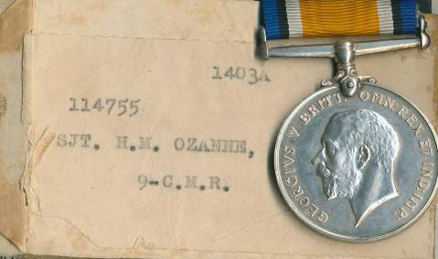
Died: 08/10 December 1915 aged 37
Decorations: Medal
From Gentleman's M. I. Club by Dante
Memorials:
- College Hall
- Guildford Old Mount Cemetery H1
- Canadian virtual Memorial
- Saskatchewan virtual Memorial

Frederick Neville Parker (3063)
Vol. III Pg 257

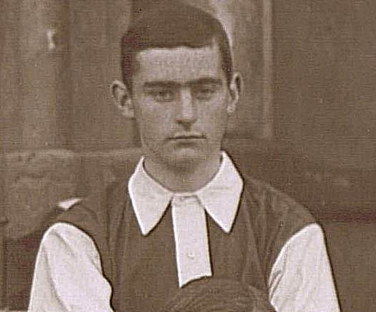

Picture taken from the school 1909 1st XI Football Team photograph.

Born: 8 November 1892 in Torquay. Son of Maj. Gen. Neville Fraser Parker (Indian Army) and Anna Sarah Abbott of 4 Bloomfield Place Bath.
Brother 3062 2nd Lt Oxford & Bucks wounded in May 1917 but survived the war.

Joined Elizabeth College in 1903 and left in 1910.
2nd XI Cricket and 1st XI Football 1908 – 10.

Business in Burma.

War Service
Private in Artist’s Corps, London Regt. 1633, 1914. March 1915 2nd Lieutenant in the 1st King’s Royal Rifle Corps.

Died: 29? April 1915 KIA aged 22
Decorations: Medal, Victory Medal 1914 Star and Clasp

Memorials:
- College Hall
- Bethune Town Cemetery II B 16

Theodore David Parkes (3099)
Service No 871/1
VOL. III Pg 264
Photo in Press? Channel Island project.
Born: 4 July 1895 in Surbiton. Elder son of Mr Henry Parkes and the late Annie Katherine Bell of Les Fauconnaires Bungalow.
Brother James 3121. Sister Molly (Mary) died at sea aged 20 on 10 Oct 1918. She was on the SS Leinster, when it was torpedoed by U Boat – 123 in the Irish Sea 43 miles west of Holyhead on its service from Kingstown Dublin to Holyhead.

Joined Elizabeth College in 1904 and left in 1914
Was a very popular pupil. In the OTC
Obtained a Classical Scholarship (King Charles) to Pembroke College , Oxford. He enlisted before metriculation, as scholar elect. ????
Served in Guernsey.
War Service
Artist's Corps 28th London Brigade, 1914. France 1914-17. OTS and Commissioned 2nd Lt in May 1915., 1/8th South Staffordshire Regiment 1915, Captain 1916.
Wounded May 1916 when a piece of a rifle grenade penetrated the thorax beneath the left clavicle and
.lodged in the scapula.

"DEAR MRS. PARKES,
It is with a heavy heart that I write to express my deep sympathy with you over the loss of your gallant son in action.
He was killed instantaneously on the 5th by a German sniper, having led his company with conspicuous dash and gallantry on the previous day. He fell near Polygon Wood, and lies buried near the mound in Polygon Wood.
The loss is a great one to me personally and to the whole regiment. I had known him since the day he joined the battalion, and I always had a very warm regard for him. I have never known anyone who was so unfailingly cheerful
under adverse conditions. It was a tonic to be near him if things were going badly. He had plenty of ability as well as
personal charm, and was one of my most trusted officers. He was beloved by his brother officers and men more perhaps
than any other officer in the battalion. We have lost one of our bravest and best.
Please accept the deepest sympathy of the whole battalion.
Yours sincerely,
A. B. Beauman, Lieut.-Colonel,
Com. 1/S. Staffordshire Regt" from the Elizabethan December 1917.

Died: 05 October 1917 KIA Polygon Wood aged 22
Decorations: Medal, Victory Medal, 1914 Star and Clasp.

Memorials:
- College Hall
- Tyne Cot Cemetery
- Foulon Cemetry

Wilfred Picton-Warlow (3015)
Vol. III Pg 248

Picture of Wilfred by kind permission of Liz Walton and Greatwarci Project

Born: 6 April 1884 in Laleston, Glamorgan. Son of Col. John Picton Warlow (Later Picton – Tuberville) and Caroline F Tuberville (Step mother, of Bridgend.

Husband of Eleanor Picton – Warlow (nee Temple)

Went to Clifton College 1901.

Joined Elizabeth College in 1901 and left in 1902

Joined the Guernsey Milita from which he passed into the 2nd Bn. Welsh Regt. on 28 Jan 1903 as 2nd Lt., Lieut. 28 Nov 1906 and Captain 7 June in 1913.
1908 went to British Columbia.
He held an Aviators Certificate No. 451 from Brooklands , flying a Bristol Biplane.
Joined No. 3 Squadron Royal Flying Corps in 1913 and appointed Flying Officer at Netheravon.
Promoted Flight Commander over the heads of six other officers 1914 and joined Number 6 Squadron.
War Service
Captain in the Royal Flying Corps
R.F.C. Flt. Cdr. Of “A” Flight. Going on leave he volunteered/ordered to take a Bleriot two seater monoplane back to England as the machine ceased to be of use on the Front and could be used for training purposes.
Last seen flying Calais to Dover 14 Dec. 1914. Never heard of since.

Died: 20 December 1914 aged 30
Decorations: 1914 - 15 Star, War Medal, Victory Medal.

Memorials:
- College Hall
- Arras Flying Services Cemetery

George Kendall Priaulx (2461) DSO MiD (4)
Vol. III Pg 128

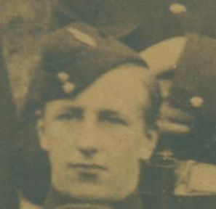
Picture Extracted from RMC Sandhurst photo approx 1895.

Born: 15 September 1877 in Guernsey. Second son of O. de Lancey Priaulx and Mary Whitchurch.
Half brother 2019.

Joined Elizabeth College in 1886 and left in 1891. 1891 – 1894 Harrow.
1895 RMC Sandhurst
Commissioned in 1898 2nd Lt in the 3rd Bn. 60th Rifles - King’s Royal Rifle Corps.
War Service
Africa 1899-1902 (Boer War) Lieutenant with 3rd Bn. KRRC operations in Natal 1899/1900. Relief of Ladysmith, Colenso, Tugela Heights, Spion Kop, Pieter’s Hill and Vaal Krantz. Initially under Sir Redvers Buller ( Guernsey Star 2 Jan 1900) and then Lord Roberts who Mentioned him in Dispatches. Advanced into Transvaal with General Clery. Afterwards joined the Mounted Infantry under General Bruce Hamilton in Operations in Orange Free State, and Cape Colony. Despatches twice. Capt 1902,
Went to India. Major 1910,
1914 in the 2nd Bn. King’s Royal Rifle Corps, dangerously wounded in Sept 1914 on the Marne. Rejoined Bn. and took command 2nd Bat. K.R.R.C. Severely wounded at Loos Sept. 1915. Lt. Col. 1915.
Rejoined unit 1917 and placed in command of 10th Service Bn. KRRC. Transferred to 11th Bn which he re-organised after the Battle of Cambrai. Battles of Mons, Le Cateau ?? capture of village of Metz, Loos., Cambrai.
1917 Mentioned in Despatches, DSO “ Conspicous gallantry and devotion to duty while in command of his battalion. With the utmost confidence and determination he brought his battalion through the village overcoming all obstacles and gaining the objective. He set a magnificent example throughout”

Died: 24 March 1918 . KIA at Voyennes in the St Quentin Offensive by a shell after being shot in the shoulder, aged 40." His battalion loved him and would have followed him anywhere" staff officer H.Q.
Decorations: Queen’s South African Medal and eight clasps including Relief of Ladysmith, Tugela Heights Laing's Nek, Orange Free State, Transvaal and Colenso, King’s Medal and 8?? Clasps, DSO, Mentioned in Despatches four times, Medal, Victory Medal, 1914 Star and Clasp.
Memorials:
- College Hall
- Pozieres Cemetery Panel 61 – 64
- Forest Memorial
- Town Church
- St Martin's Memorial????
- Harrow Memorials of the Great War.

Ernest Charles Purchas (3172)
Service No. 17954/2
Vol. III? Pg277

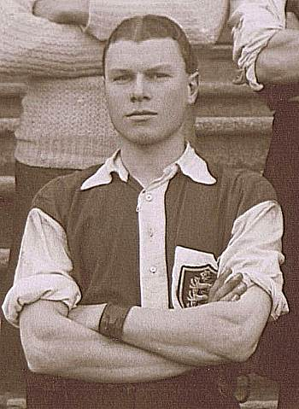

Image extracted from the school 1st XI Football Team photograph when Ernest was Captain in 1909.

Born: 12 December 1891 in Rondebosch, nr Cape Town. Younger son of Col. Charles Purchas (Deputy Assist. Director, Ordnance Camp, Didcot Berks) and Isabelle Massey Laidlaw of 39 Panton St. Haymarket , London.
Brother 3171 Major Leonard William, sisters Sybil Wainwright and Enid Marjorie.

Joined Elizabeth College in 1907 and left in 1910. Prefect 1908, Senior Prect 1909, 1st XI Football 1907,08, Capt 1909 1st XI Cricket 1910,
Senior Sports Champion 1909 – 10, Senior Prefect 1909 – 10

Entered Woolwich 1911.

War Service
2nd Lt. R.F.A. 1912.
Lieutenant in the Royal Horse Artillery “V” Bty, France 1914-15.
Accidentally killed by explosion of Trench Mortar 4 Mar 1915 and taken to Meerut Casualty Clearing Station.

Died: 04 March 1915 aged 23
Decorations: Medal, Victory Medal, 1914 – 15 Star.

Memorials:
- College Hall
- Aire Communal Cemetery 1.H.I

Gerard Beechey Howard Rice (2330) MiD (2)
Vol’ III? Pg99

Born: 21 March 1865 Sutton Courtney Berks. Youngest son of Rev. Richard John Howard Rice MA and Francis Elizabeth Irby.
Brother 1970 Charles Edward
1893 Married Nora Power Palmer daughter of late General Sir Power Palmer (1840 - 1904), India Army and Julia Helen Aylmer née Harris (1848–1896).

Bradfield College 1879 - 82
Joined Elizabeth College in 1882 and left in only 1 term

Sandhurst 1883 passed out with Honours 1884.
War Service
N.E. Frontier 1891. Manipur Medal and Clasp. Capt. 1893. Lieut. Royal Irish Fusiliers 1885. Adj 1895 - 99

S. Africa 1899-1900. Talana Hill and Lombard’s Kop – severely wounded. Queen’s Medal and two clasps.
1901 Transferred to the Indian Army and posted to 31st Punjabis.
Maj. 1903, Gazetted Lt. Col. 4 Dec. 1909,. (?? Brigadier Maj Abbottabad Bde 1904??) Colonel promoted temp Brigadier General Dec 1916 Elizabethan.

Staff College 1908 – 12.

1914 Appointed General Staff Officer 1st Grade India. Pashawar Division 1914.
Mesopotamia 1914-1916. Gazetted Col. 16 March 1914. Despatches twice Medal and Victory Medal .
1915 Brigadier General in the 31st Punjabis. Died on active service of Cholera.

Died: 07 May 1916 aged 51 of Cholera.
Decorations: Indian General Service Medal and North East Frontier Clasp. Queen’s South African Medal and Talana and Ladysmith Clasps?, Mentioned in Despatches twice, Medal and Victory Medal.

Memorials:
- College Hall
- Amara War Cemetery XX11 – 8 - 9

Notes
(cwgc has inits C B H)

Charles Edward Robinson (2962)

Vol. III Pg 238
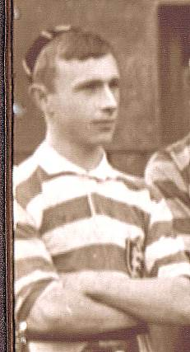
Picture of Charles taken from the school photo of the 1st XV Rugby team 1896.

Born: 2 November 1886 Shanghai, China. Son of the late Edward Le Mesurier Robinson (1594) and Mary Linklater.

Joined Elizabeth College in 1900 and left in 1904

Sandhurst 1903 – he refused the offer as he wanted to go to the Marines and his place was not high enough.
Later entered RMLI and the Royal Naval Air Service in 1914.
Attended the Central Flying School Upavon on 22 January 1914. Trained on the Short Bi plane and Maurice Farman Biplane, passing his Flying Certificate No 740 on 19th Feb 1914 and presented with it on 7th March 1914. Awarded his wings 28 April 1914. Isle of Grain Naval Air Station 29 April 1914. Commissioned 1st September 1914.
Was for some time at Dundee Naval Air Station and went from there to command the Newcastle Air Station.
Henri Farman Sea Plane , Whitley Bay 3 March 1915????
War Service
R.N.A.S. 1914. promoted Captain and served in France, and on patrol over the North Sea & Mediterranean.
Flt Cdre in the Royal Naval Air Service
Shot down and seriously wounded while flying over Turkish lines in Gallipoli November 1915, taken prisoner and died in captivity. Reported killed in Dec 1915.
Died: 08 December 1915 aged 29
Decorations: Medal, Victory Medal and 1914 – 15 Star.

Memorials:
- College Hall
- Helles Memorial

Henry Mark Fector Robinson (2788)

Vol. III Pg. 200
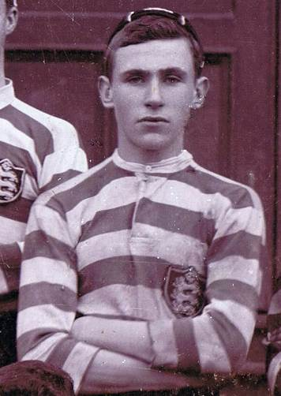
Henry from the 1898 - 99 Rugby Team Photo.

Born: 14 November 1882/3 Melbourne, Australia. Son of the late Edward Le Mesurier Robinson (1594) and Mary Linklater. Brother 2614

Joined Elizabeth College in 1895 and left in 1899.
Played Rugby 1898 Captain 2nd XV, 1899 in 1st XV had "an excellent tackle and much improved kick".

Obtained Royal Naval Studentship (24th) 1899 and wrote an article for the
Elizabethan on life as a cadet at the RNE College Keyham.
Passed to RN Engineering College, Keyham.
Appointed Engineer Lieut. In the Australian Navy 1912.
Resigned commission at out break of war and enlisted as a private in the Sportsman’s Bn. Royal Fusiliers.
War Service
Wounded in 1918 and died from the effects of his wounds in Winchester.
Dismissed from the Service - Field Court Martial.

Died: 30 August 1918 aged 35
Decorations: Medal and Victory Medal.

Memorials:
- College Hall

Notes
(in CH, but not on EC list) No trace cwgc (including mother's maiden name Quarrel)

Edward Wallace Ruse (3167)
Service No. 19516/6
Vol III? Pg 276
Born: 2 May 1895 in Fort Mathilda, Greenock,Scotland. Son of Lt. James Ruse and Alice Maria King of Weymouth.
Brother William civil engineer, George sergeant major, Frederick of FC Ruse Engineers Union Castle.

Joined Elizabeth College in 1907 and left in 1911. Prefect 1909, Senior Prefect 1911
Shooting: In 1910 he and H.G. Carpenter were sent to Bisley to compete in the Cadet Pair - their expenses being paid for by General Le Cocq. The pair placed second. The VIII, which had not competed in 1909 and 1910, went in 1911 and Edward top scored the team finishing 24th. McCrea medal 1910, Corbin Medal 1910-11, Junior Sports Champion 1911.

Woolwich 1911 entrance 15th and passed out 9th.
War Service
Joined up and served under Maj-Gen Lawson ex Governor of Guernsey.
Royal Engineers 128th Field Coy. 26th Field coy in press report.. 1914-15. Lieutenant 1915.
Battles of Neuve Chapelle & Loos wounded at both in the latter a bullet passed through both buttocks. Contracted measles while in hospital in Boulogne.
Edward Ruse and a party of men were detailed to prepare charges of wet gun cotton to destroy an enemy machine gun emplacement as well as block some trenches for an attack on Armentiers.
It was decided to prepare six charges of 20lbs each as well as some mines to be detonated electronically.
Close to the hut where they were working was the 128th Field Company 8th Yorkshire Regt. and the 70th Field Ambulance Advanced Dressing Station.
Edward was considered to be highly experienced, efficient and professional officer but he was accidentally killed with 4 others while preparing the explosives. The enquiry cosidered that the most likely reason for the explosion was a short circuit in one of the fuses.
The accident killed five RE, one 8th Yorks and one from 70th Field Ambulance and wounded a total of twenty three men.

Died: 31 December 1915 aged 20
Decorations: Medal, Victory Medal, 1914 – 15 Star.

Memorials:
- College Hall
- Erquinghem-Lys Cemetery 1 G 2

East India Dock.

George Julian Ryan (2433) DSO, Order of the Medjidie, (Turkey), MiD (2).

Vol. III Pg 123

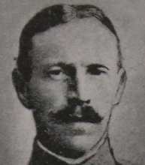
Image by kind permission of the "Our Heroes", South Dublin Libraries.

Born: 18 September 1878 in Tenby. Son of Lt Col. G Ryan, Army Medical Dept and Mrs Ryan of Ashby,Ryde, Isle of Wight.
brother 2432

Joined Elizabeth College in 1885 and left in 1893.
United Service College Westward Ho.
Sandhurst 1896.

Commissioned in to 2nd Lieutenant in 1st Battalion Royal Munster Fusiliers 1897,

War Service
Lieut. 1899. South Africa 1899 – 1901. with the mounted Infantry.
Advance on Kimberley, action at Belmont and Modder River. Operations in the Transvaal, 1900. Queens medal with five Clasps and DSO and Despatches.
Seconded for service with the Egyptian Army 1903 – 10. Saw service in Sudan in 1905 -1906 and mentioned in Despatches and received the Egyptian Medal and two Clasps.
1907 Operations in Kordofan. 1908 Soudan. Operations on the Blue Nile
Capt. 1908, Bt. Maj. 1908.
Lieutenant Colonel in the 2nd Bn. Royal Munster Fusiliers, in France 1914. Mentioned in Despatches.

Died: 23 January 1915 killed by a sniper as he returned from inspecting the trenches aged 36
Decorations: DSO, Queen’s South African Medal and five Clasps, Egyptian Medal and two clasps, mentioned in Despatches twice, Medal, Victory Medal, 1914 - 15 Star and Clasp

Memorials:
- College Hall
- Guards Cemetry, Windy Corner, Cuinchy Pas de Calais IV. B. 45

Charles Simms Reeve (2904)
Service No. 13046/3
Vol. III Pg 224?

Photo by kind permission of Barrie Bertram,
Victoria College Book of Remembrance.

Born: 26 December 1885 in Brancaster, Norfolk, (Probably Staithe House). Son of William Hawkins Simms Reeve and Mary Reeve (Nee Wilson) of Norfolk, and later Harrogate. Grandson of Simms Reeve of Brancaster Hall - JP, Recorder for Yarmouth, Lord Mayor and in 1898 High Sheriff of Norfolk.

He had two brothers George Cyril 2902, Arthur William Simms 2905.

Joined Elizabeth College in 1899 in lower 4th and left in 1901. Boxing - Bantam Weight Champion 1900. Victoria College 1901 - 2
T. Eastman Esq. Northwood Park, Winchester - a school with a Naval bias. 1902 – 04.

Sandhurst 1905
Commissioned 2nd. Lieutenant into 2nd Bn. East Surrey Regt. 1906 and served eight years in India.
1909 Promoted Lieutenant
War Service
France 1914-15
Promoted Capt. East Surrey Regt. April 1914. Regiment went to France January 1915.

Died: 14 February 1915 . KIA and buried near Shelley Farm, St. Eloi, Voormaszeele, aged 29
Newspaper report gives 16 Feb
Decorations: Medal, Victory Medal, 1914 – 15 Star.

Memorials:
- College Hall
- Ypres (Menin Gate) Memorial Panel 34
- Victoria Book of Remembrance.
- Brancaster War Memorial in St Mary the Virgin Church.
- Harrogate Cenotaph Front - Panel 3 (Right).
Notes His surname was Reeve It was not until the mid 1920s that it became hyphenated Simms - Reeve

Frederick Fieldhouse Smith (3174)
Service No. 8811
Vol. III Pg 277/8

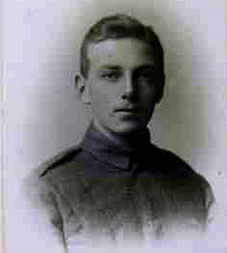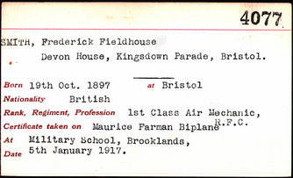
Picture of Frederick 5.1.1917 and his Royal Aero Club Certificate by kind permission of Steve Shepherd.

Born: 19 October 1897 in Bristol. Son of James Frederick Smith and Agnes Anna Smith (Nee Howell).

Joined Elizabeth College in 1907 and left in 1914.
1st XI Football and Hockey 1913 - 1914. Shot at Bisley in the Ashburton in 1913. The VIII came 22nd and Frederick made equal top score with K. Le Cheminant and A.A. Denham. Boxing Champion 1910 Baby Weight, 1912 Bantam Weight, 1914 Middle Weight. Junior Sports Champion 1913.
Obtained the Royal Aero Club Certificate (No 4077) above on 5 Jan 1917 at Brooklands School . 1st Class Military Certificate for Flying and Gunnery.. Went to Farnborough. 1st Class Air Mechanic.

War Service
Sergeant in the Royal Flying Corps 59th Squadron, which was an army co-operation unit, spotting for guns and troop movements and other vital activities. He served in the area around Arras. Promoted 2nd Lt.
Royal Flying Corps. France April 10th 1917, good work till 25 Apr 1917. On that day he and his observer Lt Dilnutt flew a line patrol at 0515 hrs and did not return. "Machine not returned owing to casualty". Frederick was taken prisoner. Died of heart failure following diptheria.
Died: 28 April 1918 aged 20 in Munster.
Decorations:
Memorials:
- College Hall
- Cologne Station Cemetery XVII A 34
- Bailiwick Roll of Honour.

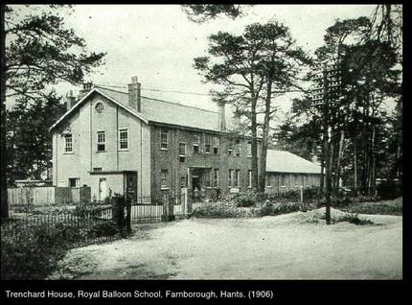
Frederick came here in 1918. Now the home of the FAST Museum, Farnborough. (FAST and Ian Fagg)

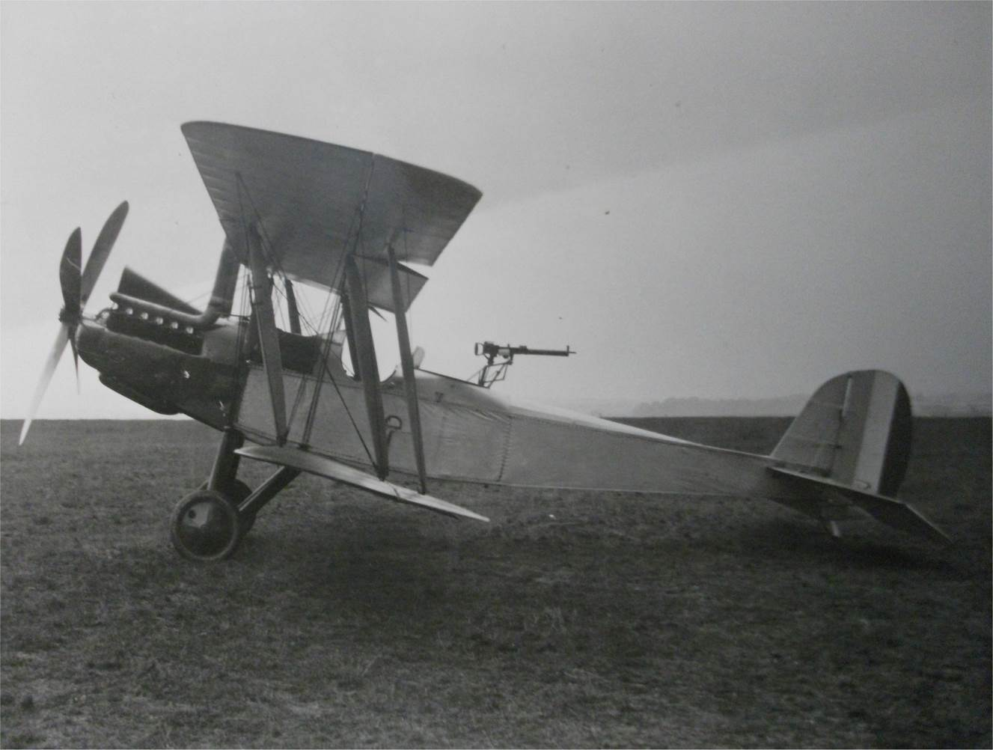
RE8 Bi Plane similar to the one used by Frederick with thanks to FAST and Ian Fagg.

Howell Charles Stephens (3266)

Vol. III Pg 22
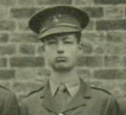

Extracted from photo of "K" Company RMC June 1916.
Born: 20 April 1898 Pension Tewfik,Cairo. Son of William Henry Stephens a teacher at Tewfikieh School, and Julie Elizabeth Howell of Cheltenham.
Bedford Grammar 1907 – 10.
Lycee Francais (Egypt) 1910 - 12.
Joined Elizabeth College in 1912 and left in 1915

Cadet at RMC Sandhurst 26 Nov 1915.
Joined 1st Bn. “A” Coy, Worcester Regt. as a second Lieut. stationed in Cairo Aug 1916.
Returned to England Sept/ Oct 1914 to Hursley Park, Winchester.
In November mobilised and sent to Le Harvre.
War Service
In the Battle of Neuve Chapelle half the strength was lost due to frost bite.
Oct. 1915 moved from 24 Bde. To 23rd. Division. Battle of Aubers Ridge. Helped support French 17th Div at Carency – attack on Contal Maison. 15 July 1916 24 Bde to 8th Division trenches of Cuinchy Front at Somme.
Gazetted 18th July 1916, 2nd Lieutenant in the Worcestershire Regiment
1917 German retreat to Hindenburg line – Langemarcke – 3rd Battle of Ypres.

Died: 31 July 1917 KIA , or died from wounds at Battle of Pilken, aged 19
Decorations:

Memorials:
- College Hall
- Ypres (Menin Gate) Memorial Panel 34
- CI Roll of Honour
- Cheltenham Cemetary Commemorations.

Notes
Not in Register List. Vol 3 of Register All facts need checking. Brother Robin 19 in 1917. Blown up or hit by shell fragment or buried by explosion. Was seen going to Medical Station. Dates wrong

Antonio (Anthony) Rodovask Hodgson - Stevens (2660)FRGS,MIME,MSE
Service No. 12046
Vol. III Pg ???
Born: 29 September 1880 Rio de Janiero. Son of Mrs. M H Stevens of Arwright Mansions, Finchley Rd.

German College in Rio de Janiero.
Joined Elizabeth College in 1891 and left in 1896.
Played Cricket 1896 – 97

Four years in the London and River Plate Bank.
Took up engineering in the Institute of Civil Engineers in 1902 FRGS, MIME, MSE.
War Service
In the New Zealand Contingent In service for 2years and 364 days (9.1.16 – 7.1.19) in training at Trentham.
Three penalties for over staying leave and drinking in Camp.
Private (Sapper) with the New Zealand Contingent in France, 1.5.16 – 20.9.18 Wounded and died on 20 Sep 1919 in Wairua N Z of Tubercle lung?

Died: 20 September 1919 aged 38
Decorations:

Memorials:
- College Hall
- Wairoa 589

Notes
(probably died after the war at home in NZ) No trace cwgc

George Butler Stoney (2544) DSO, MiD
Vol. III Pg 146
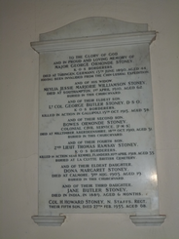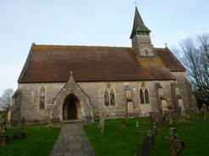
The Stoney Family Memorial (2016) St Matthew's Church, Netley Marsh, Hants (2016)
Born: 13 August 1877 in Knaresborough. Eldest son of Maj. George Ormonde Stoney (KOSB) (died 1890), and Meylia Jesse Marjorie Williamson Sinclair nee Lang (died 1910).
Joined Elizabeth College in 1888 and left in 1890, Haileybury 1891 – 95.
Sandhurst January 1896
He was a keen polo player and captained his regiment in Cairo in 1907.
War Service
2nd Lt. KOSB 1897/98, North West Frontier of India in the Tirah Campaign. Actions of Sampagha and Archanga Pass. Operations in the Bara Valley. Promoted Capt. 1904.
Seconded for service in the Egyptian Army 1906/8. He was lent by them as Landing Officer at the Dardanelles April 1915, while still a Captain, and experienced the "River Clyde" landing. He was sent to command his Regt. even though he was still a captain. Awarded the DSO " For conspicuous gallantry and ability during operations south - west of Krithia, Dardenelles from 4th to 7th June 1915. He showed great coolness and good leading, holding together the battalion, which had suffered greatly. He had been previously brought to notice for gallant conduct during the operations up to May 5th,"
In April 1915he was lent by the Egyptian Army to act as Landing Officer at the Dardenelles where he experienced the "River Clyde" landing
Promoted Lieutenant Colonel of the 1st Bn. King’s Own Scottish Borderers Oct 1915 having been in charge for five months.
Died: 15 October 1915 KIA at Gallipoli aged 38
Decorations: DSO, Despatches, Indian medal and two clasps (Tirah Campaign and Punjab Frontier?) , War Medal, Victory Medal and 1914-15 Star
Memorials:
- College Hall
- Pink Farm Helles Krithia, Sp. Mem 204
- Family Memorial in St. Matthews Church, Netley Marsh.

Notes
First brother Bowes (2545) died in 1910 aged 31. Second brother Col. Patrick Stoney MiD survived the war in Mesopotamia (2546 ). Third brother Thomas died in Flanders 1918 aged 35.

Patrick George Rawlings Storer (3215)

Vol. III Pg 285
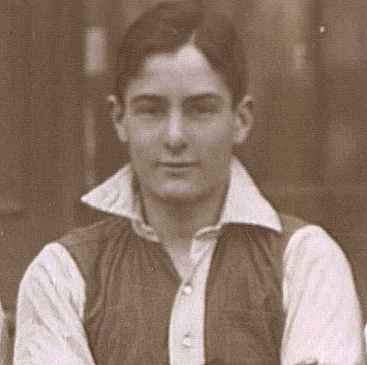
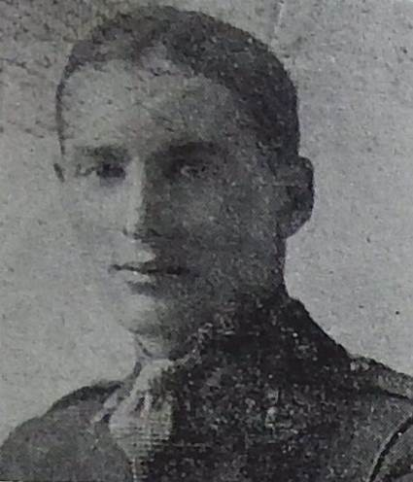
Extract from 1st XI Football Team Photo 1914 Picture from Guernsey Press June 1918

Born: 10 September 1899 Swindon. Son of George Arthur Storer and Martha Ellen King of George Rd. Guernsey.

Joined Elizabeth College in 1909 and left in 1914
1st Xi Football 1914

1916 Enlisted as a Trooper in the 5th Royal Irish Lancers.
War Service
Served in France 1916 invalided home. Entered Officer Cadet Battalion.
Commissioned 2nd Lieutenant in the Royal Field Artillery 3rd. Div Ammunition Col. and served again in France 4th June 1917.

Died: 16 June 1918 Killed, removing a "dud" shell out of harm’s way, but It exploded in his hands killing him, aged 18. "Many people would have passed a "dud" by, but he thought of possible people treading on the shell in the dark, and without thought of self,at once took steps to remove the danger" extract from the letter written by the Major of his battery.
Decorations: Medal, Victory Medal , 1914 – 15 Star

Memorials:
- College Hall
- Sandpits Cemetery Fouquereuil II. E. 10

George Stranger (3231)
Vol. ??Pg 288

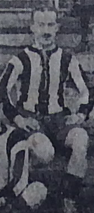
Lieutenant George Stranger Extracted from a Photo in the Weekly Press 9 Feb 1918. Coastguards v RGLI.

Born: 1 September 1894 in Guernsey. Son of William Stranger a Grower, and Ellen Buckingham, 36 Hautville.

Joined Elizabeth College in 1910 and left in 1911
Cricket?? 1st XI Football as centre forward "most promising" - Elizabethan.

War Service
Private R.G.L.I.
Dec 1917 promoted 2nd Lieutenant in the 1st Royal Guernsey Light Infantry, France

Died: 11 April 1918 KIA aged 23
Decorations: Medal and Victory Medal

Memorials:
- College Hall
- Ploegsteert Memorial Panel 11
- Stranger Memorial, Vale or St Sampson's ?????

Frederic(k) Rennell Thackeray (1601) MiD
Vol. I. Pg 237

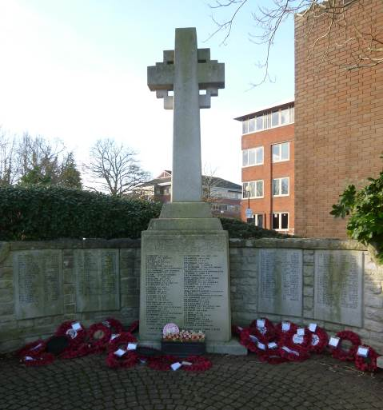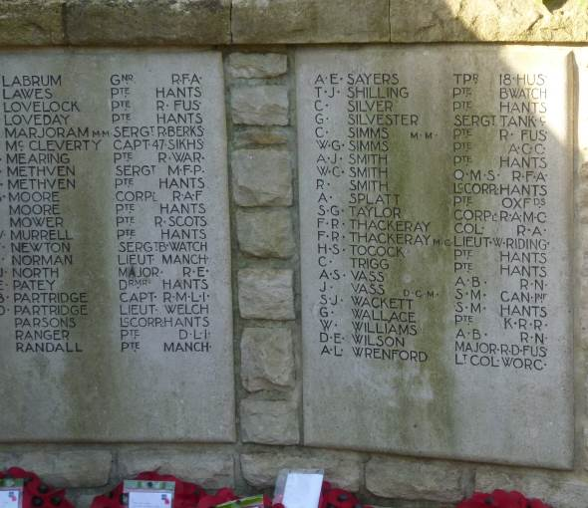
Picture of Fleet War Memorial, Hants, and the Fourth Panel with Frederick and his son recorded (2015).

Born: 31 May 1856 Jackatalla, (Now Ootacamund), Madras, India. Eldest son of Capt. Frederic R Thackeray (74th Highlanders) of Pentney, Norfolk and Elizabeth Aytoun. His father was a Borough Magistrate in Limerick (1870) and later a JP in Norfolk.
Husband of Mary Charlotte MacDonald Thackeray nee Hasted ( b in Madras) of 1 Warren Hill, Woodbridge Suffolk. Daughter of Col. John Ord Hasted R.E.
1911 Census he is living in Station Rd., (Later King’s Rd.) Fleet, Hants. One daughter Elspeth Beryl born in Bangalore, Madras 1886.
His son, Lieutenant Frederick Thackeray MC, of the Duke of Wellington's West Riding Regiment, was killed 18th April 1915, six months before his father died.
Joined Elizabeth College in 1865 and left in 1873. (1871 Aged 14 at Old College Guernsey - a boarder)
RMA Woolwich 1873,
War Service
Lieut. Royal Artillery 1876, Capt 1885, Major 1893.
1879-80 in Afghan War. Operations in Hisarah District, Besud and Khama (mentioned in dispatches, medal) Retired as a Colonel in the Royal Field Artillery 1910. Commanded 75th Brigade of Guards 16th .Div. RFA.
Died: in France of pneumonia 15 October 1915 aged 59
Decorations: Afghan War Medal, Mentioned in Despatches, 1914 -15 Star, War Medal, Victory Medal - Bronze Memorial Plaque
Memorials:
- College Hall
- Etretat Churchyard Seine Maratime 1. C. 17
- Memorial in Fleet Hampshire.

Notes Four Generations of Thackeray – Edward Talbot Indian Mutiny VC.?

Edwin de Clonard(e) Van Cooten (2428)
Service No. 301501
Vol. III Pg 122
Born: 2 October 1875 Guernsey, Christened 31 Oct 1875 at St Michel du Valle. Son of John Rhodolphus Van Cooten and Fanny Attrill.
Brother 2154
Husband of Winifred Olive Martin.

Joined Elizabeth College in 1885 and left in 1889
Mary Street House, Taunton 1889 - 94
23 April 1903 Emigrated to Ontario, Canada via Liverpool on the TSS Bavarian arrived 2 May 1903 at Montreal.
Worked as a salesman.
War Service
Enlisted in Winnepeg as a driver in the 10th Bn Canadian Field Artillary. Went to France 13 July 1916 and transferred to 37th Bn. 710th Artillery Brigade Canadian Field Artillery.

Died: 17 April 1917 KIA in France aged 41.
Decorations: Medal, Victory Medal, 1914 – 15 Star.

Memorials:
- College Hall
- Ecoivres Military Cemetery Mont-St Eloi Pas de CalaisVI. F. 16

Geoffrey Watson (3104)
Vol. III PG 265



Picture extracted from the Castle Cornet Cricket XI which appeared in the Guernsey Weekly Press August 1916.
Born: 17 September 1891 in Harrow. Elder son of David Jouffroi Watson and Ada Louisa Downs.
Brother 3116 survived the war 2nd Lt. East Surrey Regt.

Joined Elizabeth College in 1904 and left in 1905, won entrance exams to Weymouth and Dover College 1905. Went to the latter First in French and Mathematics. (Elizabethan).

Sandhurst 1910
Joined Indian Army 1911, transferred to 96th Infantry 1912, 22nd Punjabis 1914.
War Service
Lieutenant in the 28th Punjabis
Mesopotamia 1914-16.
On 5th May 1916 Geoffrey Watson was instructing “Z” Coy. 17th Lancers in Mills bomb firing from a West Spring Gun.. One of the men lit the fuse but knocked the bomb off the cup. Watson picked up the bomb and threw it twenty yards away telling the men to lie down. The bomb exploded harmlessley.
After the exercise the men spoke about it and how lucky they were to be alive. This came to the notice of Watson’s CO who recommended him for the award of the Albert Medal. However the Dept. concerned said that there were certain circumstances, which would not allow the award to be given.
Albert Medal was normally given for saving a life at sea.

Died: 20 January 1916 . KIA Mar 1916 aged 24 ???
Decorations: Medal, Victory Medal, 1914 – 15 Star.

Memorials:
- College Hall
- Basra War Cemetery Panel 54

Cyril George Weldon (2818)
Service No, 4361
VOL. III Pg206
Born: 4 November 1885 in London. Son of Dr. George Weldon and Beatrice Ellen Creed of Kensington.

Joined Elizabeth College in 1896 and left in 1901.
Amateur Dramatics 1899/90. Won the Collings Greek Prize 1899. Swimming.
1900 French Prize in Vth and Lower Certs. Oxford and Cambridge Board.
Entered South African Civil Service. He worked in the Aministrator’s Office, Cape Town when war broke out.
War Service
Served with the Govt. troops in suppressing the De Wet who was one of the leaders in the De Wet Rebellion (Maritz Rebellion) which broke out in 1914. He was taken prisoner by General Louis Botha in Mushroom Valley on 14 November of that year. Cyril served under General Botha in German West Africa 1914.
Enlisted as a Private in the 1st Regt. “D” Coy. South African Infantry and came to England in 1915 .
After training was sent with his Regt. to Egypt and then to Flanders France. He was holding a portin of the Line at Deville Wood and during a partial retreat he kept back the Germans with his Lewis Gun and was shot by a sniper.

Died: 18 July 1916 . KIA Delville Wood, Somme aged 30. He was described as "a most promising Officer"

Decorations: Medal, Victory Medal.

Memorials:
- College Hall
- Thiepval War Memorial Pier and Face AC.
- Bailiwick Roll of Honour

Hans Thomas Fell White (1468) OBE RN
Vol. III Pg 223

Born: 7 May 1856 in Melbourne and baptised in the cathedral there. Second son of Hans Thomas Fell White and Amelia Carey White, his cousin of Kilburne, Nurse Town, Beg, Cork, Ireland.
Brother of 1384.
Husband of Mary Beatrice Nichols of New Zealand.

Joined Elizabeth College in 1863 and left in 1867
Lycee Imperial Caen 1867 - 8.

Joined the Royal Navy 1869.
Naval cadet 1870, Mid. 1872, Served in Immortalite 1872 – 74, HMS Dryad in W. Indies and N. America 1874 – 76, Sub Lt. 1876, Royal Naval College 1876. , HMS Active 1876, Tourmaline 1877,
Received thanks from the Board of Trade for exertions on RMS Tasmanic, ashore off Ponce, Porto Rico 1878.
Lieut. Dec 1879. Half pay 1880.
War Service
Lieutenant aboard HMS Arab 1881 – 85; Naval Operations near Suakim, Sudan 1884 (Egyptian medal and Khedive's bronze Star) Persian Gulf and Red Sea, HMS Revenge 1885,
Senior Naval Officer on Coast of Ireland 1887 - 8. Commander 1 May 1896.
Flag Lieut. to Admiral Hon WC Carpenter Queenstown; |Senior Naval Officer on coast of Ireland, until 1888, Went on half pay and retired list 1891.
Hon Sec of the Duhallow Hunt 1892 - 1899
Retired as RN Commander 1896 to Springfoot Hall Mallow.
Served in Home Service.

Died: on 26 Mar 1919 aged 62
Decorations: O.B.E., Medal and Egyptian Star,

Memorials:
- College Hall

Notes
(died in service but not buried by cwgc after war) No trace cwgc Related to the Le Pelley’s of Sark and Le Mesuriers of Alderney. His nephew fought at Corunna under Sir John Moore was Adj General of the Guernsey Milita dying in 17 June 1865 in post. His youngest sister ?? Henrietta Cecilia was born in the Catel, Guernsey

Arthur Lucius Wilford (2815) DSO. MiD

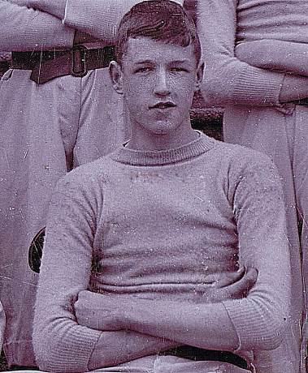
Picture of Arthur from the school photograph of the 2nd XV Rugby team 1898 - 9.

Born: 22 November 1881 in Ballina Co. Mayo, Ireland. Elder son of Col. Edmund Percival Wilford (fell at the head of his regiment in 1899) Gloucester Regt. and Constance Mary Hammond..
Vide 2829
Husband of Audrey Wilford.
Mr Bowsher’s Preparatory school to St. Paul’s London.
Tonbridge School
Joined Elizabeth College in 1896 and left in 1899
2nd XV Rugby 1899 "Ought to have been in the !st XV, but lacked practice due to army work" Elizabethan. 1899 /90
Won History Prize and Le Marchant Prize for Mathematics 1898. English Certificate and O.C. Lower Certs . Prefect.
Dec 1899 entry to Sandhurst.
Queen’s India Cadetship Sandhurst 1899.
Unattached List Indian Army 1901, temporary attached to Durham Light Infantry then 5th Bengal Light Infantry 1901.
War Service
2nd. Lt. 28 July 1900,
Bengal Light Infantry 1901-1915. Lieutenant Oct 1901, Adjutant 1904, Capt/Acting Maj. Feb 1917.
Gallipoli Maj. 6th (S) Bat. Royal Irish Fuseliers.
Lieutenant Colonel in the Royal Irish Fusiliers 5th Light Infantry Indian Army

Died: 01 July 1917 Died of wounds aged 35
Decorations: DSO, MiD in Great War , Medal, Victory Medal, 1914 – 15 Star

Memorials:
- College Hall
- Dar Es Salaam War Cemetery Tanzania 7. J. 18 and 1.A. 17.
- Bailiwick Roll of Honour
- Bailiwick Memorial.

George Gilbert Beaton Wood (3150)
Service No. 5887

Vol. III Pg 274

Born: 6 March 1885 in Hammersmith. Son of Alexander and Gertrude Wood of Antrim Mansions Hampstead, London.

Joined Elizabeth College in 1906 and left in 1911
War Service
June 1915 Enlisted as a Private Artists Rifles. 1/9th Queen Victoria’s Own Rifles, London Regt January 1916.

Died: 09 October 1916 KIA aged 31
Decorations: Medal, Victory Medal, 1914 – 15 Star

Memorials:
- College Hall
- Thiepval Memorial Pier and Face 9C

Martin Courtland de Bude Young (3199)

Vol II??? Pg 282
Born: 8 September 1894 in Naini Thal, India. Son of the late Col. Frederick de Bude Young CMG and Alice Mary M Pirie of Ripley House, Ripley, Surrey.

Educated at Heswall Cheshire, and Royal Naval College Osborne.
Joined Elizabeth College in 1908 and left in 1913 1910 to fit in
Trinity College School Ontario Canada 1913 – 14. Says 1910/11 in Register???? OTC
Played cricket for Trinity School, Port Hope Canada in 1910.(Wisden).
War Service
Private in Sportsmen's Bn.
Commissioned 2nd Lieutenant7th (S) Bat Kings Own Scottish Borderers.
Went to France in July 1915.
“In the attack on Hill 60 at the Battle of Loos he led his men over the top. When they were checked by heavy shell fire and gas fumes, Young called to Piper Lachian “Give the boys a skirl” and the advance began. Shortly afterwards he was wounded. When the stretcher bearers came to take him, he told them to take one of the Privates and started to walk back to the dressing station, but the effort was too much and he died through loss of blood” (Wisden). See also P18 Elizabethan Dec 1916)

Died: 26 September 1915 in France, wounded at Hill 60 Loos. Died of wounds aged 21
Decorations: Medal, Victory Medal and 1914-15 Star.

Memorials:
- College Hall
- Noeux Les Mines Cemetery Extn. Pas de Calais 1. A. 29.

ACKNOWLEDGEMENTS
Ian Burn and Carol Stevens of the Tadley History Society for information on Donald Lynden Bell.
Mary Lou Rowland, Deputy Archivist Hurstpierpoint College - for information about Donald Gumbley and Montagu Middleton Barney.
Liz Walton and Barrie Bertram and Great War Study Group.
RMA Museum Eastney - Heather Johnson and Alison Firth - Charles Herbert Collet DSO
Fleet Air Arm Yeovilton. Barbara Gilbert and Catherine Cooper - Charles Herbert Collet
RMAS Sebastian Puncher - OE's attending Sandhurst and Woolwich .
Keith Pike Guernsey Museum Service.
North Staffordshire Regt.
Ian Fagg of Farnborough Air Sciences & Technology Museum.
Bill Seager 59th Squadron RAF.
Alan Cross
Dot and her daughter
Sara
Medal Card Index and Paul Quilliam
De Ruvigny's Roll of Honour (Vol 4) Cull
Groombridge Memorial N.S. Done
Rachel Hassall Archivist Sherborne School for the picture of T.F. Murray.
Catherine Watson Thomas Murray
Amanda Ingram Archivist Pembroke College picture of James Travers Blount Dinwiddie.
Dave Power South Dublin Libraries EG Ozanne, GF Farran, FW Durand, AH Dobbs.
Tile Gazeteer Dorset.
Dr. Frances Hurd :- "From Hockey Field to Battlefield - Ten lives interrupted The Sandhurst Class of 1915".
Paddy O'Sullivan 5385 for Laines.

Memorials

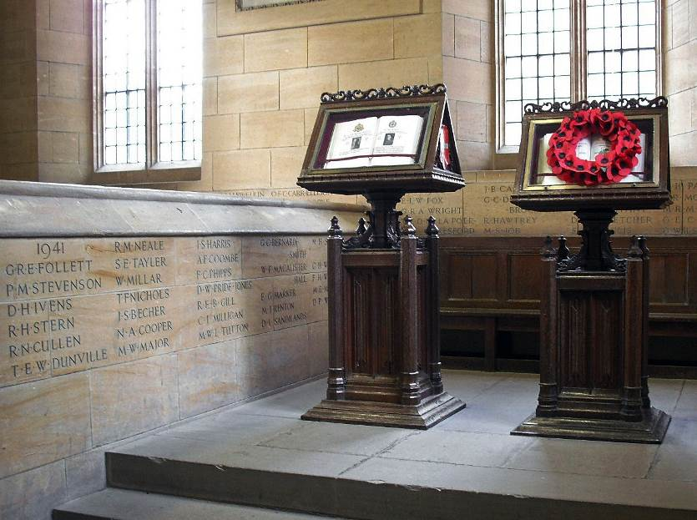

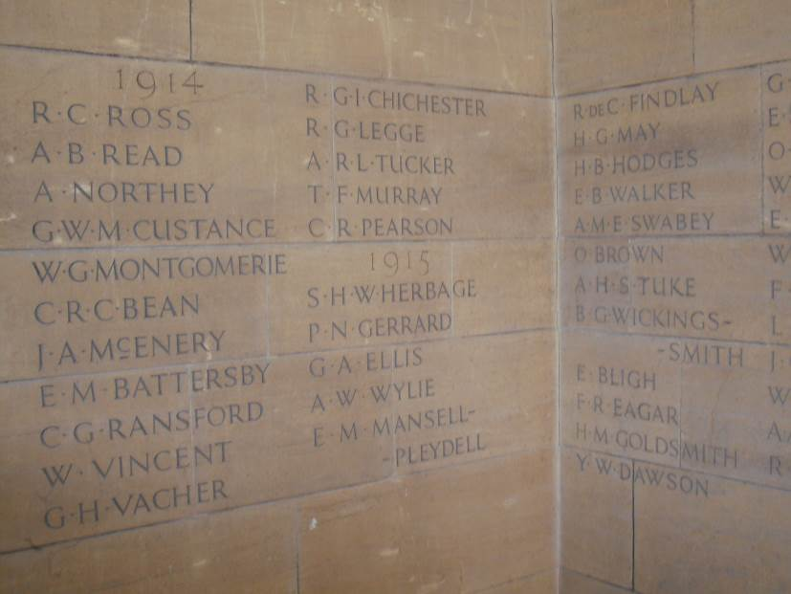

Above Sherborne Memorials.

