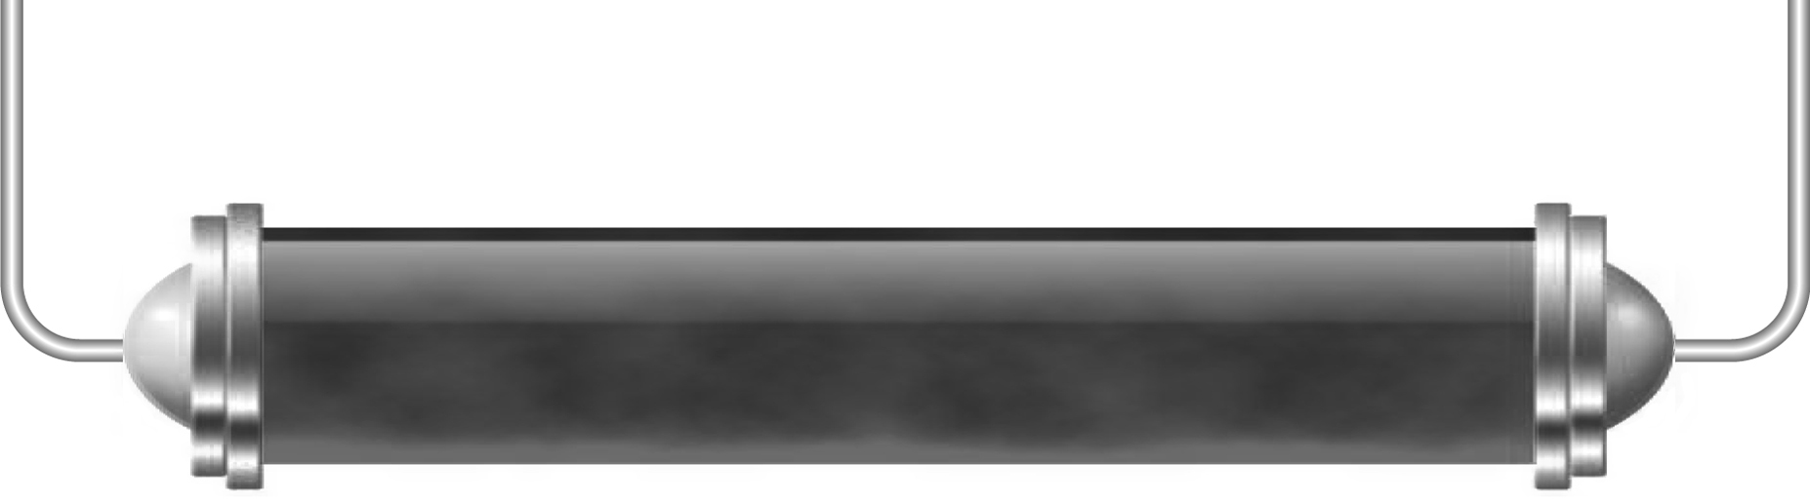
Being in control

Task 1: The role of the brain (Level 5)

Hidden in this word search are nine of the roles carried out by the brain. They are either processes it controls or things it allows you to do.
Can you find them all? (The roles you are looking for are on page 24 of your Pupil Book)
There is also an additional two-word description of what the brain does hidden in the word search.
When you find this phrase write it down here:

n | q | w | e | f | t | u | v | b | g | d | h | j | k | l | i | o | p | x | s | w | d | f
c | s | f | g | h | n | b | v | c | d | f | s | w | e | r | t | y | u | j | e | t | b | s
v | g | n | o | i | t | o | m | e | e | c | n | e | i | r | e | p | x | e | c | d | o | m
b | h | h | b | v | x | v | f | g | h | j | u | s | a | v | s | t | c | t | d | u | d | n
s | j | f | g | w | j | l | o | i | p | p | v | c | x | r | s | g | y | a | f | y | y | b
n | k | s | c | v | h | g | t | b | t | r | e | w | q | a | w | u | h | r | g | t | t | v
o | l | c | b | l | o | o | d | p | r | e | s | s | u | r | e | y | j | t | h | p | e | c
i | e | a | y | y | i | l | k | b | m | e | c | s | d | f | g | t | k | r | j | o | m | d
t | r | q | r | m | b | c | h | g | t | e | a | e | w | t | n | r | l | a | k | i | p | f
a | t | w | r | w | e | b | j | l | p | r | s | t | x | y | d | e | d | e | l | l | e | g
m | y | e | f | q | s | e | w | j | g | f | d | w | h | j | s | w | f | h | k | k | r | h
r | u | r | r | w | e | r | t | y | u | j | k | l | s | i | a | s | g | n | j | j | a | j
o | i | t | v | e | w | l | j | k | h | g | f | d | s | b | n | g | h | l | h | h | t | k
f | p | w | r | h | m | l | o | p | f | g | h | c | v | b | n | g | n | s | g | g | u | l
n | p | s | a | x | m | e | b | h | g | f | d | s | e | y | t | r | r | j | f | f | r | o
i | s | b | n | m | c | v | m | s | w | e | r | t | g | f | d | a | q | a | s | e | e | p
d | p | o | i | y | t | r | w | b | w | d | r | t | y | i | p | r | y | t | t | t | e | u
n | j | t | h | i | n | k | s | k | e | k | j | h | g | e | t | i | m | p | z | e | y | g
e | k | d | e | r | t | h | j | k | l | r | y | u | l | t | y | t | a | i | s | q | u | f
s | q | a | z | x | s | w | e | d | c | v | f | r | t | g | h | j | e | u | a | w | r | d
c | a | q | e | r | t | y | u | j | k | l | g | n | o | s | a | e | r | g | l | m | e | s
d | v | b | n | h | g | d | r | t | y | u | i | e | w | a | d | s | d | v | k | r | u | s

Task 2: The parts of the brain (Level 6)
Here is a diagram of your brain. Cut it out and glue it into your note book.
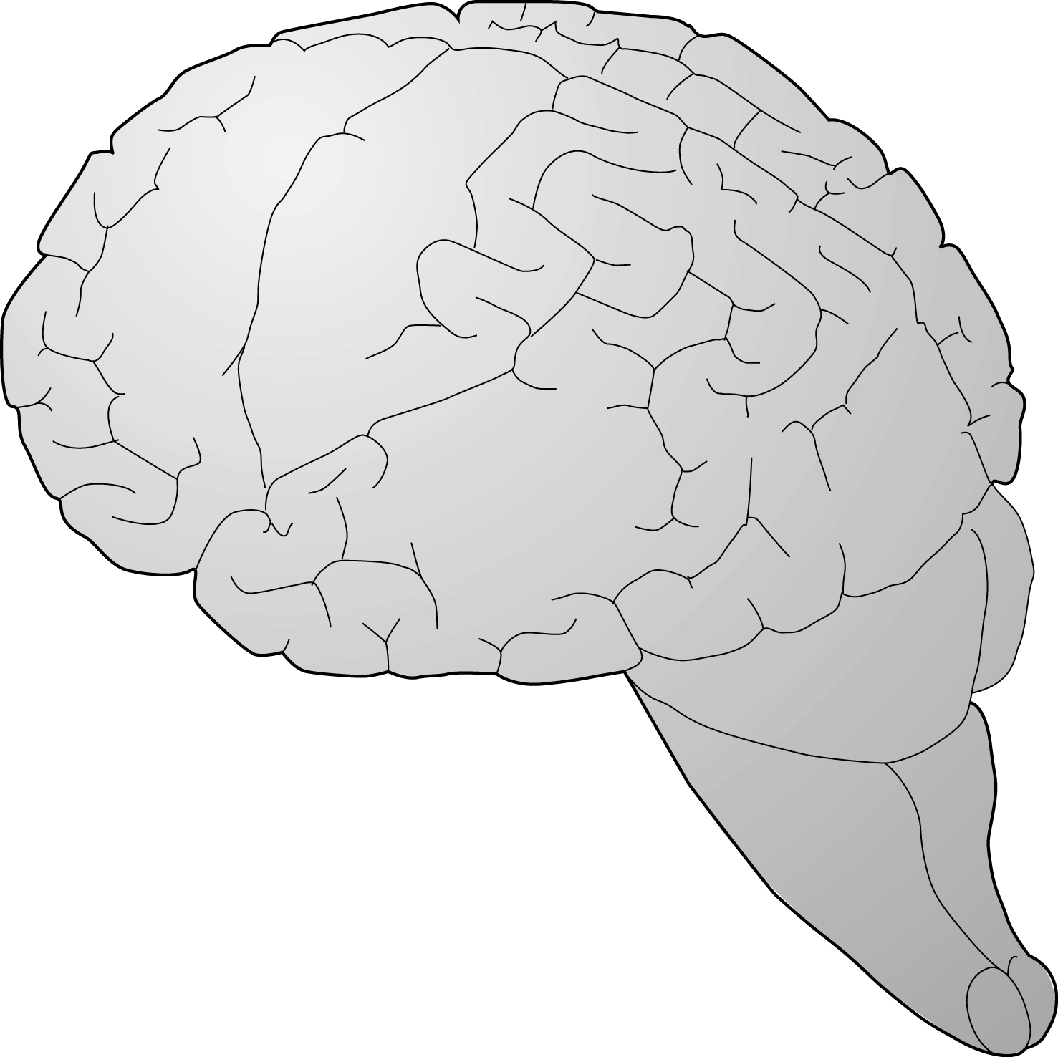
Use Figure 3 on page 25 of your Pupil Book to label this diagram as fully as you can.
Answer these two questions:
- What would happen if the cerebellum was damaged?

- What would happen if the frontal lobe was injured?

Task 3: Brain mapping (Level 7)
Using what you learned from page 25 of your Pupil Book write an article for the science section of the local newspaper describing how scientists have worked out which part of the brain does what.
The idea is to provide an explanation that the average ‘man in the street’ could enjoy, so although your account must be scientifically accurate it must also be easy to understand.

