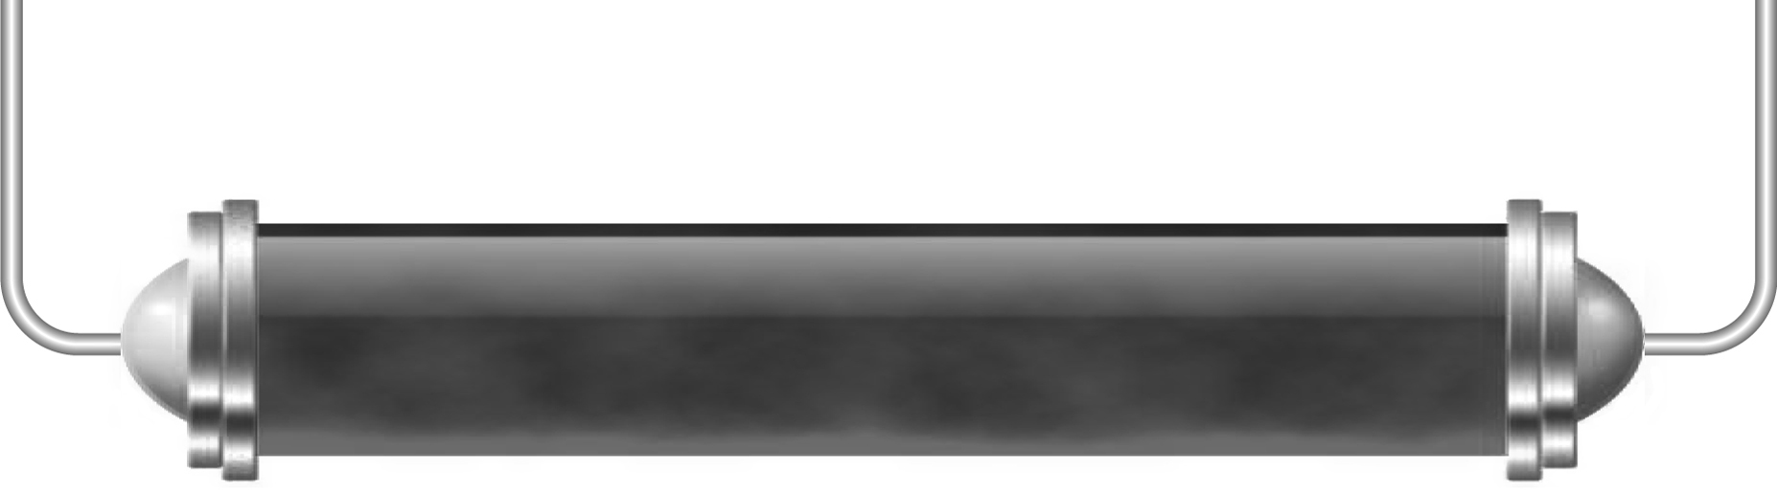
Is alcohol really
that good?

Alcohol dependency
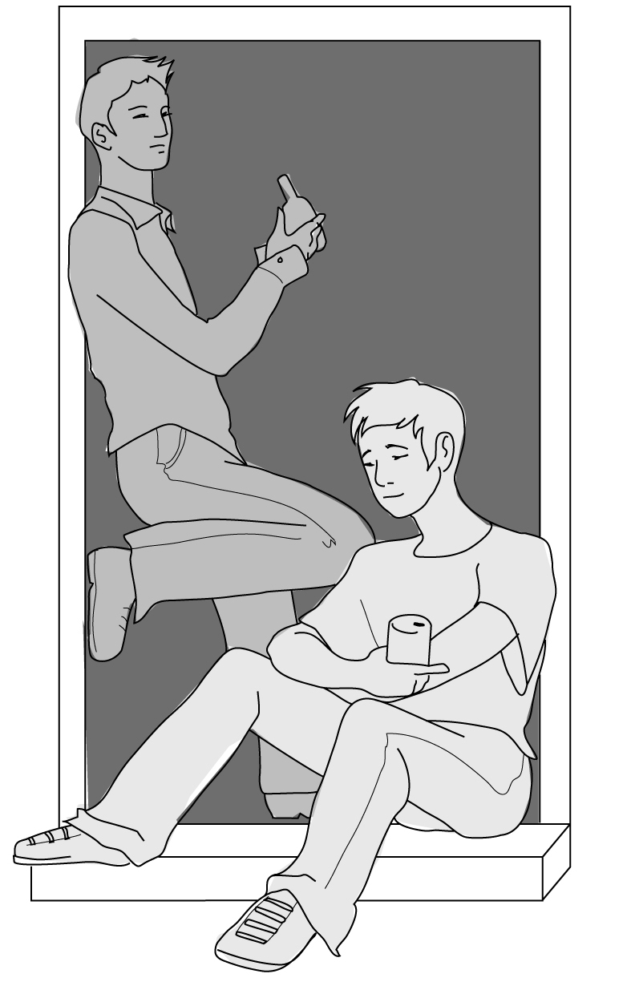
Read the passage below and answer the questions.
Stages in alcohol dependence:
Drinking alcohol is, for many, one of life's pleasures. At first a social drinker finds that they drink more than their friends do. They are able to drink more before they feel the effects. Then come periods of memory loss. Eventually they reach the stage when they are ‘dependent’ on alcohol. They feel that they cannot cope without alcohol.
Alcohol abuse is when someone frequently drinks a lot of alcohol. This can lead to serious health problems, not to mention financial ones. Someone who has reached this stage is an alcoholic. Many alcoholics die as the result of cirrhosis (sir-o-sis) of the liver.
Drinking during pregnancy can cause problems and damage to the developing baby. The risk of drinking an occasional ‘unit’ of alcohol is small. Heavy drinking – whether steadily or in binges – is dangerous for the baby and should be avoided. The most vulnerable time is during the first three months of pregnancy. Women who drink heavily during pregnancy run the risk of their baby having a low birth weight as well as liver and brain damage.
It is best not to drink at all during pregnancy.
Questions:
- What is alcohol dependency?

- What is alcoholism?

- What do many alcoholics die from?

- Why should a pregnant woman not drink alcohol?

- On a sheet of plain A4 paper, design a leaflet or poster for your local health centre giving advice to pregnant women about alcohol consumption.

Let’s Party!

Lucy went to a party and had a few drinks. Then she had a few more. She had too much to drink!
This table shows the concentration of alcohol in her blood during and after the party:
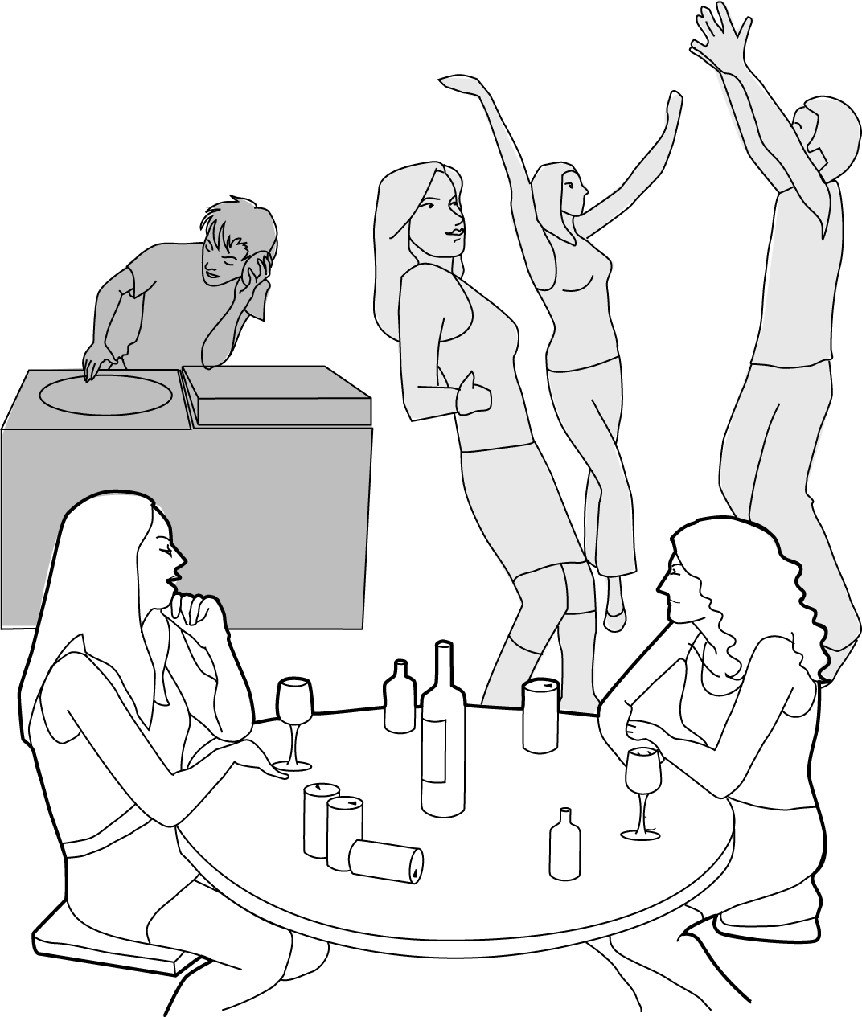
Time | Concentration of alcohol  in Lucy’s blood (%)
8 pm | 0.00
9 pm | 0.05
10 pm | 0.09
11 pm | 0.15
Midnight | 0.18
1 am | 0.21
2 am | 0.32
3 am | 0.18
4 am | 0.16
5 am | 0.15
6 am | 0.13

- On a piece of graph paper draw a line graph of the figures shown in the table.
- How much alcohol did Lucy have in her blood when she arrived at the party at 8pm?

- At about what time did she stop drinking? How can you tell?

- What happened to Lucy’s blood alcohol after 2 am?

- What would Lucy’s behaviour be like at 11 pm and then at 2 am?

