Chemical Labels
Chemical labels give us a lot of information about the chemical contained within.
First of all, it is important to realise that even the best chemicals the science department can buy from chemical companies in England, are not 100% pure.
They are slightly impure. We say they contain impurities.

Look at this (green and white) label from a bottle of potassium chloride below:
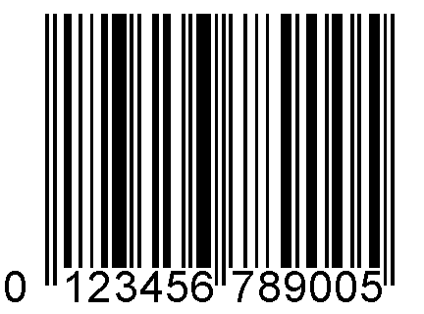

Potassium chloride
Potassium chlorure
Kaliumchlorid

Kalium chloride
Potassio cloruro
Potasio cloruro
Kaliumklorid

BDH Laboratory Supplies
Poole, BH15 1TD, UK
Tel: (01202) 669700

KCl = 74.55

Minimum assay 99 %

Maxiximum limits of Impurities

Loss on drying at 130˚
(water) 0.5 %
Sulphate 0.01 %
Calcium 0.005 %
Heavy metals 0.0005%
Iron 0.001 %
Sodium 0.05 %

Lot K23759137 709
BDHGPR™
Prod 295945C1KG
Now answer the questions below on lined paper.

- What mass of solid is in this container?

- Why do you think the name has been written out seven times?

- Why do you think the address and telephone number of the supplier has been provided?

- What other information about the manufacturing process of the solid has been given to you?

- The name for this chemical in German is kaliumchlorid. This can be abbreviated to just three letters. Find the abbreviation.

- Which of the impurities is present in the highest amount (%)?

- How many more times sodium than sulphate is there in this sample?

- Chemical companies give information about the purity of their samples to customers. Why is that useful?

- Chemical companies can charge more money for the most pure samples, the ones with no impurities. Why do you think they need to do this?

- There is one extra thing found on some dangerous chemicals, in the shape of an X or a skull and crossbones. This is a hazard symbol and it stands out because it has a brightly coloured background. Which colour is it?

