Water and Plants

Some small or primitive plants, such as mosses, absorb all the water and nutrients they need directly from their environment.

Larger plants do not have a large enough surface area to take in the resources they need to support their greater cell number.
Like most multicellular animals, they have developed specialised tissues for transporting water and nutrients to all their cells.

Plants that have specialised transport systems are known as vascular plants.

Transporting Water and Nutrients
Plants need to move water from roots to leaves for photosynthesis (plus transport and support).
The sugars produced in photosynthesis are needed for respiration throughout the plant.

Transporting Water and Minerals:
Water and dissolved minerals are transported by specialised tissue called xylem.
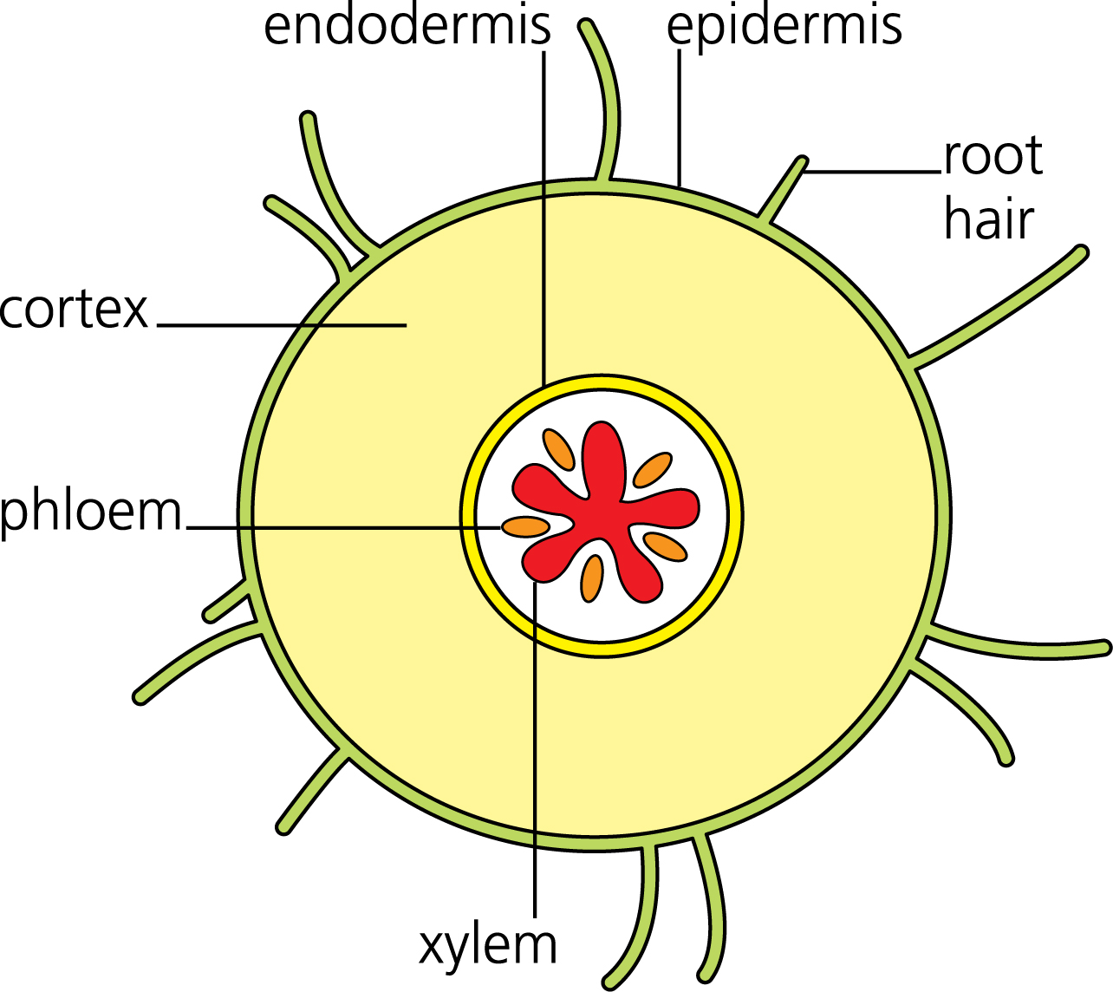

Roots:
Outgrowths known as root hairs give the root a
large surface area for water uptake.

[Water travels through the cortex, which consists
of relatively undifferentiated parenchyma cells, to
the vascular tissues in the stele.]

Xylem:
Water moves through pores or pits, in elongated (dead) [tracheid] cells, [while vessel elements with] perforated end plates join end to end to form continuous vessels.
[Sclerenchyma fibres provide support.]

Leaves:
In the leaf, vascular bundles are surrounded by mesophyll tissue.
This contains air spaces into which water evaporates.
Water vapour then leaves the plant via the stomata, which open and close to control water loss.
Transporting Sugars:
Sugars, mainly sucrose, are transported around a plant in the phloem.

Phloem:
Phloem consists of living cells known as sieve tubes. Each one is supported by a companion cell as it lacks some organelles to allow sap to move easily (through them).
[Sclerenchyma fibres provide support.]

Tubers:
Tubers, such as (those found in) the potato, are enlarged roots, which store sugars by converting them into starch. The tuber grows as the plant is photosynthesising, but breaks down again to provide sucrose when it is needed for growth.

Fruits:
Fruits (also) store sugars by converting them into starch or sugars such as fructose.
Unlike tubers, they do not provide energy for the growing plant. Instead they provide energy for the daughter plant, and attract the animals that distribute their seeds.

The Transpiration Stream
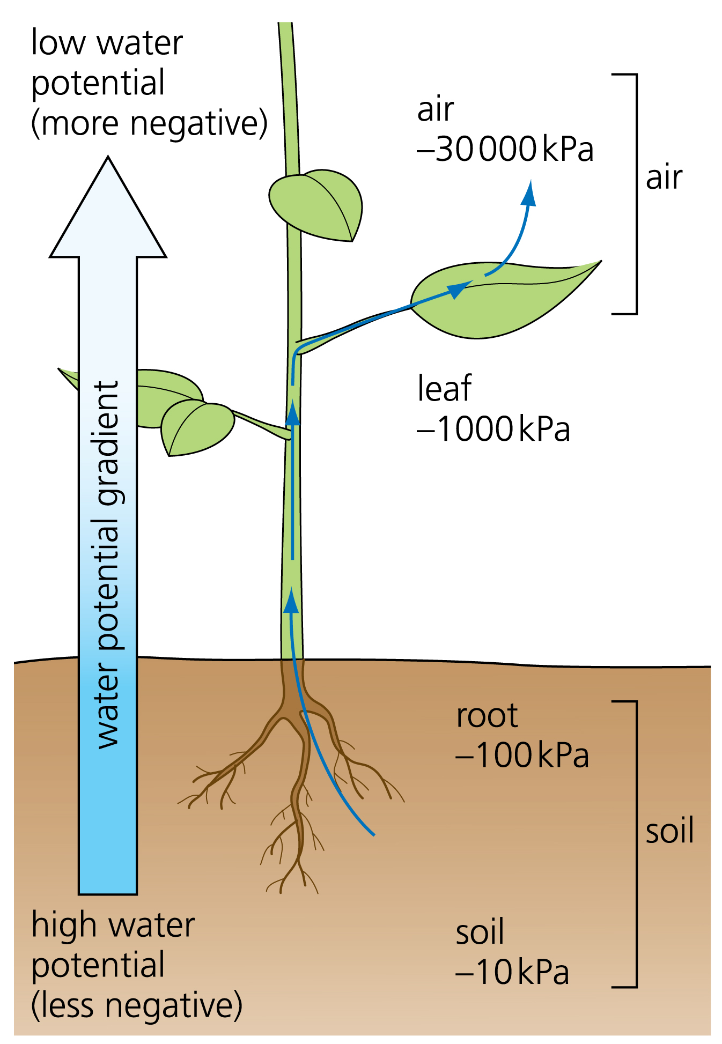
Plants lose water from their leaves by transpiration.
This draws water up the stem in a constant stream,
(known as the transpiration stream).

The root is lined with a layer of cells called the epidermis.
Many of these cells feature and outgrowth known as
a root hair, which increases the surface area for
(water molecules to enter by) osmosis.
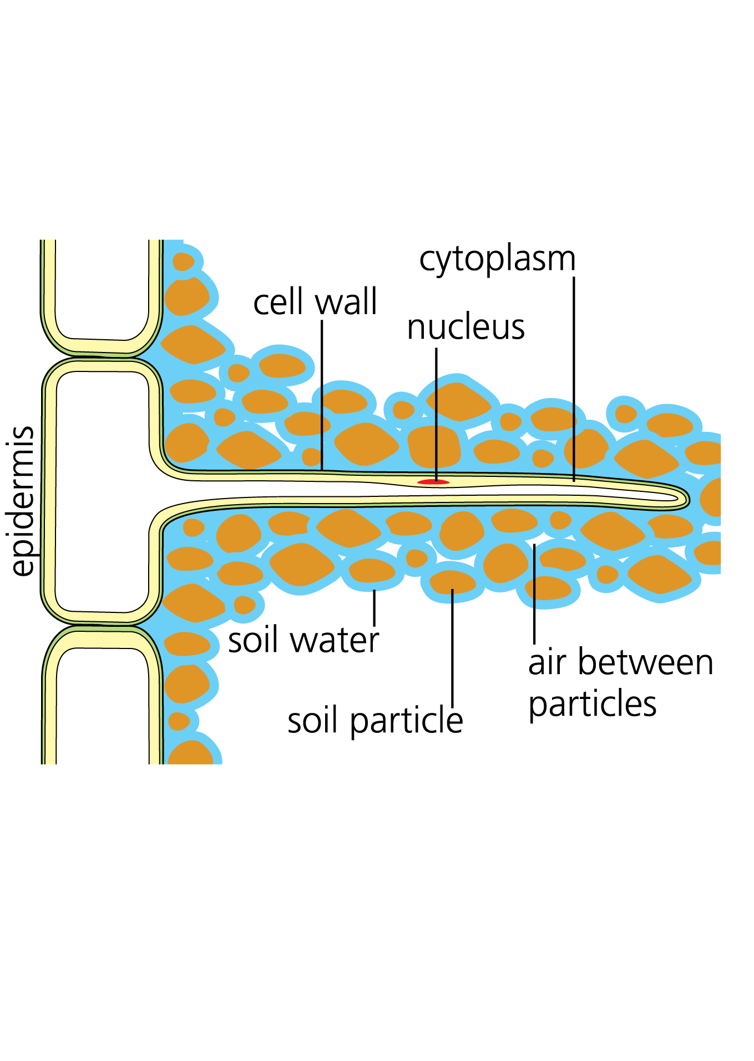

The water must now move through the main bulk of the root [– the cortex –] to reach the xylem.

[It may travel via the symplast (symplastic) pathway, moving between (the cytoplasm of) cells via pores in cell walls called plasmodesmata…or it may travel through the cortex via the apoplast (apoplastic) pathway, moving through the cellulose matrix of the cell walls, until it reaches the endodermis.

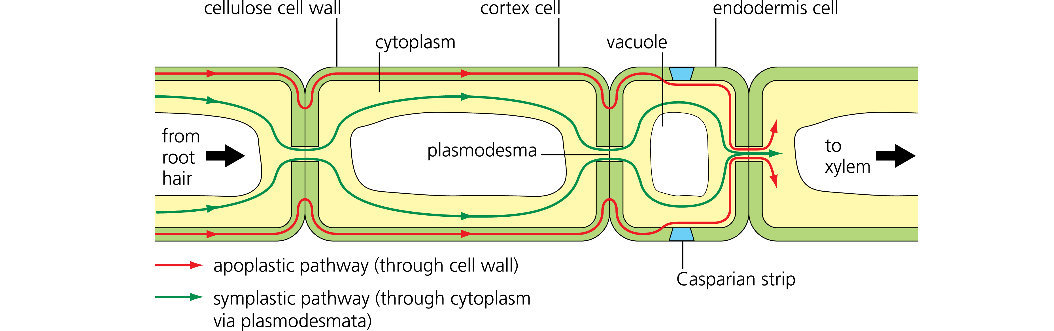

The endodermis separates the root cortex from the stele, which contains the xylem. Here, the apoplast pathway (via cell walls) is blocked by a coating of suberin on the cell walls, known as the Casparian strip.

The Casparian strip gives the plant more control over what enters the xylem, as water must go through the cell membrane of the endodermal cells, which is selectively permeable.]

Water now enters the xylem and begins to rise up the root towards the stem.
It is drawn upwards by cohesion of water molecules to each other, as water leaves the plant by transpiration (and pushed up by root pressure).

When the water reaches the leaf it moves out of the xylem into the surrounding cells by osmosis. Water vapour enters the air spaces in the spongy mesophyll.

Water vapour finally diffuses out of the plant via the stomata. This is process is also known as transpiration.

The stomata open and close in response to factors e.g. incident light and availability of water.

Water Potential
Water tends to move from areas of high water concentration to areas of low water concentration. If this occurs across a partially permeable membrane it is called osmosis.
Water also tends to move from areas of high hydrostatic pressure to areas of low hydrostatic pressure. It is also affected by gravity and electrostatic forces, such as those that cause surface tension.

The collective term for the tendency of water to move due to any of these effects is water potential.

Root Pressure
Water is usually drawn up a plant by the tension resulting from transpiration and cohesion between water molecules.

In some situations, such as 100% humidity, a plant is unable to transpire. Instead, water can be transported by positive pressure from below. This is known as root pressure.

Solutes are actively transported into the roots of the plant, causing water to enter by osmosis. This increases the hydrostatic pressure in the root, forcing water up the stem.

Cohesion–Tension Theory
Water is a polar molecule, meaning that its positive and negative charges are not evenly distributed. The oxygen atom has a slight negative charge, while the two hydrogen atoms are slightly positive.

This means that, in the xylem, water molecules spontaneously arrange so that positive and negatively charged poles lie next to each other.

This causes the molecules to cohere, or stick together, so that as some leave a plant by transpiration, others are pulled up behind them.

This requires a continuous (i.e. unbroken) column of water in the xylem to maintain cohesion.

