Water and Plants

Some small or primitive plants, such as mosses, absorb all the water and nutrients they need ____________ from their environment.

Larger plants do not have a large enough ___________ area to take in what they need.
Like most multicellular animals, they have developed specialised ____________for transporting ____________and ____________to all their cells.

Plants that have specialised transport systems are known as ____________ plants.

Transporting Water and Nutrients
Plants need to move _________ from _________ to _________ for photosynthesis (plus transport and support).
The sugars produced in ____________ are needed for ____________ throughout the plant.

Transporting Water and Minerals:
Water and dissolved ____________ are transported by specialised tissue called _________.
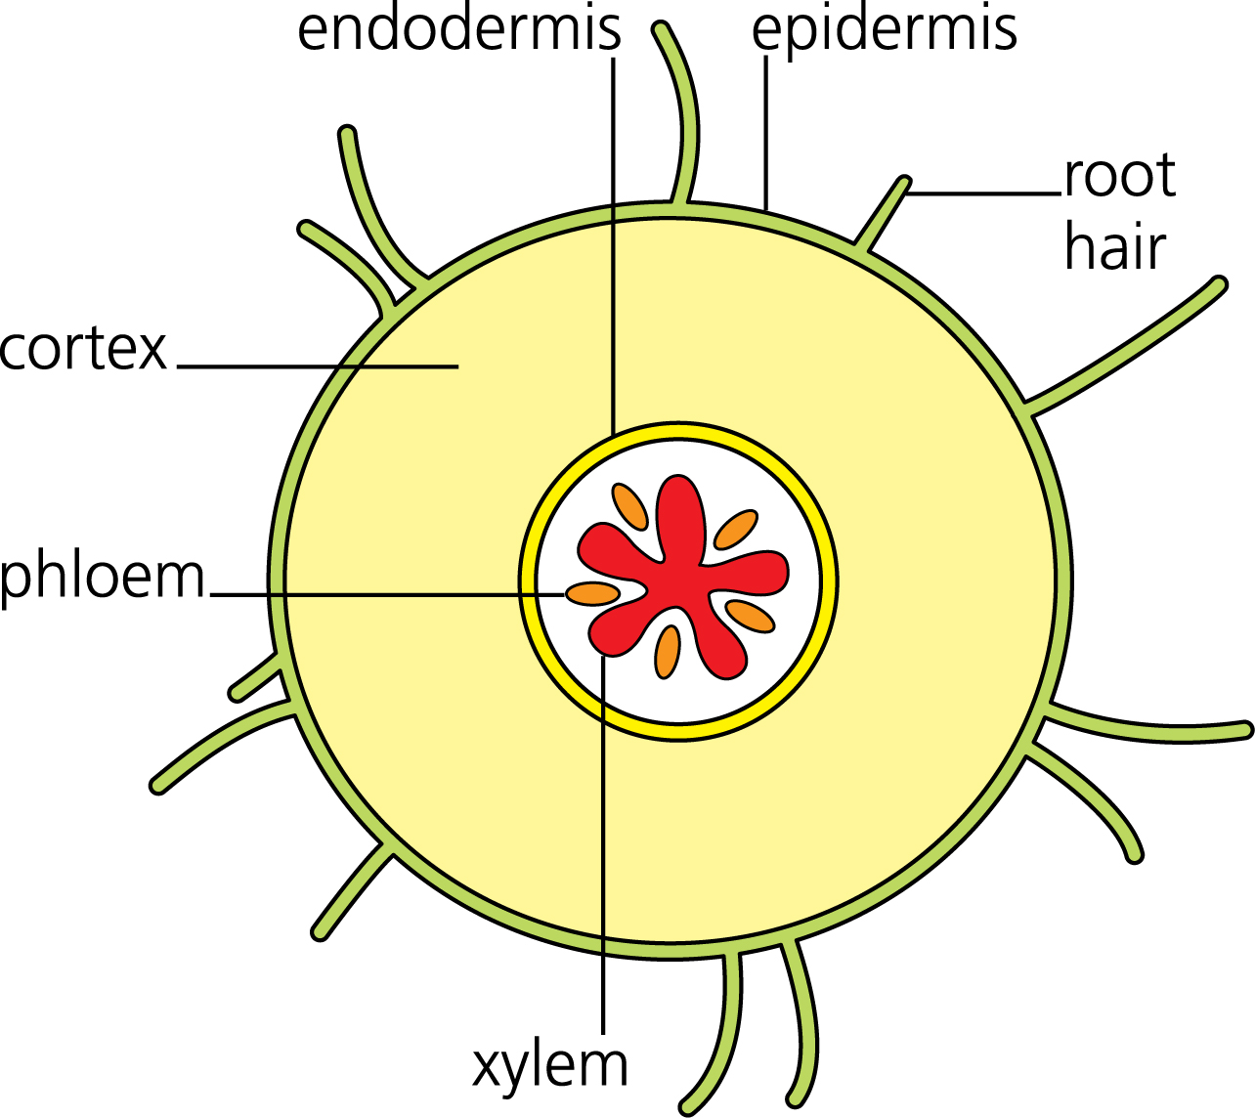

Roots:
Outgrowths known as ______ ______ give the root a
large surface area for water uptake.
[Water travels through the _________ , which consists
of relatively undifferentiated parenchyma cells, to
the vascular tissues in the stele.]

Xylem:
Water moves through pores or pits, in elongated (dead) tracheid cells, while vessel elements with perforated end plates join end to end to form ____________ vessels.
[Sclerenchyma fibres provide support.]

Leaves:
In the leaf, vascular bundles are surrounded by ____________ tissue.
This contains ______ ____________ into which water ____________.
Water vapour then leaves the plant via the _______, which open & close to control water loss.
Transporting Sugars:
Sugars, mainly ____________, are transported around a plant in the ____________.

Phloem:
Phloem consists of ____________ cells known as ______ ______. Each one is supported by a ___________ cell as it lacks some organelles to allow sap to move easily (through them).
[Sclerenchyma fibres provide support.]

Tubers:
Tubers, such as (those found in) the potato, are enlarged roots, which store sugars by converting them into __________ . The tuber grows as the plant is photosynthesising, but breaks down again to provide sucrose when it is needed for __________ .

Fruits:
Fruits (also) store sugars by converting them into starch.
Unlike tubers, they do not provide energy for the growing plant. Instead they provide energy for the ____________ plant, and attract the animals that distribute their seeds.

The Transpiration Stream
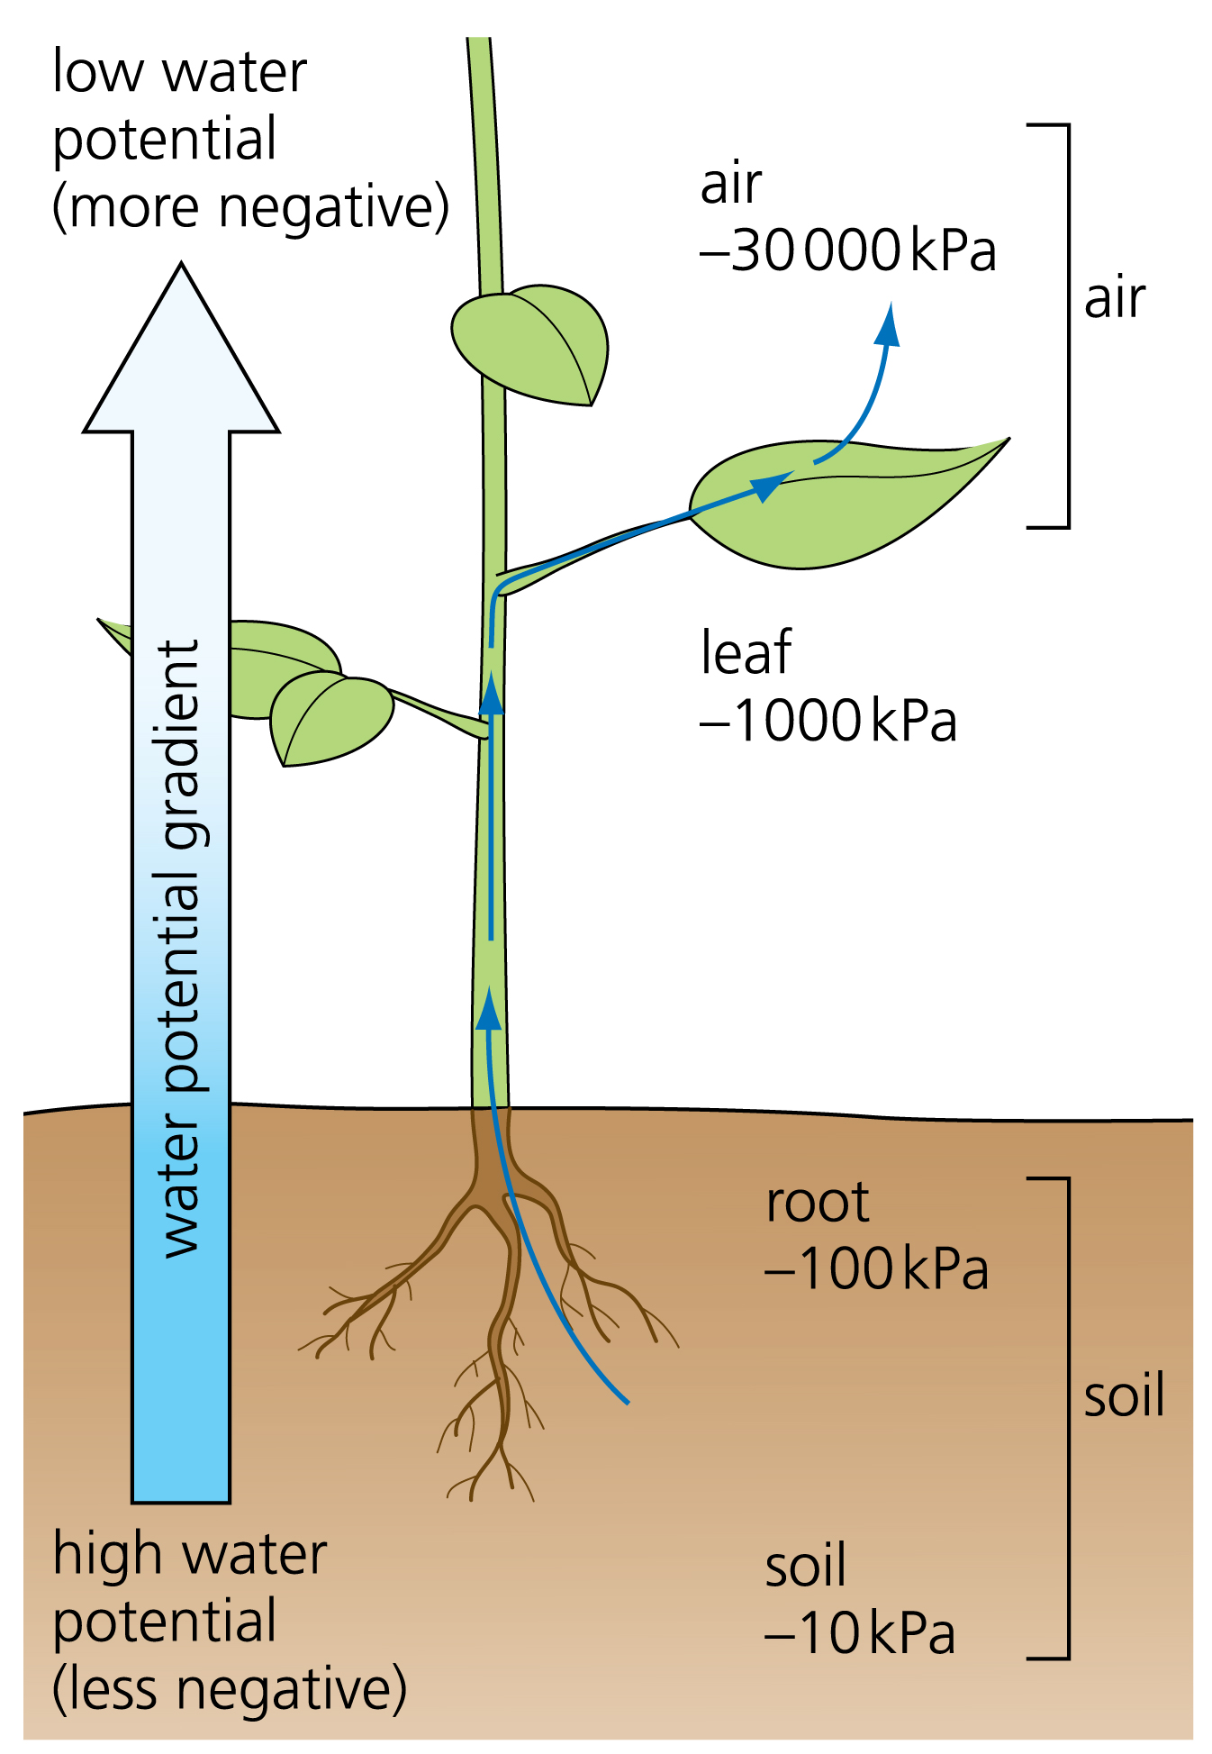
Plants lose water from their leaves by ____________.
This draws water up the stem in a constant stream,
(known as the transpiration stream).

The root is lined with a layer of cells called the epidermis.
Many of these cells feature and outgrowth known as
a root hair, which increases the surface area for
(water molecules to enter by) ____________ .
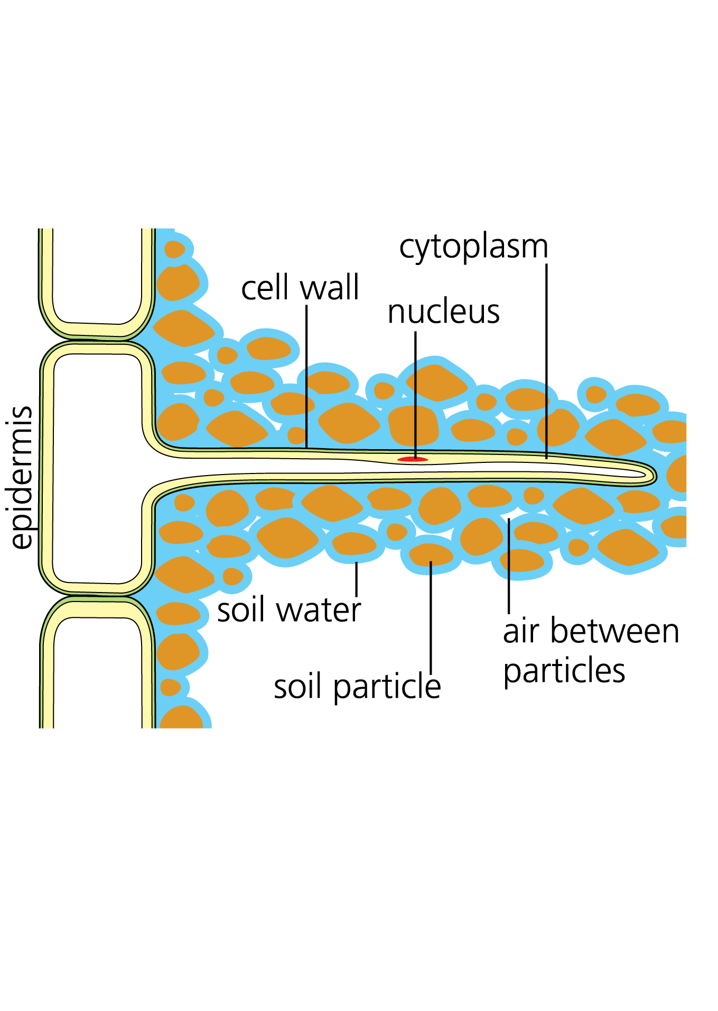

The water must now move through the main bulk of the root, [the ______ ,]to reach the xylem.
[It may travel via the ____________ (symplastic) pathway, moving between (the cytoplasm of) cells via pores in cell walls called plasmodesmata…or it may travel through the cortex via the ____________ (apoplastic) pathway, moving through the cellulose matrix of the cell walls, until it reaches the ____________.]

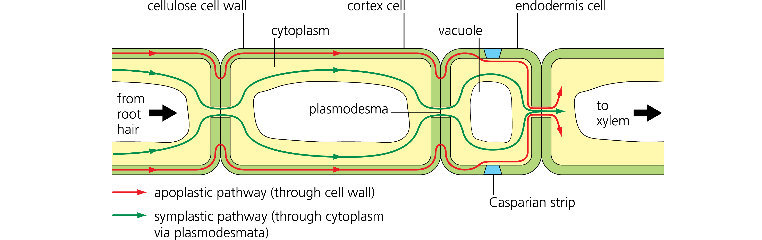

[The endodermis ____________ the root cortex from the stele, which contains the xylem. Here, the apoplast pathway (via cell walls) is blocked by a coating of ____________ on the cell walls, known as the ____________ strip.

The Casparian strip gives the plant more __________ over what enters the xylem, as water must go through the cell membrane of the endodermal cells, which is __________ permeable.]

Water now enters the xylem and begins to travel up the root towards the stem.
It is drawn upwards by ____________ of water molecules to each other, as water leaves the plant by transpiration (and pushed up by root pressure, see overleaf).

When the water reaches the leaf it moves out of the xylem into the surrounding cells by ______ Water vapour enters the air spaces in the spongy mesophyll.

Water vapour finally diffuses out of the plant via the ____________.
This is the process known as ____________.
The stomata open and close in response to factors e.g. incident light and availability of water.

Water Potential
Water tends to move from areas of high water ________ to areas of low water __________.
If this occurs across a partially permeable membrane it is called ____________.

Water also tends to move from areas of high ____________.pressure to areas of low ____________.pressure.
It is also affected by ____________.and ____________.forces, such as those that cause surface tension.

The collective term for the tendency of water to move due to any of these effects is water potential.

Root Pressure
Water is usually drawn ____ a plant by the ____________ resulting from ____________and ____________between water molecules.
In some situations, such as 100% humidity, a plant is unable to transpire. Instead, water can be transported by ____________pressure from ____________. This is known as root pressure.
____________are ____________transported into the roots of the plant, causing __________ to enter by __________.
This increases the ____________ pressure in the root, forcing water _______ the stem.

Cohesion–Tension Theory
Water is a __________ molecule, meaning that its positive and negative charges are not evenly distributed. The oxygen atom has a slight negative charge, while the two hydrogen atoms are slightly positive.
This means that, in the xylem, water molecules spontaneously arrange so that positive and negatively charged poles lie next to each other.
This causes the molecules to ____________, or stick together, so that as some leave a plant by transpiration, others are ____________ _____ behind them.

