2:5:2
Magnetic fields
All magnets affect magnetic materials in their surroundings.
Carry out the following investigation. Make sure you follow your teacher’s instructions.
- Put a magnet in the middle of a sheet of paper.
- Sprinkle iron filings all around it.
The filings will line up because the magnet exerts a force on them.
The lines are closest where the magnetism is strongest.
- Draw the shape of the lines around your magnet.

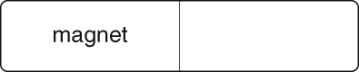

The ends of the magnets are called its poles.
- Write down where the iron filings are closest together. This is where the magnetism is strongest.

- Why do you think it is easiest to pick up magnetic objects using the ends of the magnet, and not the middle of it?

