2:5:4
Making magnets
Magnetic materials are made from particles that all behave like little bar magnets.
If these particles are pointing in different directions, their magnetism cancels out.
If the particles all line up in one direction, their magnetism adds up.
You are going to make a magnet using a large paperclip. The paperclip is made from a magnetic material, but it has not yet been magnetised.
Method
- Collect a magnet and a large paperclip. Straighten out the paperclip.
- Firmly rub the North pole of the magnet from the centre of the paperclip to one end.
- Repeat this about 25 times. Make sure you lift the magnet up when you return it to the centre.
- Turn the magnet around and rub the South pole of the magnet from the centre of the paperclip to the other end of the paperclip.
- Repeat this about 25 times. Make sure that you lift the magnet up when you return it to the centre.
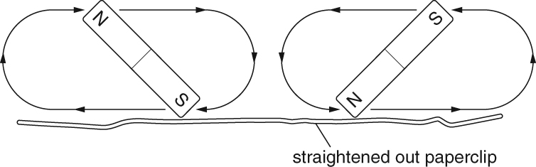
Test the paperclip to see if it has been magnetised.
- How does it affect a nearby compass?

- Can it pick up small magnetic materials?

- What happens if you cut the paperclip in two?

