Enzyme Questions

Q1. A protease is an enzyme that digests protein. The graph shows how the activity of a protease varies with temperature.
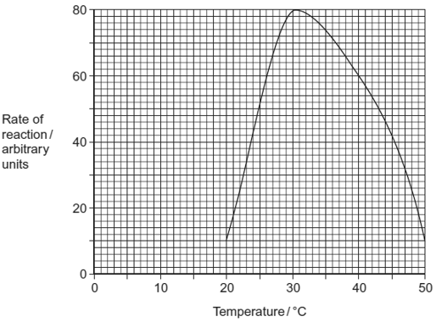
(a) (i) Describe what the graph shows about the effect of temperature on the rate of reaction.
.............................................................................................................
.............................................................................................................
.............................................................................................................
(1)

(ii) Explain the shape of the curve between 30 °C and 50 °C.
.............................................................................................................
.............................................................................................................
.............................................................................................................
.............................................................................................................
.............................................................................................................
(3)

(b) Students investigated the effect of pH on the activity of the protease.
• The students used agar plates containing protein. The protein made the agar cloudy.
• They made four wells of equal size in the agar of each plate.
• They added a drop of protease solution to each of the wells. The protease solution in each well was at a different pH.
• The students incubated the agar plates for 4 hours at a constant temperature.
The diagram shows the agar plates after they were incubated and the pH of the protease solution in each well.
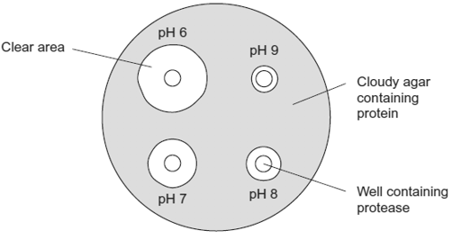
(i) How should the students make sure that the pH of the protease solution did not change?
.............................................................................................................
(1)
(ii) Use the graph to suggest a suitable temperature for incubating the plates.
Explain your answer.
.............................................................................................................
.............................................................................................................
.............................................................................................................
(1)
(iii) Use the diagram to describe the effect of pH on the activity of this protease.
.............................................................................................................
.............................................................................................................
.............................................................................................................
(1)
(Total 7 marks)
Q2. (a) Explain how the shape of an enzyme molecule is related to its function.
......................................................................................................................
......................................................................................................................
......................................................................................................................
......................................................................................................................
......................................................................................................................
......................................................................................................................
(3)

(b) Bacteria produce enzymes which cause food to decay. Explain how vinegar, which is acidic, can prevent the action of bacterial enzymes in some preserved foods.
......................................................................................................................
......................................................................................................................
......................................................................................................................
......................................................................................................................
......................................................................................................................
......................................................................................................................
(3)
(Total 6 marks)

Q3. Catalase is an enzyme. It catalyses the breakdown of hydrogen peroxide in the reaction:
2H₂O₂ → 2H₂O + O₂
hydrogen water oxygen
peroxide

In an investigation, samples of different substances were added to hydrogen peroxide in a series of test tubes. The rate of reaction was measured by recording the rate at which bubbles of oxygen were produced. A scale going from 0 for no bubbles to 5 for the maximum rate of bubbling was used to measure this. The results are shown in the table.

Tube | Substance added | Rate at which bubbles of  oxygen were produced
A | Piece of liver | 4
B | Ground liver and sand | 5
C | Sand | 0
D | Piece of cooled, boiled liver | 0

(a) Explain the difference between the rate at which bubbles were produced in.
(i) tubes A and B;
..............................................................................................................
.............................................................................................................
.............................................................................................................
.............................................................................................................
(2)

(ii) tubes A and D.
.............................................................................................................
.............................................................................................................
.............................................................................................................
.............................................................................................................
.............................................................................................................
.............................................................................................................
(3)

(b) Explain the purpose of tube C.
......................................................................................................................
......................................................................................................................
(1)

(c) The graph shows the energy changes which take place during the reaction in which hydrogen peroxide is converted to water and oxygen.
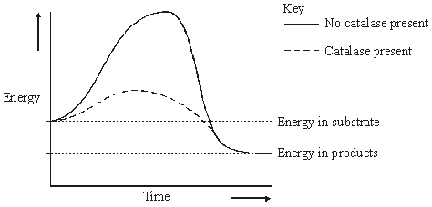
Use the graph to explain why
(i) hydrogen peroxide breaks down at a lower temperature when catalase is present than when it is not present;
.............................................................................................................
.............................................................................................................
(1)

(ii) test tubes A and B became warmer when the reaction was taking place.
.............................................................................................................
.............................................................................................................
.............................................................................................................
.............................................................................................................
(2)
(Total 9 marks)

Q4. Gangliosides are lipids found in the cell surface membranes of nerve cells. Hexosaminidase is an enzyme present in blood that breaks down gangliosides. If gangliosides are not broken down, they damage nerve cells.
(a) Hexosaminidase only breaks down gangliosides. It does not break down other lipids.
Explain why this enzyme only breaks down gangliosides.
......................................................................................................................
......................................................................................................................
......................................................................................................................
......................................................................................................................
......................................................................................................................
(3)

(b) Hexosaminidase is found in the blood of healthy people. People with Tay Sachs disease do not have this enzyme in their blood.
Doctors confirm Tay Sachs disease by using a blood test. The technician carrying out the test adds a solution containing a high concentration of gangliosides to a sample of blood from the person being tested. The technician then measures the concentration of gangliosides in the person’s blood at regular intervals.

(i) Complete the graph below by sketching a curve to show the results you would expect for a person with Tay Sachs disease. Label this curve T.
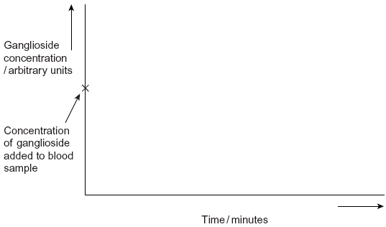
(1)

(ii) Sketch a curve on the same graph to show the results you would expect for a healthy person who does not have Tay Sachs disease. Label this curve H.
(1)

(c) Scientists are trying to find a way to give the missing enzyme to people with Tay Sachs disease. Suggest why they cannot give the enzyme as a tablet that is swallowed.
......................................................................................................................
......................................................................................................................
......................................................................................................................
......................................................................................................................
(2)
(Total 7 marks)

Q5. (a) Sucrose, maltose and lactose are disaccharides.
(i) Sucrase is an enzyme. It hydrolyses sucrose during digestion. Name the products of this reaction.
................................................... and ..................................................
(2)

(ii) Sucrase does not hydrolyse lactose. Use your knowledge of the way in which enzymes work to explain why.
.............................................................................................................
.............................................................................................................
.............................................................................................................
.............................................................................................................
(2)

(b) A woman was given a solution of sucrose to drink. Her blood glucose concentration was measured over the next 90 minutes. The results are shown on the graph.
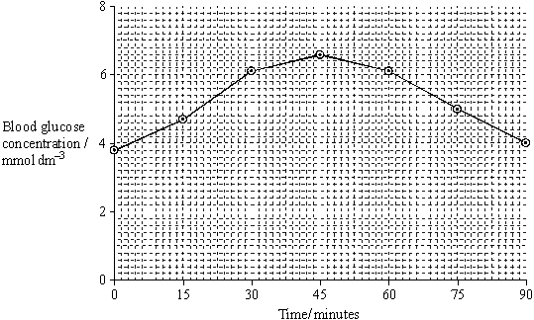
(i) Describe how the woman’s blood glucose concentration changed in the period shown in the graph.
.............................................................................................................
.............................................................................................................
.............................................................................................................
.............................................................................................................
(2)

(ii) Explain the results shown on the graph.
.............................................................................................................
.............................................................................................................
.............................................................................................................
.............................................................................................................
(2)

(iii) This woman was lactose intolerant.
On the graph, sketch a curve to show what would happen to her blood glucose concentration if she had been given a solution of lactose to drink instead of a sucrose solution.
(1)
(Total 9 marks)

Q6. A glucose biosensor is an instrument used to measure glucose concentration. It contains an enzyme called glucose oxidase.
(a) A glucose biosensor detects only glucose. Use your knowledge of the way in which enzymes work to explain why.
......................................................................................................................
......................................................................................................................
......................................................................................................................
......................................................................................................................
......................................................................................................................
......................................................................................................................
(3)

(b) It is better to use a biosensor than the Benedict’s test to measure the concentration of glucose in a sample of blood. Suggest two reasons why.
1 ...................................................................................................................
......................................................................................................................
2 ...................................................................................................................
......................................................................................................................
(2)

(c) (i) Diabetes mellitus is a disease that can lead to an increase in blood glucose concentration. Some diabetics need insulin injections. Insulin is a protein so it cannot be taken orally. Suggest why insulin cannot be taken orally.
.............................................................................................................
.............................................................................................................
.............................................................................................................
(1)

(ii) A drug company produced a new type of insulin. Scientists from the company carried out a trial in which they gave this new type of insulin to rats. They reported that the results of this trial on rats were positive. A newspaper stated that diabetics would benefit from this new drug. Suggest two reasons why this statement should be viewed with caution.
1 ..........................................................................................................
.............................................................................................................
2 ..........................................................................................................
.............................................................................................................
(2)
(Total 8 marks)
Q7. The graph shows the effect of substrate concentration on the rate of an enzyme-controlled reaction.
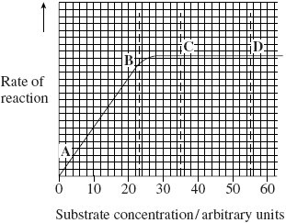
(a) (i) Describe what the graph shows about the effect of substrate concentration on the rate of this enzyme-controlled reaction.
.............................................................................................................
.............................................................................................................
.............................................................................................................
.............................................................................................................
(2)

(ii) What limits the rate of this reaction between points A and B? Give the evidence from the graph for this.
.............................................................................................................
.............................................................................................................
.............................................................................................................
.............................................................................................................
(2)

(iii) Suggest a reason for the shape of the curve between points C and D.
.............................................................................................................
.............................................................................................................
(1)

(b) Sketch a curve on the graph to show the rate of this reaction in the presence of a competitive inhibitor.
(1)

(c) Methotrexate is a drug used in the treatment of cancer. It is a competitive inhibitor and affects the enzyme folate reductase.
(i) Explain how the drug lowers the rate of reaction controlled by folate reductase.
.............................................................................................................
.............................................................................................................
.............................................................................................................
.............................................................................................................
.............................................................................................................
(2)

(ii) Methotrexate only affects the rate of the reaction controlled by folate reductase.
Explain why this drug does not affect other enzymes.
.............................................................................................................
.............................................................................................................
(1)
(Total 9 marks)
Q8. Some enymes digest protein. They hydrolyse the peptide bonds between amino acids. The extent to which a protein is digested is called the degree of hydrolysis (DH). The DH value may be calculated from the equation:
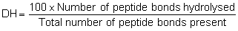
(a) (i) A protein molecule contains 151 amino acids. What is the total number of peptide bonds in this molecule?
.............................................................................................................
(1)

(ii) A molecule of this protein is digested. The DH value of the digested protein is 18. Calculate the number of peptide bonds that have been hydrolysed.

Answer ......................................
(1)
(b) What would be the DH value of a protein if it were completely hydrolysed to amino acids? Explain how you arrived at your answer.
DH value ......................................................................................................
Explanation ..................................................................................................
......................................................................................................................
......................................................................................................................
(2)

Enzymes A and B digest protein. The graph shows the effect of pH on the rates of reaction of these enzymes.
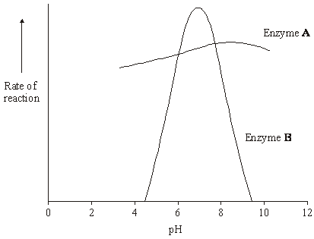
(c) Pepsin is a protein-digesting enzyme found in the stomach. It has an optimum pH of 2 and is fully denatured at pH 6. Sketch a curve on the graph to show the effect of pH on the rate of reaction of pepsin.
(1)

(d) Explain why the rate of reaction of enzyme B is low at pH 5.
......................................................................................................................
......................................................................................................................
......................................................................................................................
......................................................................................................................
......................................................................................................................
......................................................................................................................
(3)

(e) Enzyme A is present in some washing powders used for cleaning clothes. Use the graph to suggest why enzyme A would be of more use in washing clothes than enzyme B.
......................................................................................................................
......................................................................................................................
......................................................................................................................
(1)

(f) Use your knowledge of protein structure to explain why enzymes are specific and may be affected by non-competitive inhibitors.
......................................................................................................................
......................................................................................................................
......................................................................................................................
......................................................................................................................
......................................................................................................................
......................................................................................................................
......................................................................................................................
......................................................................................................................
......................................................................................................................
......................................................................................................................
......................................................................................................................
......................................................................................................................
......................................................................................................................
......................................................................................................................
(6)
(Total 15 marks)

Q9. (a) The diagrams represent an enzyme, its substrate and two other molecules, A and B.
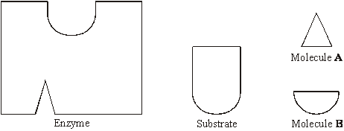
The addition of a non-competitive inhibitor will prevent the formation of an enzyme-substrate complex. Draw a labelled diagram based on relevant molecules selected from the diagram above to explain how this occurs.

(2)
(b) A decrease in temperature decreases the kinetic energy of molecules in a solution. Explain how a decrease in temperature decreases the rate of an enzyme-controlled reaction.
......................................................................................................................
......................................................................................................................
......................................................................................................................
......................................................................................................................
(2)

(c) Urea breaks hydrogen bonds. Explain how the addition of urea would affect the rate of an enzyme-controlled reaction.
......................................................................................................................
......................................................................................................................
......................................................................................................................
......................................................................................................................
......................................................................................................................
......................................................................................................................
(3)
(Total 7 marks)

Q10. In an investigation, the rate at which phenol was broken down by the enzyme phenol oxidase was measured in solutions with different concentrations of phenol. The experiment was then repeated with a non-competitive inhibitor added to the phenol solutions. The graph shows the results.
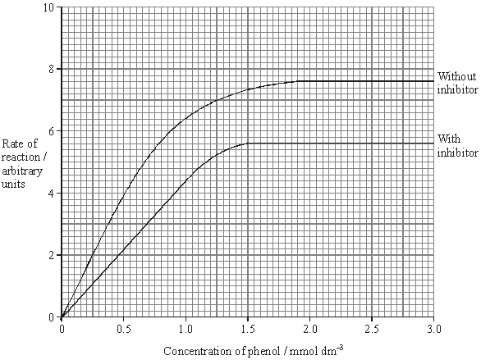
(a) Explain why an increase in concentration of phenol solution from 2.0 to 2.5 mmol dm^{–3} has no effect on the rate of the reaction without inhibitor.
......................................................................................................................
......................................................................................................................
......................................................................................................................
(2)
(b) Explain the effect of the non-competitive inhibitor.
......................................................................................................................
......................................................................................................................
......................................................................................................................
(2)
(c) Calculate the percentage decrease in the maximum rate of the reaction when the inhibitor was added. Show your working.

Percentage decrease ...........................................
(2)
(d) Draw a curve on the graph to show the results expected if a competitive inhibitor instead of a non-competitive inhibitor had been used.
(1)
(Total 7 marks)
Q11. (a) Amylase is an enzyme which hydrolyses starch to maltose. Some amylase and starch were mixed and the mixture incubated at 37 °C until the reaction was complete.
(i) Sketch a curve on the axes below to show the progress of this reaction.
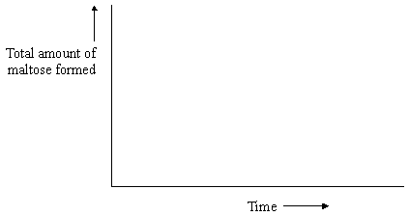
(1)
(ii) Explain why the rate of the reaction decreases as the reaction progresses.
.............................................................................................................
.............................................................................................................
.............................................................................................................
(2)
The effect of temperature on the rate of reaction of an enzyme was investigated. A test tube containing the enzyme and a test tube containing the substrate were incubated separately at each of the temperatures being investigated. After 5 minutes, they were mixed and the rate of reaction was determined. The experiment was repeated but, this time, the enzyme and the substrate were left for 60 minutes before they were mixed. The results of the investigation are shown in the graph.
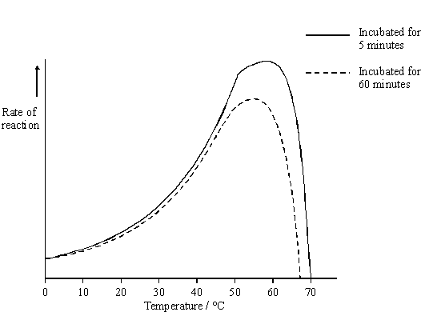
(b) The enzyme solution used in this investigation was made by dissolving a known mass of enzyme in a buffer solution. Explain why a buffer solution was used.
......................................................................................................................
......................................................................................................................
(1)
(c) (i) Use the graph to describe how incubation time affects the rate of the reaction.
.............................................................................................................
.............................................................................................................
.............................................................................................................
.............................................................................................................
(2)
(ii) The maximum rate of reaction with an incubation time of 60 minutes is less than the maximum rate of reaction with an incubation time of 5 minutes. Explain why.
.............................................................................................................
.............................................................................................................
.............................................................................................................
.............................................................................................................
.............................................................................................................
.............................................................................................................
(3)
(d) Explain how inhibitors affect the rate of enzyme-controlled reactions.
......................................................................................................................
......................................................................................................................
......................................................................................................................
......................................................................................................................
......................................................................................................................
......................................................................................................................
......................................................................................................................
......................................................................................................................
......................................................................................................................
......................................................................................................................
......................................................................................................................
(6)
(Total 15 marks)
Q12. Two samples of the roots of pea plants were placed in solutions containing potassium ions. An inhibitor to prevent respiration was added to one solution. The concentrations of potassium ions in the two solutions were measured at regular intervals. The graph shows the results.
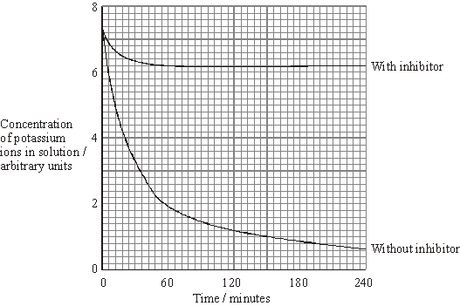
(a) Explain the decrease in the concentrations of potassium ions in the two solutions between 0 and 30 minutes.
(i) With inhibitor
......................................................................................................................................
......................................................................................................................................
(2)
(ii) Without inhibitor
......................................................................................................................................
......................................................................................................................................
(1)
(b) Explain why there is no further decrease in the concentration of potassium ions in the solution with the inhibitor after 60 minutes.
...............................................................................................................................................
..............................................................................................................................................
(2)
(c) The substance malonate is an inhibitor of respiration. It has a structure very similar to the substrate of an enzyme that catalyses one of the reactions of respiration. Explain how malonate inhibits respiration.
...............................................................................................................................................
...............................................................................................................................................
...............................................................................................................................................
(2)
(Total 7 marks)

