Additional Unit 2 Biological Molecules Questions

Name: ……………………………. Mark: …………/37 Grade: ………..
Q1. Cellulose is made from one type of monomer. The monomers are held together by bonds. The diagram shows parts of three cellulose molecules in a cell wall.
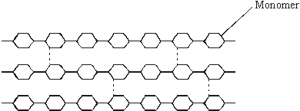
(a) Name the monomer present in cellulose.
......................................................................................................................
(1)

(b) Name the type of reaction that converts cellulose to its monomers.
......................................................................................................................
(1)

(c) Cotton is a plant fibre used to make cloth. Explain how cellulose gives cotton its strength.
......................................................................................................................
......................................................................................................................
......................................................................................................................
......................................................................................................................
......................................................................................................................
......................................................................................................................
(3)
(Total 5 marks)

Q2. The diagram shows an organism called Chlamydomonas.
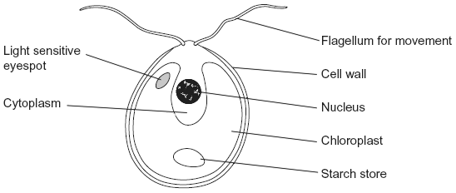
(a) Name two structures shown in the diagram that are present in plant cells but are not present in animal cells.
1 ...................................................................................................................
......................................................................................................................
2 ...................................................................................................................
......................................................................................................................
(2)
(b) Chlamydomonas lives in fresh water ponds. Use your knowledge of osmosis to suggest an advantage of using starch as a carbohydrate store.
......................................................................................................................
......................................................................................................................
......................................................................................................................
......................................................................................................................
......................................................................................................................
(2)
(c) Chlamydomonas has adaptations that help it to maintain a high rate of photosynthesis.
Use information in the diagram to explain what these adaptations are.
......................................................................................................................
......................................................................................................................
......................................................................................................................
(Extra space) ...............................................................................................
......................................................................................................................
(3)
(Total 7 marks)

Q3. (a) Give one feature of starch and explain how this feature enables it to act as a storage substance.
Feature ........................................................................................................
Explanation ..................................................................................................
......................................................................................................................
......................................................................................................................
(2)

(b) The diagram shows part of a cellulose molecule.
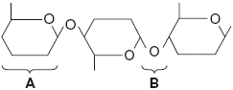
(i) Name part A.
.............................................................................................................
(1)
(ii) Name bond B.
.............................................................................................................
(1)

(c) The structure of cellulose is related to its role in plant cell walls. Explain how.
......................................................................................................................
......................................................................................................................
......................................................................................................................
......................................................................................................................
......................................................................................................................
......................................................................................................................
(3)
(Total 7 marks)

Q4. (a) What is a tissue?
......................................................................................................................
......................................................................................................................
(1)

(b) A student cut a thin section of tissue from a potato and examined it with an optical microscope.
(i) Starch was present in the cells of this tissue. Describe how the student could find out where in the cells the starch was present.
.............................................................................................................
.............................................................................................................
.............................................................................................................
.............................................................................................................
.............................................................................................................
(2)

(ii) The student cut a thin section of the tissue. Explain why it was important that the section was thin.
.............................................................................................................
.............................................................................................................
.............................................................................................................
.............................................................................................................
.............................................................................................................
(2)

(c) The cell walls of potato cells contain cellulose. Cellulose and starch are both carbohydrates. Describe two ways in which molecules of cellulose are similar to molecules of starch.
......................................................................................................................
......................................................................................................................
......................................................................................................................
......................................................................................................................
(2)
(Total 7 marks)

Q5. (a) Name the process in which cells become adapted for different functions.
......................................................................................................................
(1)

(b) Palisade cells are found in leaves. The diagram shows a palisade cell.
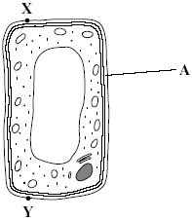
(i) Name structure A.
.............................................................................................................
(1)

(ii) The real length of this cell between X and Y is 20 micrometres (µm). By how many times has it been magnified? Show your working.

Answer ............................................
(2)

(iii) Explain one way in which this cell is adapted for photosynthesis.
.............................................................................................................
.............................................................................................................
(1)
(Total 5 marks)

Q6. The electron micrograph shows part of a chloroplast.
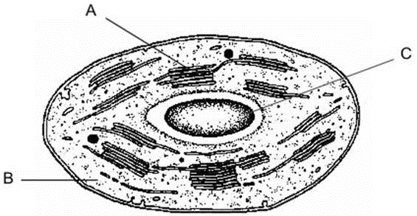
(a) Name the parts labelled A and B and, for each, describe one role in the process of photosynthesis.
A Name ........................................................................................................
Role ...........................................................................................................
(2)
B Name ........................................................................................................
Role ...........................................................................................................
(2)

(b) (i) Name the main substance present in the part labelled C.
.............................................................................................................
(1)

(ii) How is this substance formed?
.............................................................................................................
.............................................................................................................
(1)
(Total 6 marks)

