Additional Exchange Questions
Q1. (a) Describe the features of fish gills that give them a large surface area.
......................................................................................................................
......................................................................................................................
......................................................................................................................
......................................................................................................................
(2)

The graph shows the relationship between gill surface area and body mass for three species of fish.
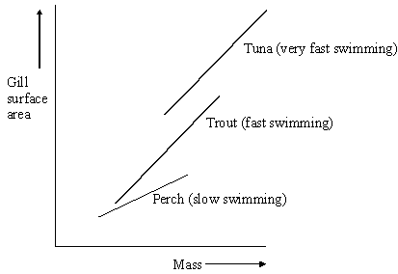
(b) (i) Describe the relationships between gill surface area, mass and swimming speed shown in the diagram.
.............................................................................................................
.............................................................................................................
(1)

(ii) Explain the relationship between gill surface area and swimming speed.
.............................................................................................................
.............................................................................................................
.............................................................................................................
.............................................................................................................
(2)
(Total 5 marks)

Q2. The graph shows the surface area to volume ratio of cubes of different size.
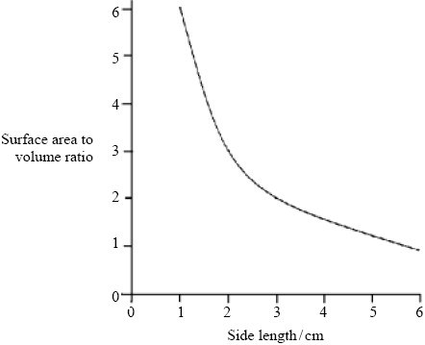
(a) Elephant seals are mammals that live in water that has a temperature of between 0 °C and 4 °C. Elephant seals are very large. Use the graph to explain the advantage of a large size to elephant seals.
......................................................................................................................
......................................................................................................................
......................................................................................................................
......................................................................................................................
(2)

(b) (i) Describe how single-celled organisms exchange respiratory gases.
.............................................................................................................
.............................................................................................................
(1)

(ii) This method of gas exchange is only possible in very small organisms.
Explain why.
.............................................................................................................
.............................................................................................................
.............................................................................................................
.............................................................................................................
(2)
(e) An insect lives in air. Describe how the insect is able to obtain oxygen and limit water loss.
......................................................................................................................
......................................................................................................................
......................................................................................................................
......................................................................................................................
......................................................................................................................
......................................................................................................................
......................................................................................................................
......................................................................................................................
......................................................................................................................
......................................................................................................................
......................................................................................................................
......................................................................................................................
(6)
(Total 15 marks)
Q3. The drawing shows part of the lower leaf epidermis of sorghum.
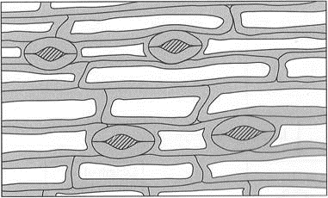
(a) Calculate the number of stomata per mm² of the leaf surface. Show your working.

Answer ....................................... stomata per mm²
(2)

(b) Sorghum has few stomata per mm² of leaf surface area. Explain how this is an adaptation to the conditions in which sorghum grows.
......................................................................................................................
......................................................................................................................
......................................................................................................................
......................................................................................................................
......................................................................................................................
......................................................................................................................
(3)
(Total 5 marks)
Q4. Many insects release carbon dioxide in short bursts even though they produce it at a constant rate. The diagram shows how this is achieved in one particular insect.
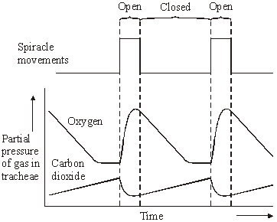
(a) Using information from the diagram, suggest what stimulates the spiracles to open.
......................................................................................................................
......................................................................................................................
(1)

(b) Explain what causes the oxygen concentration in the tracheae to fall when the spiracles are closed.
......................................................................................................................
......................................................................................................................
......................................................................................................................
......................................................................................................................
(2)

(c) The insect lives in dry conditions. Suggest an advantage of the pattern of spiracle movements shown in the diagram.
......................................................................................................................
......................................................................................................................
......................................................................................................................
......................................................................................................................
(2)
(Total 5 marks)
Q5. In an investigation, a locust was given alternating supplies of atmospheric air and pure
carbon dioxide. The rate of pumping movements of the insect’s abdomen was measured.
The graph shows the results.
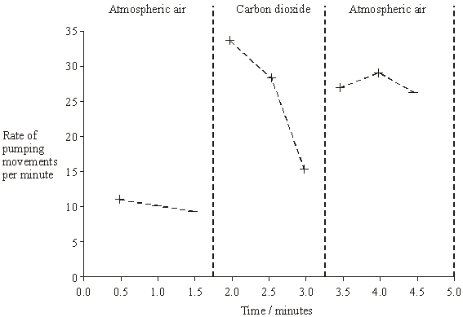
(a) Explain what caused
(i) the rise in the rate of abdominal pumping movements between 1.5 and 2.0 minutes,
.............................................................................................................
.............................................................................................................
(1)
(ii) the fall in the rate of abdominal pumping movements between 2.0 and 3.0 minutes.
.............................................................................................................
.............................................................................................................
.............................................................................................................
.............................................................................................................
(2)

(b) The rate of abdominal pumping movements increases between 3.0 and 3.5 minutes. Suggest the advantage of this change to the locust.
......................................................................................................................
......................................................................................................................
(1)
(Total 4 marks)
Q8. (a) Explain how the ventilation mechanism of a fish and the structure of its gills result in the efficient uptake of oxygen from water.
......................................................................................................................
......................................................................................................................
......................................................................................................................
......................................................................................................................
......................................................................................................................
......................................................................................................................
......................................................................................................................
......................................................................................................................
......................................................................................................................
......................................................................................................................
......................................................................................................................
(6)
Table 1 compares some features of water and air.

Feature | Water | Air
Relative density | 1000 | 1
Maximum concentration of oxygen / cm³ dm^{–3} | 9 | 130

Table 1
Table 2 shows some features of gas exchange in a fish and in a mammal.

Feature | Fish | Mammal
Percentage of oxygen extracted from water or air | 80 | 25
Oxygen consumption at rest / cm³ kg^{–1} hour^{–1} | 100 | 200

Table 2

(b) (i) The fish has a body mass of 0.2 kg. Calculate the volume of water it will need to pass over its gills each hour to supply the oxygen required when resting. Show your working.

Answer ............................................ dm³ / hour^{–1}
(2)

(ii) Ventilation in mammals involves movement of air to and from the gas exchange surface in a tidal pattern. Using information in the tables, explain why it is easier to move water over the gas exchange surface of a fish in one direction rather than in a tidal pattern.
.............................................................................................................
.............................................................................................................
.............................................................................................................
.............................................................................................................
(2)

(c) A rise in the temperature of water decreases the amount of oxygen dissolved in the water. As the water temperature rises, the rate of ventilation in a fish also rises. Explain the advantage of this.
......................................................................................................................
......................................................................................................................
......................................................................................................................
......................................................................................................................
(2)
(Total 12 marks)

Q9. (a) Gas exchange in fish takes place in gills. Explain how two features of gills allow efficient gas exchange.
1 ...................................................................................................................
......................................................................................................................
2 ...................................................................................................................
......................................................................................................................
(2)
(b) A zoologist investigated the relationship between body mass and rate of oxygen uptake in four species of mammal. The results are shown in the graph.
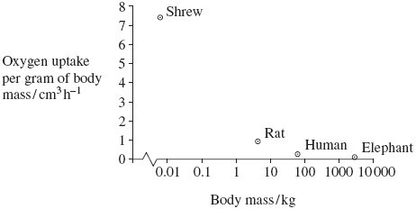
(i) The scale for plotting body mass is a logarithmic scale. Explain why a logarithmic scale was used to plot body mass.
.............................................................................................................
.............................................................................................................
(1)
(ii) Describe the relationship between body mass and oxygen uptake.
.............................................................................................................
.............................................................................................................
(1)
(iii) The zoologist measured oxygen uptake per gram of body mass. Explain why he measured oxygen uptake per gram of body mass.
.............................................................................................................
.............................................................................................................
.............................................................................................................
.............................................................................................................
(2)
(Total 6 marks)

M1. (a) 1 Large surface area provided by lamellae/filaments;
Q Candidates are required to refer to lamellae or filaments. Do not penalise for confusion between two
2 Increases diffusion/makes diffusion efficient;
3 Thin epithelium/distance between water and blood;
4 Water and blood flow in opposite directions/countercurrent;
5 (Point 4) maintains concentration gradient (along gill)/equilibrium
not reached;
5 Not enough to say gives steep concentration gradient
6 As water always next to blood with lower concentration of oxygen;
7 Circulation replaces blood saturated with oxygen;
8 Ventilation replaces water (as oxygen removed);
6-8 Accept answers relating to carbon dioxide
6 max

(b) Mixing of air and water (at surface);
Air has higher concentration of oxygen than water;
Diffusion into water;
Plants/seaweeds near surface/in light;
Produce oxygen by photosynthesis;
2 max

(c) Not much oxygen near sea bed;
Toadfish haemoglobin (nearly) saturated/loads readily at /has higher
affinity for oxygen at low partial pressure (of oxygen);
2

(d) (i) The chimpanzee and the bonobo are more closely related (than
to the gorilla);
They have identical amino acids/one of the amino acids is
different in the gorilla;
2

(ii) (Chimpanzee) orang-utan;
Amino acids different so bases different;
Few hydrogen bonds;
3
[15]

M2. (a) (gills have) lamellae on filaments;
lots of both;
2
(b) (i) all 3 go up;
Accept converse
1
(ii) more oxygen can be supplied;
for more respiration;
Accept answer relating to CO₂
2
[5]

M3. (a) Small surface area to volume ratio;
Loses less heat (to the water);
2
(b) (i) Diffusion through cell/body surface;
Q The key term here is diffusion
1
(ii) Small organisms have large surface area to volume ratio;
Rate of diffusion depends on surface area;
All parts of cell only a short distance from exchange surface;
2 max

(c) Surface area of leaves;
Different shoots will have leaves with different surface areas;
2
(d) Draw line/curve of best fit/from line/curve of best fit;
Find slope/gradient/divide distance moved by time;
2

(e) 1 Air enters through (open) spiracles;
2 Through tracheae;
3 Diffusion gradient in trachea
4 Tracheae associated with all cells/closely associated with cells;
5 Oxygen diffuses into cells;
6 Ventilation replacing air in tracheae;
7 Body covered with (waterproof) waxy layer/cuticle;
8 Spiracles are able to close;
6 max
[15]

M4. (a) 235–240;;
(one mark for an answer between 200-300
based on 2 - 3 stomata in 0.01mm²
Alternatively, one mark for calculating the area of the
rectangle correctly as 0.016 – 0.017mm²)
2

(b) grows in arid / dry conditions;
less surface area;
(rate of) transpiration / water loss would be reduced;
3
[5]

M5. (a) (diffusion) gradient will be maintained all the way along the gill / the
amount of oxygen in the water is always higher than in the blood /
the numbers in the water are always higher than in the blood;
more oxygen will diffuse into the blood;
2

(b) (i) 100 cycles per minute;
(principle of 60/x or 0.6 seen gains one mark)
2
(ii) shuts mouth;
raises the floor of the mouth cavity;
decreases volume in the mouth cavity;
2 max

(iii) the fish has lowered the floor of its mouth cavity;
(therefore) the pressure in the mouth falls below that of the
opercular cavity;
OR
the fish has closed the flap covering the opercular cavity;
(therefore) the pressure in the opercular cavity increases
above that of the mouth cavity;
2
[8]

M6. (a) increasing carbon dioxide concentration / partial pressure;
(decrease in oxygen negates)
1

(b) (oxygen is used in) respiration;
therefore diffuses (from tracheae) to tissues;
oxygen unable to enter organism;
2 max

(c) spiracles not open all the time;
therefore there is less water loss
(by diffusion through spiracles);
2
[5]

M7. (a) (i) high/higher CO₂ concentration / lack of oxygen;
1
(ii) CO₂ asphyxiates / is toxic;
lack of oxygen for (aerobic) respiration;
lack of energy / ATP (for pumping movements);
reduced muscle function / muscle fatigue
2 max
(b) removal of (excess) CO₂ / oxygen to break down lactate / to
repay oxygen debt/to enable aerobic respiration;
1
[4]

M8. (a) (explanation must be linked to structures to gain second mark for each linked pair)

filaments/lamellae ; | large SA;
gill plates or secondary lamellae;
large number of capillaries; | to remove oxygen / to maintain a gradient;
thin epithelium; | short diffusion pathway;
pressure changes; | to bring in more water / to maintain gradient;
countercurrent flow (or description); | exchange/diffusion along whole length / concentration gradient maintained / equilibrium not achieved / blood always meets water with higher oxygen concentration;

6

(b) (i) requires 20 cm³ of oxygen / extracts 7.2 cm³ of oxygen /
reject if referring to volume of water
;
2.7/2.8 (dm³h^{–1});
(correct answer award 2 marks)
2
(ii) high (relative) density/heavy;
requires large input of energy;
difficult to push back out;
2 max

(c) (for each pair second point must be linked to first)
to provide same amount of oxygen;
need to have more water flowing over gills;
OR
metabolic rate/respiration increases (with increase in temperature);
so more oxygen required;
2 max
[12]
QWC 1

M9. (a) Filaments/lamellae provide large surface area;
Thin/flattened epithelium/one/two cell layers so short diffusion
pathway (between water and blood);
Countercurrent/blood flow maintains concentration/diffusion gradient;
Q Do not credit thin cell walls/membranes
2 max

(b) (i) Large/wide range of values (so can fit on graph);
1
(ii) Decrease in uptake with increase in mass/negative correlation;
1
(iii) Enables comparison;
As animals differ in size/mass;
2

(iv) Smaller animals have larger surface area to volume ratio;
Allow converse for larger animals.
Allow appropriately named animal as an alternative to smaller or larger animals.
Lose more heat per gram of tissue;
Respire more/faster (relative to body mass);
Oxygen used in respiration;
3 max
[9]

