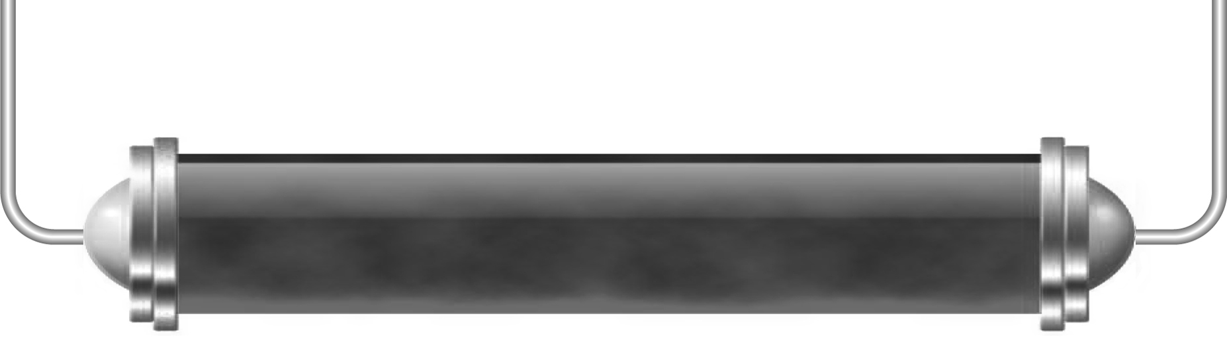
Day and night

Task 1: Earth quiz (Level 4)

Answer these questions to see how much you know about our home planet. Try them yourself first and then share your answers with a partner to see if you agree.

- Is the Earth still or does it spin on an axis?

- If you think it spins how long do you think it takes to complete one rotation?

- Does the Earth move around the Sun, or does the Sun move around the Earth?

- Does the Earth move around the Moon or does the Moon move around the Earth?

- Which is closer to Earth, the Sun or the Moon?

- Why do we have night time when it is dark and we cannot see the Sun?

- Can you name a planet that is closer to the Sun than the Earth is?

- Can you name a planet that is further away from the Sun than the Earth is?

Task 2: Modelling the Earth, the Sun and the Moon (Levels 5–6)

You are going to make an orrery, which is a model showing how different planets move in relation to each other. We know that the Earth orbits the Sun, but what about the Moon? Think about this as you make your model.
This is only a model, and all models have limitations. What are the limitations or weaknesses of this model?

Task 3: How our lives have changed (Level 6)

For thousands of years people thought that the Earth was at the centre of everything and that the Sun moved around the Earth. Nicolaus Copernicus is thought to be the first person to realise that it was the Earth that moved around the Sun. Can you find out:
- In what year was Copernicus born?

- In what year did Copernicus die?

- Copernicus’s ideas were supported by Galileo, what else is Galileo famous
for discovering?

- Copernicus’s ideas were later proved by Isaac Newton, what else is Newton famous
for discovering?

- Why were people before Copernicus unable to find out what he found out, when people coming after him could prove his ideas were correct?

