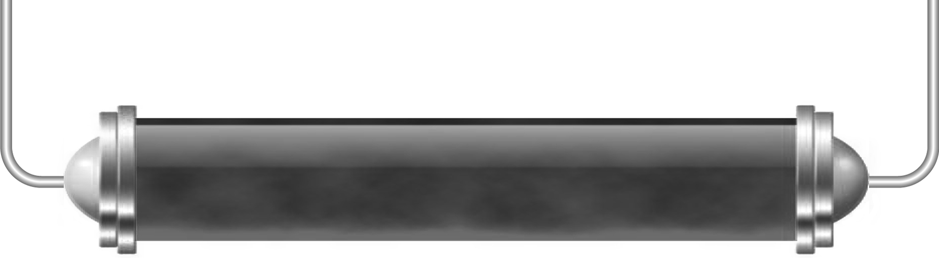
The seasons

Task 1: How things change (Levels 3–5)
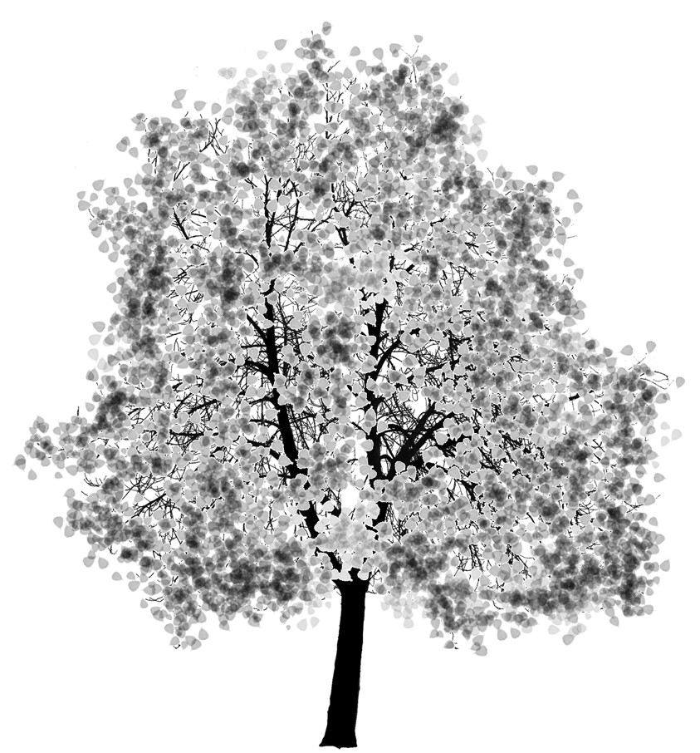
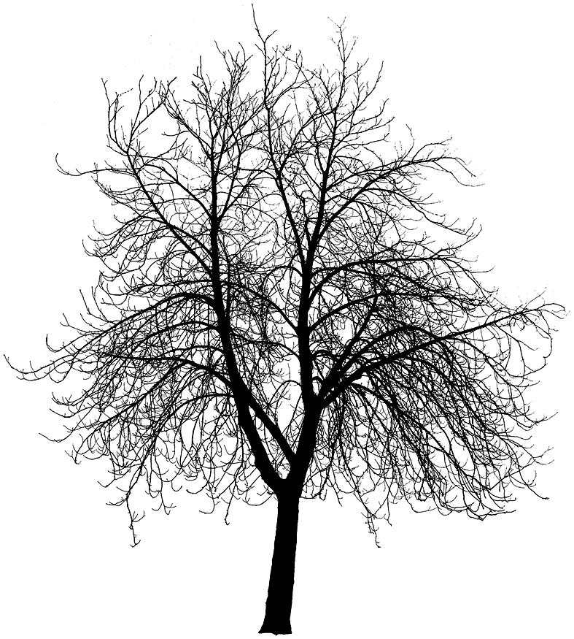
What month is it now?
Which season of the year are we in?
Write down five things you can see from the classroom window – be quite specific about what you write.

What month will it be in six months’ time?

What season of the year will that be?
Look at the things you have written above and decide which ones will be the same and which will be different in six months’ time. For those that will be different, describe how they will be different.

The same | Different | Different because……

Task 2: Different times of year (Levels 5–7)

Work in a group. Your teacher will tell you which location and season to look at from the list below.
A country in the Northern hemisphere in June
A country in the Northern hemisphere in December
A country in the Southern hemisphere in June
A country in the Southern hemisphere in December
A country on the equator in June
A country on the equator in December
The North Pole in June
The North Pole in December
The South Pole in June
The South Pole in December
Prepare a poster showing the position of the Earth and the Sun in the month you have been given. Then for your location explain what the conditions are like – use the internet to help you find out the hours of sunshine and the average temperature and rainfall for example. Illustrate your poster with some images of what you think people’s lives are like in your location at that time of year. You are going to share your poster with the rest of the class at the end of the lesson.

Task 3: Gradual change (Levels 4–6)

We all know that days are longer in summer than in winter but do you know how quickly day length changes?

Record sunrise and sunset times for where you live and at least one other location over a week. At the end of this time plot a graph showing how the days get longer or shorter.

Location 1: |  |  | Location 2:
Date | Sunrise | Sunset | Date | Sunrise | Sunset

